**Day 55**

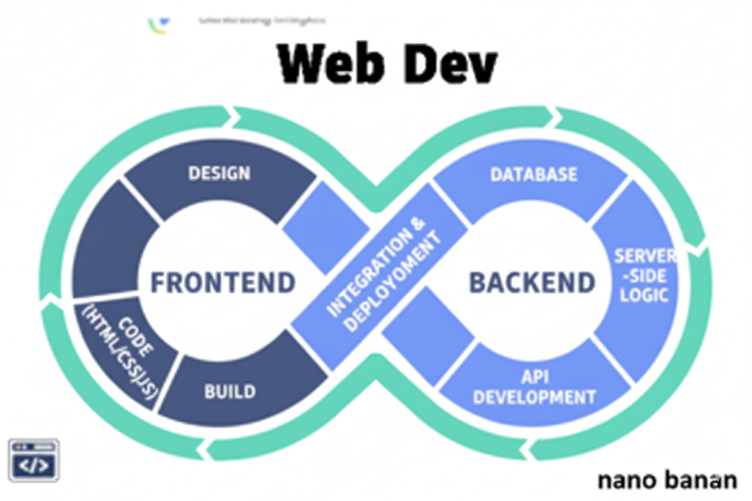

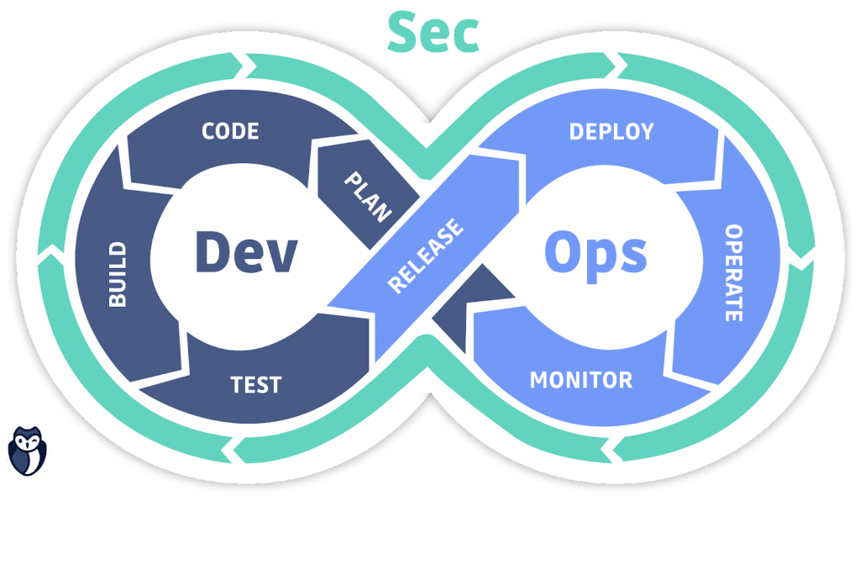

**“Web Development + Security”**

**Hooks & State in React:**

**What Are Hooks?**

Hooks are special functions in React that let you *“hook into”* React’s features like state, lifecycle, etc., inside functional components.

Before Hooks (React <16.8), only class components could handle state. Now, functional components can do everything.

**Commonly Used Hooks**

| Hook | Purpose |
| --- | --- |
| useState() | To create and manage state |
| useEffect() | To perform side effects (like API calls) |
| useContext() | To use context API |
| useRef() | To access/manipulate DOM elements |
| useReducer() | For complex state logic |
| useMemo() | For performance optimization |

**What Is State?**

* State is data that belongs to a component and can change over time.
* When state changes, React re-renders the component automatically.
* Think of it as the memory of your component.

Now, to understand these concepts, let’s first bring the vite+react:

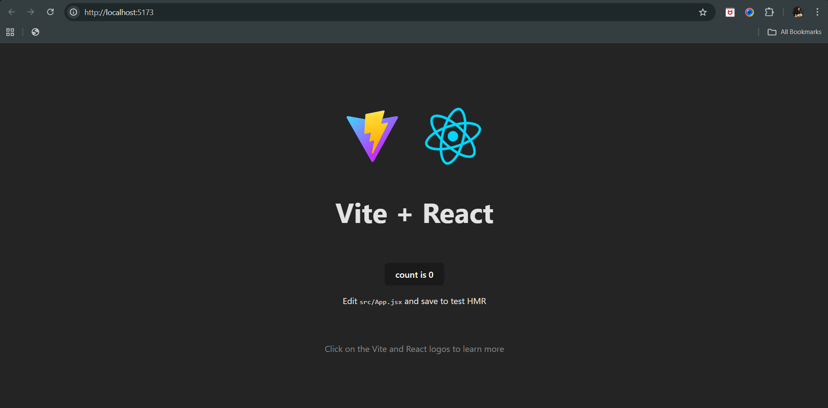

For this, where can we find the state and the function for this:

In the App.jsx, we can see this snippet:

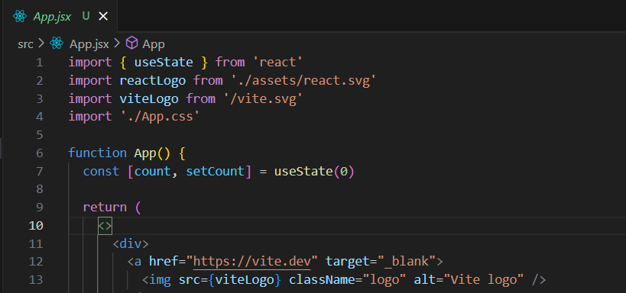

Here the line number 7, it has count and setCount and useState; we can see that the ‘count’ is the state and ‘setCount’ is the function to be used to update the count and useState says to start it with 0.

So, can we change the initial value form 0 to 10? Yes we can do so, let’s see: (we have removed the other things)

App.jsx:

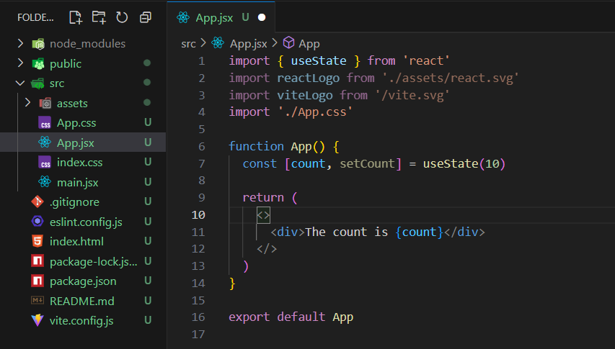

Output:

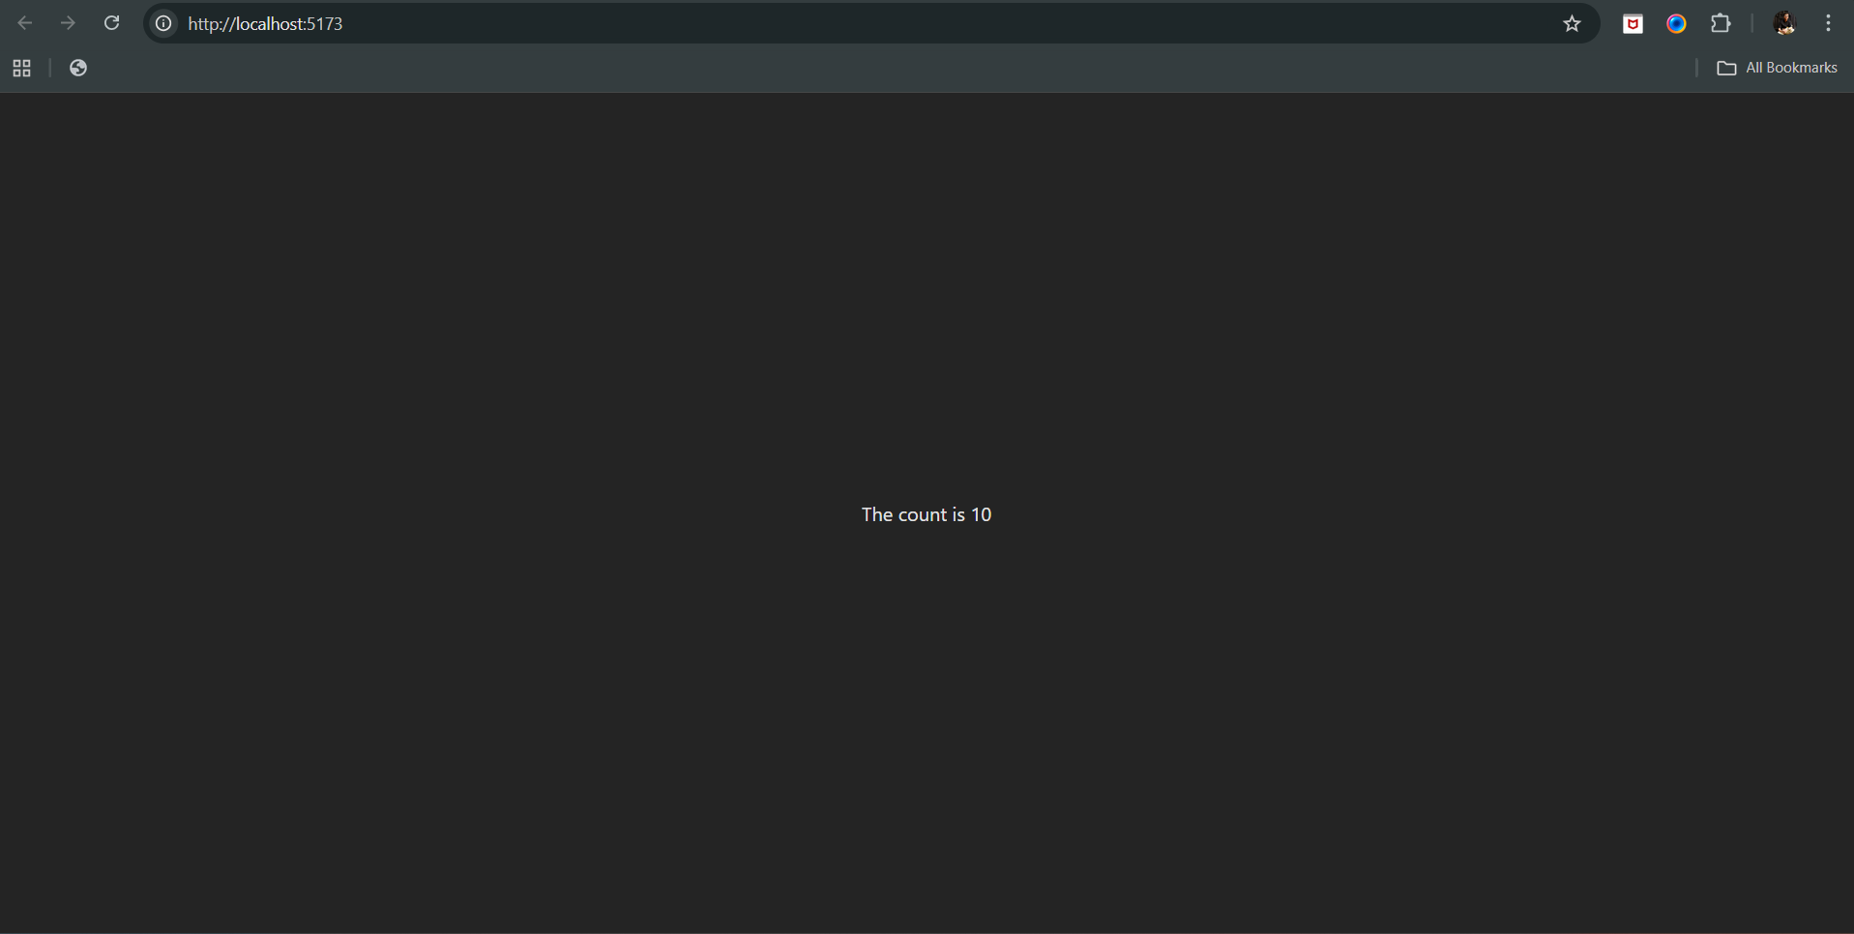

Now, we will add the button, which on being clicked update the count value:

App.jsx:

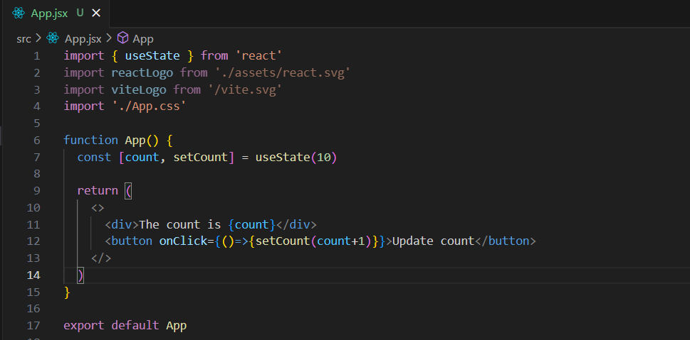

Output:

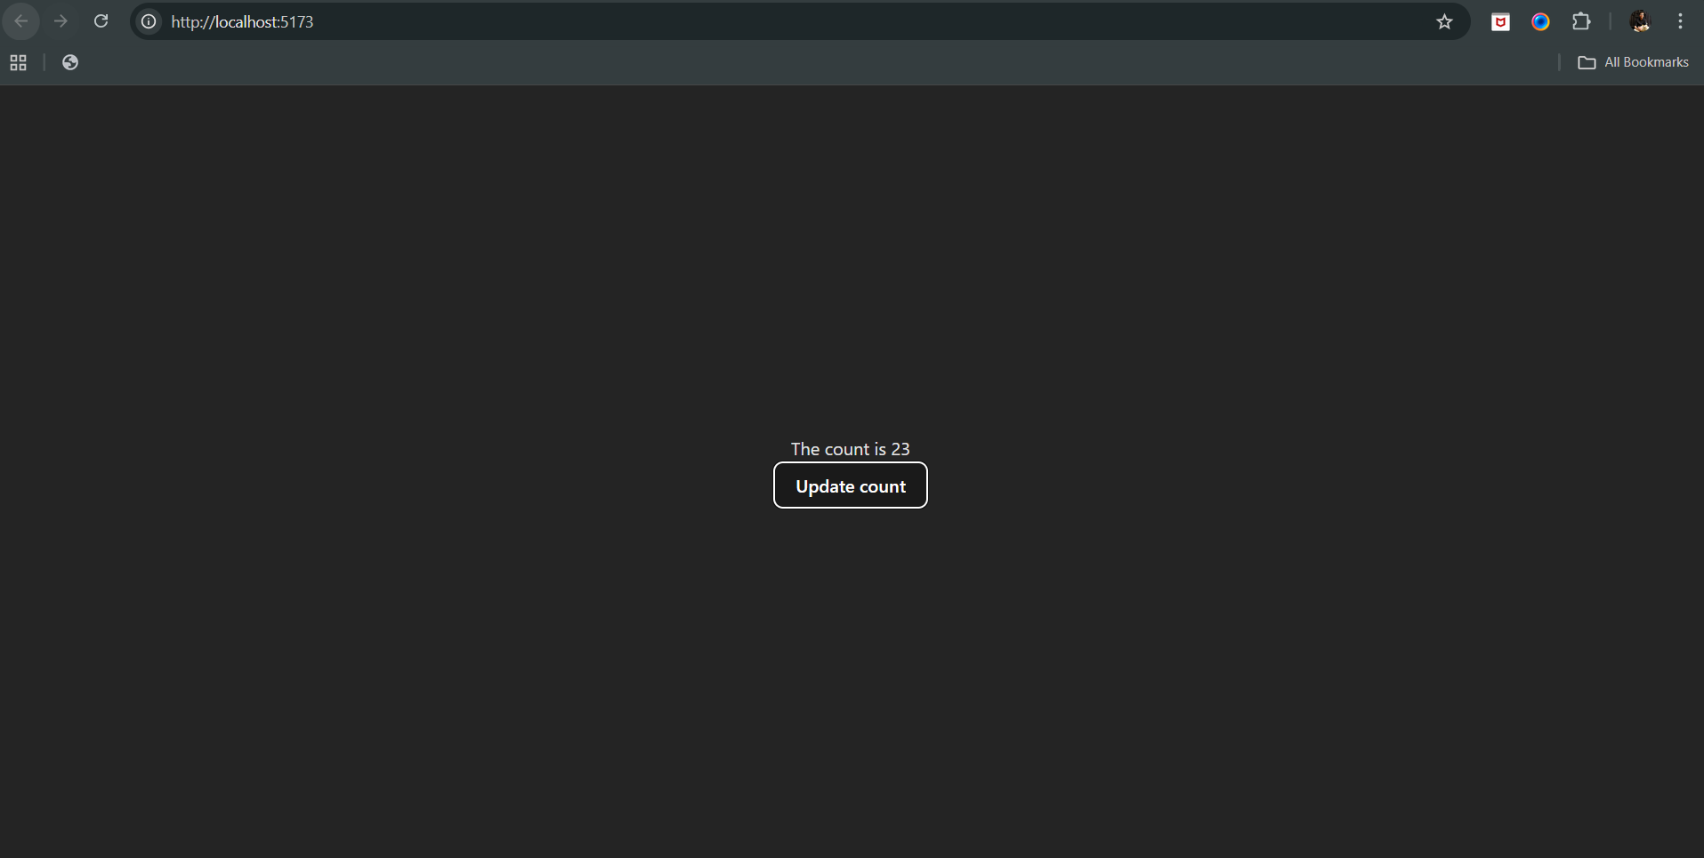

--The End--