**Day 58**



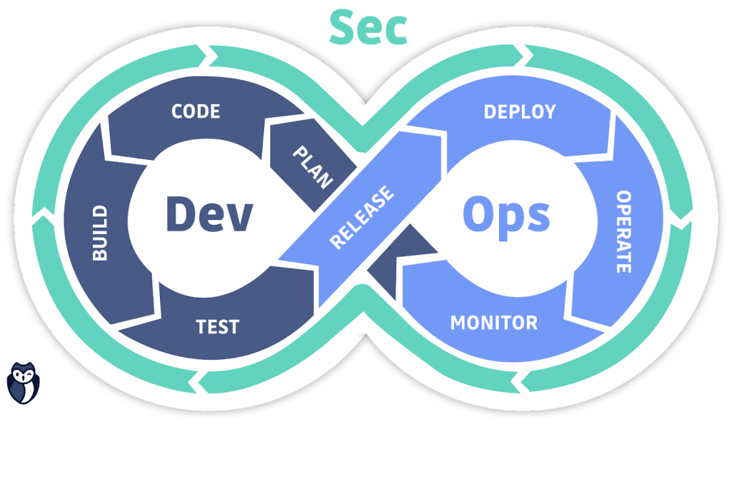

**“Web Development + Security”**

**Conditional Rendering & Rendering Lists in React:**

**What is Conditional Rendering?**

Conditional Rendering means showing (or hiding) components or elements based on a condition —  
just like using if, else, or the ternary operator in plain JavaScript. In React, it helps display different UI parts dynamically, depending on state, props, or data.

**What is Rendering Lists?**

Rendering Lists means displaying multiple similar elements — like a list of users, products, or tasks — by looping over an array.

React does this using the .map() function.

**In Short**

* Conditional rendering = *show/hide content dynamically*
* List rendering = *display many items efficiently*
* Together, they make React apps interactive and data-driven

To understand, we will run the npm run dev, as we always do from last few days:

Output:

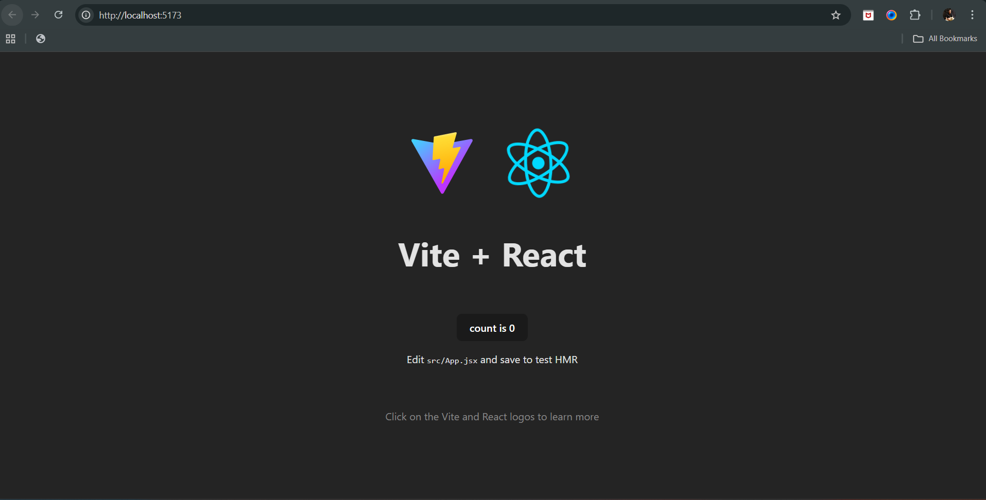

Now, suppose we want that a button above the count will show only if the showBtn which is a variable in the snippet be true, since by default its value is false. For this we will edit the App.jsx as shown below:  
App.jsx: line number 8 and 21 added

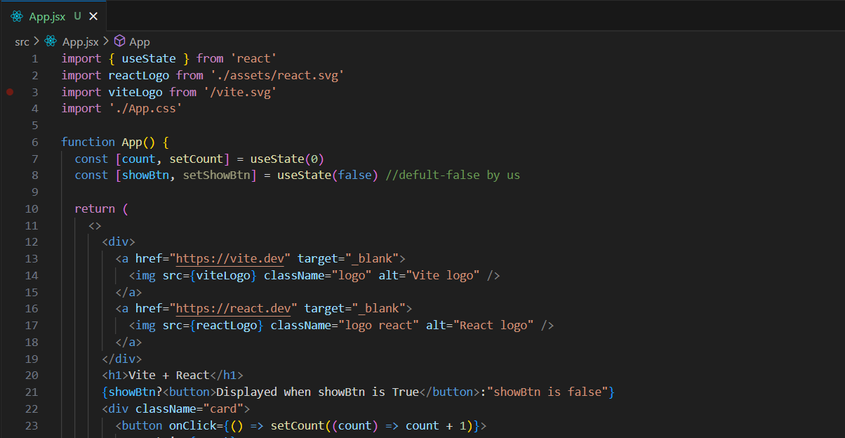

Output: since showBtn in the code is written as false.

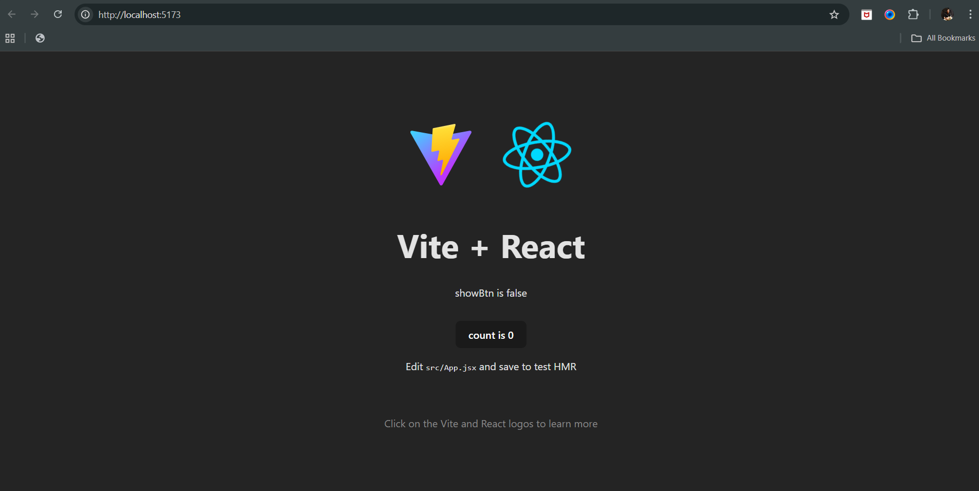

Now, in case we hard code the line number 8 to be true, then.

App.jsx: see line 8 changed from false to true.

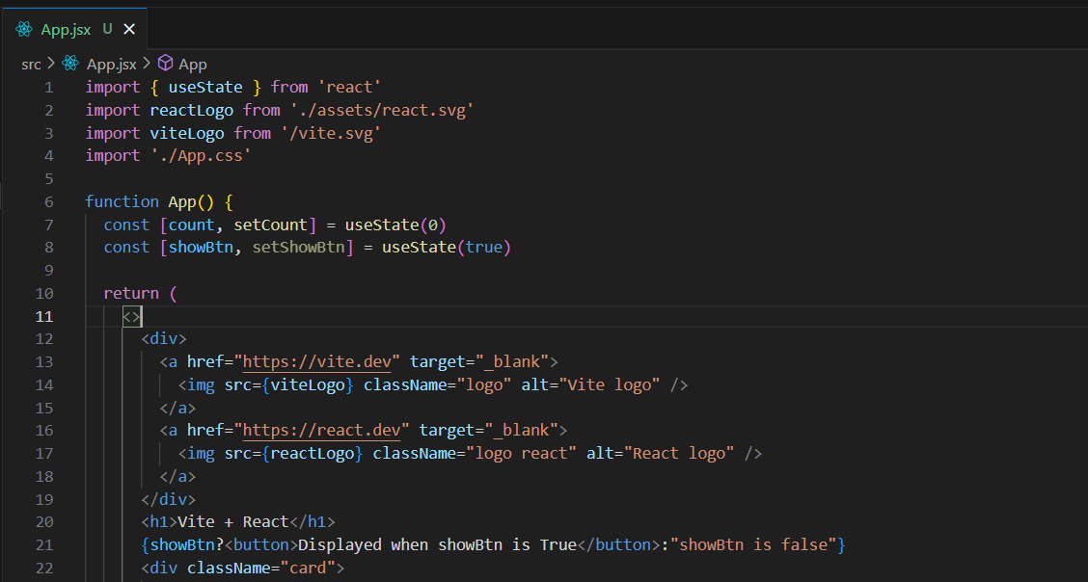

Output: as expected button is visible.

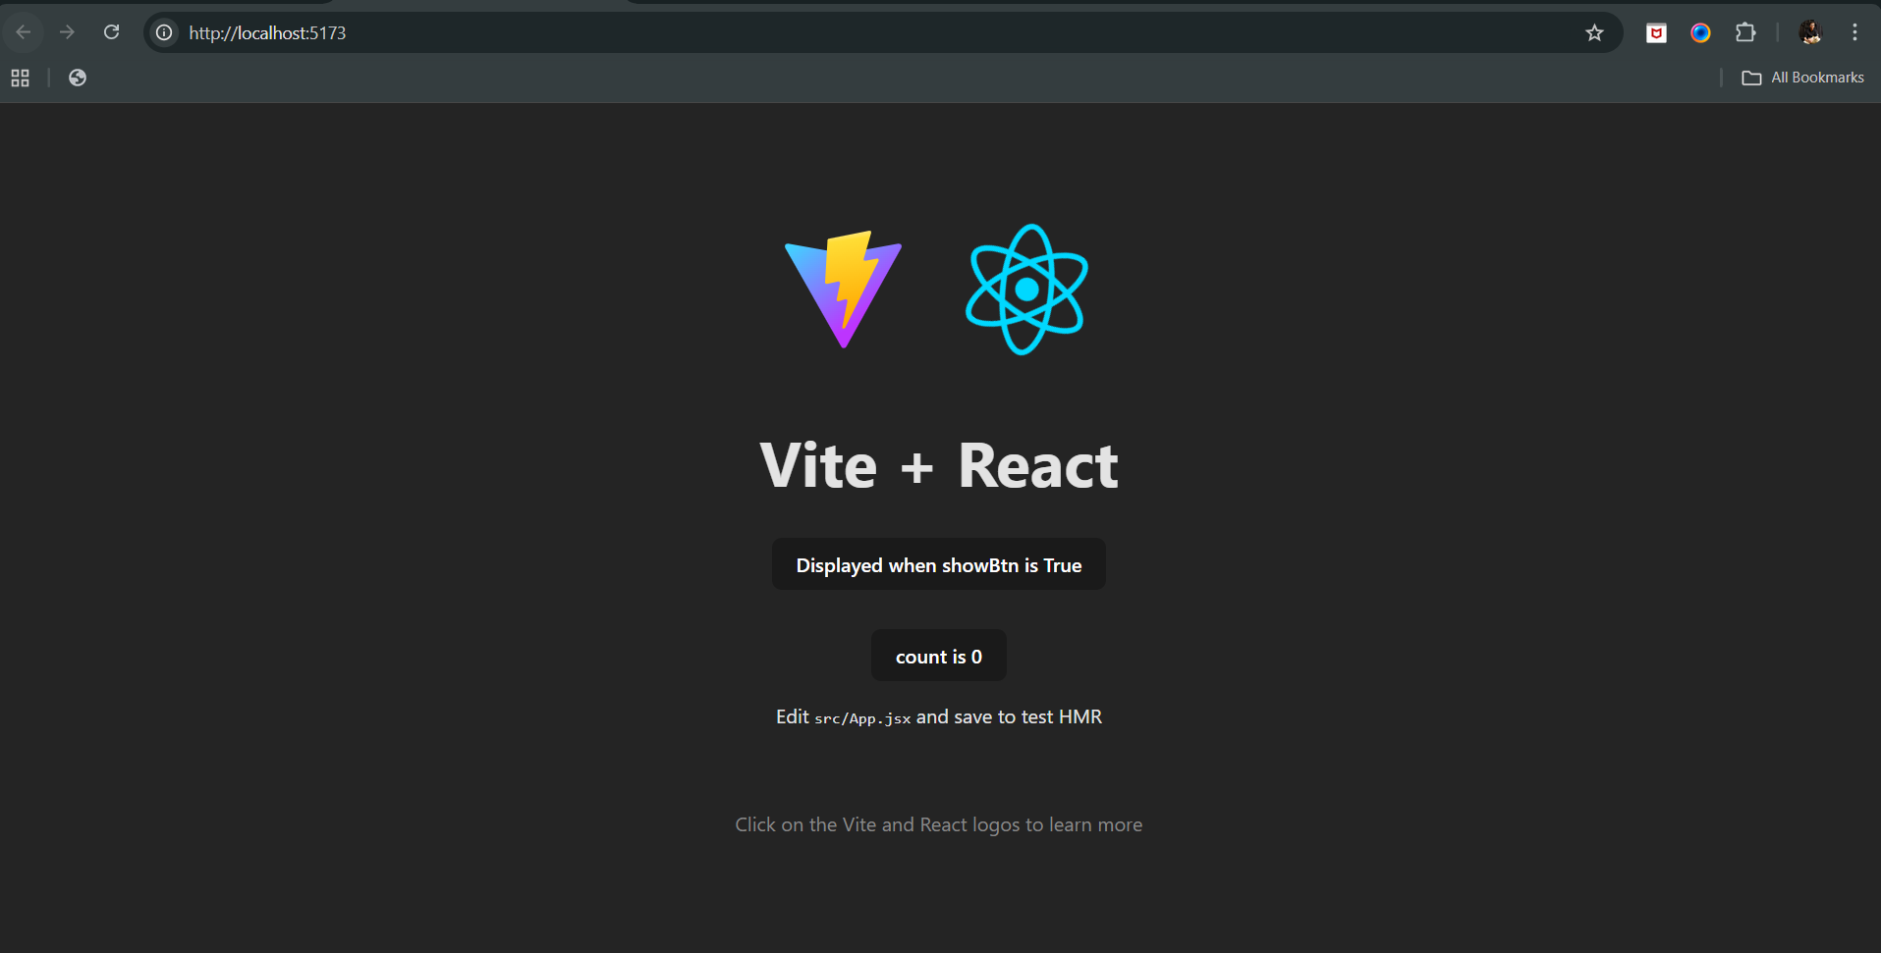

Is there any other standard way to do so? Yes, we can use && in the {} to do so, as shown below:

App.jsx: notice line number 8 and 21.

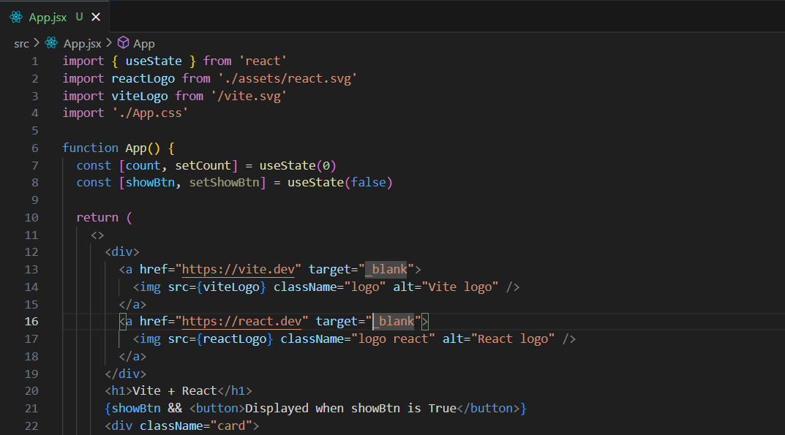

Output: as it is false, button will not show.

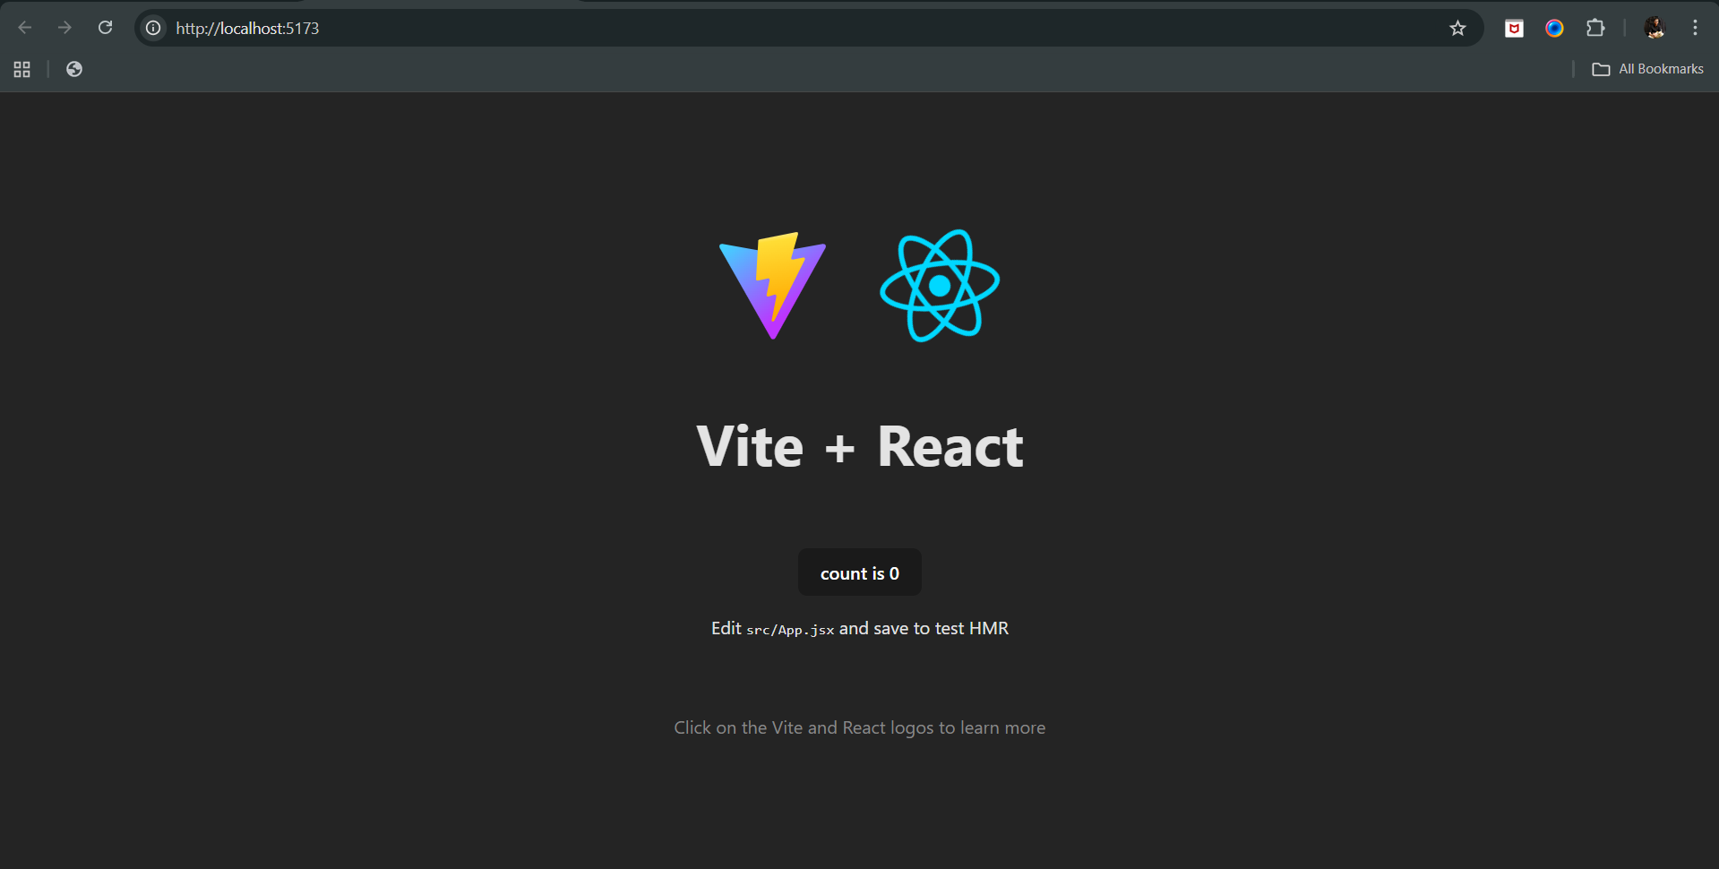

Now, can we make the changes such that when the count button will be clicked the button will get toggled? Yes, we can do so. See below:

App.jsx: notice line 23.

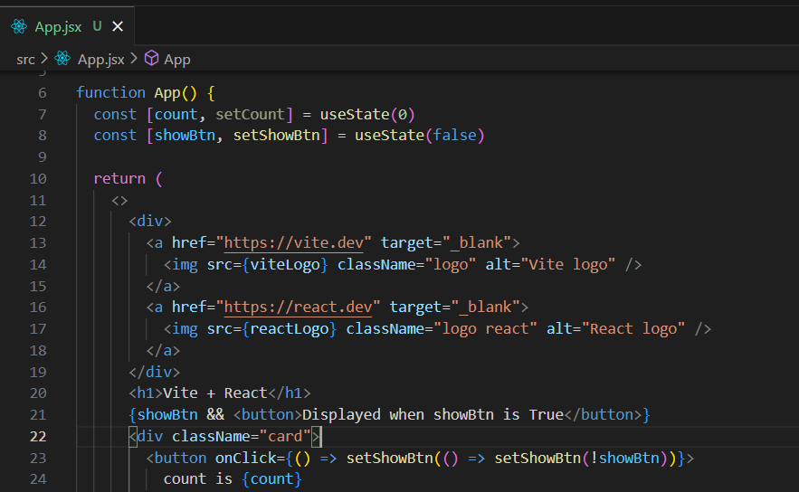

Output: since by default it is false, button will not be visible when loaded first

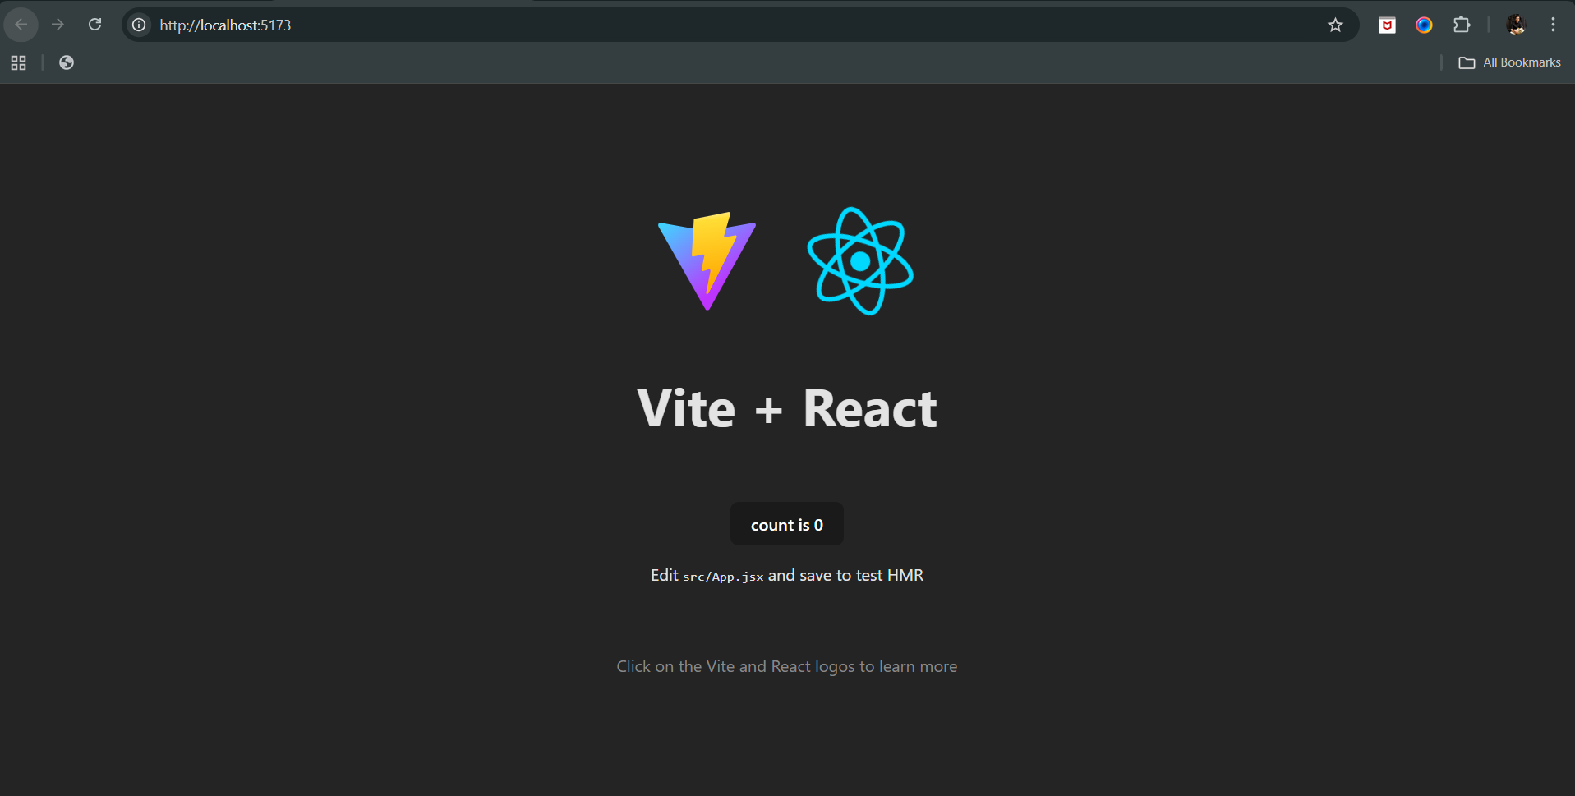

Output: when count button was clicked

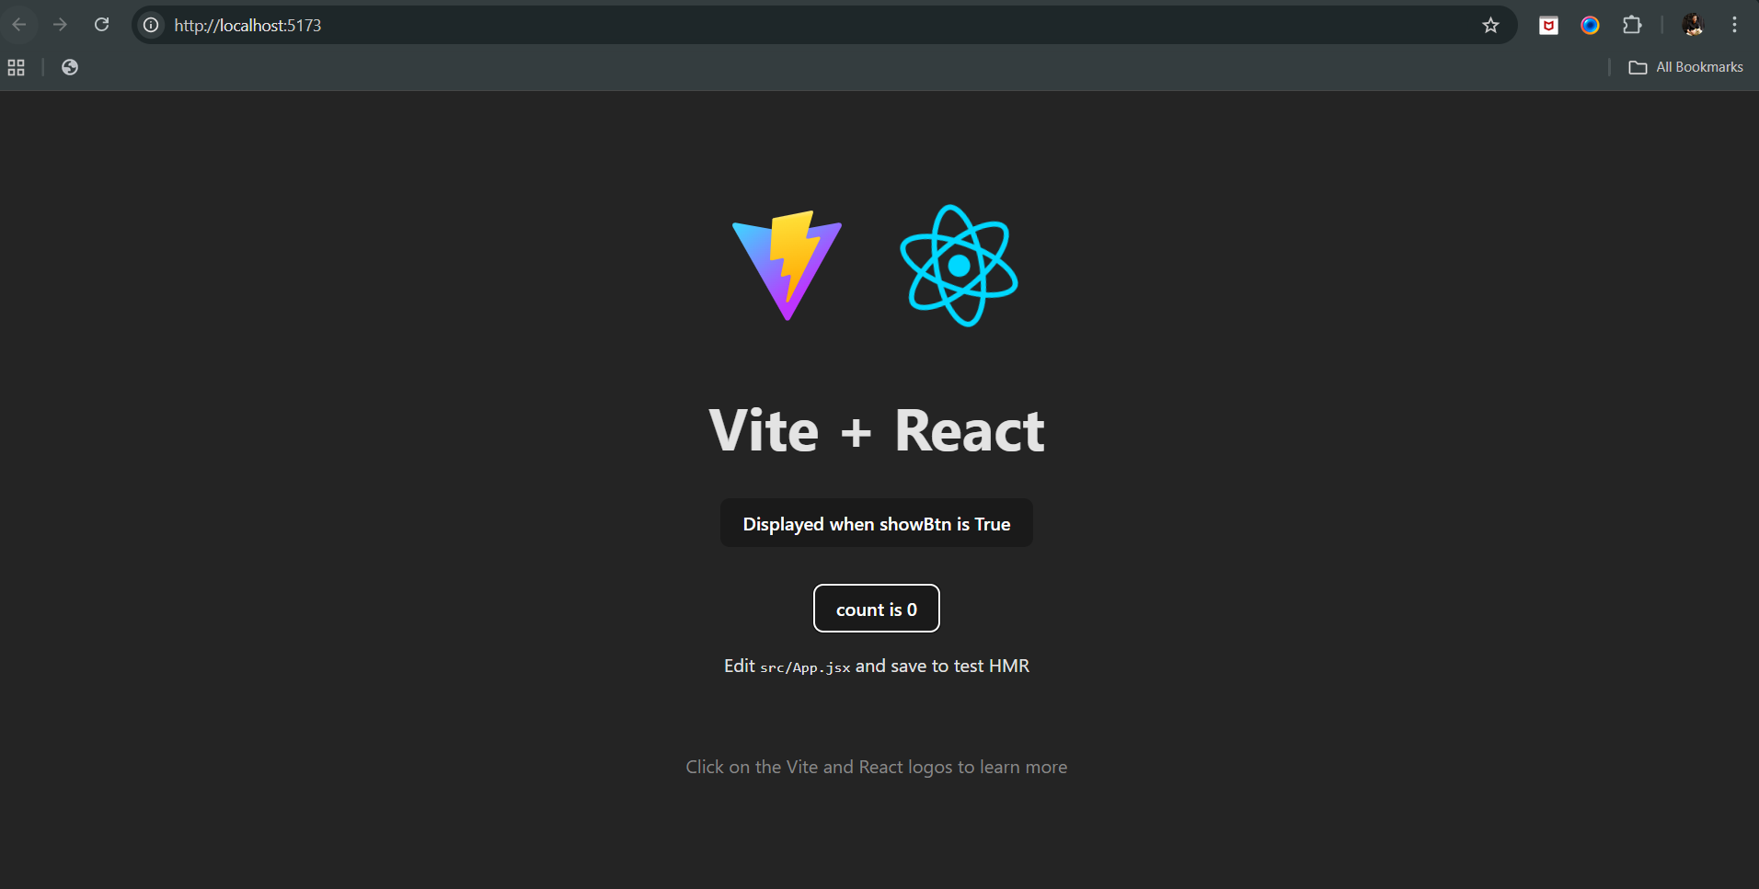

Output: when button was clicked again



--The End--