**Day 60**

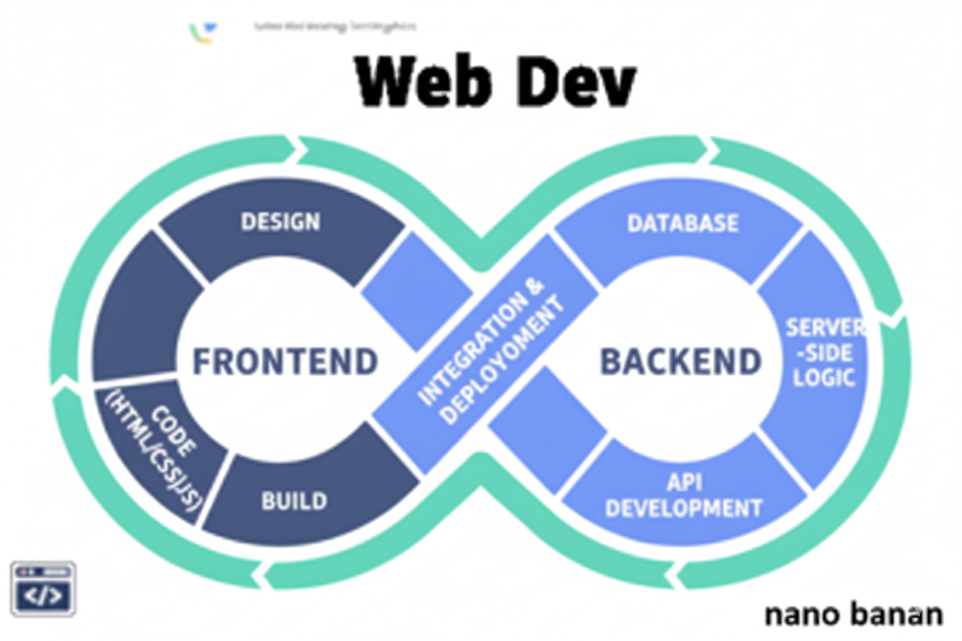



**“Web Development + Security”**

**React Router: Routing in React:**

**What is React Router?**

React Router is a library that allows navigation between different pages or views in a single-page React application (SPA) — without reloading the page. It handles the routing logic inside the browser, keeping your app fast and smooth.

To understand from the basics, we will first start the React + Vite as we are doing since last few videos:

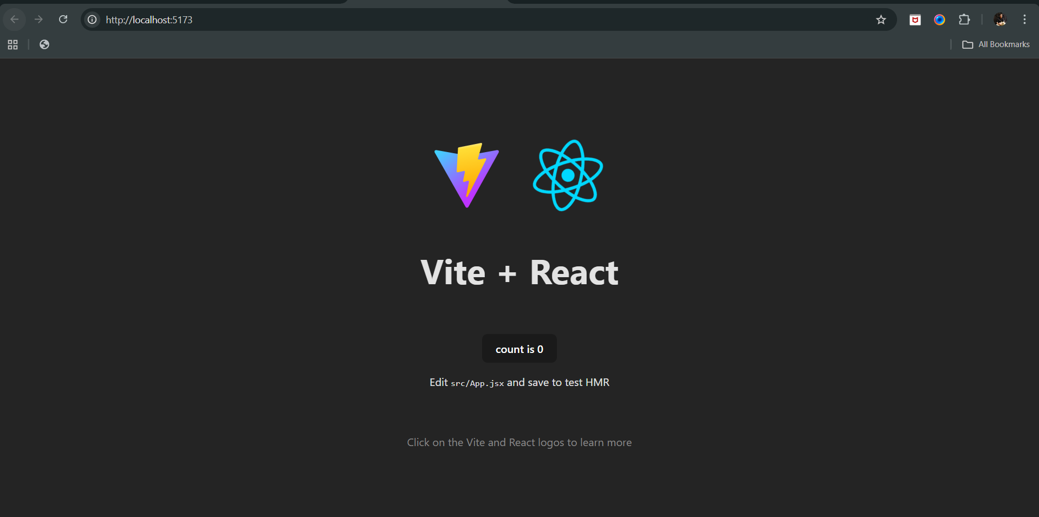

Now, first before we start anything, we should know what’s the issue with <a> tag that we need react router? Basically, when we click on the link of the <a> tag, the new page appears, but reloaded, in react router this reloading doesn’t take place. Hence, used.

So, how to use it? Use the below command to install it:

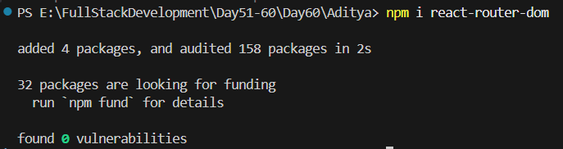

Now, to see the usage, let’s first create a components folder and make Navbar.jsx inside it:

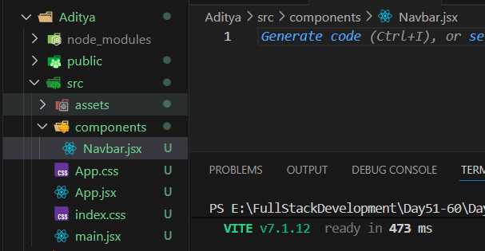

Also, we will add a home page, and for this we will create the Home.jsx in the components folder, and use it later in the App.jsx as the element.

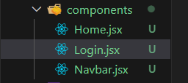

Now, code for each:

Home.jsx:

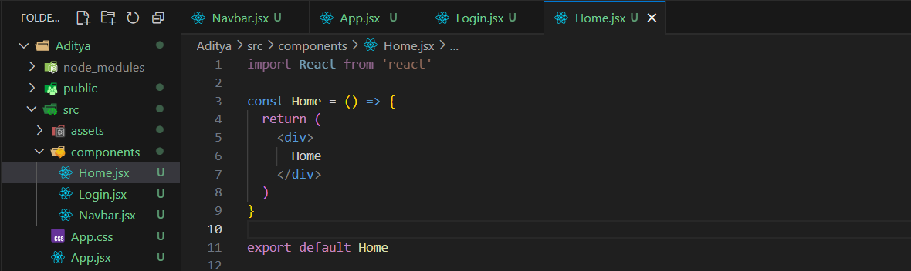

Login.jsx:

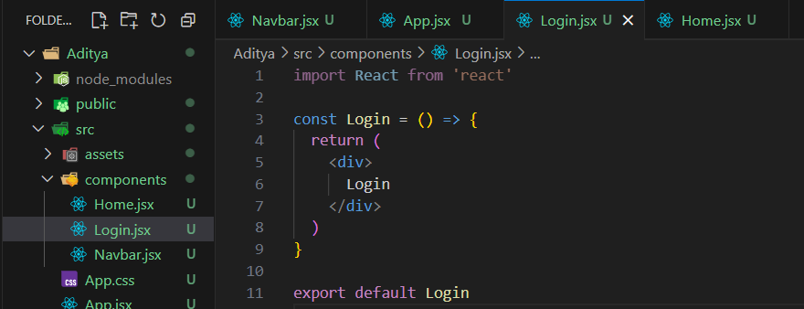

Navbar.jsx:

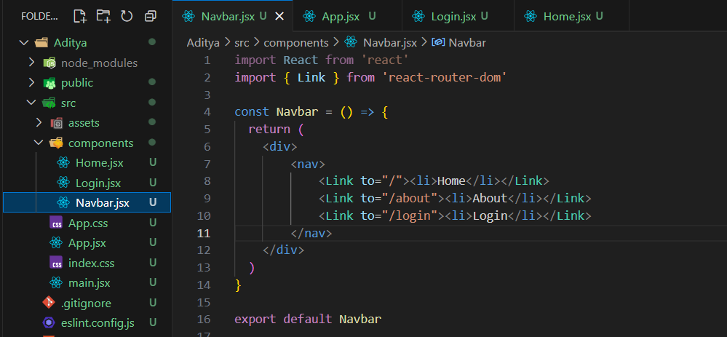

App.jsx:

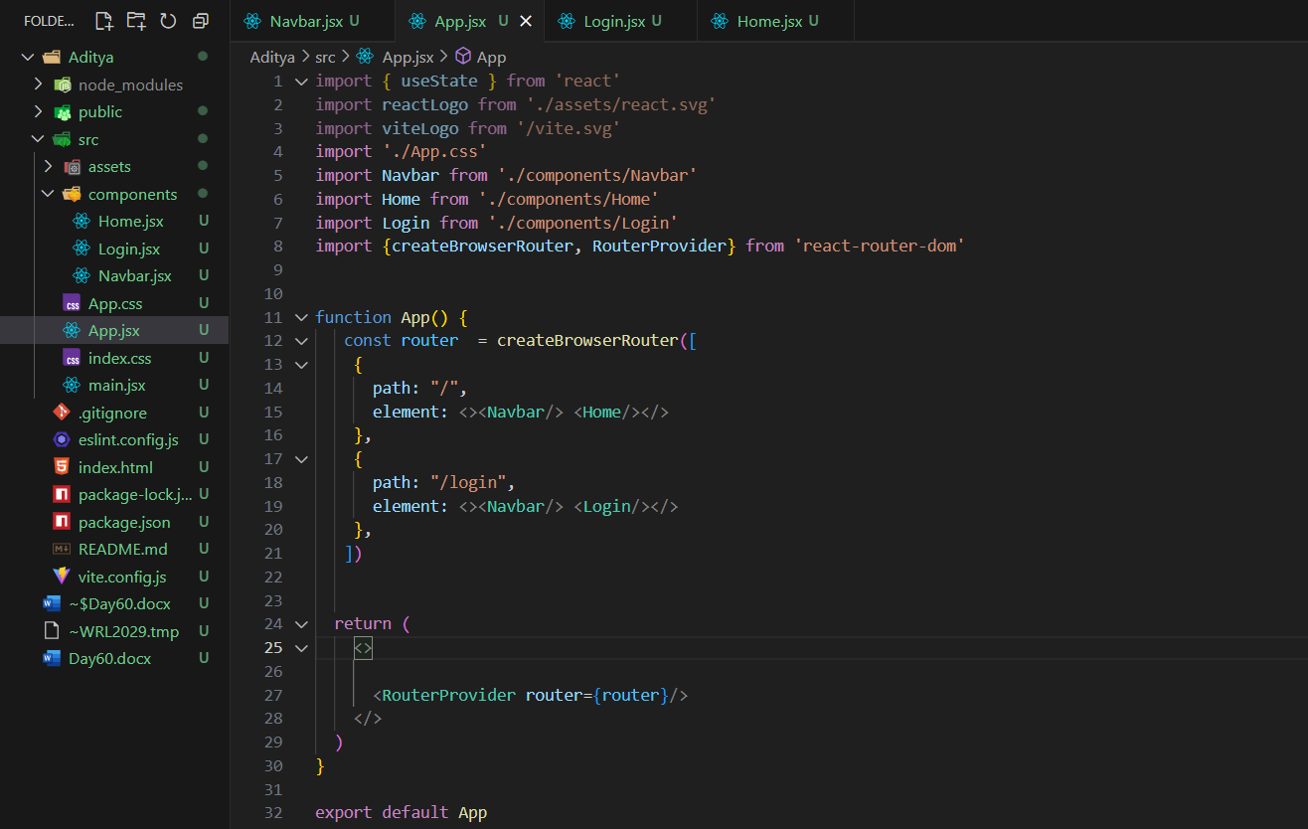

Output: at start

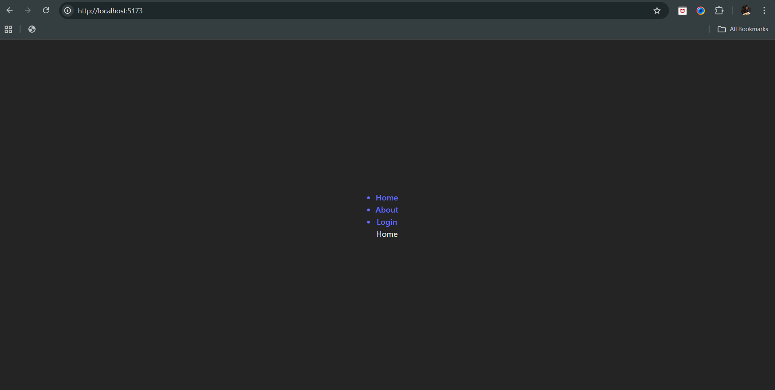

Output: when login was clicked, page don’t reload.

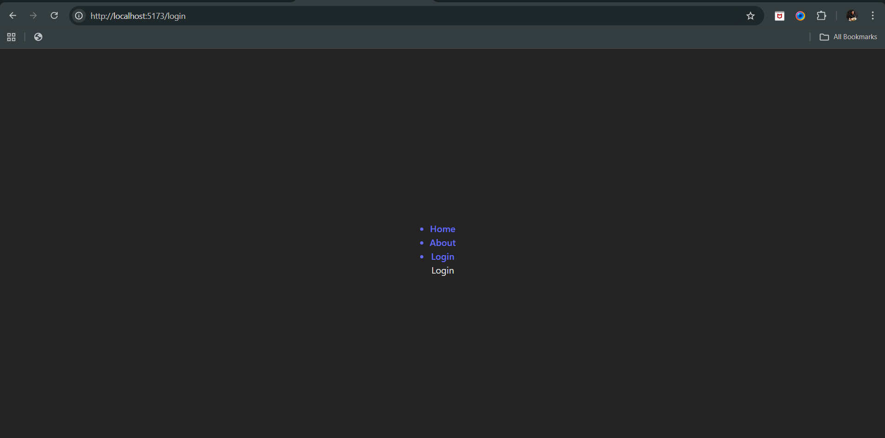

--The End--