## **Project “NAME” 1-Page GDD**

*Cute Sauron fighting the world*

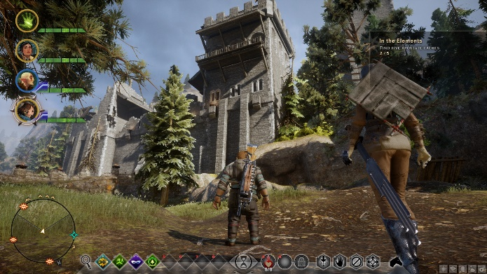



**Genre:** ARPG, 3rd person  
**Target Audience:** T for Teen

**Controls:** Mouse & keyboard

**Thematic Setting:** Humorous Medieval Fantasy

**Tech Stack:** Unity 5+, Blender

**Platform(s):** Steam

**Game Moment:** 2 minutes of good gameplay against a big group of knights in a village, basic combat and seeing enemies fly when they die.

**Game Summary:** *Project “NAME” is a game where you play as an overpowered character trapped in the form of a small cute rabbit. As a rabbit, you can mind control enemies my sitting on top of their head and pass some of your power to them, making them your weapons of destruction. Then, in a humorous fashion, you destroy the kingdom and see how the world tries to stop you.*

**Core Player Experience: Humorous Overpowered Character**

**Central Theme (story flavor):** Even a group of heroes isn’t strong enough. Playing a villain in a hero game.

**Design Pillar:** Humorous, Overpowered Badass

**Anticipated Remarkability:** Playing as an overpowered, impactful character. You get to see your overpowered-ness instead of just simply hitting enemies until they are dead.

**Anticipated Steam Early Access Launch date:**

**Feature Development Priorities:**

**Comparative Products:**