Android testing framework provides a rule, ActivityTestRule to launch an android activity before executing the test cases. It launches the activity before each method annotated with @Test` and @Before. It will terminate the activity after method annotated with @After. A sample code is as follows,

@Rule
public ActivityTestRule<MainActivity> mActivityTestRule = new ActivityTestRule<>(MainActivity.class);
Espresso needs at least a single JUnit rule of type ActivityTestRule to specify the activity. Android JUnit runner will start the activity to be launched using ActivityTestRule.

Espresso’s method onView takes a single argument of type Matcher (View matchers), finds the corresponding UI view and returns corresponding ViewInteraction object. ViewInteraction object returned by onView method can be further used to invoke actions like click on the matched view or can be used to assert the matched view. A sample code to find the view with text, “Hello World!” is as follows,



Once onView matches and returns ViewInteraction object, any action can be invoked by calling “perform” method of ViewInteraction object and pass it with proper view actions. A sample code to click the matched view is as follows,



Once onView matches and returns the ViewInteraction object, any assert can be checked using check method of ViewInteraction by passing it with proper view assertion. A sample code to assert that the matched view is as follows,



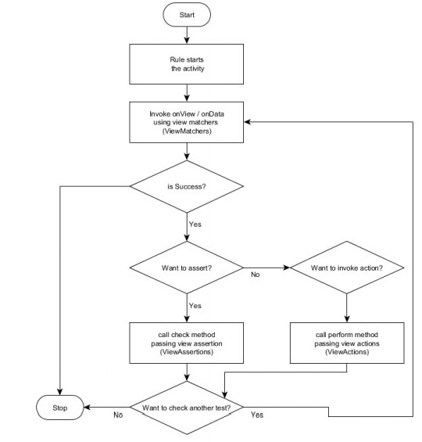


Hamcrest is itself a framework for writing matcher objects.

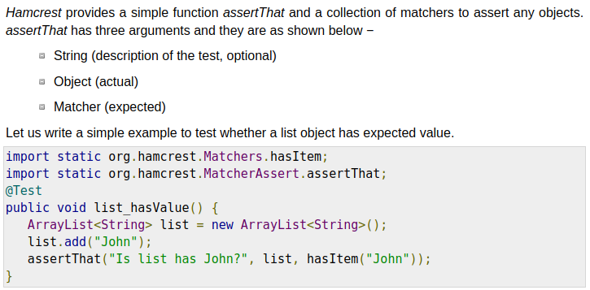
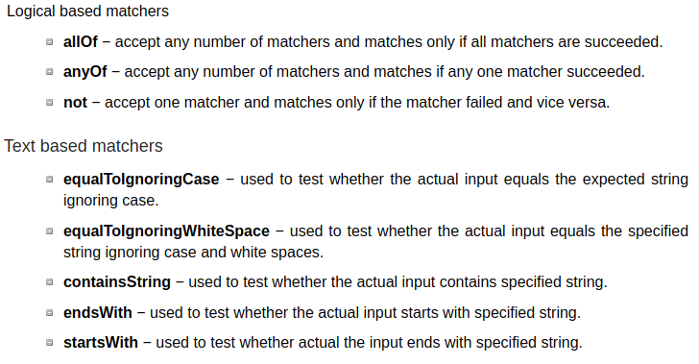
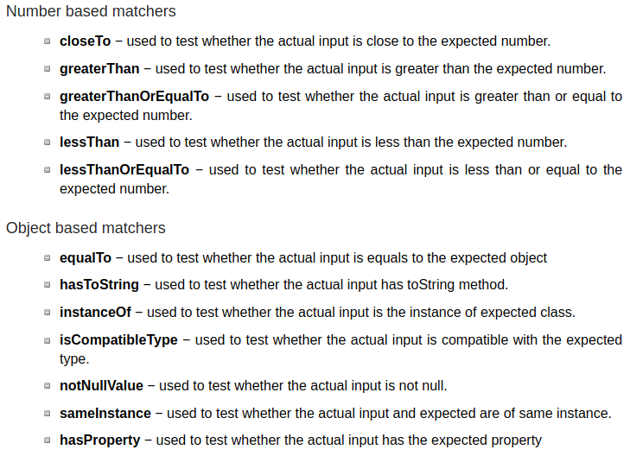


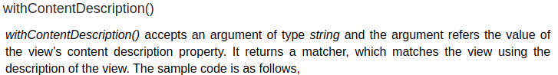

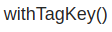

….

Matchers personnalisés :

