# DWM1001 Development Board - Power Consumption

# Measured through USB port

|  |  |  |  |  |
| --- | --- | --- | --- | --- |
| **Firmware** | **Setup** | **U** | **I (max)** | **P** |
| Unknown | Unknown | 5V | 31mA | 156mW |

# Estimation with a 3V battery

|  |  |  |  |  |
| --- | --- | --- | --- | --- |
| **Firmware** | **Setup** | **U** | **I (max)** | **P** |
| Unknown | Unknown | 3V | 52mA | 156mW |

# Measured with laboratory power supply (16/06/2023)

**Power supply on J1 connector**

|  |  |  |  |  |
| --- | --- | --- | --- | --- |
| **Firmware** | **Setup** | **U** | **I (max)** | **P** |
| Anchor/Transmitter | 4 Anchors - 1 Listener | 3.7V | 40mA | 148mW |
| Listener/Tag | 1 Listener – 1 Anchor | 3.7V | 34mA | 126mW |

# Datasheet extract DW1001

The current level described in the datasheet has never been observed in the previous measure campaign.

As described in the datasheet, the power needed by the module could reach 1.75W

# Battery 2h autonomy based on a 156mW consumption

Pile bouton rechargeable Panasonic 3V, 100mAh, 30mm, Lithium Vanadium Pentoxyde, VL3032

https://fr.rs-online.com/web/p/piles-bouton-rechargeables/0407906

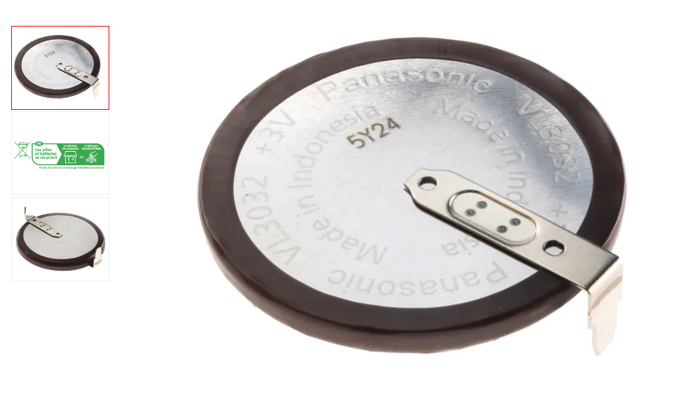

# Battery 2h autonomy based on a 1.75W consumption

<https://fr.rs-online.com/web/p/batteries-taille-speciale/1251266>

# Annexes

# Connecteur Molex 1.25 PicoBlade

https://fr.rs-online.com/web/p/cordons-fil-a-carte/2248682?cm_mmc=FR-PLA-DS3A-_-google-_-CSS_FR_FR_Cables_%26_cordons_et_fils_Whoop-_-(FR:Whoop!)+Cordons+fil+%C3%A0+carte-_-2248682&matchtype=&pla-321942550056&gclid=CjwKCAjwp6CkBhB_EiwAlQVyxcc8EZtD0tO86evE6WI9BrQd634MpPSwJFvt0ENdIkdJy4kvpd5NmhoC4hoQAvD_BwE&gclsrc=aw.ds

avec une confiance faible