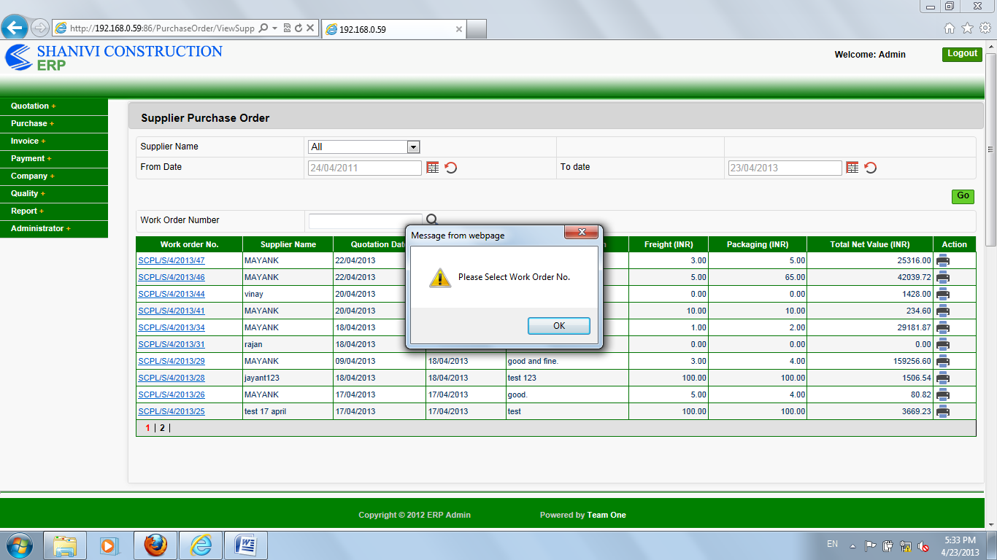

On supplier purchase order page,

Click directly on search button,

A popup opens and the message should be like “please enter work order number”.

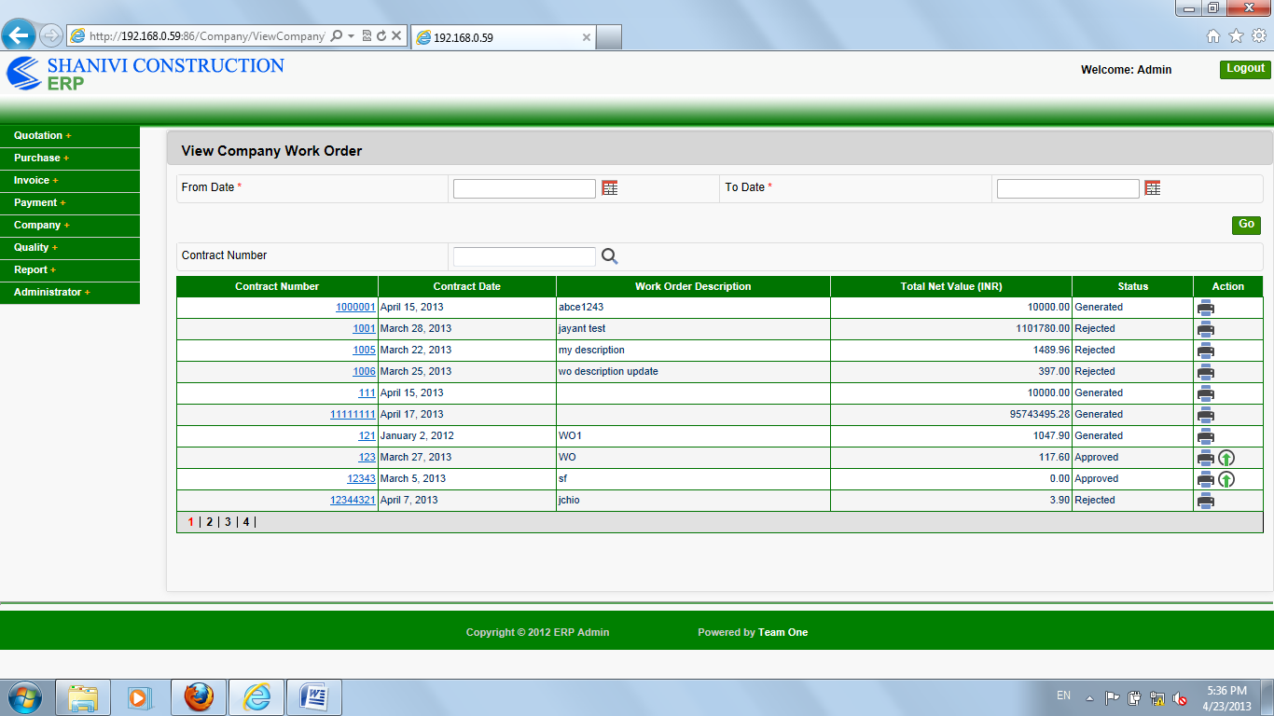

On company work order page,

In the grid here contract number data is in right side but contract date is in left side,

But both the data should be on same side either right or left in all the grid.

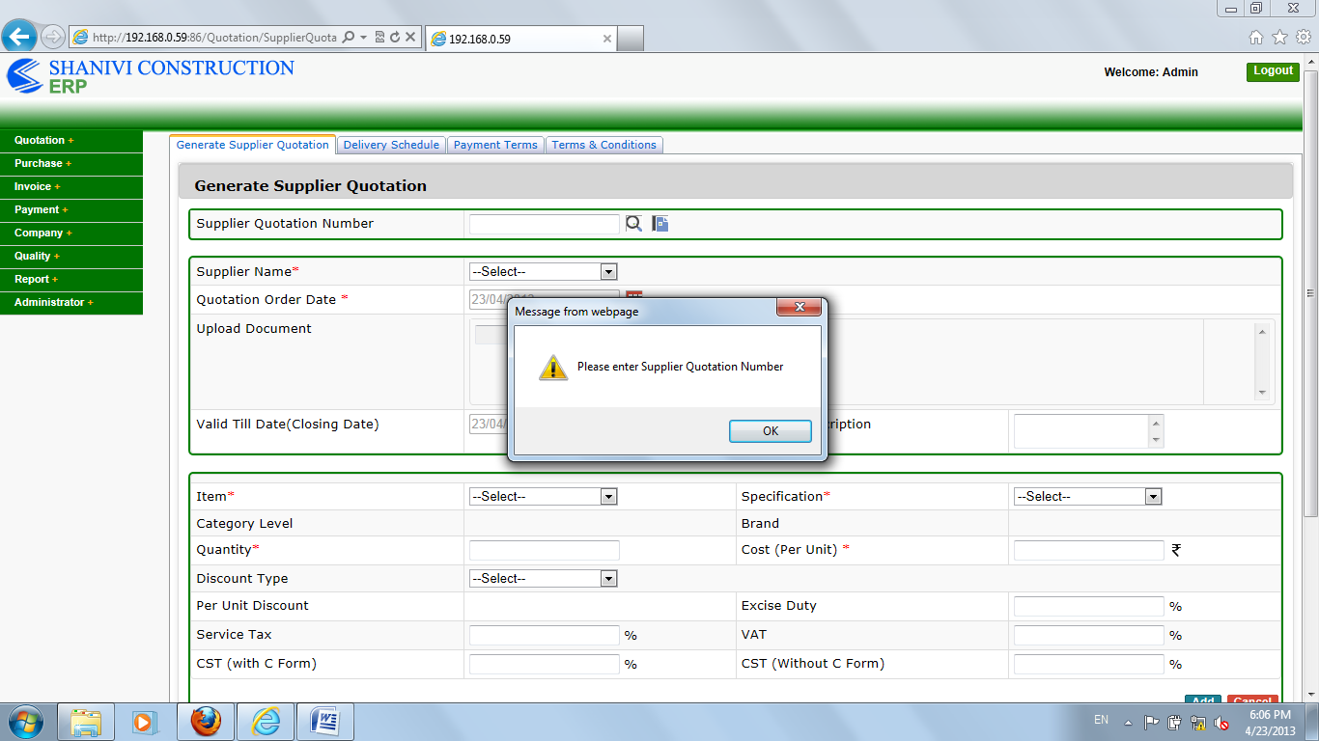

On generate supplier quotation page,

The spelling of “enter ” should be “Enter”.

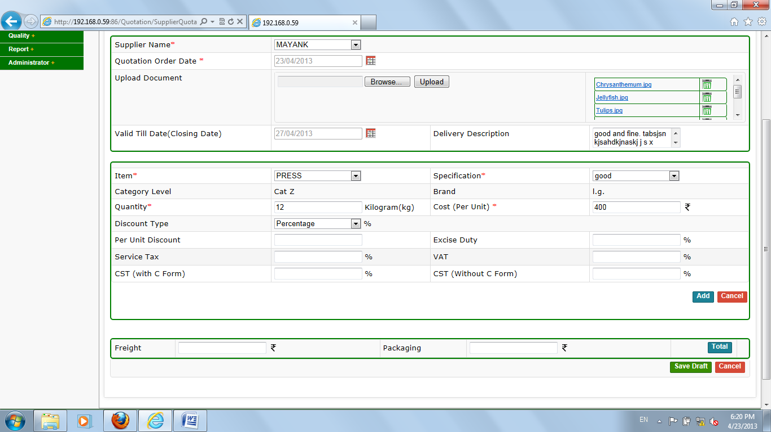

On generate supplier quotation page,

The % sign and rupee sign should be in front of “per unit discount” text box.

And on the place of “INR” it should be “rupee sign”.

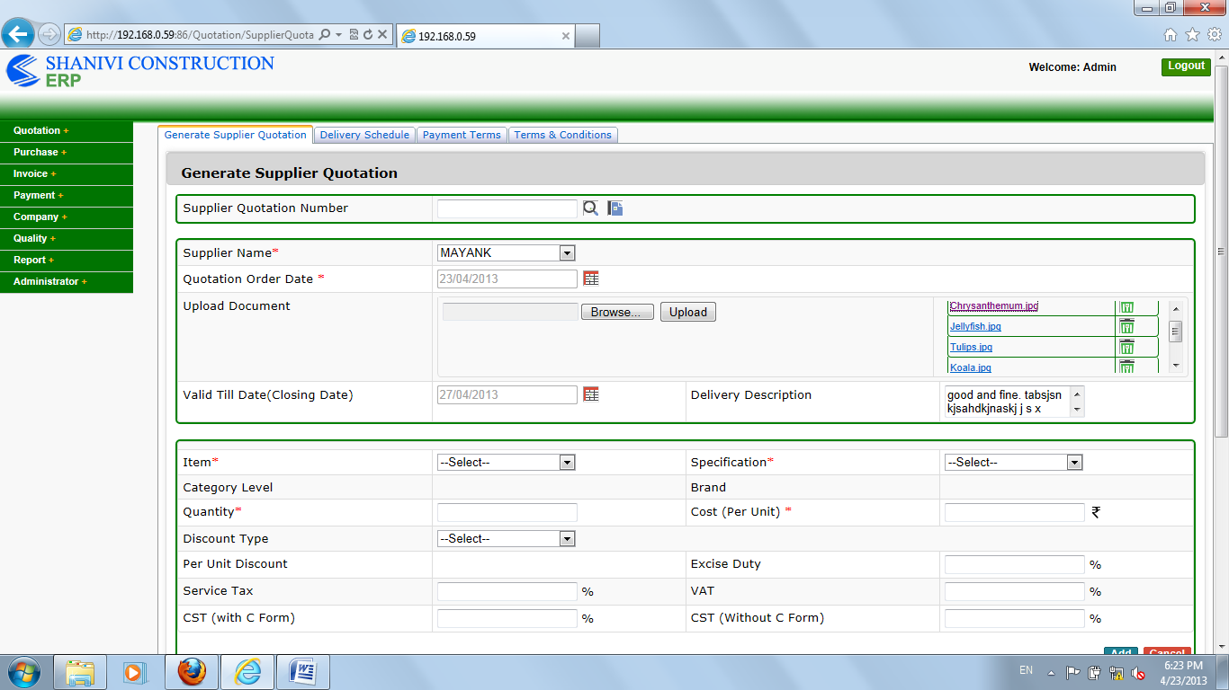

On generate supplier quotation page,

The uploaded files is not being open.

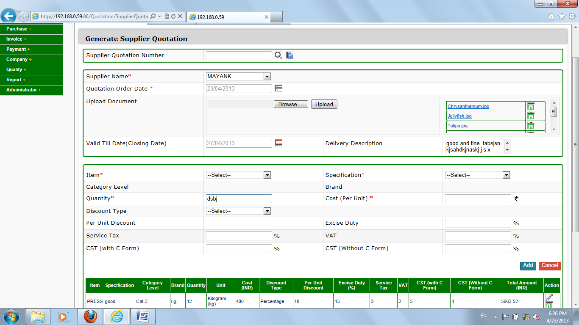

On generate supplier quotation page

Here in quantity type any words than press enter than the cursor will be reverse.

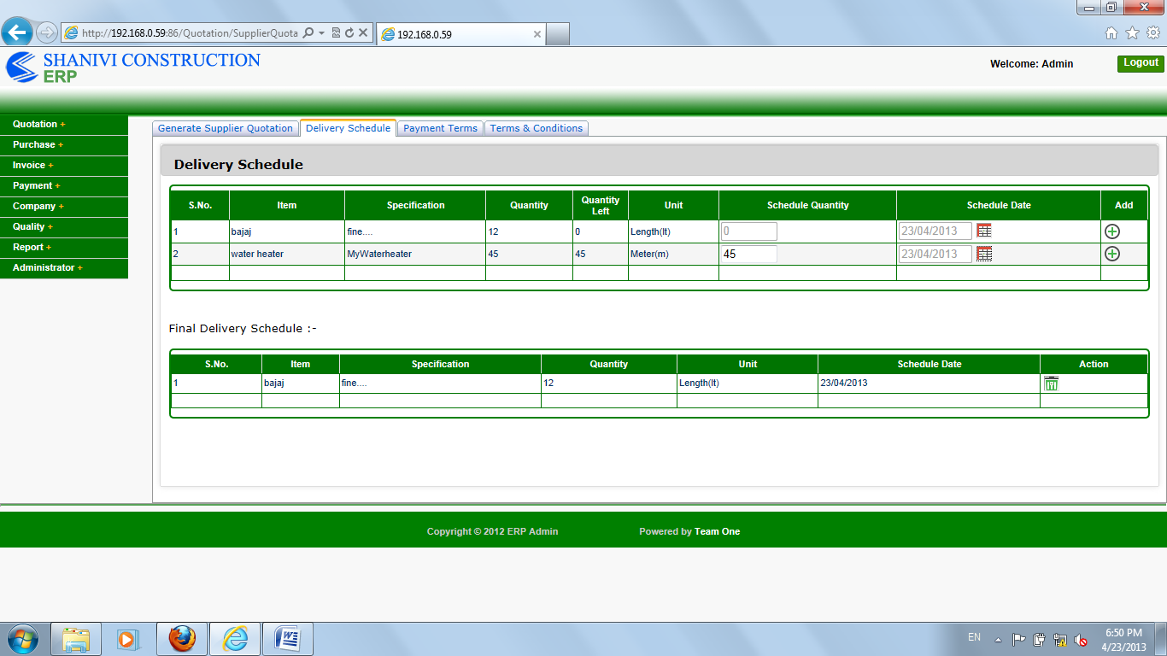

On supplier quotation delivery schedule page,

In the grid these lines should be remove accept main grid border.

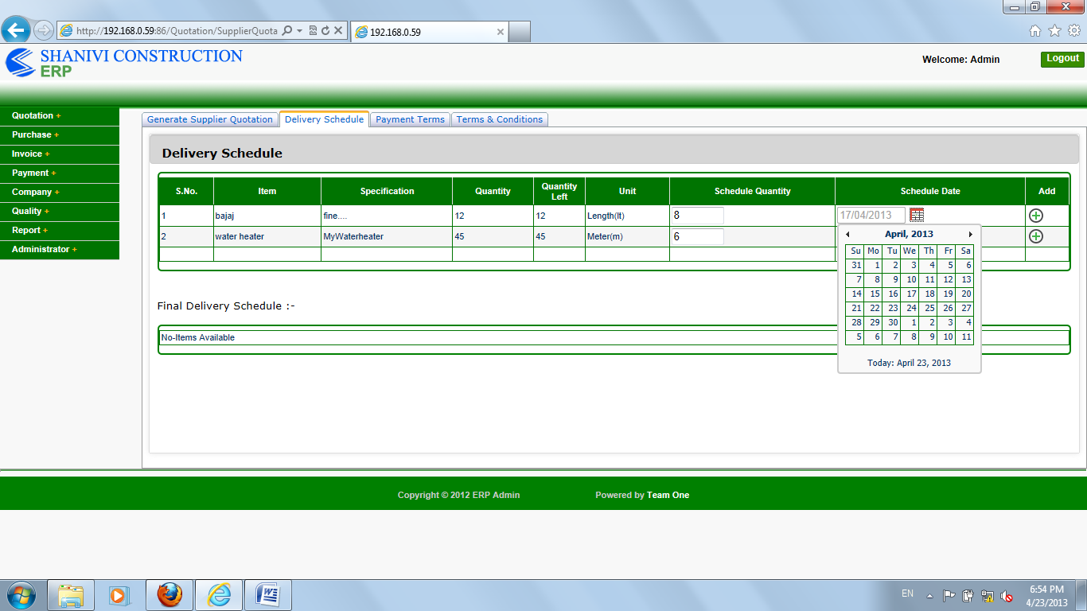

On delivery schedule page,

In the calendar today date should be highlight in all the calendars.

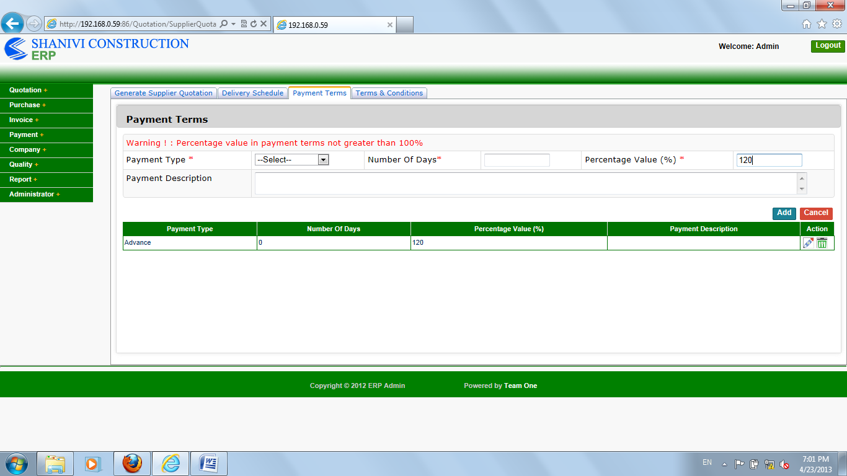

On supplier payment term page,

It is taking more than 100% advance in the grid and with warning.

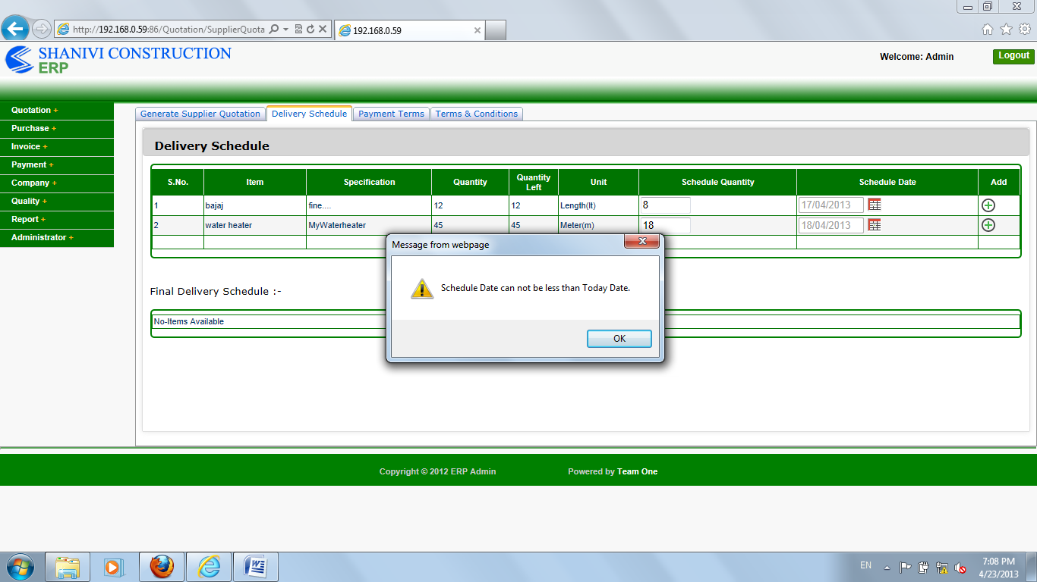

On supplier delivery schedule page,

On the popup all the spellings should start by capital letters.

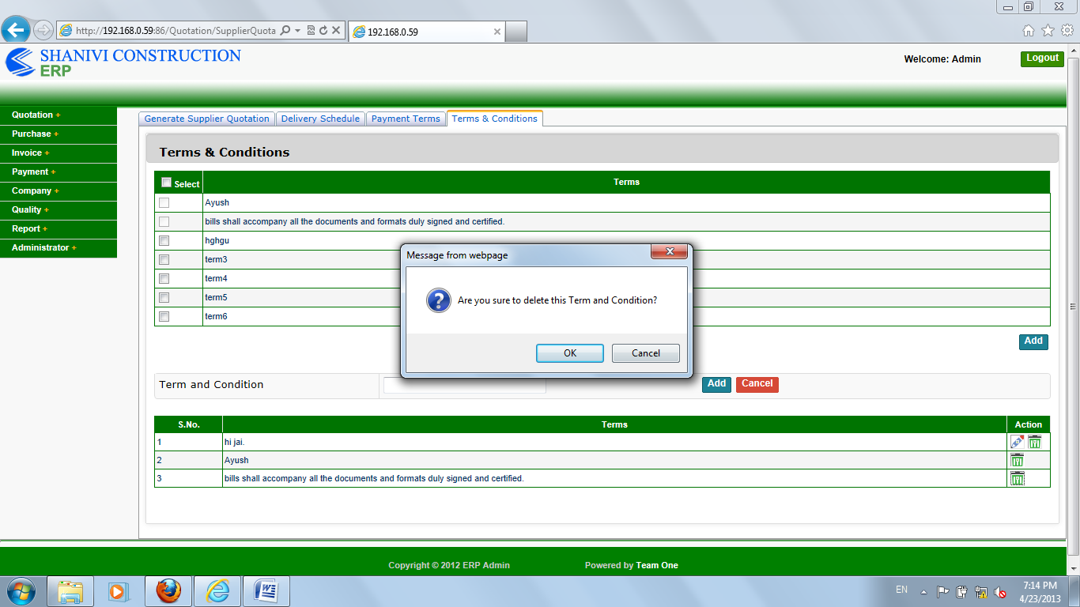

On term and condition page,

All the spellings should start from capital letters or same order.

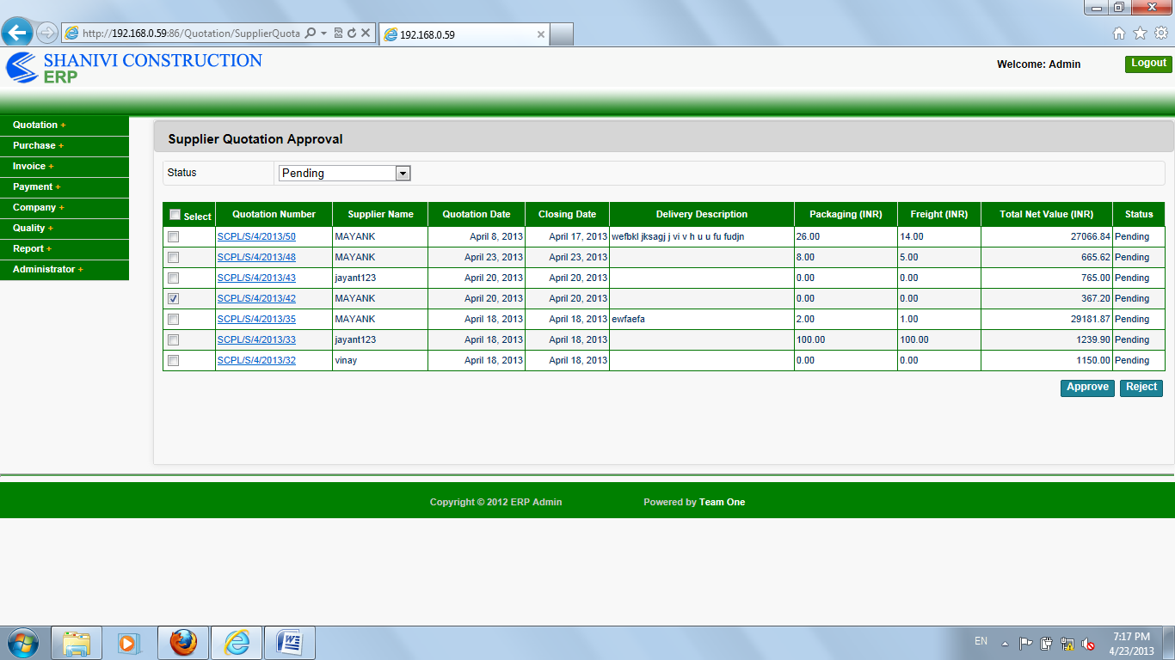On supplier quotation approval page ,

The sign of “INR” should be of “rupee sign”, Because of similarity.

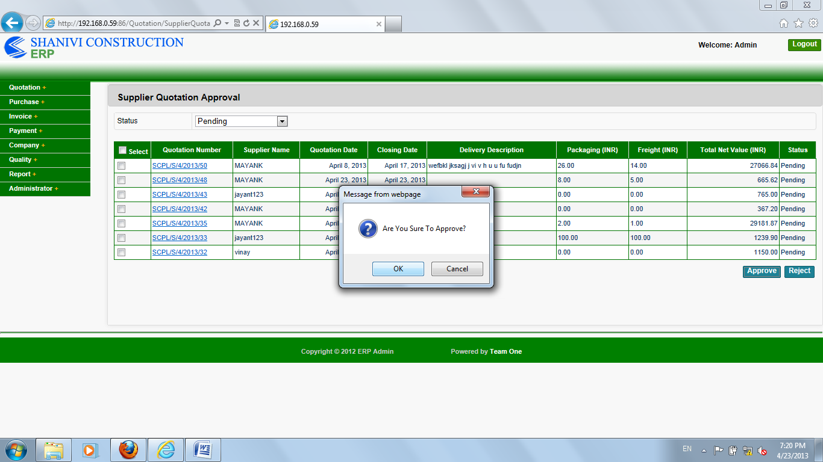

On supplier quotation approval page,

Click directly on approve or reject button,

Than it will say that “are you sure to approve or reject” after that it will say that “please check at least one ”,

Here “check box message should be first” after that it should show that “are you sure to approve”.

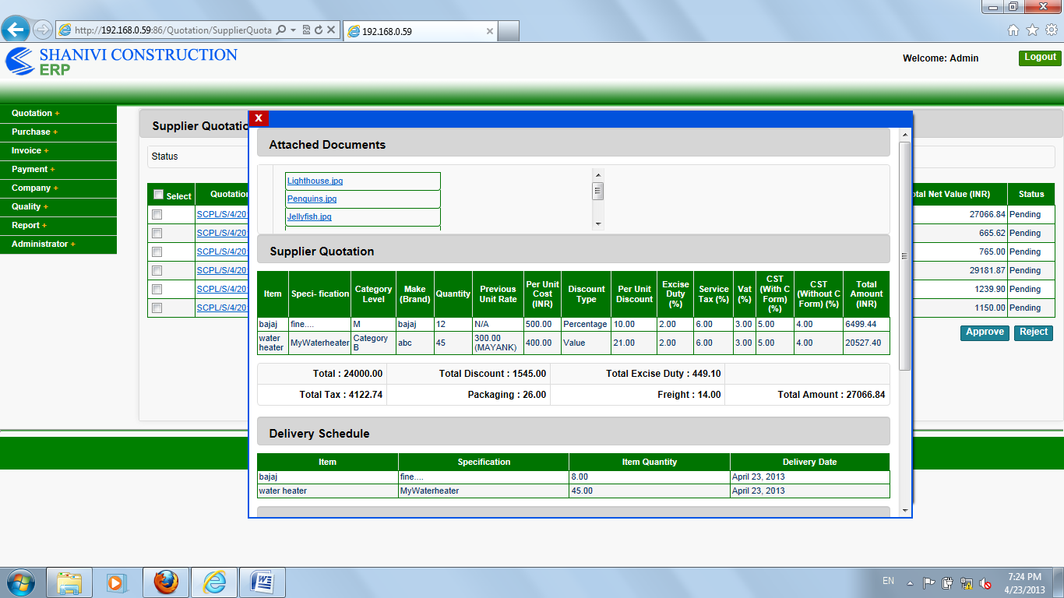

On supplier quotation approval page,

When we click on link than in opened file the close sign should be like all pages.

Here we are not able to open uploaded file.

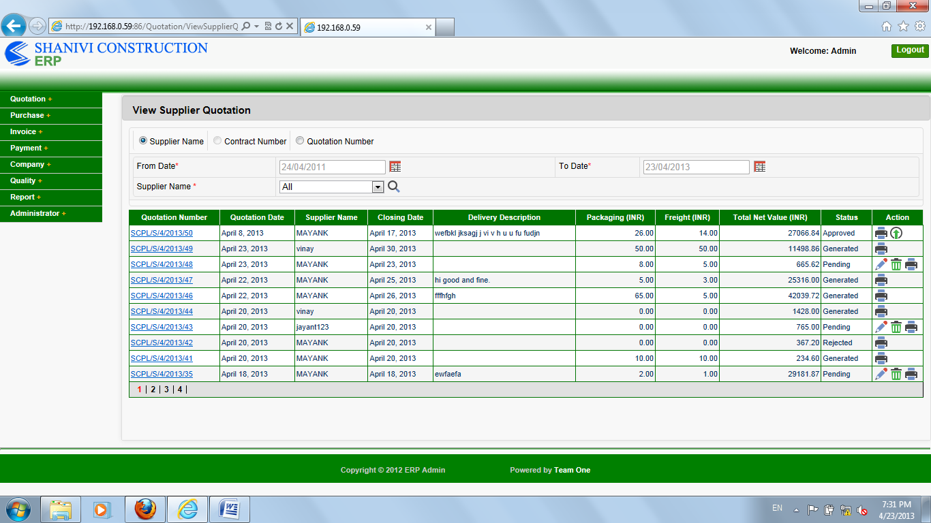

On view supplier quotation page,

Contractor number radio button is not working.