## Media Streaming with IBM Cloud Video Streaming

**Project Title:** Media Streaming using Cloud

**Problem Statement:**

* Develop a virtual cinema platform using IBM Cloud Video Streaming.
* Upload favorite movies and videos for on-demand viewing.
* Enable users to share movies nights with friends and family globally.
* Prioritize seamless streaming and high-quality video playback.
* Aim for an immersive cinematic experience for users.

**Problem Definition:**

* Lack of a dedicated platform for users to seamlessly upload, stream, and enjoy movies and videos on-demand.
* Absence of a centralized virtual cinema experience that allows for sharing movie nights with friends and family regardless of location.
* Challenges in providing a high-quality and immersive cinematic experience during virtual movie nights.
* Difficulty in integrating various components like user interface, on-demand playback, and cloud video streaming services into a cohesive virtual cinema platform.

**INNOVATION**

InfiniteReel: Revolutionizing Movie Nights with Virtual Cinema

**Introduction:**

# The virtual cinema platform project is geared towards enhancing the movie-watching experience through innovative features and seamless integration.

# One key innovation in this project is the integration of user-generated playlists and real-time chat, adding a layer of customization and interactivity that enriches the movie-watching experience.

# This innovative feature will allow users to create more engaging visual narratives and connect with their audience on a more profound level.

**Innovation Components**

**1. Requirement Analysis:**

* Understand the specific requirements and objectives of incorporating user-generated playlists and real-time chat features into the virtual cinema platform.

**2.** **Design the User Interface:**

* Work with UX/UI designers to create intuitive interfaces that allow users to create, manage, and share playlists easily.
* Design a chat interface that is integrated seamlessly within the platform.

**3.** **Integrate User-Generated Playlists:**

* Develop a system that enables users to create and curate their playlists by selecting desired movies or videos. Implement features to add, remove, and reorder content within the playlists.

**4. Implement Real-Time Chat:**

* Utilize appropriate technologies to integrate a real-time chat system within the platform. Implement features like group chat, private messaging, and message notifications to enhance user interactions during movie-watching.

**5. Ensure Privacy and Moderation:**

* Implement privacy settings and moderation features to give users control over who can access their playlists and participate in chat discussions. Allow for reporting and blocking options to maintain a safe and enjoyable environment.

**6. Enable Social Sharing:**

* Integrate social media sharing capabilities, allowing users to share their playlists and movie choices with their network, promoting engagement and expanding the platform's reach.

**7. Optimize for Multiple Devices:**

* Ensure the features work seamlessly on various devices such as computers, tablets, and smartphones to provide a consistent and enjoyable user experience across platforms.

**8. Testing and Feedback:**

* Conduct rigorous testing of the implemented features to identify and address any bugs or usability issues. Gather feedback from a group of users to refine and improve the user-generated playlist and real-time chat functionalities.

**9. Launch and Deployment:**

* Launch the updated virtual cinema platform with the integrated user-generated playlists and real-time chat features. Monitor platform performance and user engagement post-launch.

**10. Iterative Enhancements:**

* Continuously gather user feedback and analytics data to identify areas for improvement. Implement regular updates and enhancements to the playlist and chat features based on user needs and preferences.

­­­

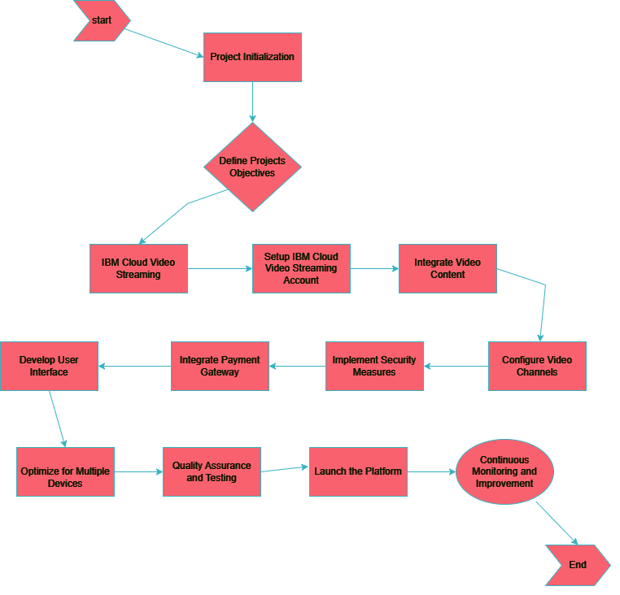IMPLEMENTATION FLOW CHART

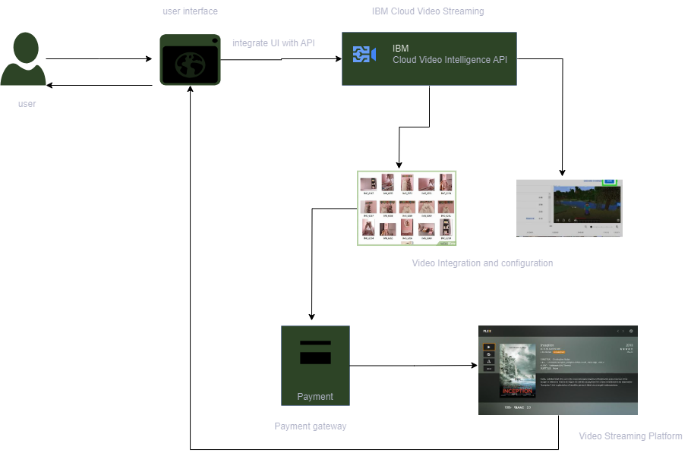

Work Flow Diagram

Conclusion:

* Leveraging IBM Cloud Video Streaming guarantees a smooth and uninterrupted streaming experience. High-quality video playback ensures that users are immersed in the cinematic world without interruptions, optimizing their enjoyment.
* Incorporating real-time chat fosters community engagement, allowing users to interact, share thoughts, and express their opinions during movie-watching sessions. This adds a social dimension to the platform, making the experience more engaging and enjoyable.
* The virtual cinema platform optimizes efficiency by streamlining the process of setting up movie nights, inviting friends and family, and curating playlists. Moreover, the platform is accessible across various devices, ensuring that users can enjoy their favorite movies anytime, anywhere.