1. Run the testdb.sql file
2. Go to your computer settings, find your current Internet connection  
   copy the IPv4 address  
   手机屏幕截图

   描述已自动生成
3. in JDBCUtils  
   图形用户界面, 应用程序

   描述已自动生成  
   文本

Replace those with yours
4. If you still cannot connect to db, try following:  
   Go to your mysql folder, type cmd and press enter  
   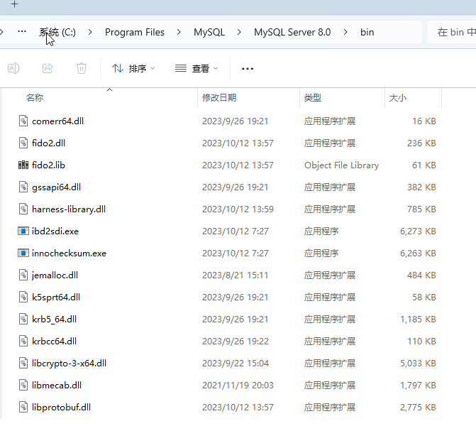  
   图形用户界面, 文本, 应用程序

   描述已自动生成  
   文本

   描述已自动生成  
   Execute following:  
     
   CREATE USER 'username'@'%' IDENTIFIED BY 'password';  
   GRANT ALL PRIVILEGES ON \*.\* TO 'username'@'%' WITH GRANT OPTION;  
   FLUSH PRIVILEGES;  
     
   (Remember to replace username and password with yours)  
     
     
     
     
   Then go to HeidiSQL, create a new one to test if its ok  
   图形用户界面, 应用程序

   描述已自动生成  
     
     
   If you still have problem, go to Windows security center and press advanced settings->Inbound port rule->create a new rule->select port->press next  
   图形用户界面, 应用程序

   描述已自动生成  
   图形用户界面, 应用程序

   描述已自动生成  
   Then select TCP, type 3306, then press next all the way down till the end
5. If there’s still problem, I have no idea wtf is going on