1. Implementation of DB
2. Implement the different json and xml interpretations from providers
3. Implement the logic of provider loging for costs
4. Implement the logic of provider precedence in base of costs and availability
5. Logs with the Akka API Log and with write to DB Data
6. Test of Load
7. Better Joining of tasks and not paralell execution (TO evaluate again ApplicationTimed)
8. To Configure Docker Machine for DB and For Application
9. Test Load and compare to the same project in .net.

Project in .NET done since it was a little difficult to create the logic of communications between elements direcly in SCALA –AKKA and Play Framework

Project in IntelliJ – SCALA –Akka-Play Famework Json

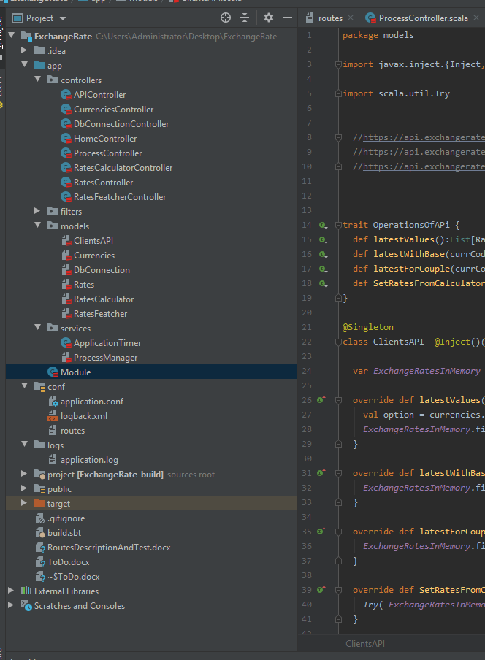

Project in Visual Studi MVC .NET CORE

