Simple Chat Guide

1. The project contains the SimpelChat folder and the SimpeChat.war file.

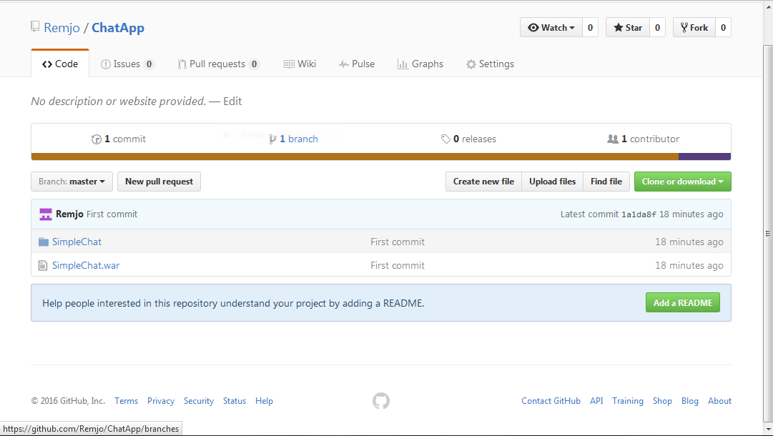

1. The Simple chat folder contains the development project files in Eclipse. Just add the project to Eclipse IDE.

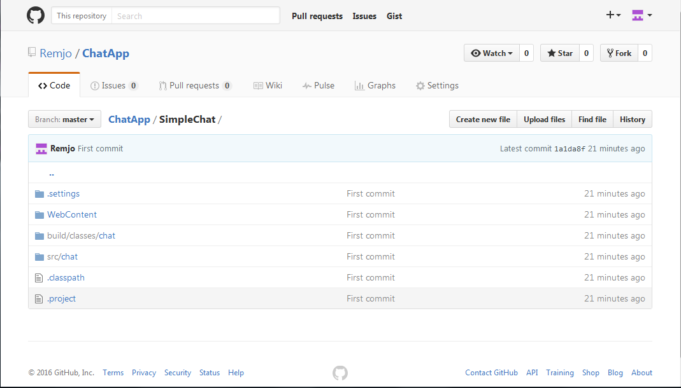

1. Export you own war file based on the Eclipse project or use the SimpleChat war and deploy in Application Server like Tomcat. Once Deploy Access the Site like this example: <http://192.168.1.114:8080/SimpleChat/> and see the login page. Type your login name and click Submit button.

