KWAME NKRUMAH UNIVERSITY OF SCIENCE AND
TECHNOLOGY



COLLEGE OF ENGINEERING

FACULTY OF MECHANICAL AND AGRICULTURAL ENGINEERING

DEPARTMENT OF AGRICULTURAL ENGINEERING

MECHANICAL ENGINEERING LAB II
TITLE : BELT FRICTION
GROUP 18

NAME INDEX NUMBER
PARKER NATHANIEL 4856410
OWUSU-ANSAH ALBERT 4856310
BOFFAH KOFI OBENG 4852310
OTOO NENYI OBED 4855710

SUMMARY
The experiment was carried out to confirm the laws of belt friction and to determine the co-efficient of friction of the belt and pulley used. This was done by using the rotating cylinder apparatus, a peg, a piece of belt connected to a load hanger and a spring balance at different ends of the belt and weight(load). The peg is inserted in the first hole, and the spring balance with the belt and load hanger hanged on the peg, the belt is allowed to rest on the pulley in one of the four grooves. A thread is used to measure the circumference of the grooves of the pulley and the length that the belt covers is also measured, this was used to calculate the angle of lap θ. A load of 2lbf to 10lbf in an increment of 2lbf at a time was hanged on the load hanger and a reading T₁ was taking from the spring balance in each case. A direction of rotation was selected and another reading T₂ taking in each case this was repeated for three more different grooves. The whole process was repeated for two more holes at different angles. The readings T₁, T₂ and θ was used to calculate the effective co-efficient of friction µ.

INDIVIDUAL CONTRIBUTION
During the experiment PARKER NATHANIEL and OTOO OBED NENYI organized the report and recorded the data obtained in the experiment, OWUSU-ANSAH ALBERT also put the data obtained in a tabular form and BOFFAH OBENG KOFI was also rotating the cylindrical wheel throughout the experiment.

OBJECTIVE
- The experiment is intended to enable us to study the relationship between belt tensions, angle of lap and co-efficient of friction for flat and v belts.
- It further helps determine the effect of the angle of lap and belt tension on the power that can be transmitted for belt drive mechanism.
- The experiment lastly is to compare the power transmission compatibility of flat and v belts.

INTRODUCTION
Belt drivers are very important components in many different machines. They are
Inexpensive and low maintenance making them ideal for certain uses. In the write
Configuration they can also be used in gear boxes of cars to provide continuously variable gear ratios. This technique is becoming more common in high end sports cars which have “flapy paddle” gear shifting technology. They are also used for far simpler uses such as (sticking with the car) driving the fan in the front of an engine. However for all these purposes there is one large limiting factor which is that belt drives tend to slip. The amount of slip depends on several factors, the coefficient of friction between the belt and the pulley, the belt profile and the torque transmitted.

APPARATUS
Steel cylinder with wheels rotatable by wheels.
Metre rule.
rope
DESCRIPTION OF EXPERIMENTAL SETUP
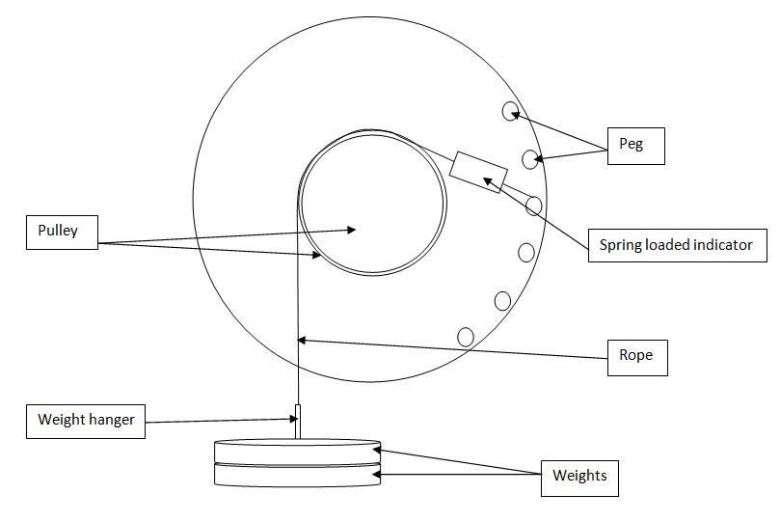

PROCEDURE
Using the equipment shown above
The belt was fixed in the v- groove and the peg was fixed into the top-most hole to give the angle of lap Ѳ, with the spring balance connected in between.
Weights are hung on the other side of the belt and T1 is recorded from the spring balance.
The handle was then rotated slowly and steadily and T2 was taken from the spring balance.
The process was repeated for the several values of the angle of lap Ѳ, and T1 and the corresponding value of T2 were also found.
The angle of lap was measured using a rule and thread.

THEORY
Let
T₁ = tension in the belt where the weight is hanged
T₂ = tension recorded by the spring balance on the other end
ѳ = the angle of lab or contact
= co-efficient between the belt and the pulley
The ratio of the two tensions may be found by considering an elemental piece of the belt MN subtending an angle 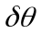at the centre of the pulley B as shown below. Forces keeping MN in equilibrium include:
- Tension T in the belt at M acting tangentially,
- Tension T + in the belt at N acting tangentially,
- Normal reaction R acting outward at P (p is at the middle of MN)
- Friction force (F) = R acting at right angle to R and in the opposite direction of the motion of the pulley.

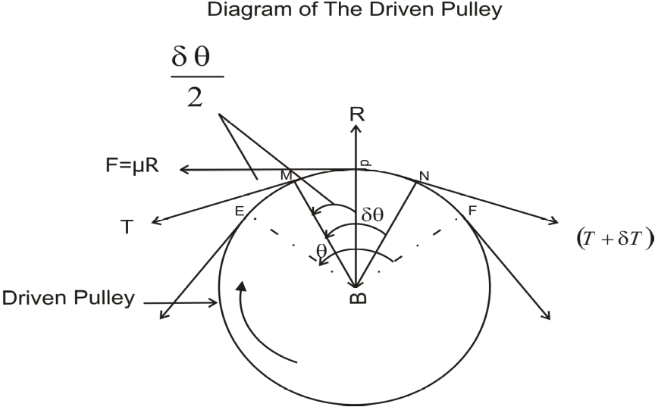

From the diagram above and by Pythagoras theorem, $R=Tsin\frac{δθ}{2}$
Taking,$T=(T+δT)$, » $R=\left(T+δT\right)sin\frac{δθ}{2}$
Since the angle is too small,$sin\frac{δθ}{2}=\frac{δθ}{2}$
$$R=\left(T×\frac{δθ}{2}\right)+\left(T×\frac{δθ}{2}\right)\left(δT×\frac{δθ}{2}\right)$$
$$=\left(T×δθ\right)+\left(δT×\frac{δθ}{2}\right)$$
Since $δT×\frac{δθ}{2}$ is negligible, it implies that $R=T×δθ……………..\left(1\right)$
Resolving vertical forces from diagram,
$$F=\left(T+δT\right)cos\frac{δθ}{2}-Tcos\frac{δθ}{2}$$
Also, since δθ is very small, $cos\frac{δθ}{2}=1$ thus, reduces to unity.
It implies that, $F=\left(T+δT\right)-T$
$$=δT$$
But $F=µR$
Implying that, $µR=δT$
$$R=\frac{δT}{µ}…………..\left(2\right)$$
Equating (1) and (2),
$$T×δθ=\frac{δT}{µ}$$
Therefore, $µδθ=\frac{δT}{T}$
Integrating the above between limits T₁ and T₂,
Implies that $\int_{T_{2}}^{T_{1}}{\frac{δT}{T}=µ\int{δθ}}$
$$ln\frac{T_{1}}{T_{2}}=µθ$$
Therefore, $\frac{T_{1}}{T_{2}}=e^{µθ}$

For a flat belt,$\frac{T_{1}}{T_{2}}=e^{µθ}$

Diagram of the V-belt in the v groove
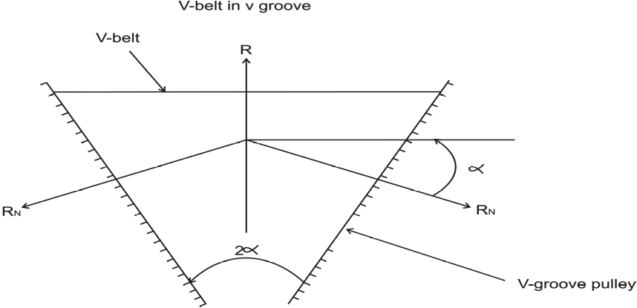

Let
R_{N} = Normal reaction between belt
2 = angle of groove
= co-efficient of friction between belt and pulley
R = total reaction in the plane of groove
Resolving vertical forces on diagram, $R=Rnsinα+Rnsinα$
$$=2Rnsinα$$
⇒$Rn=\frac{R}{2sinα}=\frac{R}{2}cosecα$
But friction $=2µRn$
$$=2µ×\frac{R}{2}cosec$$
$$\left(Rn=\frac{R}{2}cosecα\right)$$
$$= µR×cosecα$$
$$=R\left(µcosecα\right)$$
From the above comparing with flat belt,
⇒$\frac{T_{1}}{T_{2}}=e^{θ\left(µcosecα\right)}$
$$=e^{µθ cosecα}$$
$=e^{µ^{1}θ}µ^{1}=µcosecα$ Therefore, $µ^{1}=\frac{µ}{sinα}$
Calculations
There are four different grooves in the setup. There are three (3) v-grooves and one (1) flat groove. The three v – grooves are denoted 1st groove, 2nd groove and 3rd groove. The last one is a flat pulley.
The circumferences of the various grooves are listed below:
Groove 1 = 27.6cm
Groove 2 = 29.8cm
Groove 3 = 29.8cm
Flat pulley = 31.00cm

FOR PEG 1
Angle of lap for groove 1 = $\frac{8}{ 29}×360°=99.31°$
Angle of lap for groove 2 = $\frac{6.3}{30}×360°=$ 75.6$°$
Angle of lap for groove 3 = $\frac{6.1}{30.5}×360°=$ 72.0$°$
Angle of lap for flat pulley = $\frac{5.9}{30.7}×360°=$ 69.19$°$

FOR PEG 2
Angle of lap for groove 1 = $\frac{6.8}{ 29}×360°=$84.41$°$
Angle of lap for groove 2 = $\frac{7}{30}×360°=$ 84$°$
Angle of lap for groove 3 = $\frac{7.5}{30.5}×360°=$ 88.52$°$
Angle of lap for flat pulley = $\frac{8}{30.7}×360°=$ 93.81$°$

FOR PEG 3
Angle of lap for groove 1 = $\frac{11}{ 29}×360°=$136.55$°$
Angle of lap for groove 2 = $\frac{12}{30}×360°=$ 144$°$
Angle of lap for groove 3 = $\frac{13}{30.5}×360°=$ 153.44º
Angle of lap for flat pulley = $\frac{14}{30.7}×360°=$ 164.16$°$
Solving for $µ$ from
$$\frac{T_{1}}{T_{2}}=e^{µθ}, ⇒µ=\frac{ln\left({T_{1}}/{T_{2}}\right)}{θ}$$

TABLE OF RESULTS
TABLE OF VALUES FOR PEG 1
Weight | Groove 1 |  |  | Groove 2 |  |  | Groove 3 |  |  | Flat
 | T1 | T2 | $$µ$$ | T1 | T2 | $$µ$$ | T1 | T2 | $$µ$$ | T1 | T2 | $$µ$$
2 | 3 | 8 | -0.246 | 4 | 6 | -0.134 | 4 | 5 | -0.077 | 3 | 5 | -0.184
4 | 5 | 15 | -0.275 | 5 | 10 | -0.228 | 5 | 9 | -0.203 | 5 | 8 | -0.169
6 | 8 | 17 | -0.189 | 7 | 14 | -0.228 | 7 | 11 | -0.156 | 7 | 11 | -0.162
8 | 10 | 19 | -0.161 | 10 | 18 | -0.194 | 9 | 14 | -0.152 | 9 | 14 | -0.159
10 | 13 | 23 | -0.143 | 11 | 21 | -0.213 | 12 | 18 | -0.140 | 11 | 17 | -0.157

GROOVE 1 PEG 1GROOVE 2 PEG 1
Weight | log T1 | log T2
2 | 0.477 | 0.903
4 | 0.699 | 1.176
6 | 0.903 | 1.230
8 | 1.000 | 1.279
10 | 1.114 | 1.362
Weight | log T1 | log T2
2 | 0.602 | 0.778
4 | 0.699 | 1.000
6 | 0.845 | 1.146
8 | 1.000 | 1.255
10 | 1.041 | 1.322

GROOVE 3 PEG 1FLAT PULLEY PEG 1
Weight | log T1 | log T2
2 | 0.602 | 0.699
4 | 0.699 | 0.954
6 | 0.845 | 1.041
8 | 0.954 | 1.146
10 | 1.079 | 1.255
Weight | log T1 | log T2
2 | 0.477 | 0.699
4 | 0.699 | 0.903
6 | 0.845 | 1.041
8 | 0.954 | 1.146
10 | 1.041 | 1.230

TABLE OF VALUES FOR PEG 2
Weight | Groove 1 |  |  | Groove 2 |  |  | Groove 3 |  |  | Flat
 | T1 | T2 | $$µ$$ | T1 | T2 | $$µ$$ | T1 | T2 | $$µ$$ | T1 | T2 | $$µ$$
2 | 3 | 10 | -0.355 | 3 | 8 | -0.291 | 3 | 6 | -0.195 | 3 | 6 | -0.184
4 | 5 | 17 | -0.361 | 6 | 13 | -0.230 | 5 | 10 | -0.195 | 5 | 7 | -0.089
6 | 9 | 22 | -0.264 | 8 | 18 | -0.240 | 7 | 13 | -0.174 | 7 | 13 | -0.164
8 | 10 | 25 | -0.270 | 10 | 21 | -0.220 | 10 | 16 | -0.132 | 9 | 16 | -0.153
10 | 12 | 25 | -0.216 | 11 | 25 | -0.243 | 12 | 20 | -0.144 | 11 | 20 | -0.159

GROOVE 1 PEG 2GROOVE 2 PEG 2
Weight | log T1 | log T2
2 | 0.477 | 1.000
4 | 0.699 | 1.230
6 | 0.954 | 1.342
8 | 1.000 | 1.398
10 | 1.079 | 1.398
Weight | log T1 | log T2
2 | 0.477 | 0.903
4 | 0.778 | 1.114
6 | 0.903 | 1.255
8 | 1.000 | 1.322
10 | 1.041 | 1.398

GROVE 3 PEG 2 FLAT PULLEY PEG2

Weight | log T1 | log T2
2 | 0.477 | 0.778
4 | 1.000 | 0.845
6 | 0.845 | 1.114
8 | 0.954 | 1.204
10 | 1.041 | 1.301
Weight | log T1 | log T2
2 | 0.477 | 0.778
4 | 0.699 | 1.000
6 | 0.845 | 1.114
8 | 1.000 | 1.204
10 | 1.079 | 1.301

TABLE OF VALUES FOR PEG 1
Weight | Groove 1 |  |  | Groove 2 |  |  | Groove 3 |  |  | Flat
 | T1 | T2 | $$µ$$ | T1 | T2 | $$µ$$ | T1 | T2 | $$µ$$ | T1 | T2 | $$µ$$
2 | 3 | 14 | -0.281 | 3 | 10 | -0.208 | 3 | 8 | -0.160 | 3 | 7 | -0.128
4 | 6 | 22 | -0.237 | 5 | 16 | -0.201 | 5 | 12 | -0.142 | 5 | 12 | -0.133
6 | 8 | 25 | -0.208 | 8 | 20 | -0.158 | 7 | 17 | -0.144 | 7 | 16 | -0.125
8 | 9 | 25 | -0.186 | 9 | 25 | -0.177 | 10 | 21 | -0.120 | 9 | 19 | -0.113
10 | 11 | 25 | -0.150 | 11 | 25 | -0.143 | 11 | 25 | -0.133 | 11 | 21 | -0.098

GROOVE 1 PEG 3
Weight | log T1 | log T2
2 | 0.477 | 1.146
4 | 0.778 | 1.342
6 | 0.903 | 1.398
8 | 0.954 | 1.398
10 | 1.041 | 1.398

GROOVE 2 PEG 3
Weight | log T1 | log T2
2 | 0.477 | 1
4 | 0.699 | 1.204
6 | 0.903 | 1.301
8 | 0.954 | 1.398
10 | 1.041 | 1.398

GROOVE 3 PEG 3FLAT PULLEY PEG 3
Weight | log T1 | log T2
2 | 0.477 | 0.903
4 | 0.699 | 1.079
6 | 0.845 | 1.230
8 | 1.000 | 1.322
10 | 1.041 | 1.398
Weight | log T1 | log T2
2 | 0.477 | 0.845
4 | 0.699 | 1.079
6 | 0.845 | 1.204
8 | 0.954 | 1.279
10 | 1.041 | 1.322

Slope = 1.397 Intercept = -0.825

Slope = 0.85 Intercept = -0.0957

Slope = 0.873
Intercept = -0.054

Slope = 1.061 Intercept = -0.263

Slope = 1.45 Intercept = -1.004

Slope = 1.152 Intercept = -0.541

Slope = 1.188 Intercept = -0.462

Slope = 0.781
Intercept = -0.324

Slope = 1.931
Intercept = -1.750

Slope = 1.342
Intercept = -0.877

Slope = 1.163
Intercept = -0.567

Slope = 1.152
Intercept = -0.517

Peg/groove | Angle (radians) | µ | Log(T₁)/log(T₂)  (mean)
1/1 | 1.733 | -0.203 | 0.734
1 / 2 | 1.319 | -0.199 | 0.763
1/3 | 1.257 | -0.146 | 0.822
1/flat | 1.208 | -0.166 | 0.812
2 / 1 | 1.473 | -0.293 | 0.688
2/2 | 1.466 | -0.245 | 0.716
2/3 | 1.545 | -0.168 | 0.780
2/flat | 1.637 | -0.150 | 0.773
3/1 | 2.383 | -0.212 | 0.646
3/2 | 2.513 | -0.177 | 0.668
3/3 | 2.678 | -0.140 | 0.703
3/flat | 2.865 | -0.119 | 0.719

COMMENTS
The accuracy of the experiment could be seen to be moderate since some are determined to be more than 1 and others less than 1. This could be attributed to the spring balance used to measure the tensions T₁ and T₂. The spring might have been plastically deformed.
When the belt is not slipping, the coefficient of friction should be 1.
The value of obtained in the experiment is 0.063 .
Percentage accuracy 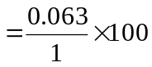% = 6.3% (taken from the slope obtained, 0.063, compared to the standard slop, 1)
Published value of μ for steel in contact with leather is 0.4 to 0.6

CONCLUSION
Belt drives use the friction between the pulley and the belt around the arc of the contact to transmit torque. The belt is initially stretched with an initial tension between the two pulleys.

For efficient performance, the belt is supposed to touch the bottom of the groove. But in this experimental technique, the belt touches the sides of the grooves and this is a limitation of the technique. I suggest that, a belt with a smaller diameter is used in performing the experiment

REFERENCE
Lab manual
Wikipedia search engine
221 Friction Proced spr2006

