KWAME NKRUMAH UNIVERSITY OF SCIENCE AND TECHNOLOGY
COLLEGE OF ENGINEERING
DEPARTMENT OF AGRICULTURAL AND BIOSYSTEMS ENGINEERING

CONSTRUCTION OF A PIG FARM FOR 300 ADULT PIGS AND 700 PIGLETS
AE 453
GROUP ONE

GROUP MEMBERS
WIAFE EVANS KOFI 6033816
YARO PHILIP YARO 6029816
KORANTENG AYERAKWA ISAAC 6029516
OPOKU AMA GIFTY 6031616
ASAMOAH SYLVESTER 6025916
NII ADOTEY ADDO 6023416
MENSAH ISAAC BENJAMIN KOFI 6030216
OFOSU ERNEST NANA ARKO 6031516
COBBINAH JUDAH PRINCE 6027316

1.0 Introduction

1.1 Background study
Pig farming or swine production is a branch of animal husbandry where domestic pigs are raised and bred for the purpose of food. They are highly valued as a source of meat and fat, this type of livestock is mainly raised for human food but may also supply skin, fat and other materials for clothing, ingredients for processed foods, medical use and cosmetics.
Breeds of pigs commonly reared includes landrace, duroc, Yorkshire, etc. mostly referred to as the exotic breeds of pigs. Pig farming or production maybe done in three (3) ways; intensive commercial units, commercial free range enterprise or extensive farming. For the purpose of this project, we consider the intensive commercial unit or housing system due to the large number of pigs to be raised and its being very cost-efficient in this instance. Also this system feed is readily available and provides a greater degree of protection for the pigs.

1.2 Objective
The main objective of this project is to construct a housing unit for 1000 pigs (300 adults and 700 piglets)
Other objectives of this project includes;
- Providing a hazard free environment for the pigs (regulated ventilation, appropriate spacing and protection against rain and direct sun).
- Applying scientific management practice
- Providing safety from attacks.

2.0 Materials
The materials to be employed for the housing unit are concrete blocks for the base of the housing, steel for the columns, doors and door frames and aluminum sheets for roofing.
The structure for storage and mixing of feed would be present outside the housing unit of the pigs.

2.0 SPACING AND VENTILATION

2.1 Spacing
Total number of pens = 16 for both adults and piglets
Adult pens = 6
Piglets pens = 10
Number of adult pigs per pen = $\frac{300}{6}$ = 50 pigs.
Number of piglets per pen = $\frac{700}{10}$ = 70 piglets
ADULT PIGS
Area of pen = 4.50m × 8.0m
Nominal area of an adult pig =$\frac{4.50 × 8.0}{50}$ = 0.72m² per pig
PIGLETS
Area of the pen = 3.5m × 8.0m
Nominal area of a piglet = $\frac{3.50 × 8.0}{75}$ = 0.373m² per piglet.

2.2 Ventilation System
We are depending on natural ventilation through the wide open spaces(windows) created on all sides of the structure. This was done to reduce cost involved in putting up the housing unit.
Clay soil would also be used to linen the inner walls of the housing unit to help maintain a lower temperature, hence keeping the pens or rooms cool at all times.

3.0 EQUIPMENT

- Bulb per pen for lighting
- Feeders for hosting/containing feed
- Drinkers for hosting water

4.0 Pictorial drawings of the housing system

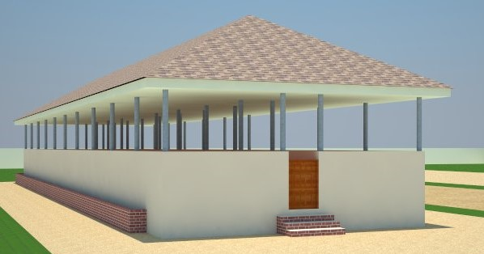
Pictorial view of the structure

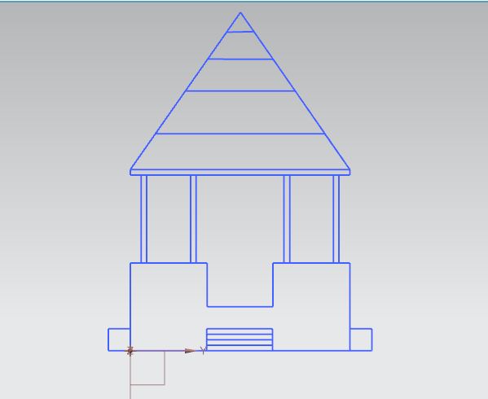
Front elevation
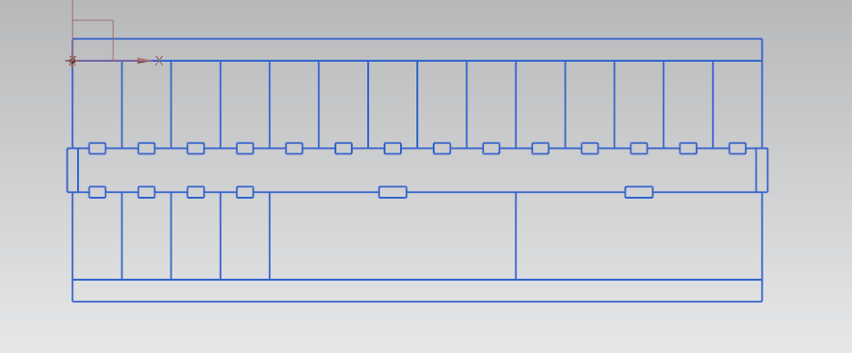
floor plan of the structure

5.0 JUSTIFICATION
The structure is divided into twenty partitions, 6 equal partitions for adult pigs and 10 set of partitions for the piglets. For the other 4 chambers, 2 being used for farrowing and weaning and the other 2 serving as a storage for feed and other items. There would be 50 pigs per pen for the adults and 70 piglets per pen. Steel columns and beams would be used to support the whole structure. Clay soil included in the construction to provide a low room temperature. Drains are always present in all pens to facilitate easy cleaning of the pens.

6.0 CONCLUSION
Considering the structural plan, both the adult pigs and piglets will be free from predators they will also have free access to feed and enough space for free movement within their various pens. Necessary design plans have been implemented to cater for enough ventilation in the structure. Drains have been provided for easy disposal of waste. Also enough lightening has been provided for night activities.

