Marine split gas air condition system.
Central marine air conditioning systems, also known as split systems, have the air conditioning components split between two separate units. The units are installed in different locations and are connected by insulated copper tubing, through which the refrigerant travels. The condensing unit (made up of a compressor, seawater condenser and electrical components) is generally mounted in the engine room, while the evaporator (including the evaporator coil and a blower) is installed in the living area.
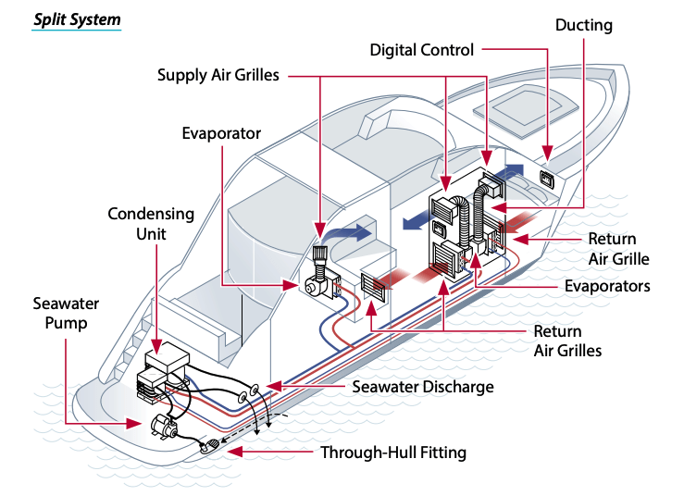

Marine split Condensing units

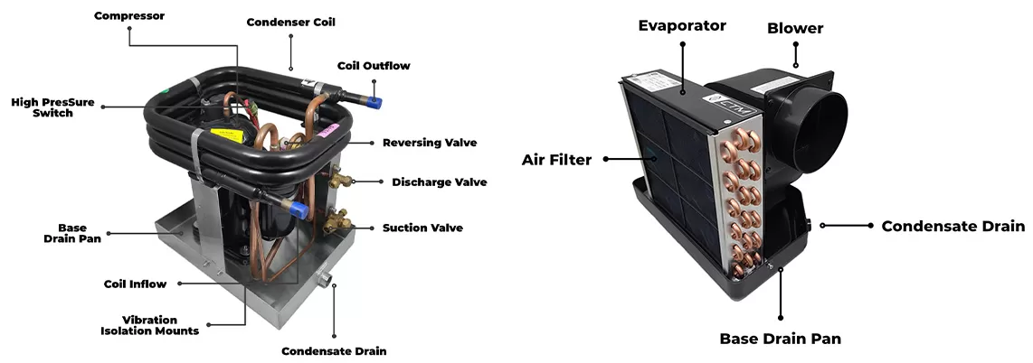
Condenser and Compressor unit

Evaporator unit.

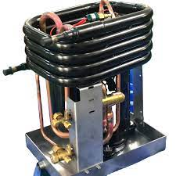
Sea condensing unit.

Installation
A split unit air conditioner is an air conditioning system that consists out of two separate units; the water or air-cooled condensing unit and the air handling unit. The air handling unit is installed in the air-conditioned room itself, whereas the condensing unit is installed either in the engine room or other mechanical space. With the compressor and sea water cooled condenser situated in the engine room, this allows plenty of space for just the evaporator / fan assembly to be located in the accommodation area connected by insulated refrigerant lines, perfect for vessels with very limited space availability where a self-contained system might be unsuitable. The condensing unit can be mounted outside as well. The two units are connected by insulated refrigerant lines. The compressor and the condenser are placed in the condensing unit. The evaporator coil is placed in the evaporating unit. As the condensing unit isn’t placed inside the conditioned area, the split unit air conditioner system is a lot quieter.

In light of the above stated information, certain precautionary measures must be adhered to during installation.
- Never install your air conditioner in the bilge or engine room areas. Ensure that the selected location is sealed from direct access to bilge and/or engine room vapors. Do not terminate condensate drain line within three feet of any outlet of engine or generator exhaust systems, nor in a compartment housing an engine or generator, nor in a bilge, unless the drain is connected properly to a sealed condensate or shower sump pump.
- Do not install in spaces containing gasoline engines, tanks, LPG cylinders, regulators, valves or fuel line fittings. Failure to comply may result in injury or death.
- Always observe precautions described in the literature, tags and labels attached to the unit.
- Follow all safety codes.
- Wear safety glasses and work gloves and place a fire extinguisher close to the work area.

Split system advantages:
Less space needed in the living area for the air handlers.
Quieter because the compressor is in the engine room.
A wide selection of air handler types.

