Q1
A ship 160 m long has draughts 7.70 m forward and 8.25 m aft. MCT1cm is 250 tonne.m and LCF is 1.8 m forward of amidships. Calculate the new draughts after a mass of 200 tonne was moved longitudinally aft a distance of 55 m.

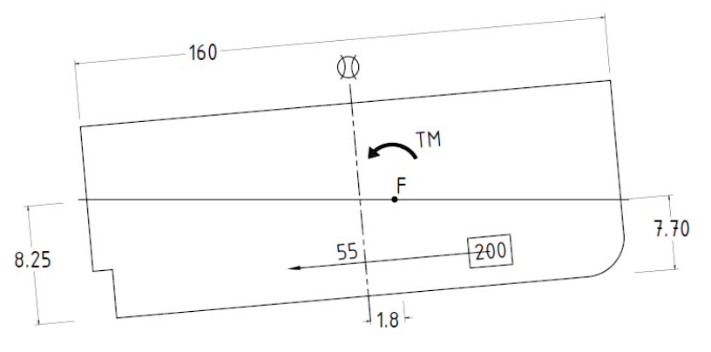
[Ans: 7.48 m; 8.47 m]

SOLUTION:

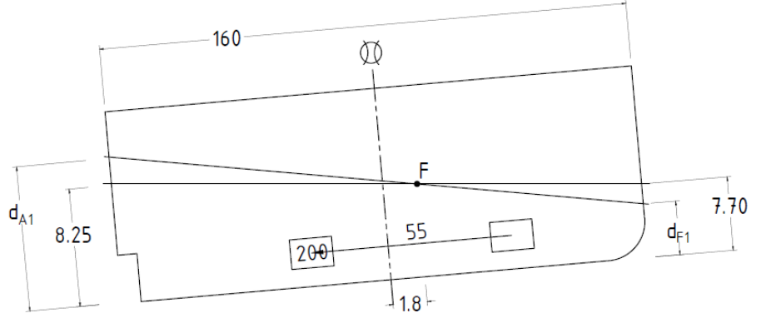

$$TM=200×55=11000 T.m Aft$$

$$t=\frac{TM}{{MCT1}_{cm}}=\frac{11000}{250}=44 cm$$
Therefore:
$$d_{F1}=7.70-\frac{0.44}{160}\left(\frac{160}{2}-1.8\right)=7.48 m$$

$$d_{A1}=8.25+\frac{0.44}{160}\left(\frac{160}{2}+1.8\right)=8.47 m$$

Q2
A ship of length 122 m has the centre of flotation 7.62 m abaft amidships. In a particular condition of loading the measured draughts are 6.56 m and 7.60 m forward and aft respectively. Determine the true mean draught.
[Ans: 7.145 m]

SOLUTION:

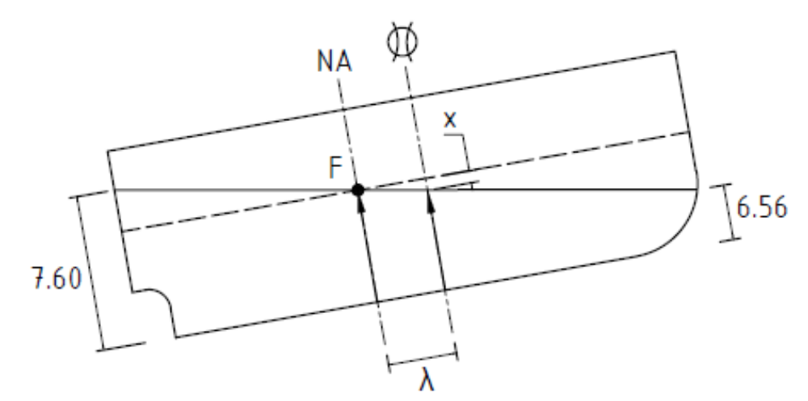

$$d_{T}=d_{M}+x$$

$$=\frac{d_{F}+d_{A}}{2}+\frac{Tλ}{L}$$

$$=\frac{7.60+6.56}{2}+\frac{\left(7.60-6.56\right)×7.62}{122}=7.145 m$$

Q3
A ship of length 107 m has draughts 6.1 m fwd and 5.5 m aft. Determine the true mean draught if LCF = 3 m fwd of amidships.

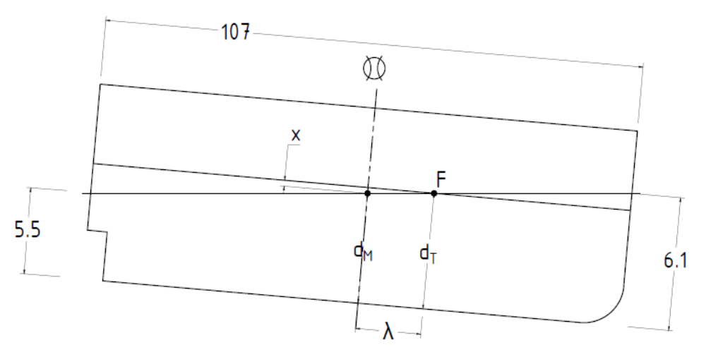
[Ans: 5.817 m]

SOLUTION:

$$d_{T}=d_{M}+x$$

$$=\frac{d_{F}+d_{A}}{2}+\frac{Tλ}{L}$$

$$=\frac{6.1+5.5}{2}+\frac{\left(6.1-5.5\right)×3}{107}=5.817 m$$

Q4
A ship of length 107 m has a displacement of 6330 tonnes when floating at draughts 6.1 m fwd and 5.5 m aft. KM_{L} = 140 m and KG = 4.5 m. If LCF = 3 m fwd of amidships. Determine the new end draughts when 100 tonnes of cargo is moved forward a distance of 30 m.

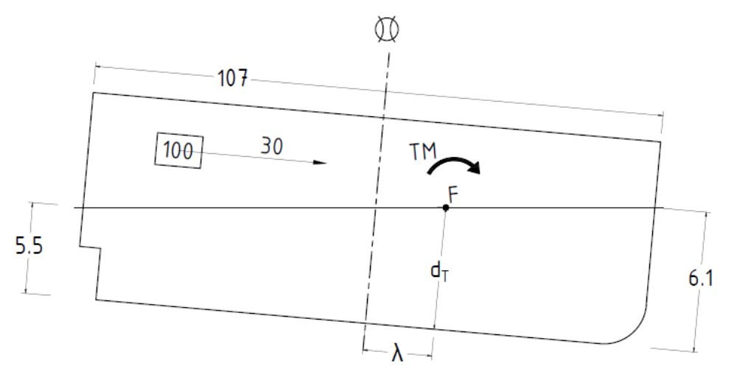
[Ans: 6.277 m; 5.302 m]

SOLUTION:

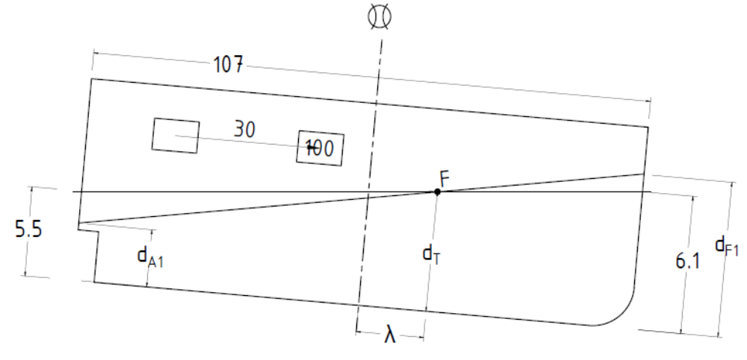

$$TM=100×30=3000 T.m$$

$${GM}_{L}=140-5=135 m$$

$${MCT1}_{m}=\frac{∆.{GM}_{L}}{L}=\frac{6330×135}{107}=7986.45 T.m$$

$$t=\frac{TM}{{MCT1}_{m}}=\frac{3000}{7886.45}=0.3756 m$$

$$d_{F1}=6.1+\frac{0.3756}{107}\left(\frac{107}{2}-3\right)=6.277 m$$

$$d_{A1}=5.5+\frac{0.3756}{107}\left(\frac{107}{2}+3\right)=5.302 m$$

Q5
A ship of length 100 m has a displacement of 6350 tonnes when floating at draughts 5.5 m fwd and 6.1 m aft. KM_{L} = 140 m and KG = 5 m. If LCF = 3 m fwd of amidships. Determine the distance that 100 tonnes should be moved to bring the vessel on an even keel.

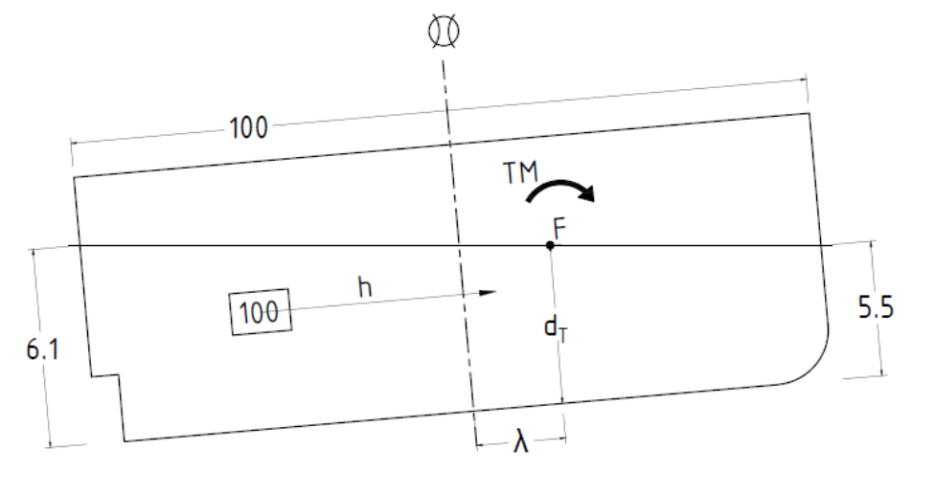
[Ans: 51.435 m F]

SOLUTION:

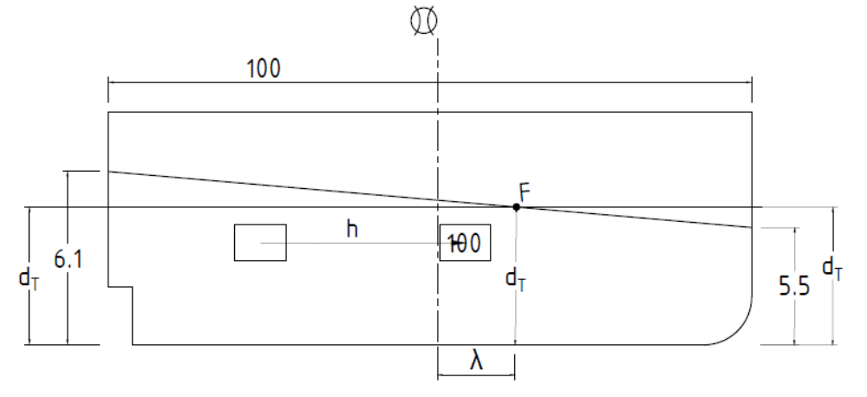

In the trimmed condition:

$$d_{T}=d_{M}-\frac{T.λ}{L}=\frac{5.5+6.1}{2}-\frac{\left(6.1-5.5\right)×3}{100}=5.782 m$$

In the final condition:

$$d_{T}=d_{F1}=d_{A1}=5.782 m$$

$$TM=100×h mFwd$$

$${MCT1}_{m}=\frac{∆.{GM}_{L}}{L}=\frac{6350×\left(140-5\right)}{100}=8572.5 T.m$$

$$t=\frac{TM}{{MCT1}_{m}}=\frac{100×h}{8572.5}$$

$$d_{F1}=5.782=5.5+\frac{{100h}/{8572.5}}{100}\left(\frac{100}{2}-3\right)$$

$$h=\frac{\left(5.782-5.5\right)×100×8572.5}{100×47}=51.435 m$$

Confirm with draught aft:

$$d_{A1}=5.782=6.1+\frac{{100h}/{8572.5}}{100}\left(\frac{100}{2}+3\right)$$

$$h=\frac{\left(6.1-5.782\right)×100×8572.5}{100×53}=51.435 m$$

Q6
A ship of length 110 m has a displacement of 6300 tonnes when floating at draughts 6.1 m fwd and 6.5 m aft. Determine the effect on the draughts of filling a double bottom tank whose capacity is 216 tonnes and has a centroid of tank 18 m forward of the centre of flotation of the vessel. Assume that the GM_{L} = 136 m, LCF = 3.5 m fwd of midship and TPC = 12.

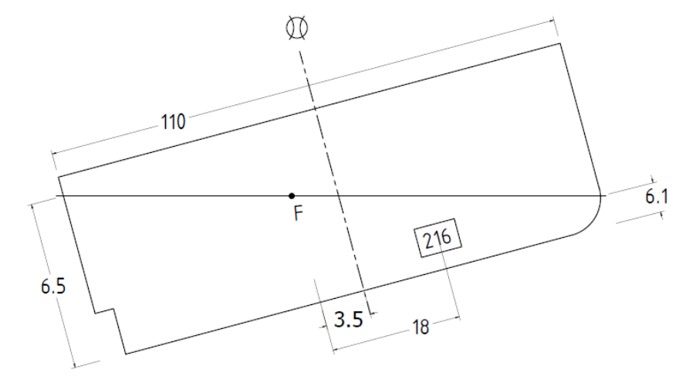
[Ans: 6.54 m; 6.45 m]

SOLUTION:

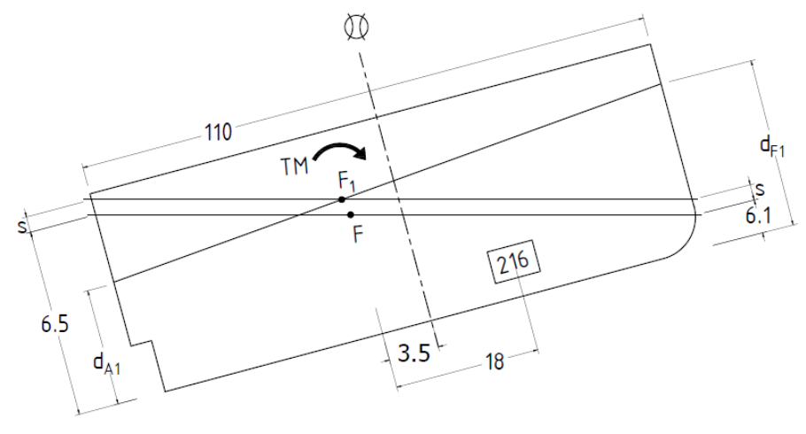

$$∆=6330+216=6546 Tonnes$$

$$s=\frac{216}{12}=18 cm$$

$$TM=216×18=3888 T.m$$

$${MCT1}_{cm}=\frac{6546×136}{110}=8093.24 {T.m}/m$$

$$t=\frac{3888}{8093.24}=0.48 m$$

Therefore:
$$d_{F1}=6.1+0.18+\frac{0.48}{110}\left(\frac{110}{2}+3.5\right)=6.535 m$$

$$d_{A1}=6.5+0.18-\frac{0.48}{110}\left(\frac{110}{2}-3.5\right)=6.450 m$$

Q7
A ship of length 107 m has a displacement of 6330 tonnes when floating at draughts 6.1 m fwd and 5.5 m aft. Determine the end draughts when 204 tonnes of fuel is consumed at a centroid 9 m fwd of the centre of flotation, the LCF is 3.5 m aft of midships. MCT1cm = 79.5 tonne.m and TPC = 12.

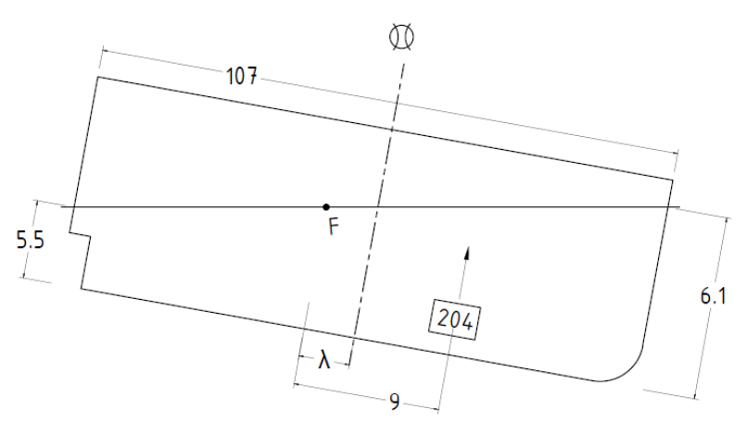
[Ans: 5.807 m; 5.438 m]

SOLUTION:

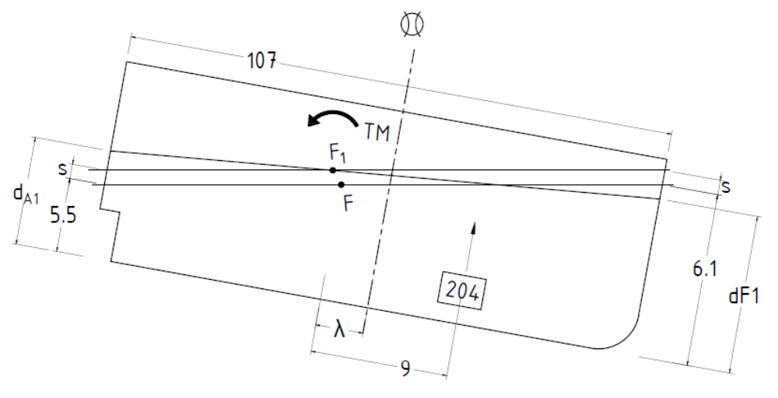

$$s=\frac{204}{12}=17 cm$$

$$∆_{1}=6330-204=6126 T$$

$$TM=204×9=1836 T.m Aft$$

$$t=\frac{1936}{79.5}=23.09 cm$$

Therefore:
$$d_{F1}=6.1+0.17+\frac{0.2309}{107}\left(\frac{107}{2}+3.5\right)=5.807 m$$

$$d_{A1}=5.5+0.17-\frac{0.2309}{107}\left(\frac{107}{2}-3.5\right)=5.438 m$$

Q8
A ship of 250 m length arrives at a loading berth displacing 28 000 tonne. The centre of gravity is 7.0 m above the keel and 2.0 m aft of midships.

The following changes now take place:
- 8000 tonne of water ballast are discharged from Kg 5.0 m and Lcg 50.0 m forward of midships.
- 1500 tonne fuel is taken on board at Kg 2.0 m and Lcg 88.8 m aft of midships.
- 50 270 tonne of cargo is loaded at Kg 8.0 m and Lcg 16.0 m forward of midships.

The following particulars have been taken from the ships hydrostatic table:

d (m) | Δ (Tonne) | KM_{L} (m) | LCB (m) | LCF (m)
12.0 | 66 595 | 357.1 | 5.02 F | 2.90 A
12.6 | 77 845 | 369.7 | 4.78 F | 3.38 A

Determine the draughts for the final condition of loading.
[11.59 m; 12.93 m]

SOLUTION:

Mass (T) | Kg (m) | Lcg_{MS} | Vertical  Moments | Longitudinal  Moments
 |  |  |  | F | A
28000 | 7.0 | 2.0A | 196000 |  | 56000
-8000 | 5.0 | 50.0F | -40000 | -400000
1500 | 2.0 | 88.8A | 3000 |  | 133200
50270 | 8.0 | 16.0F | 402160 | 804320
71770 |  |  | 561160 | 404320 | 189200

$$KG=\frac{561160}{71770}=7.819 m$$

$${LCG}_{MS}=\frac{404320-189200}{71770}=2.997 mF$$
By Interpolation:

$$\frac{71770-66595}{77845-66595}=0.46=\frac{d-12}{12.6-12}=\frac{{KM}_{L}-357.1}{369.7-357.1}=\frac{LCB-5.02F}{4.78-5.02F}=\frac{LCF-2.9A}{3.38-2.9A}$$

Therefore:

$$d=\left(12.6-12\right)0.46+12=12.276 m$$

$${KM}_{L}=\left(369.7-357.1\right)0.46+357.1=362.896 m$$

$${LCB}_{MS}=\left(4.78-5.02\right)0.46+5.02F=4.4096 mF$$

$${LCF}_{MS}=\left(3.38-2.90\right)0.46+2.90A=3.1208 mA$$

Diagrammatically:

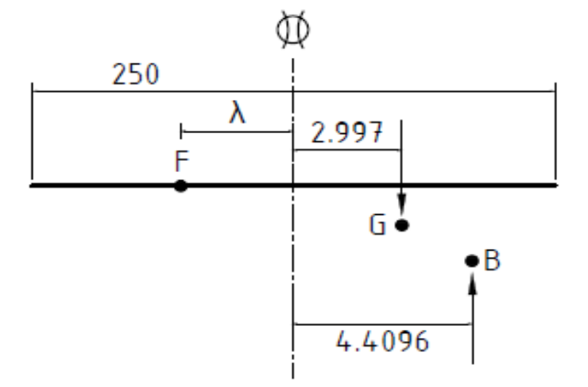

$$TM=71770\left(4.9096-2.997\right)=137267.302 T.m$$

$${GM}_{L}=362.896-7.819=355.077 m$$

$${MCT1}_{cm}=\frac{71770×355.077}{250}=101935.585 {T.m}/m$$
Therefore:

$$t=\frac{137267.302}{101935.505}=1.347 m$$

$$d_{F1}=12.296-\frac{1.347}{250}\left(\frac{250}{2}+3.1208\right)=11.59 m$$

$$d_{A1}=12.296+\frac{1.347}{250}\left(\frac{250}{2}-3.1208\right)=12.93 m$$

Q9
A ship 90 m long displaces 5200 tonne and floats at draughts of 4.95 m forward and 5.35 m aft when in sea water of 1023 kg/m³. The waterplane area is 1100 m², GM_{L} 95.0 m, LCB 0.6 m forward of midships and LCF 2.2 m aft of midships.

Calculate the new end draughts when the vessel moves into fresh water of 1002 kg/m³.
[5.078 m; 5.419 m]

SOLUTION:

$$s=\frac{∆}{A_{W}}\left(\frac{ρ_{S}-ρ_{F}}{ρ_{S}ρ_{F}}\right)=\frac{5200}{1100}\left(\frac{1.023-1.002}{1.023×1.002}\right)=0.09684 m$$

$$TM=∆×{BB}_{1}=∆\left(\frac{ρ_{S}-ρ_{F}}{ρ_{S}ρ_{F}}\right)\left(\overset{↔}{LCB-LCF}\right)$$

$=5200\left(\frac{1.023-1.002}{1.023}\right)\left(0.6+2.2\right)=298.89 T.m$F

$${MCT1}_{cm}=\frac{5200×95}{90}=5488.89 {T.m}/{cm}$$
Therefore:

$$t=\frac{298.89}{5488.89}=0.0545 m$$

$$d_{F1}=4.95+0.09684+\frac{0.0545}{90}\left(\frac{90}{2}+2.2\right)=5.07 m$$

$$d_{A1}=5.35+0.09684-\frac{0.0545}{90}\left(\frac{90}{2}-2.2\right)=5.42 m$$

Q10
A ship of length 69 m floats in fresh water 0.996 m³/tonne with draughts forward and aft of 4.25 m and 5.03 m respectively. Calculate the displacement in tonnes using the following hydrostatic information for salt water 0.976 m³/tonne.

Displacement at 4.65 m mean draught = 2352 tonne
Corresponding LCF = 1.98 m fwd of midships
Corresponding TPC = 5.8

What is the change in trim when she now passes into salt water, assuming that the MCT1cm is 62 tonne.m and LCB is 1.37 m forward of midships, and what will be the new end draughts?
[Ans: 2303.8 T; 0.4741 m; 3.94 m; 5.19 m]

SOLUTION:

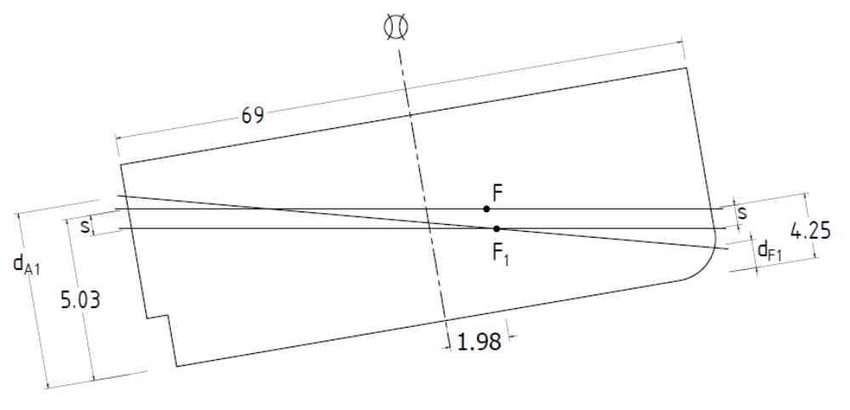

In fresh water:

$$d_{T}=\frac{5.03+4.25}{2}-\frac{\left(5.03-4.25\right)×1.98}{69}=4.66 m$$

As given since this is approximately equal to d_{T} in S.W. then:

$$∇_{F}=∇_{S}$$

$$\frac{∆_{F}}{ρ_{F}}=\frac{2352}{ρ_{S}}$$

$$ρ_{S}=\frac{1}{0.976}=1.025 T/m^{3}$$

$$ρ_{F}=\frac{1}{0.996}=1.004 T/m^{3}$$

$$∆_{F}=2352×\frac{1.004}{1.025}=2308.8 Tonne$$

When she sails into S.W.
$${TPC}_{F}={TPC}_{S}×\frac{ρ_{S}}{ρ_{F}}=5.8×\frac{1.004}{1.025}=5.681$$

$$TM=∆\left(\frac{ρ_{S}-ρ_{F}}{ρ_{F}}\right)×\overset{⃡}{FB}=2308\left(\frac{1.025-1.004}{1.004}\right)\left(1.98-1.37\right)=29.394 T.mSA$$

$$t=\frac{29.394}{62}=0.4741 m$$

$$s=\frac{∆}{{TPC}_{F}}\left(\frac{ρ_{S}-ρ_{F}}{ρ_{F}}\right)=\frac{2308.8}{5.681}\left(\frac{1.025-1.004}{1.004}\right)=8.308 cm$$

$$d_{F1}=4.25+0.08308-\frac{0.4741}{69}\left(\frac{69}{2}-1.98\right)=3.94 m$$

$$d_{A1}=5.03-0.08308+\frac{0.4741}{69}\left(\frac{69}{2}+1.98\right)=5.19 m$$

Q11
A ship of length 135 m floats in sea water 1025 kg/m³. In the light condition the ship has a displacement 5000 tonne and the centre of gravity is at midships. Loading now takes place as detailed in table below:

LOAD | MASS (Tonne) | Lcg from midhip (m)
General cargo | 3890 | 40.0 F
General cargo | 3380 | 34.0 A
Refrigerated cargo | 680 | 48.0 A
Oil fuel | 720 | 15.7 F
Fresh water | 80 | 58.0 F
Stores, etc. | 50 | 33.6 A

Determine the draughts forward and aft for the loaded condition using the relevant data extracted from the accompanying hydrostatic curves.
[7.37 m; 7.83 m]

SOLUTION:

Masses (T) | Lcg (m) | Moments
Masses (T) | Lcg (m) | F | A
5000 | 0 | 0 | 0
3800 | 40.0 F | 155 600
3380 | 34.0 A |  | 114 920
680 | 48.0 A |  | 32 640
720 | 15.7 F | 11 304
80 | 58.0 F | 4 640
50 | 33.6 A |  | 1 680
13 800 |  | 171 544 | 149 240

$$L{CG}_{MS}=\frac{171 544-149 240}{13 800}=1.616 mF$$

From curves:
d = 7.6 m
MCT = 174.0 T.m
LCF_{MS} = 0.1 mA
LCB_{MS} = 2,2 mF

On plotting:

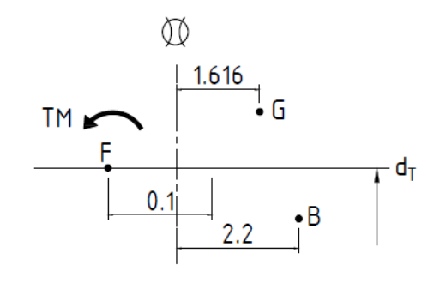

$$TM=13800\left(2.2-1.616\right)=8059.2 T.m A$$

$$t=\frac{8059.2}{174}=46.32 cm$$

$$d_{F1}=7.6-\frac{0.4632}{135}\left(\frac{135}{2}+0.1\right)=7.37 m$$

$$d_{A1}=7.6+\frac{0.4632}{135}\left(\frac{135}{2}-0.1\right)=7.83 m$$

Q12
A ship 100 m long is trimmed 1.5 m by the stern. A double bottom tank 12 m X 10 m X 1.5 m has the sounding pipe at the after end. Find the sounding which will indicate that the tank is full.

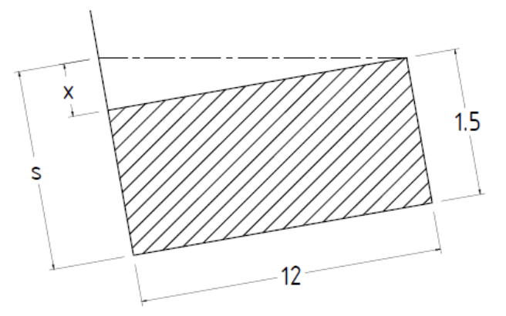
[Ans: 1.68 m]

SOLUTION:

$$\frac{x}{12}=\frac{1.5}{100}$$

$$x=\frac{1.5×12}{100}=0.18 m$$

$$s=1.5+x=1.68 m$$

Q13
A ship 100 m long is trimmed 2 m by the stern. A double bottom tank l: 15 m, b: 20 m, depth: 1.5 m, which has the sounding pipe situated at the after end, is being filled with fuel oil of relative density 0.8. The present tank sounding is 1.6 m. Find the sounding when the tank is full, and also how much more oil is required to fill the tank.

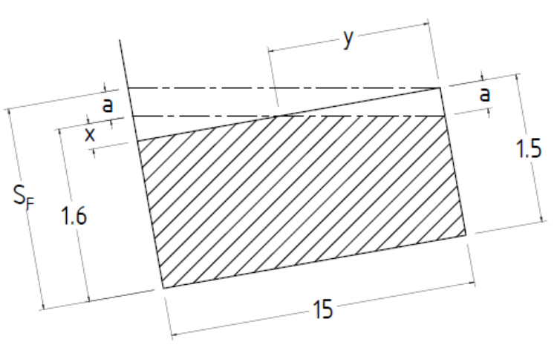
[Ans: 1.80 m; 16 Tonnes]

SOLUTION:

To determine sounding when full:

$$x=1.6-1.5=0.1 m$$

$$\frac{x}{\left(15-y\right)}=\frac{a}{y}=\frac{T}{L}$$

$$\frac{T}{L}=\frac{2}{100}=0.02$$

$$\left(15-y\right)×0.02=x=0.1$$

$$y=15-\frac{0.1}{0.02}=10 m$$

$$a=0.02×y=0.2 m$$

$$S_{F}=1.6+a=1.8 m$$

To determine how much more to fill tank:

$$mass=\frac{1}{2}×y×a×Breadth×Density=\frac{1}{2}×10×0.2×20×0.8=16 Tonne$$

Q14
A ship floating at draught 7.7 m forward and 7.9 m aft sustains a damage on collision and has to lift the bow to reduce the draught forward to 6.7 m. The ship is about to enter port in which the maximum permissible draught is 8.3 m. To do this, it is decided to discharge cargo from No.1 hold (centre of gravity 75 m forward of midship) and No.4 hold (centre of gravity 45 m aft of midship). MCT1cm is 200 T.m/m and TPC is 15. Centre of flotation is amidships. Find the minimum amount of cargo to discharge from each hold.
[Ans: 171.08 T; 278.92 T]

SOLUTION:

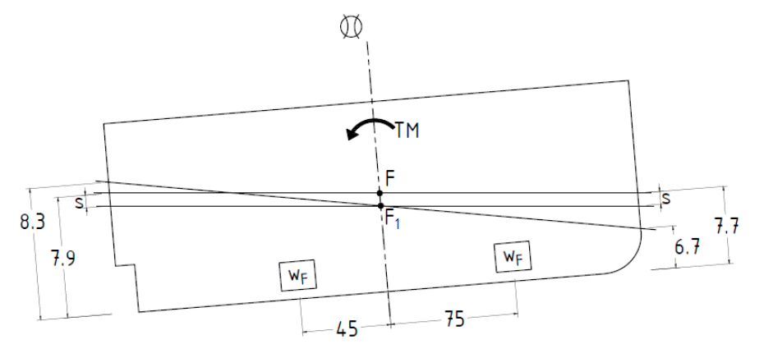

Limiting draught fwd when entering port:

$$6.7=7.7-s-\frac{t}{L}\left(\frac{L}{2}\right)$$

$\frac{t}{2}+s=7.7-6.7=1.0$ Eqn. 1

Limiting draught aft when entering port:
$$8.3=7.9-s+\frac{t}{L}\left(\frac{L}{2}\right)$$

$\frac{t}{2}-s=8.3-7.9=0.4$ Eqn. 2

Eqn. 1 + Eqn. 2

$$2×\frac{t}{2}=1.0+0.4$$

$t=1.4 m$ A

$$s=1.0-\frac{t}{2}=\frac{t}{2}-0.4=0.3 m$$

Due to total cargo discharged:

$$s=\frac{w_{F}+w_{A}}{TPC}$$

$$w_{F}+w_{A}=0.3×15×100=450 T$$

$$w_{F}=450-w_{A}$$

$$t=\frac{TM}{MCT}$$

$$TM=1.4×200=280 T.m$$

By moments about F₁:

$$280=45w_{A}-75w_{F}=45w_{A}-75\left(450-w_{A}\right)$$

$$w_{A}=278.92 Tonne$$

$$w_{F}=450-278.92=171.08 Tonne$$

Q15
After loading a ship recorded 12 000 Tonne displacement at draughts 6.40 m forward and 6.80 m aft. Determine the position of its longitudinal centre of gravity using the attached hydrostatic curves.

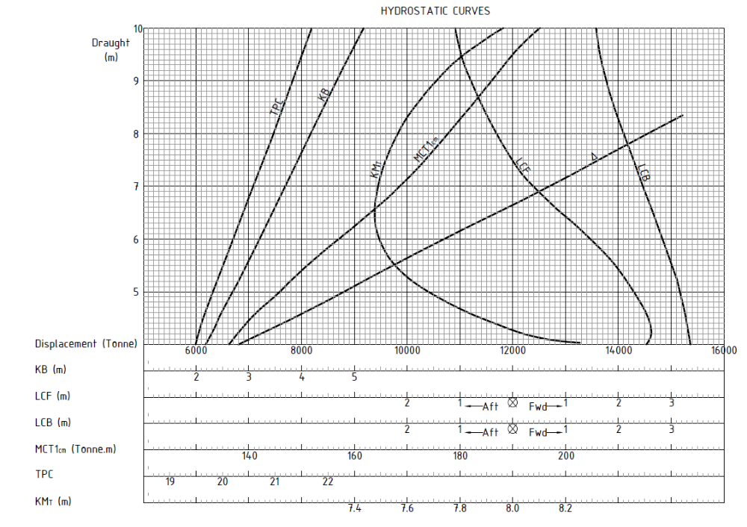
[Ans: 3.69 m F]

SOLUTION:

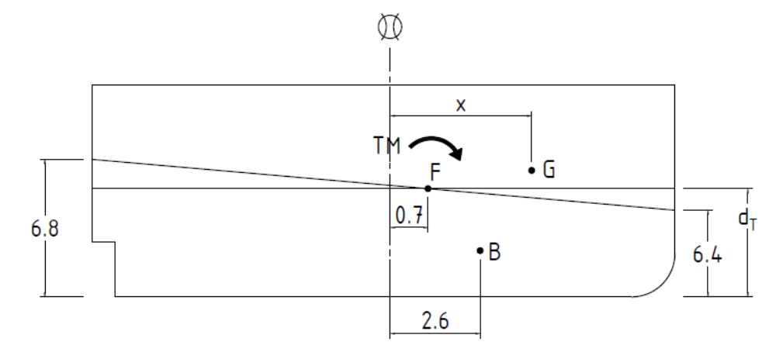

At 12 000 Tonne displacement:

$$d_{T}=6.65 m$$

$${LCB}_{MS}=2.6 m F$$

$${LCF}_{MS}=0.7 m F$$

$${MCT1}_{cm}=164 Tonne.m$$

Now:
$$TM=∆\left(x-2.6\right)=12 000x-31 200$$
Also:
$$TM=t×MCT=T×MCT=\left(8.1-7.7\right)×164=6560 T.m/m$$
Therefore:

$$12 000x-31 200=6560$$

$$x=\frac{6500+31 200}{12 000}=3.69 m$$

