Advanced Statistics Project - Factor Hair Problem

Submitted by
Renjith Mohan K
03/08/2020

1Table of Contents
1 Project Objective..........................................................................................................…...........3
2 Assumptions...............................................................................................................................3
3 Exploratory Data Analysis – Step by step approach ..................................................................3
3.1 Environment Set up and Data Import...............................................................................…....3
3.1.1 Install necessary Packages and Invoke Libraries...............................................….….............3
3.1.2 Set up working Directory ...................................................................................……........…..3
3.1.3 Import and Read the Dataset...............................................................................……...........4
3.2 EDA - Basic data summary, Univariate, Bivariate analysis, graphs………………………….........…...4
3.2.1 EDA - Basic data summary Inference...........................................................................……….4
3.2.2 EDA - Uni-variate Analysis…………………………………………………………………………………………………5
3.2.3 EDA - Bi-variate Analysis……………………………………………………………………………………………………5
3.3 EDA - Check for Outliers and missing values and check the summary of the data set…………..6
3.3.1 EDA - Outlier Identification Inferences………………………………………………………………………………6
3.3.2 EDA - Missing Value Identification- Inferences………………………………………………………………….7
3.3.3 EDA Summary of data set - Inferences………………………………………………………………………………7
3.4 Check for Multicollinearity……………………………………………………………………………………………………8
3.4.1 Check for Multicollinearity - Inferences……………………………………………………………………………..8
3.5 Simple Linear Regression………………………………………………………………………………………………………9
3.5.1 Simple Linear Regression- Inference………………………………………………………………………………….9
3.6 Perform PCA/FA and Interpret the Eigen Values…………………………………………………………………..9
3.6.1 Perform PCA/FA and Interpret the Eigen Values- Inference………………………………………………10
3.7 Output Interpretation of PCA/FA…………………………………………………………………………………..…….13
3.8 Perform Multiple Linear Regression (MLR)…………………………………………………………………………..14
3.9 MLR Summary Interpretation………………………………………………………………………………………………15
4.0 Output Interpretation of MLR………………………………………………………………………………………………15
5.0 Appendix A – Source Code................................................................................................….....17

1 Project Objective
The objective of the project is to use the dataset 'Factor-Hair-Revised.csv' to build an optimum regression model to predict satisfaction. As a part of it, we will be performing the below activities -

• Importing the dataset in R
• Understanding the structure of dataset
• Perform exploratory data analysis on the dataset.
•Check for evidence of multi collinearity
•Perform simple linear regression for the dependent variable with every independent variable.
•Perform PCA/Factor Analysis
•Perform Multiple Linear Regression
•Insights from the dataset

2 Assumptions
We assume that the default level of significance will be 5% - 0.05 (95% CI)

3 Exploratory Data Analysis – Step by step approach
A Typical Data exploration activity consists of the following steps:

1. Environment Set up and Data Import
2. Variable Identification
3. Univariate Analysis
4. Bi-Variate Analysis
5. Missing Value Treatment (Not in scope for our project)
6. Outlier Treatment (Not in scope for our project)
7. Variable Transformation / Feature Creation - We use dimension reduction technique PCA/Factor Analysis in this dataset
8. Feature Exploration

We shall follow these steps in exploring the provided dataset.
Although Steps 5,6 and 7 are not in scope for this project, a brief about these steps (and other
steps as well) is given, as these are important steps for Data Exploration journey.

3.1 Environment Set up and Data Import
3.1.1 Install necessary Packages and Invoke Libraries
As a part of this problem, we installed the packages - “psych” and “corrplot”. psych is a package that has a set of functions used primarily for multivariate analysis and scale construction using factor analysis, principal component analysis etc and corrplot is used to package is a graphical display of a correlation matrix.The packages were installed using install.packages() function and afterwards loaded into library with the aid of library() function.

Please refer Appendix A for Source Code

3.1.2 Set up working Directory
Setting a working directory on starting of the R session makes importing and exporting data
files and code files easier. Here the working directory is chosen as C:/2020/RProgramming/Advanced Statistics where we have the data sets, codes etc. related to the project. We do this with the aid of setwd() function.

Please refer Appendix A for Source Code

3.1.3 Import and Read the Dataset
The given dataset is in .csv format. Hence, the command “read.csv” is used for importing the
file.

Please refer Appendix A for Source Code.

3.2 EDA - Basic data summary, Univariate, Bivariate analysis, graphs

Approach: For basic data summary /variable identification, we use the R functions - dim, names, str, summary, head, tail. The purpose of each of the functions are briefly mentioned below -

dim - we use this to get the dimension of the data frame meaning the number of rows and columns.
names - we use this to identify the colum/variable names.
str - we use this to get the structure of the variable/column names like factor, integer or numeric.
summary - we use this to get a summary of the column names. It gives us the 5 point summary with details of min, max. Median, 25th percentile & 75th percentile.Basically we perform descriptive statistic with this one.
head - we use this to check a sample of data from the data frame. By default it gives the first 6 records.
tail - we use this also to check sample records from the data frame. By default it gives the last 6 records.

We will perform Uni-variate analysis using a histogram using multi.hist() function for all 12 variables and bi-variate analysis of each of the 11 variable against “Satisfaction” variable using a scatter plot by using plot() function.

Please refer Appendix A for Source Code.

3.2.1 EDA - Basic data summary Inference

Below are the inferences from the above EDA step -

Using “dim”, we identified that the Factor Hair data set has 100 rows and 13 columns. We also verified that the column names are proper and from “str” command, all available variables are numeric in nature except for “id” variable which is integer in nature. One insight derived from this is that since id is non numeric and does not help with our further analysis, we will be dropping it from our data set and proceed ahead.We also confirmed that the data is proper by checking first and last 6 records by using the head and tail functions.

Please refer Appendix A for Source Code.

3.2.2 EDA - Uni-variate Analysis

Approach: Use Histogram

From this histogram below, we can see that the variables - Ecom,TechSup, ProdLine, WartyClaim, OrdBilling somewhat follows a normal distribution.Also we can see that there are outlier values for Ecom, OrdBilling, SalesFImage, DelSpeed, Satisfaction, WartyClaim.

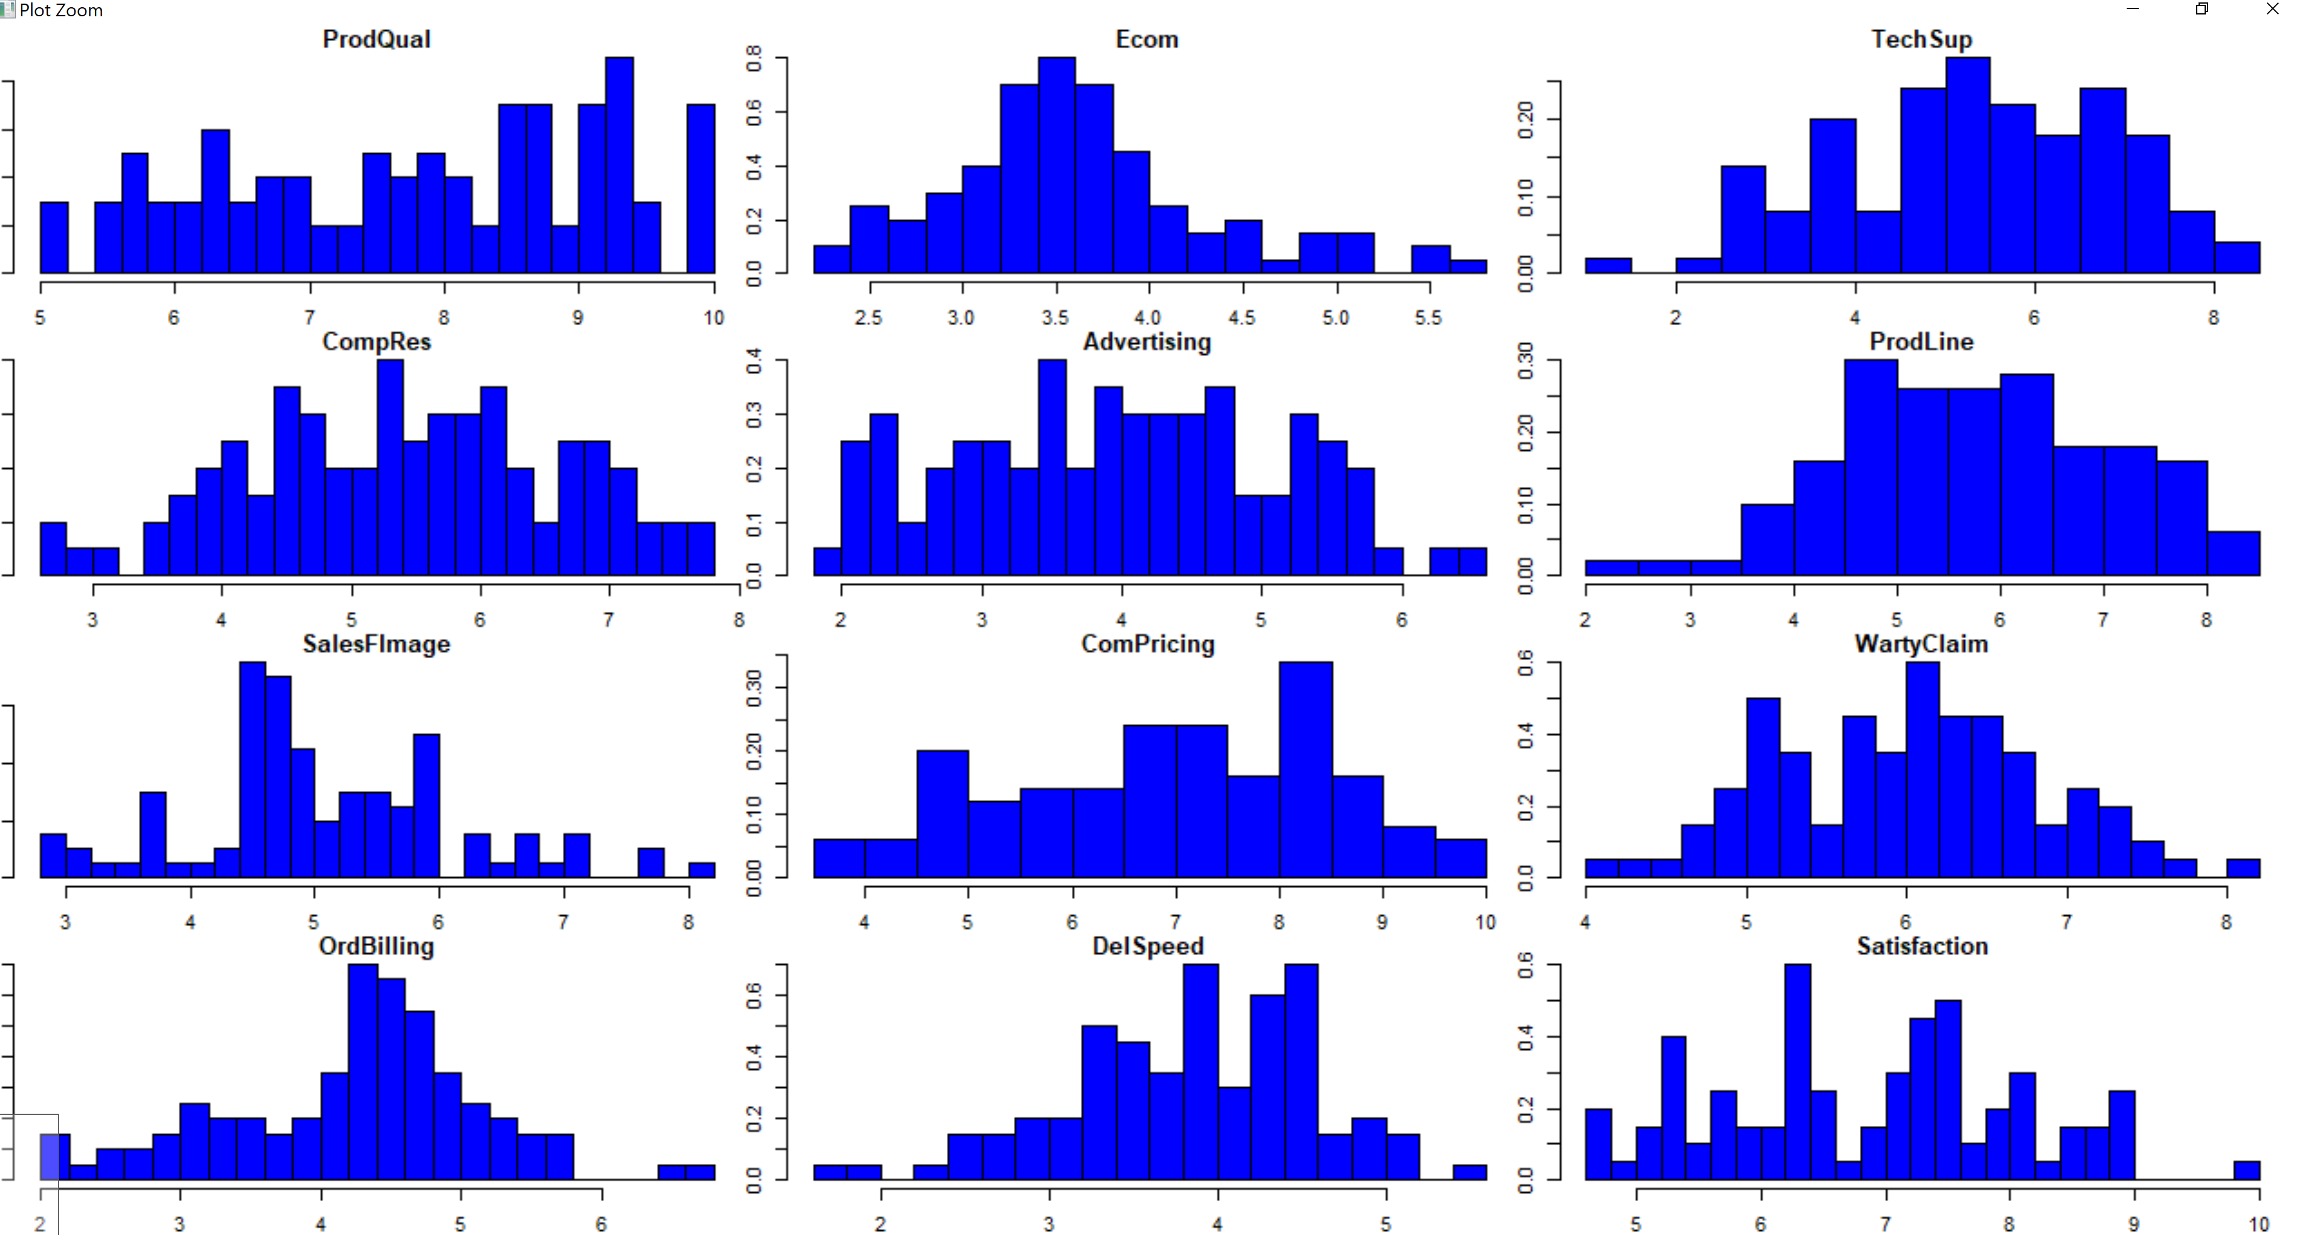

3.2.3 EDA - Bi-variate Analysis

Approach: Use scatter plot

From our bi-variate analysis, we observe that of all the 11 variables, ProdQual, Ecom, Advertising, CompRes, ProdLine, SalesFImage, OrdBilling, DelSpeed seems to have decent positive correlation meanwhile the variable - ComPricing seems to have slight negative correlation. However the variables- TechSup & WartyClaims claim to have no/very low correlation.

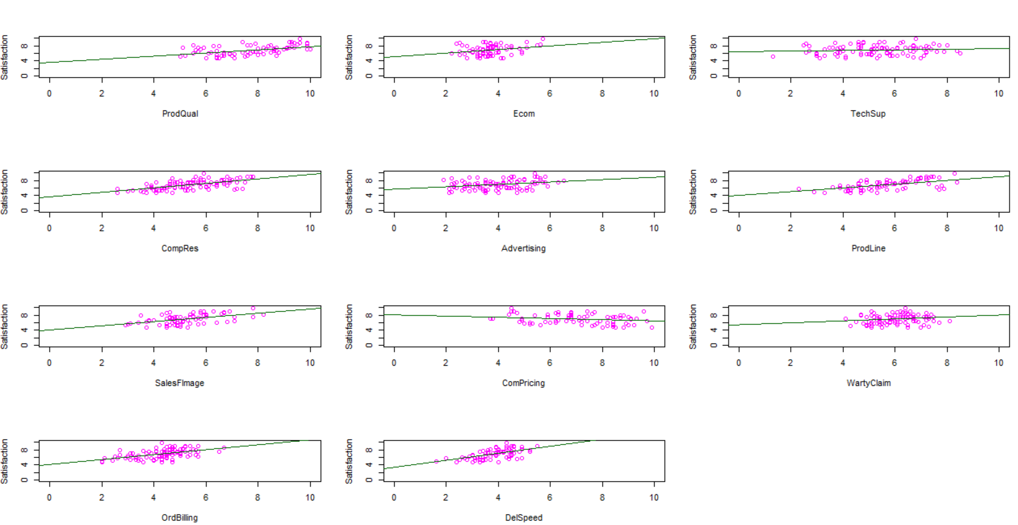

Please refer Appendix A for Source Code.

3.3 EDA - Check for Outliers and missing values and check the summary of the dataset

Approach: Use boxplot, is.na()and summary()

We use a boxplot() function for identifying the outliers.The missing values can be identified by using is.na() function and the five point summary of the data set can be obtained by using a summary() function.

3.3.1 EDA - Outlier Identification Inferences

From the boxplot, we infer that the variables- Ecom, SalesFImage,OrdBilling, DelSpeed have outliers and most number of outlier are available for Ecom variable.
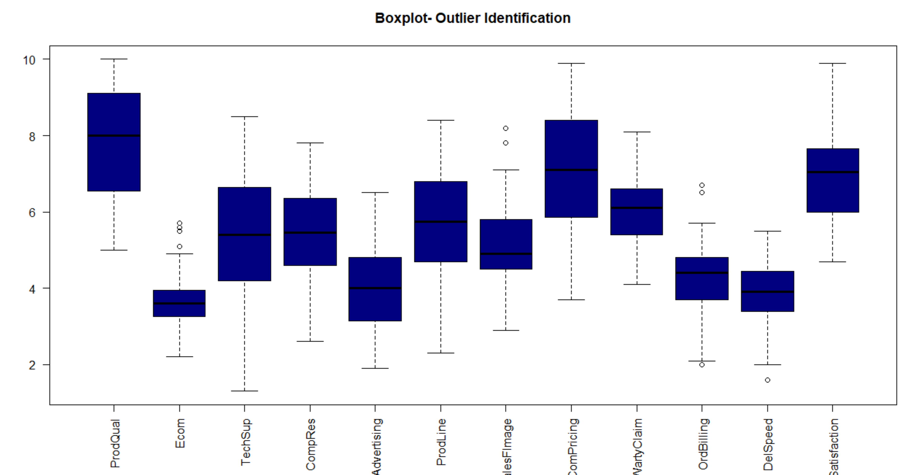
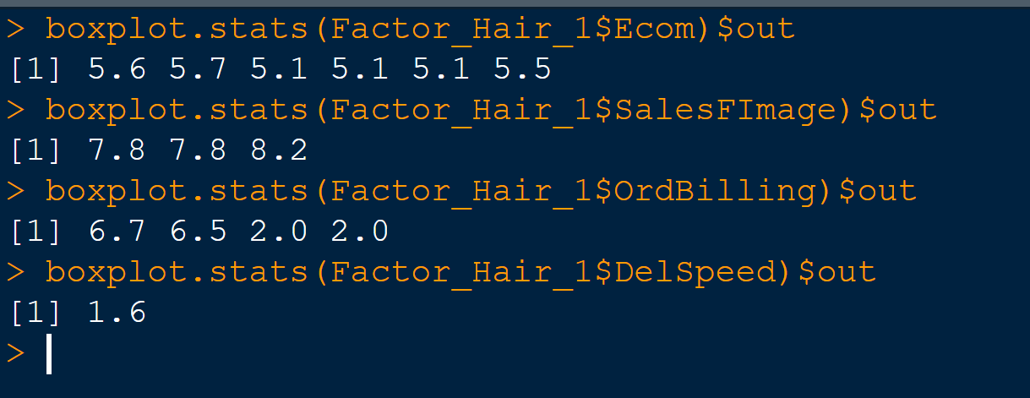
Please refer Appendix A for Source Code.

3.3.2 EDA - Missing Value Identification- Inferences
There are no missing values in this data set and so we are good to proceed with further analysis.

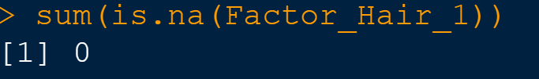

Please refer Appendix A for Source Code.

3.3.3 EDA Summary of data set - Inferences
From the summary function ,we infer that for all the variables, the values are within the range of 10 which means that we don’t have to further scale this dataset.

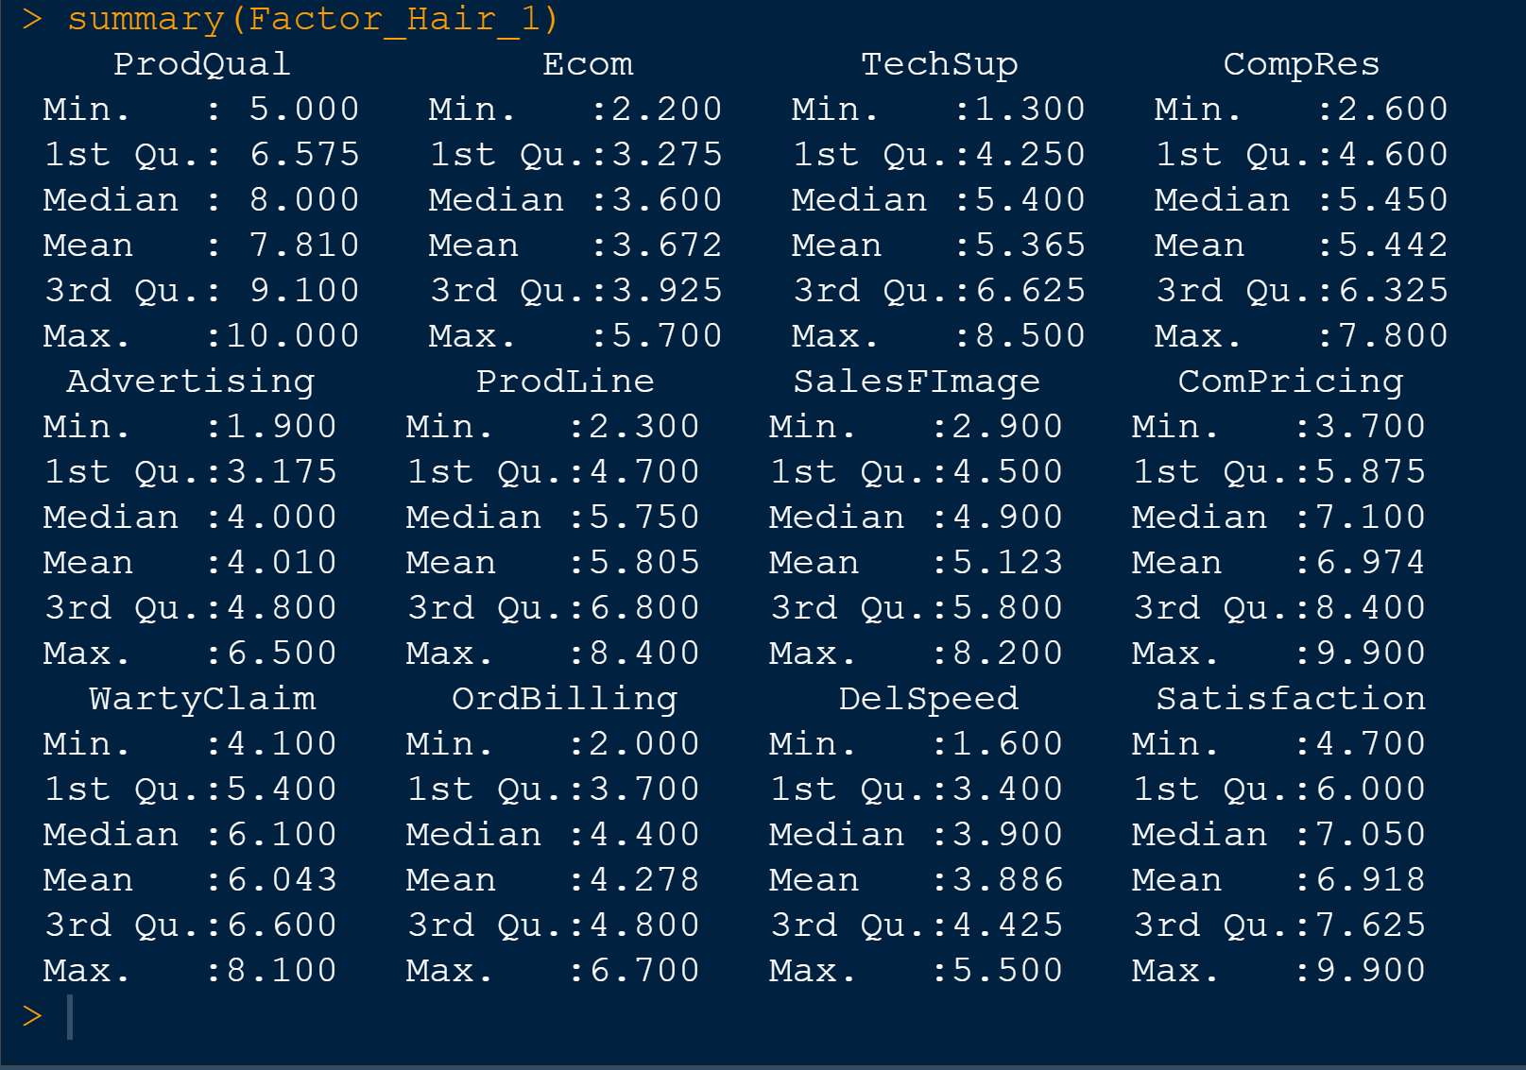

Please refer Appendix A for Source Code.

3.4 Check for Multicollinearity

Multi collinearity is a condition when there is a significant correlation between the independent variables of a dataset. We can check for multi-collinearity by using a correlation matrix and then comparing the correlation value using a corrplot. Also pictorially the correlation of each variable can be represented by a pairs() function scatter plot.

Approach: Use Correlation matrix and corrplot.

3.4.1 Check for Multicollinearity - Inferences

After applying the corrplot by taking the correlation matrix values, we can see that the below variables are very highly correlated -
Delspeed & CompRes
WartyClaim & TechSup
SalesFImage & Ecom
OrdBilling & CompRes

Apart from this we also observed that there are other variables which are mildly correlated. This means that we have a dataset whose independent variables have a significant correlation with each other and that shows that multi-collinearity exists in our data set. So we can go ahead and proceed with dimension reduction techniques.

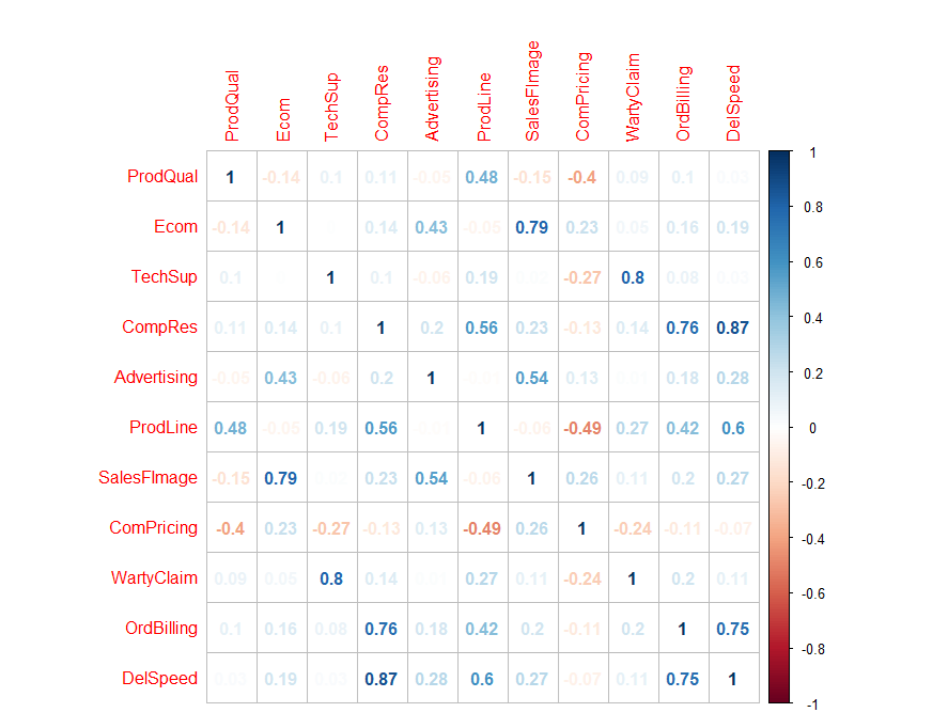

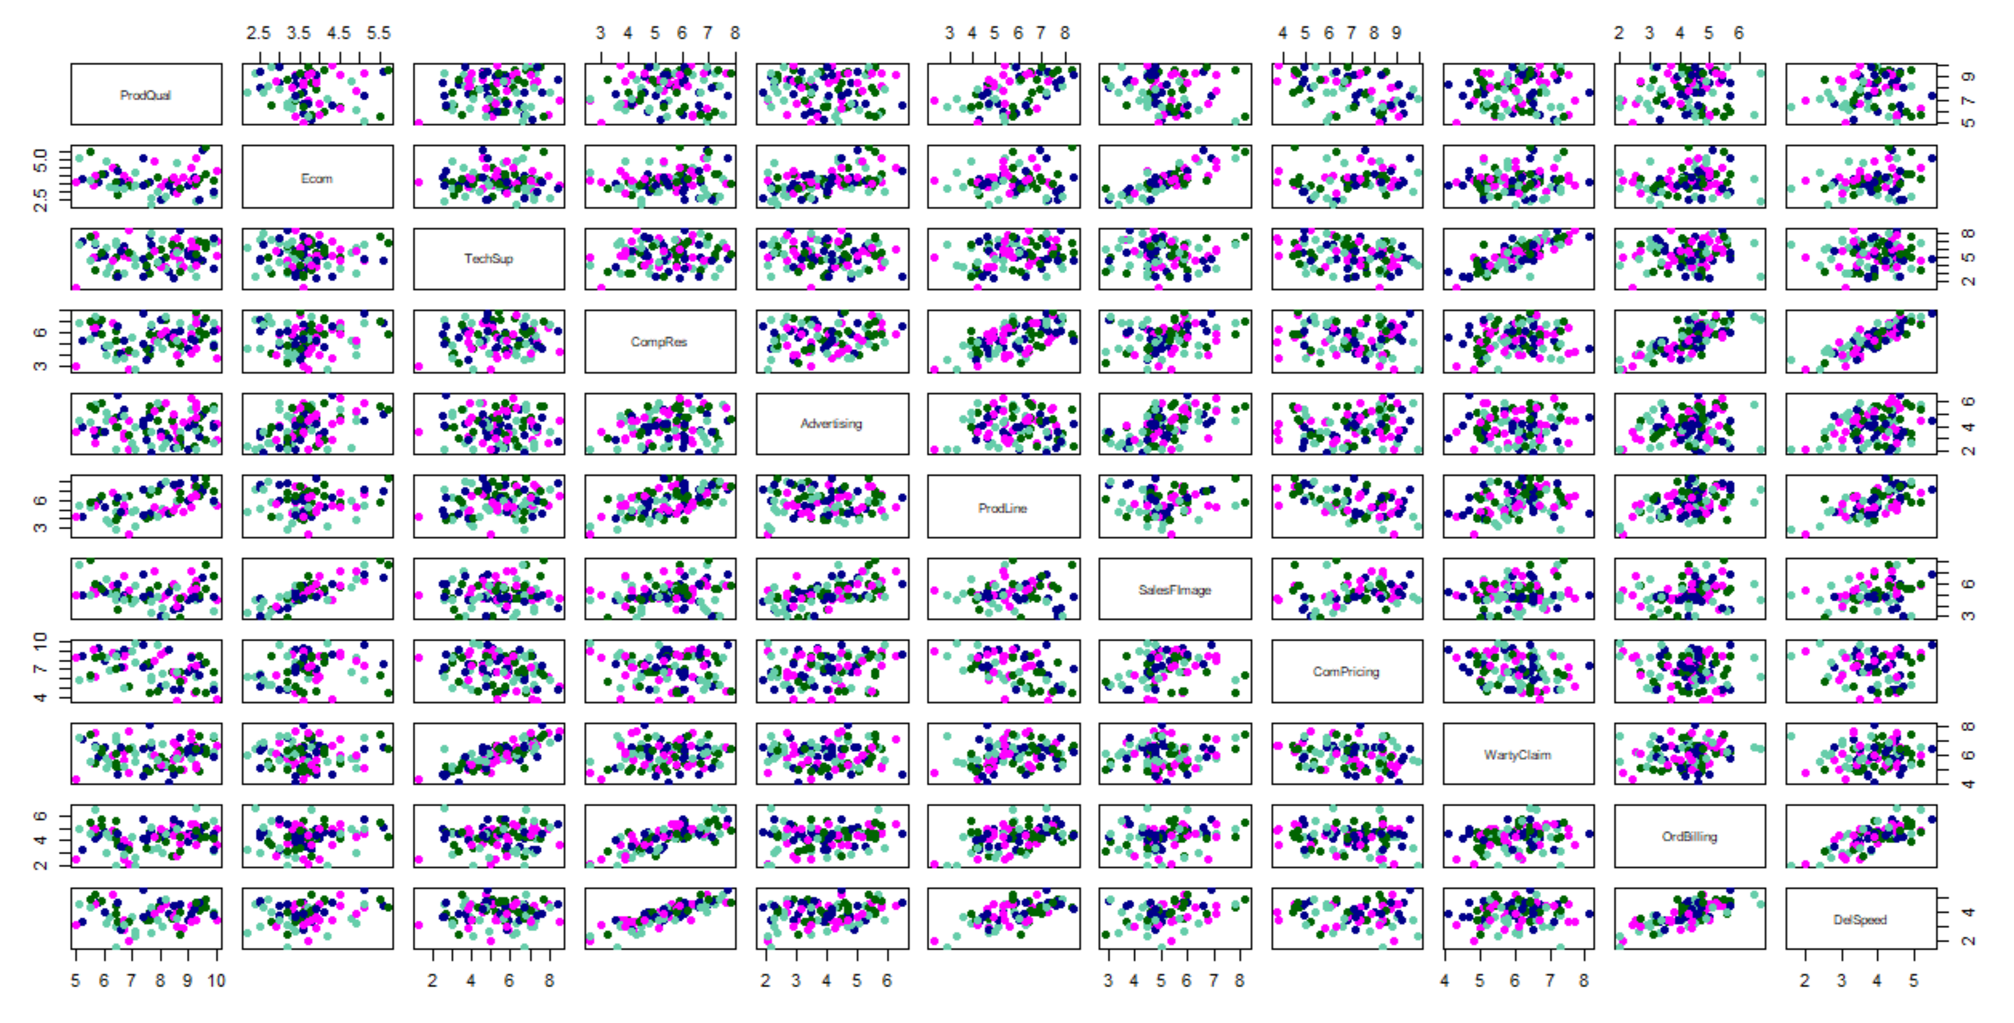

Please refer Appendix A for Source Code.

3.5 Simple Linear Regression
Simple linear regression is a predictive analytics technique where we obtain the relationship of one independent variable with a dependent variable.
Here we perform the simple linear regression of all 11 independent variables against the dependent/target variable to see if they are statistically significant or not. We will use the default alpha value of 0.05 ( 95 percent Confidence Interval)

3.5.1 Simple Linear Regression- Inference
From the linear regression analysis, we observe that the independent variables - TechSup & WartyClaim has a p-value of greater than 0.05 which means that, we cannot reject the null hypothesis and so they are not statistically significant for the dependent variable- Satisfaction. All other variables in the data set has a significant relationship with the dependent variable.

Please refer Appendix A for Source Code.

3.6 Perform PCA/FA and Interpret the Eigen Values
Principal component analysis is a dimensions reduction technique and often used as an intermediary step for further analysis.Here we will perform the principal component analysis followed by factor analysis. We first remove the dependent variable from the data frame and then use the prcomp function and all principal components are extracted at one go and then optimum number of components will be decided.To further confirm upon this optimum number, we use a Scree plot which has Eigen value/variance on the y axis and principal components on the axis. As a part of arriving at the optimum number of factors, Kaiser Normalization Rule is applied which states that we should not include any PC if its variance is less than 1. After PCA, we do factor analysis. There are a few tests that we perform to see if Factor Analysis can be applied to the dataset. These incude Kaiser-Meyer-Olkin(KMO) Measure of Sampling Adequacy & Bartlett’s Sphericity Test. The FA will be performed with the factors unrotated and rotated(varimax).we use principal() function for performing factor analysis in R. In order to improve interpretability, the factors are often rotated. Usually the rotations are orthogonal, but oblique rotations are also possible. The most common rotation is varimax which is expected to increase the already large correlations, and reduce the already small correlations. After looking at the output, we decide which analysis to proceed with.

3.6.1 Perform PCA/FA and Interpret the Eigen Values- Inference
The summary of prcomp() function shows the details of PC1 - PC11 variables in the descending order of their variance . Also from PCA output, we can see that the first four components explains almost 80% of the total variance which is good enough for us to proceed with four factors.

Now from the screeplot, after passing the o/p from prcomp, we see that the elbow is happening at for the 5th factor, however applying Kaiser’s rule, we will consider only factors whose Eigen values are greater than 1. So we will only consider the first 4 components as a part of analysis.

KMO analysis reveals that the overall MSA is 0.65 which is greater than 0.5 and same is the case for individual variables as well.So it makes sense to do Factor analysis.

The Sphericity test reveals that we have a p-value of 1.793e-96 which is statistically significant to reject the Null hypothesis that all variables in the dataset are uncorrelated.So definitely we can say that some variables are correlated and we can proceed dimension reduction using Factor Analysis.

The output from Factor analysis loading and mapping for un-rotated and rotated are shown below. Here with varimax rotation ( orthogonal), we are having a better mapping.

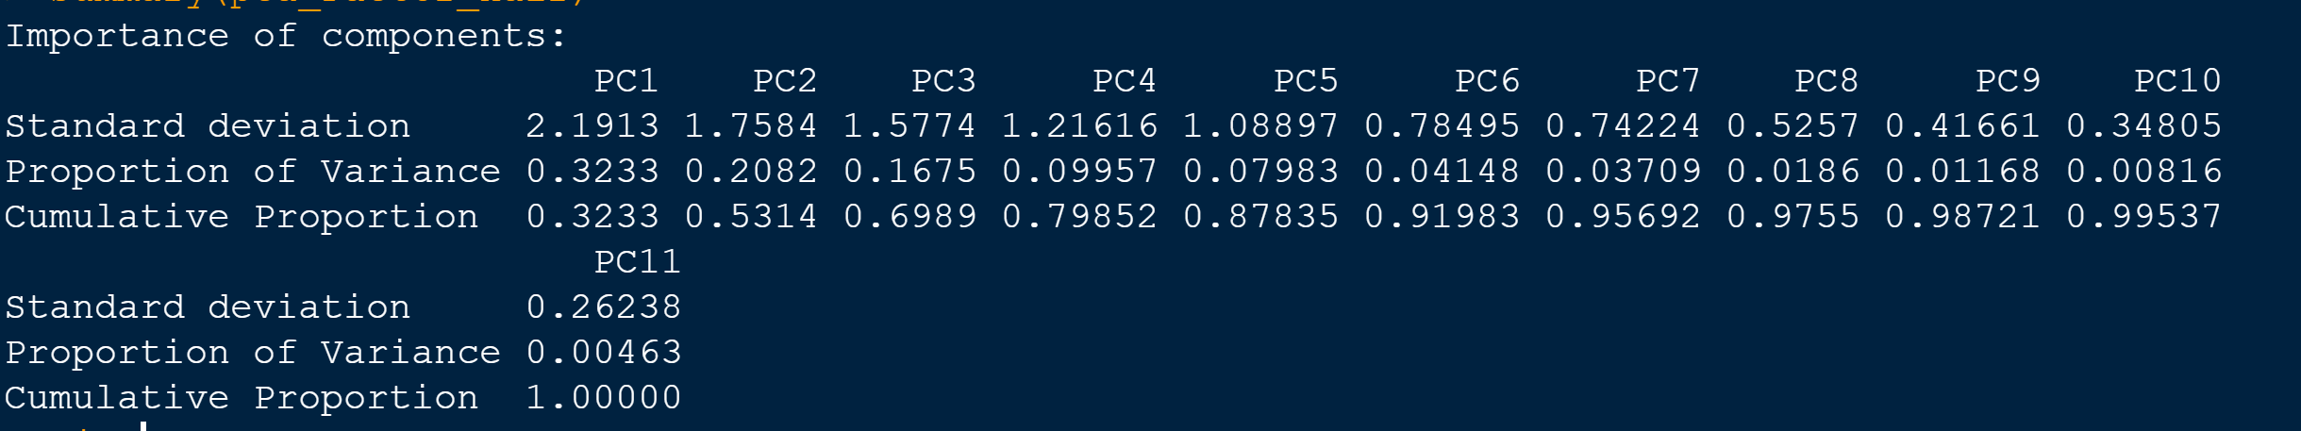

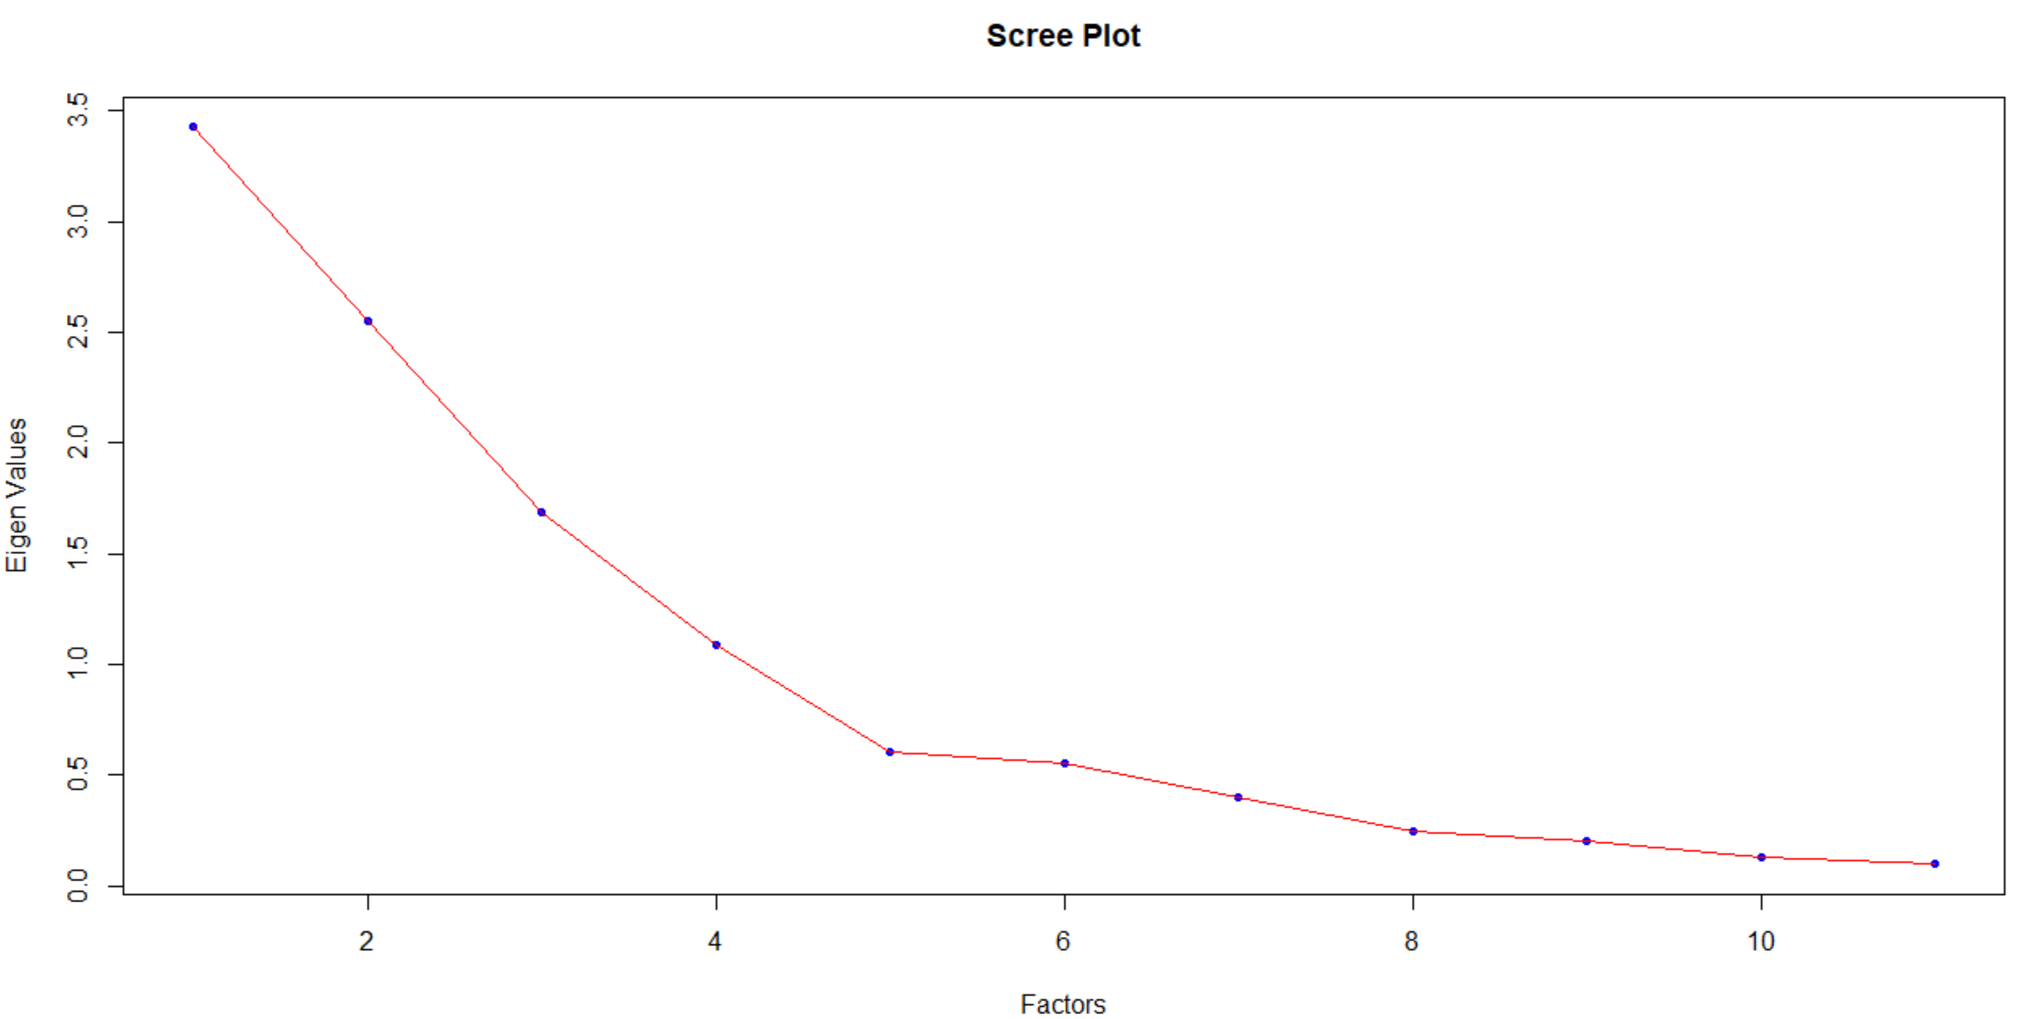
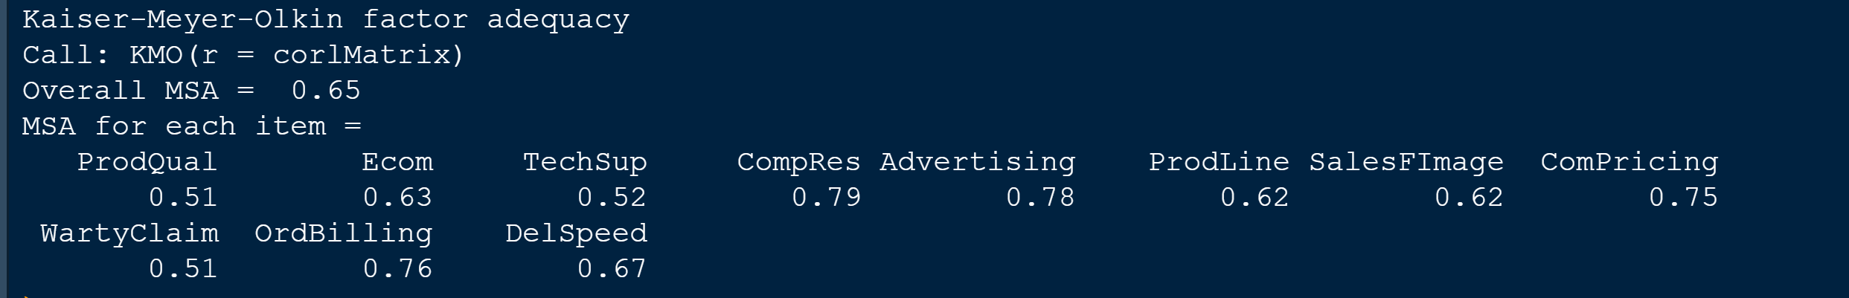

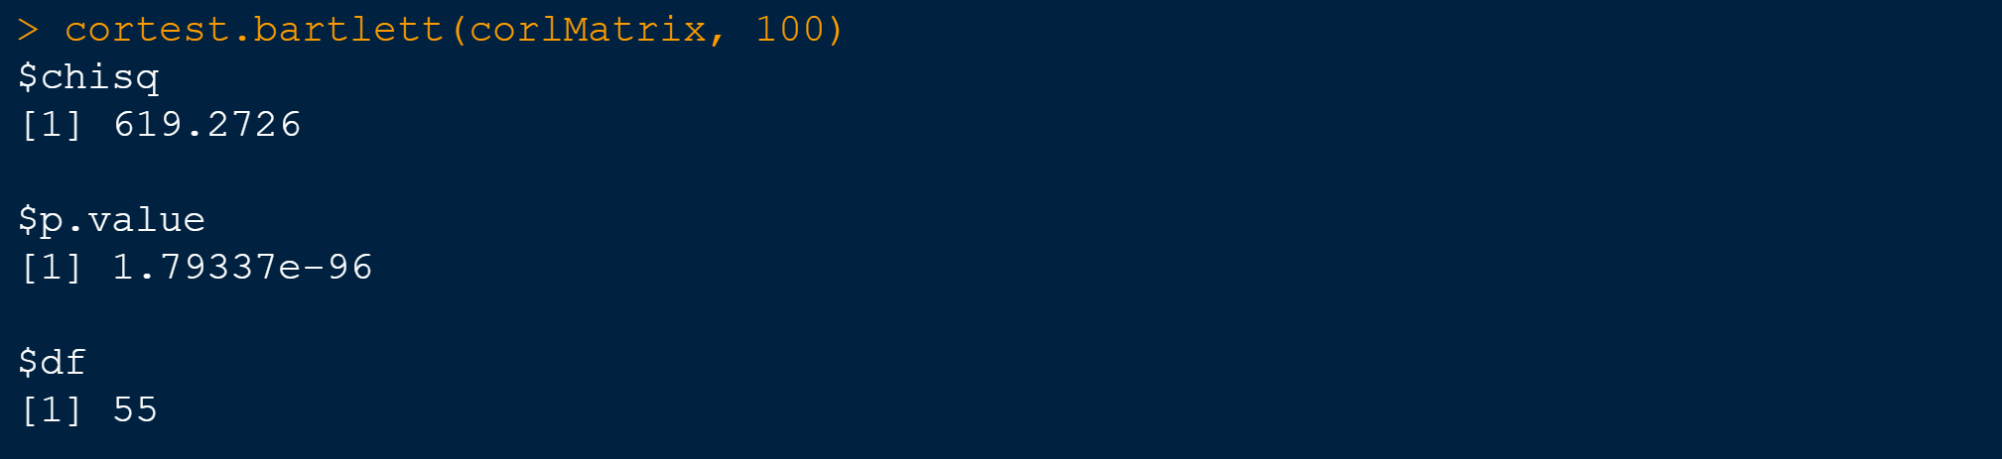

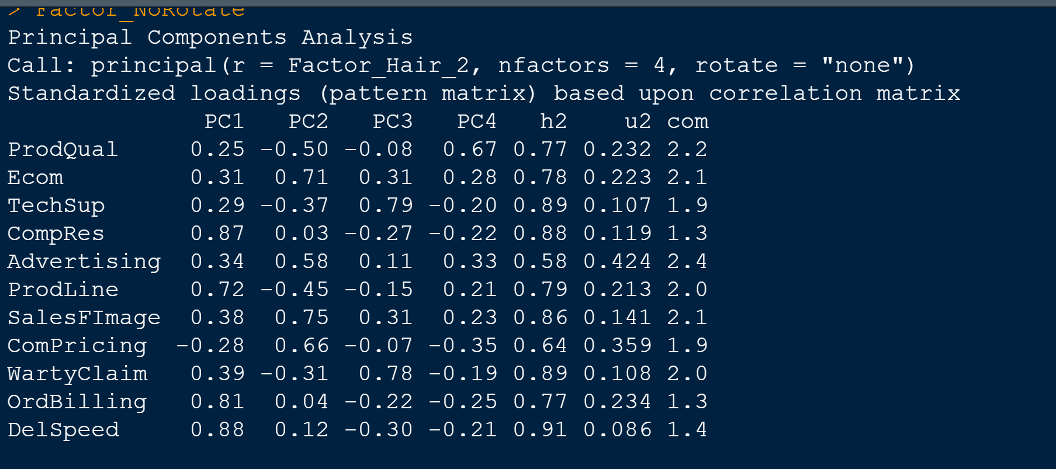
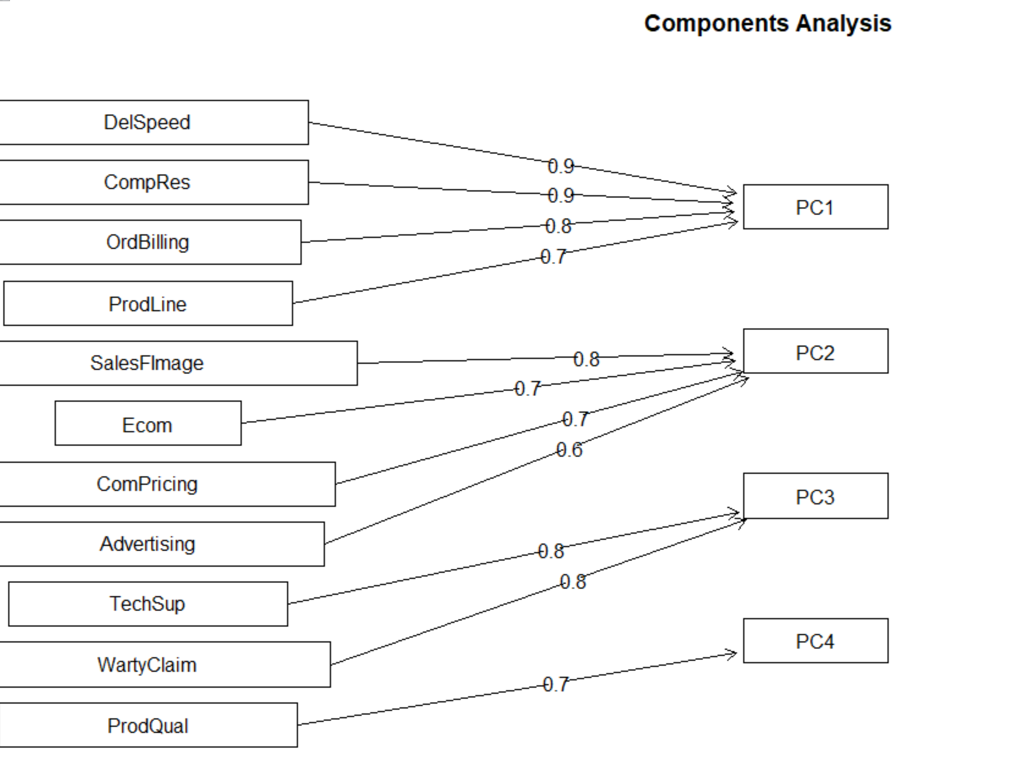

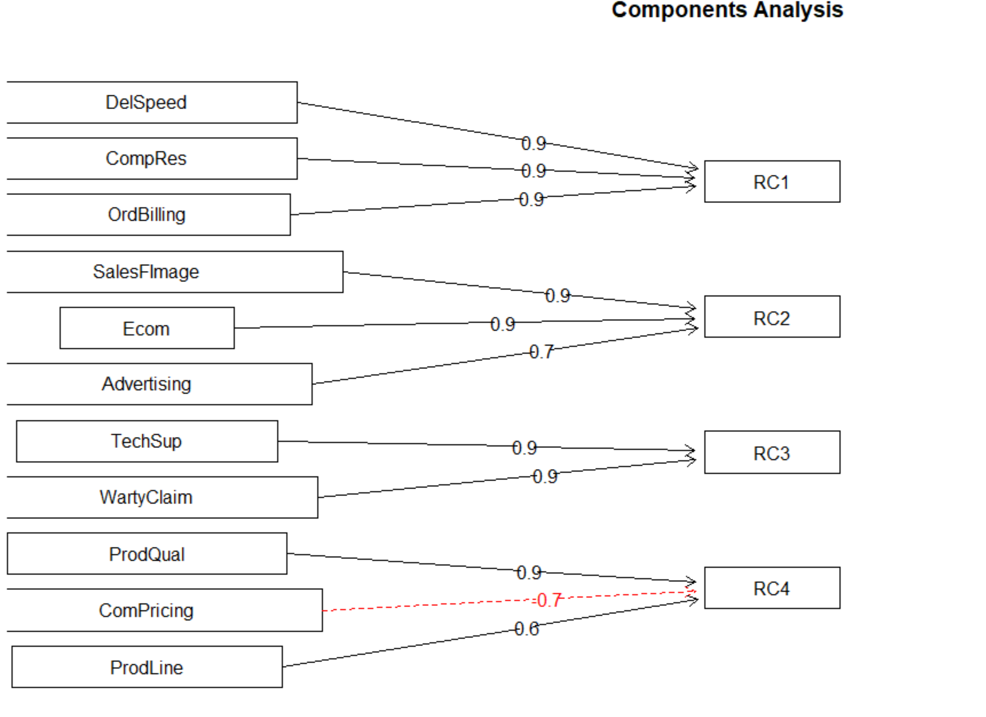

Please refer Appendix A for Source Code.

3.7 Output Interpretation of PCA/FA

- Tell why only 4 factors are being asked in the questions :
Ans: We have a total of 11 independent variables for which dimension reduction technique need to be performed.so ideally we are looking to bring down the number of variables by grouping them together.So it makes sense to take into account of only 4 factors assuming that each factor can explain the variances for 2-3 variables. Anything more than 4, we might end up cluttering the factors and might not yield a productive result.

Q) Tell whether it is correct in choosing 4 factors:
Ans: The choice of the number of factors depend on the output from scree plot after applying Kaiser’s normalization rule. In our screeplot, we checked for the elbow point and saw that only 4 factors have a variance greater than 1. So as per the rules it is correct in choosing only 4 factors. To confirm our deductions, we also checked the output from PCA and the cumulative variance explained by all the 4 variables was 80% which is a good enough number to confirm on the selection.

Q)Name the factors with correct explanations :
Ans: Now that we selected 4 factors and obtained output of their mapping with unrotated Vs rotated, we took the rotated output (varimax) for our analysis. The factor output mapping we got is as below -

RC1 - DelSpeed, CompRes,,OrdBilling
RC2 - SalesFImage,Ecom,Advertising
RC3 - TechSup, WartyClaim
RC4 - ProdQual, ComPricing, ProdLine

In order to arrive at meaningful names, we need to understand these variables first. For first factor category (RC1), the associated variables we dealing with are Delivery Speed, Complaint Resolution and Order Billing which are associated with the product purchases. So we name the first factor as “PurchaseDetails”. For the second factor category(RC2), we have SalesForceImage, Ecommerce & Advertising which are all related to the marketing part and so we name it as “Marketing”. For the third factor(RC3), we have only 2 variables- Technical Support & warranty claims which are both pointing towards post services of the product so we name the factor as “AfterServices”. And for the last factor (RC4), the variables mapped are ProductQuality, Competitive Pricing and ProductLine which are all pointing towards the product details, so we name the factor as - “ProdDetails”. Also as a part of renaming variables, we also change the dependent variable -Satisfaction into “CustSatisfaction”.

3.8 Create a new data frame
We have created a new data frame with 5 columns, the first four columns are factors derived from factor Analysis and the last column is the dependent variable.
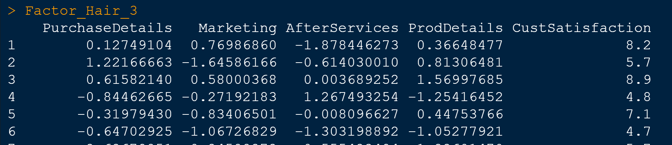

We also perform a correlation plot of the new dataframe after excluding the independent variable to check multi-collinearity again. From o/p, we deduct that there is no multi-collinearity in this data set.

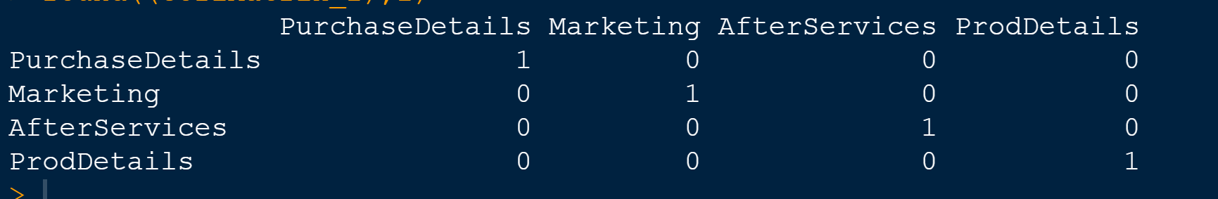

Please refer Appendix A for Source Code.

3.8 Perform Multiple Linear Regression (MLR)

Here we will perform the multiple linear regression of CustSatisfaction(Independent) variable against the four factors- PurchaseDetails, Marketing, AfterServices, ProdDetails as dependent variables.

3.9 MLR Summary Interpretation

From MLR output, we see that the variables - PurchaseDetails, Marketing, ProdDetails have a p-value of less than 0.05 and hence they are statistically significant. But the variable- AfterServices have a p-value of 0.348 which is greater than 0.05 and hence this variable is not statistically significant for analysis.

We have an R-Square value of 0.66 and adjusted R-Square of 0.64 . We will take into the latter as it provides more accuracy which means that our mode is able to explain around 64% of the variances of the dependent variable by the 4 independent variables.

We have the degrees of freedom of 4 & 95 which are respectively for the columns and rows.Also we noted that the F-Statistic value is 46.21 which is fairly high explaining that the error within is lower than between and the overall p-value was found to be 2.2e-16 which mean the linear model is overall statistically fit for the given data as our p-value is much lower than the level of significance (0.05).

And the intercept value was found to be 6.918 which is the constant term in our MLR equation. The coefficients for PurchaseDetails is the highest at 0.62 followed by ProdDetails at 0.54.The variable Marketing has a coefficient of 0.50 and AfterSales has the least coefficient of 0.07.

Finally we can write the MLR o/p equation as below -

CustSatisfaction = 6.918 + 0.62*PurchaseDetails + 0.51*Marketing + 0.07*AfterSales + 0.54*ProdDetails.

Since AfterSales is not statistically significant, we can remove that variable and the new equation is below -4

CustSatisfaction = 6.918 + 0.62*PurchaseDetails + 0.51*Marketing + 0.54*ProdDetails.

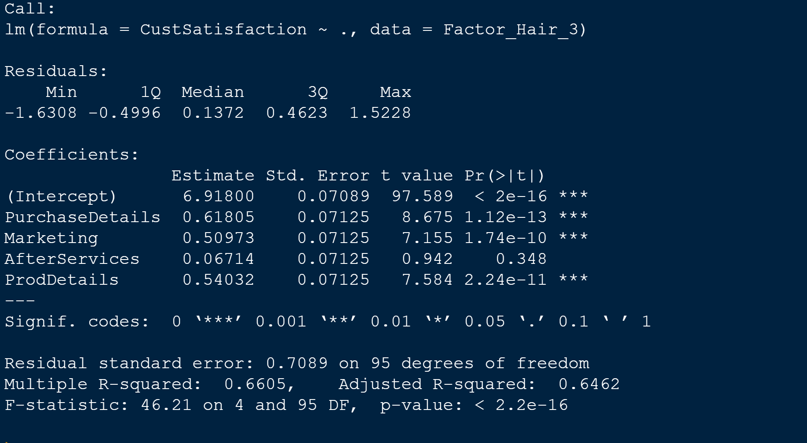

Please refer Appendix A for Source Code.

4.0 Output Interpretation of MLR
The purpose of this project was to build an optimum linear Regression model to predict Customer satisfaction score.As a part of this we performed exploratory data analysis on the data set after checked for outliers and missing values.After that, we checked for evidence of multi-collinearity which means if there was a relationship between the independent variables and we found out it exists in our data set.We also did a simple linear regression of our independent variable-Customer satisfaction with all dependent variables. From that analysis we found that the variables TechSup and WartyClaims are not statistically significant for the dependent variable. After simple Linear regression, we performed a correlation analysis & principal component analysis on our data as a dimension reduction technique. With the help of eigen value obtained from correlation,we arrived at the optimum number of factors. After that we did a factor analysis in two possible scenarios - 1) Un-rotated & 2)Rotated. We found that the rotated data gave a better mapping of the variables and after which we provided meaningful names to those new variables - 1)PurchaseDetails 2) Marketing 3) Afterservices 4) ProdDetails.After factor analysis, we then performed a Multi Linear Regression of the newly created 4 independent variables against the dependent variable.

After doing a multi linear regression (MLR), we arrived at a linear regression equation with CustomerSatisfaction explained in an equation by the independent variables - PurchaseDetails, Marketing, ProdDetails & AfterServices. Here we remove the variable- AfterServices because we deduct that it is not statistically significant based on the p-value. On further observation it makes intuitive sense because AfterServices constitute of the original variables -TechSUp & WartyClaim which when we performed simple linear regression turned out to be statistically insignificant as well. So we went ahead and dropped the ‘AfterServices” variable from our Multi Linear Regression equation which can be used to predict the variable-CustomerSatisfaction.

The final equation is as below -

CustSatisfaction = 6.918 + 0.62*PurchaseDetails + 0.51*Marketing + 0.54*ProdDetails.

Now with the aid of this predictive model, we can forecast the Customer satisfaction provided we have the details for independent variables - Purchase Details, Marketing & ProdDetails. For instance, if we have the PurchaseDetails=0.12, Marketing=0.77 and ProdDetails=0.37, then our model predicts that the CustomerSatisfaction can be calculated as below

Prediction Sample o/p:
CustomerSatisfaction = 6.918 + 0.62*0.12 + 0.51*0.77 + 0.54*0.37 = 7.58

Also we can say that the variable PurchaseDetails has the highest impact on CustSatisfaction because it has the highest value among the list of coefficients.

Thus we were able to create a predictive model from the provided dataset.

5.0 Appendix A – Source Code

#=======================================================================
#
# Factor Hair Analysis- Advanced Statistics - Predictive Modelling
#
#=======================================================================

# Setting the directory
getwd()
setwd("C:/2020/RProgramming/Advanced Statistics")
install.packages("psych")
install.packages("corrplot")

library(psych)
library(corrplot)

# Importing the data
Factor_Hair <- read.csv("Factor-Hair-Revised.csv")
View(Factor_Hair)

#Variable Identification
dim(Factor_Hair)
names(Factor_Hair)
str(Factor_Hair)
head(Factor_Hair)
tail(Factor_Hair)

# Removing the first variable-ID from dataset
Factor_Hair_1 <- Factor_Hair[,-1]
Factor_Hair_1
View(Factor_Hair_1)
names(Factor_Hair_1)

#Attaching the dataset
attach(Factor_Hair_1)

#Univariate Analysis using multi.hist
multi.hist(Factor_Hair_1,density=F,col="blue")

#Bivariate Analysis
par(mfrow = c(4,3))#Convert Plotting space
for (i in c(1:11)) {
plot(Factor_Hair_1[,i],Satisfaction,
xlab = names(Factor_Hair_1[i]), ylab = NULL, col = "magenta",
cex.lab=1, cex.axis=1, cex.main=1, cex.sub=1,
xlim = c(0,10),ylim = c(0,10))
abline(lm(formula = Satisfaction ~ Factor_Hair_1[,i]),col = "dark green")
}

#Outlier Identification - Boxplot
par(mfrow =c(4,5))#Convert Plotting space
boxplot(Factor_Hair_1[],las=2,main="Boxplot- Outlier Identification", col="navy blue")

boxplot.stats(Factor_Hair_1$Ecom)$out
boxplot.stats(Factor_Hair_1$SalesFImage)$out
boxplot.stats(Factor_Hair_1$OrdBilling)$out
boxplot.stats(Factor_Hair_1$DelSpeed)$out

# Checking for missing values
sum(is.na(Factor_Hair_1))

#Check for multi-collinearity
#Correlation Matrix & Corrplot
corlMatrix <- cor(Factor_Hair_1[-12])
corrplot(corlMatrix,method="number")

# Pair wise scatter plot
pairs(Factor_Hair_1[1:11],pch=20,col=c("dark blue","dark green","magenta","aquamarine3"))

# Perform Simple Linear Regression against Satisfaction

model_ProdQual = lm(Satisfaction ~ ProdQual)
summary(model_ProdQual)

model_Ecom = lm(Satisfaction ~ Ecom)
summary(model_Ecom)

model_TechSup = lm(Satisfaction ~ TechSup)
summary(model_TechSup)

model_CompRes = lm(Satisfaction ~ CompRes)
summary(model_CompRes)

model_Adv = lm(Satisfaction ~ Advertising)
summary(model_Adv)

model_ProdLine = lm(Satisfaction ~ ProdLine)
summary(model_ProdLine)

model_SalesF = lm(Satisfaction ~ SalesFImage)
summary(model_SalesF)

model_ComPrice = lm(Satisfaction ~ ComPricing)
summary(model_ComPrice)

model_Warty = lm(Satisfaction ~ WartyClaim)
summary(model_Warty)

model_OrdBill = lm(Satisfaction ~ OrdBilling)
summary(model_OrdBill)

model_DelSpeed = lm(Satisfaction ~ DelSpeed)
summary(model_DelSpeed)

#Perform rincipal Component Analysis

# Eigen Value calculation
ev = eigen(corlMatrix)
EigenValue = ev$values
EigenValue

# Plotting Screeplot
plot(EigenValue, main = "Scree Plot", xlab = "Factors", ylab = "Eigen Values", pch = 19, col = "blue")
lines(EigenValue, col = "red")

# Removing the dependent variable -Satisfaction from the dataset for PCA
Factor_Hair_2 <- Factor_Hair_1[-12]
names(Factor_Hair_2)

# Principal Component Extraction
pca_Factor_Hair <- prcomp(Factor_Hair_2)
summary(pca_Factor_Hair)

# Factor Analysis

# Perform Kaiser-Meyer-Olkin (KMO) Measure of Sampling Adequacy(MSA > 0.5)
KMO(corlMatrix)

# Perform Bartlett Sphericity Test < 0.05
cortest.bartlett(corlMatrix, 100)

# FA With No Rotation (no: of factors = 4)
Factor_NoRotate <- principal(Factor_Hair_2,nfactors=4,rotate = "none")
Factor_NoRotate
fa.diagram(Factor_NoRotate)

# FA with Rotation- Varimax(no: of factors = 4)
Factor_Rotate <- principal(Factor_Hair_2,nfactors=4,rotate = "varimax")
Factor_Rotate
fa.diagram(Factor_Rotate)

# Obtaining Factor Scores from FA o/p with Rotation
Factor_Hair_2_Scores <- Factor_Rotate$scores
Factor_Hair_2_Scores

# Creating a new Dataframe with 5 variables
Factor_Hair_3 <- cbind(Factor_Hair_2_Scores,Factor_Hair_1[12] )
Factor_Hair_3
# Adding new names to the columns
colnames(Factor_Hair_3) <- c("PurchaseDetails","Marketing","AfterServices","ProdDetails","CustSatisfaction")

Factor_Hair_3

# Perform Correlation with new variables
corlMatrix_2 <- cor(Factor_Hair_3[-5])
round((corlMatrix_2),2)
corrplot(corlMatrix_2,method="number")

# Multiple Linear Regression (MLR)

linearModel_new = lm(CustSatisfaction ~., data = Factor_Hair_3)
summary(linearModel)

###############################THE END####################################

