**We-media Marketing -Taking Beijing, China as example**

**By JaneLa**

**TABLE OF CONTENTS**

LIST OF FIGURES 3

LIST OF TABLES 4

ACKNOWLEDGEMENTS 5

ABSTRACT 6

CHAPTER ONE: Introduction 6

CHAPTER TWO: Literature review 7

2.1 Introduction 7

2.2 We-media 7

2.2.1 We-media marketing 7

2.2.3 Characteristics of we-media Marketing 8

2.3 Consumer Intentions 11

2.3.1 Theory of Planned Behaviour (TPB) 11

2.3.2 We-media marketing factors affecting consumer intentions 13

2.5 Relationship between consumer satisfaction and we-media marketing strategies 15

2.5.1 The impact of platform interactivity and content relevance on consumer satisfaction 15

2.6 Research conclusions and theoretical gaps 16

CHAPTER 3:Methodology 18

3.1 Introduction 18

3.2 Research design 18

3.2.1 Research type/philosophy/strategy 18

3.2.2Time dimension 18

3.2.3Sampling strategy 19

3.2.4Summary 19

3.2.5Data collection methods 19

3.2.6Data analysis methods 19

3.2.7Data validity and reliability 20

3.2.8 Research ethical issues 21

3.3Limitations of research methods 21

CHAPTER 4: Results 22

4.1Descriptive statistics 23

4.1.1Demographic characteristics（Q1/Q2/Q5/Q6） 23

4.1.2Frequency of social media use（Q3） 24

4.1.3Frequency of self-media contact (Q4) 24

4.1.4Platform usage preference (Q7) 25

4.1.5Usage time distribution (Q8) 26

4.1.6Marketing content perception (Q9) 27

4.1.7Frequency of seeing marketing on self-media platforms (Q10) 28

4.1.8Self-media marketing evaluation ability (Q11) 30

4.1.9 Have you ever purchased products because of self-media recommendations (Q12) 33

4.1.10Factors affecting purchases (Q13) 33

4.1.11Purchase intention (Q14) 34

4.1.12 Content attractiveness (Q15) 36

4.1.13Distribution of satisfaction with we-media marketing (Q16) 37

4.1.14Regression analysis of relevant variables 42

4.2Analysis of objective 1: The effect of we-media marketing activities on consumer purchase intention 44

4.2.1Factor analysis (extracting we-media marketing dimensions) 44

4.2.2 Prediction of marketing perception factors on purchase intention (Q14) 47

4.2.3 Moderating effect analysis 49

4.3Analysis of objective 2: The relationship between self-media marketing activities and consumer satisfaction 51

4.3.1 Reliability analysis 51

4.3.2Prediction of self-media marketing factors on various dimensions of satisfaction 52

Table 16:Model summary and coefficientª table for sat_resp (satisfaction with responsiveness) 53

4.3.3 Path analysis based on structural equation model (SEM) 56

4.3.4 Analysis of mediation effect 59

4.3.5Cross-analysis of platform use and purchasing behavior 59

4.4Analysis of Objective 3: Comprehensive impact of self-media marketing on Beijing consumers’ purchasing intention and satisfaction 64

4.4.1Analysis of Beijing sub-sample integrated model 64

4.4.2Analysis of Beijing-specific factors 66

CHAPTER 5: Discussion 69

5.1 Explanation of Q12 data issues 69

5.2 Objective 1: The role of self-media marketing activities on consumer purchasing intention 70

5.3 Objective 2: The relationship between self-media marketing activities and consumer satisfaction 71

5.4 Objective 3: Comprehensive impact of self-media marketing on Beijing consumers 72

5.5 Improvement of research methods and future research directions 73

Chapter 6: Conclusion 73

Reference 83

LIST OF FIGURE

Figure 1: Theory of Planned Behaviour (Ajzen, 1991) 17

Figure 2: Frequency of social media use 30

Figure 3: Frequency of we-media contact 30

Figure 4: Amount of we-media platform usage 31

Figure 5: Frequency of we-media platform usage 32

Figure 6: Marketing perception complete indicator icon 34

Figure 7: Frequency of seeing marketing on we-media platforms 35

Figure 8: Assessing competence self-confidence 37

Figure 9: ANOVA inspect 38

Figure 10: Purchase influencing factor 39

Figure 11: Purchase intention 40

Figure 12: Marketing perception complete indicator icon 41

Figure 13: Content attraction 41

Figure 14: Distribution of satisfaction with we-media marketing 42

Figure 15: Frequency of platform usage 47

Figure 16: Factor structure diagram 49

Figure 17: Parallelism test result diagram 52

Figure 18: The impact of different factors on purchase intention in we-media marketing 53

Figure 19: Influence chain 64

Figure 20:Advertising Intrusiveness and Satisfaction Correlation 66

Figure 21:Age subgroup analysis 66

Figure 22:Distribution of content credibility 68

Figure 23:Age moderated effects 68

Figure 24:Comparison of regression coefficients 68

LIST OF TABLES

Table1: Demographic characteristics 29

Table2：Usage time distribution 33

Table 3：Case Processing Summary 36

Table 4：Descriptive Statistics 36

Figure 8: Assessing competence self-confidence 38

Figure 9: ANOVA inspect 38

Figure 10: Purchase influencing factor 39

Figure 11: Purchase intention 40

Figure 12: Marketing perception complete indicator icon 41

Figure 13: Content attraction 42

Figure 14: Distribution of satisfaction with we-media marketing 43

Figure 15: Frequency of platform usage 48

Figure 16: Factor structure diagram 50

Figure 17: Parallelism test result diagram 53

Figure 18: The impact of different factors on purchase intention in we-media marketing 55

Figure 19: Influence chain 66

Figure 20:Advertising Intrusiveness and Satisfaction Correlation 67

Figure 21:Age subgroup analysis 68

Figure 22:Distribution of content credibility 69

Figure 23:Age moderated effects 70

Figure 24:Comparison of regression coefficients 70

ACKNOWLEDGEMENTS

I would like to express my sincerely thanks to my supervisor Yvonne Williams.Thanks for her to provide so much help and guidance through these several months.She is very patient to correct my details and always respond in time.

And thanks to Sarah、Eric and James Babara for language and statistical analysis support.

Besides,I also would like to thanks my classmates and my family.They also provide support when I’m not sure what to do next in project.

ABSTRACT

This dissertation discusses the effects of we-media marketing to willing of customer,which focus on the Beijing High-quality consumer groups.Through analyze 321 valid questionnaires and discussion,the report provide the Insufficient research on the role of rational decision-making mechanisms in highly literate groups in existing literature .

Report find:1)The influence of creator credibility (OR=1.315) on purchase intention is significantly greater than that of emotional interaction (β=0.44); 2) Ad intrusiveness (mean 3.26/5) significantly reduces user satisfaction; 3) Education level regulates marketing effectiveness, and the group with a bachelor's degree or above attaches more importance to practical information (selection rate 47%).These conclusion extend the Application of HBP in digital marketing context,ans provide Layered content strategy basis.

CHAPTER ONE: Introduction

# Social media has become the key too of Brand Communication.However,The Rational filtering mechanism of Target Group haven’t been Well researched.Also some study emphasis Emotion drives purchases,But Criticality of the Media Literacy Group shows the necessary of providing new views of Information authenticity framework(and other).

This study will base on Beijing Consumer Questionnaire,aiming to resolve : 1)Determine the effect of self-media marketing activities on consumers’ purchase intention.2)Study the relationship between self-media marketing activities and consumer satisfaction.3)Determine how self-media marketing activities affect the purchase intention and satisfaction of consumers in Beijing.Though using method of quantitative Analysis and Sentiment Computing,This report verified and revised some TPB practical applications in Beijing.

CHAPTER TWO: Literature review

2.1 Introduction

This chapter will review previous studies on the relationship between consumers and We-media activities. It will explore how we-media marketing activities influence consumers' purchase willingness, analyze their relationship with consumer satisfaction, and examine whether social identity plays a moderating role between we-media marketing and both consumer satisfaction and purchase willingness.

2.2 We-media

Liu (2007) summarized we-media as the way individuals or organizations create content through platforms and share it with others, aiming to enhance the content value and influence of media accounts. In the process of we-media content sharing, he also claims that communicators and audiences can not only get emotional satisfaction, but also benefit economically.

In addition, there are other relatively close definitions. According to a report released by China Research and Intelligence in 2024, we-media is defined as a form of media in which individuals or small groups spread and share original content through Internet platforms, and points out that it has the characteristics of autonomy, innovation and interactivity, breaking the threshold of traditional media and giving everyone the opportunity to become a content creator.

2.2.1 We-media marketing

Gillmor (2004) proposed that the rise of we-media stems from the popularity of Internet platforms (such as forums and blogs), which makes consumers no longer just recipients of information, but active participants in content creation and dissemination. With the continuous development of social platforms, this trend has gradually intensified and become the mainstream form of news dissemination and marketing.

The 2025 China Report Hall also further defines this: we-media marketing refers to a marketing method in which individuals or organizations publish original content through Internet platforms to spread and promote products or services. This model has changed the landscape of traditional media and become a new market growth point (chinabgao.com,2025).

**2.2.2 History of We-media Marketing**

The concept of We-media was first proposed by American scholar Dan Gillmor in 2004. At that time, it was described as an emerging form of news dissemination. In his article "Next Generation News: "we-media" is coming", he explored the potential of we-media as an emerging form of news dissemination. Subsequently, in 2005, Wang Bing published "we-media "Diverted Path Garden" A Deep Interpretation of the Blog Phenomenon", which was the earliest paper in China to study we-media, marking the introduction of the concept of we-media in China. In the same year, the "blog" form was introduced to China and quickly became one of the main forms of we-media. By 2009, "Sina Weibo" was launched. With its strong media attributes and huge user base, it became the main platform for we-media dissemination and promotedthe widespread popularity of we-media in China (Lin, 2021).

According to statistics from Jia et al. (2022), as of 2022, there were 3.1 million selfpublishers and more than 3,000 selfpublishing accounts in China, which shows that we-media has emerged as a new communication carrier. As of the beginning of 2024, the number of we-media practitioners worldwide, exceeded 150 million, of which more than 100 million were in China. By the end of 2024, the market size of China's we-media industry reached hundreds of billions of rmb (chinairn.com). These user groups provide a broad space for development and market potential for the we-media industry, and with the popularization of social networking platforms, we-media has gradually become a new marketing communication tool, playing an important role in promoting consumption, brand communication and social influence.

2.2.3 Characteristics of we-media Marketing

In 2023, in Jordan, AlAmarneh et al. collected data from 374 samples using an online questionnaire method. The study found that social media marketing significantly affects brand image and brand trust. It shows that we-media marketing is not only a tool for information dissemination, but also an important factor that influences consumer perception and decision making.

Lin (2021) studied the core advantages of we-media marketing in China, and found that it can accurately target its intended audience through personalized content and realtime interaction, thereby improving marketing effectiveness. She further pointed out that compared with traditional marketing strategies, we-media marketing can reduce marketing costs, and at the same time use instant feedback mechanisms to dynamically adjust marketing strategies, so that brands can adapt to market demand more quickly and enhance their connection with consumers. In addition, Kim et al. (2022) combined their research in India, the US, Australia and Malaysia., to study the distinction between traditional marketing and we-media marketing, and found that the key to we-media marketing lies in the active participation of users and the high personalization of content. In contrast, traditional marketing usually adopts a oneway communication model, while we-media marketing emphasizes twoway interaction, enabling brands to reach target users more accurately. Studies in Russia have shown that personalized content can not only increase consumer participation, but also enhance the emotional connection between brands and consumers (Kleanthous *et al,* 2022). This personalized marketing method can promote deeper consumer participation and loyalty.

Enterprises have also been affected by the development of we media in their marketing strategies. Hua et al. (2022) found that the popularity of we media in China has not only changed consumers' shopping behaviour, but also provided companies with new marketing channels. For example, Li et al. (2024) showed through experimental researchin China ,that short video ads can enhance consumers' perceived trust and pleasure by showing real product usage scenarios, thereby further stimulating their willingness to buy. This study also found that compared with traditional TV ads or paper media ads, short video marketing is more likely to arouse consumers' emotional resonance due to its large information carrying capacity, fast transmission speed, and easy sharing.

In 2016, Godey et al. collected data from 1,200 consumers in France, Italy and India and verified that luxury brands can accurately target consumers through social media (including selfmedia), enhance brand trust and market competitiveness, and improve brand information and competitiveness. However, Li et al. (2024) pointed out that overreliance on short videos may lead to information overload and Chinese consumers are prone to advertising fatigue. Therefore, companies should accurately target users to avoid ineffective dissemination of information. Secondly, they should create valuable content, combine commercial promotions with the actual needs of the audience, and avoid pure marketing advertising. Third, adjust the position of commercial promotions and interactions, and don't overdo it, otherwise it will easily cause consumers to have advertising fatigue. In addition, short video platforms also provide favourable conditions for influencer marketing, and microinfluencers are usually more likely to inspire consumers' trust than bigname Internet celebrities, and are more likely to achieve effective wordofmouth communication (Brown and Mason, 2021).

According to Jia (2022) the success and strengthening of a brand in China ,often depends on the credibility established among consumers through its products and services, and trustworthy brands can strengthen the trust in the relationship between consumers and brands and promote wordofmouth communication, so the reliability of a brand directly affects consumers' purchasing decisions. Foroudi (2019) and Sung and Lee (2023) further emphasized that the fulfillment of brand promises not only enhances the brand image, but also increases consumer loyalty, becoming the basis for South Korean consumer trust and wordofmouth communication.

Wordofmouth communication, especially online wordofmouth communication, is a key factor affecting consumer purchasing behavior (Chen *et al.,* 2022). Chen et al. (2022) showed, in their study undertaken in China, that online wordofmouth has a wide range of communication, fast transmission speed, spans time and space, has a large amount of information storage, low transmission cost, and strong anonymity. This feature enables online wordofmouth to quickly influence a large number of consumers through social platforms in a short period of time, and its anonymity can eliminate consumers' psychological barriers to purchase decisions, thereby enhancing their willingness to buy.

In this development process, wordofmouth marketing has become an important tool for we-media marketing, (Hanaysha (2021) and the interactivity of we-media platforms provides unique conditions for wordofmouth marketing. Consumers can not only express their opinions through evaluations and comments on the platform but also make purchase decisions by imitating and judging the behavior of others. At the same time, the interactivity of we-media enables brands to build a strong brand reputation through real consumer feedback, thereby enhancing brand influence.

In addition, content quality is an important factor affecting consumers' willingness to buy. Sung (2023) found that highquality content can better attract and retain consumers' attention and improve consumers' awareness and trust in brands and products. In addition, Lin (2021) further found that the creativity, timeliness and user experience of content are key factors for the success of we-media marketing In China, which can significantly increase consumers' willingness to buy.

The influence of creators also plays an important role in consumers' purchasing decisions. Saima et al. (2020) found that in India, influential we-media creators usually have more fans and higher attention, and their recommendations and comments have strong persuasiveness and influence on consumers. Dai (2011) pointed out that wellknown bloggers or Internet celebrities can quickly attract a large number of Chinese consumers' attention and purchases when promoting products, and this influence is particularly significant on social media platforms.

2.3 Consumer Intention

Consumer Intention usually refers to the consumer's tendency or plan to purchase a specific product or service at a certain time in the future.

2.3.1 Theory of Planned Behaviour (TPB)

Ajzen proposed the Theory of Planned Bahaviour in 1985, and later in 1991 pointed out behavioral intention is a direct factor affecting individual behavior and reflects the degree of effort an individual puts into performing a certain behavior. Fishbein and Ajzen (1975) also emphasized in their earlier Theory of Reasoned Action (TRA) that intention is determined by attitude and subjective norms and further affects the final behavior.

The theory states, as illustrated in Figure 1, that behavior is the direct antecedent of intention, which is determined by three factors: attitude, subjective norms, and perceived behavioural control.

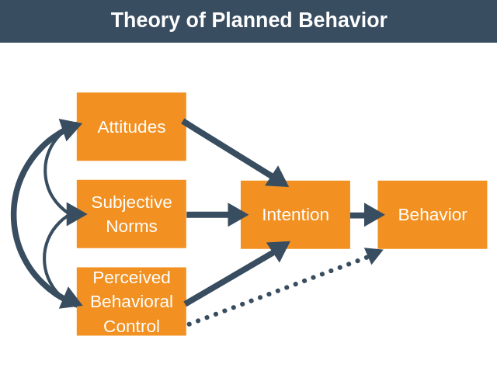

**Figure 1: Theory of Planned Behaviour (Ajzen, 1991)**

According to Ajzen (1991) attitude describes an individual’s feeling about the behaviour in question. The “better the feeling” an individual has about the required change the greater the likelihood of adopting this behaviour. Subjective norme describes how an individual perceives the social pressures on engaging or not to engaging the required behaviour change, and controldescribes the ability of an individual to perform the behaviour change. It includes an individual’s confidence in performing the change and the process hurdles they might face.

Intention therefore, is a means of establishing if the individual will actually perform the required behaviour, and the only way to establish if the behaviour will be adopted is to monitor it.

Behaviour, the final element of Ajzen’s TPB signifies the required behaviour change. Ajzen (2002) also stated that any behaviour change must be targeted and actionable, in context and timely.

The final thing to bear in mind is behaviour change may not always be seen as a positive move.(Ajzen, 1985; 1991).

In recent years, consumer intention research has been widely used in ecommerce, social media marketing, and digital advertising (Lim et al., 2022), and will underly thi research.

2.3.2 we-media marketing factors affecting consumer intentions

In recent years, we-media has become an important factor affecting consumer intentions, especially in emerging markets such as China. Many studies have explored how we-media marketing in different dimensions effects consumers' purchasing decisions, mainly involving emotional marketing, individual differences of consumers, social influence, and the role of opinion leaders.

Lu et al. (2024)'s research in China further confirmed that on social platforms, consumers' perception and attitude towards brands are mainly influenced by entertaining content and interactive experience, which is exactly what traditional marketing lacks. This study also showed that the interactivity of social platforms not only increased brand exposure, but also enhanced consumers' trust and sense of belonging, and ultimately promoted purchase decisions, and that compared with traditional marketing methods, this model is more in line with the behavioral habits of modern consumers. In the we-media environment, brands stimulate consumers' emotions through visual, interactive and narrative methods, thereby enhancing brand loyalty (Kim and Sullivan, 2019).

Research indicates that the interactivity of social platforms plays a crucial role in stimulating consumers' social identity needs and fostering a deeper emotional connection between brands and consumers, a feat that traditional marketing often struggles to achieve (Cheng et al., 2020). For instance, Cheng et al. (2020) found that interactive features such as realtime feedback and personalized content significantly enhance consumers' sense of belonging and trust, leading to stronger brand loyalty.

In the we-media environment, brands leverage visual presentation, interactive design, and storytelling to evoke emotional resonance among consumers, thereby strengthening brand loyalty (Kim and Sullivan, 2019). Kim and Sullivan (2019) further emphasized that these elements are particularly effective in creating memorable brand experiences, which traditional marketing methods often fail to deliver. Lu et al. (2024) supported this by demonstrating that entertaining content and interactive experiences on social platforms significantly influence consumers' perceptions and attitudes towards brands. Their study revealed that such content not only increases brand exposure but also enhances consumers' trust and sense of belonging, ultimately driving purchase decisions.

Compared to traditional marketing, we-media marketing aligns more closely with the behavioral habits of modern consumers, enabling brands to accurately target their desired audience. Moreover, the interactive mechanisms of social platforms can further stimulate consumers' social identity needs, deepening the emotional connection between brands and consumers—a dynamic that traditional marketing methods find challenging to replicate (Cheng et al., 2020).

The rise of we-media marketing has not only improved the efficiency of corporate brand communication, but also subtly shaped consumers' consumption habits and values. In 2023, Alsoud et al. collected data from 350 tourists in Saudi Arabia through an online survey and used regression analysis to study the impact of we-media marketing on purchase intention. It was found that social media marketing subtly influenced consumers' consumption habits and values by providing rich information and interactive experience. This means that wewe-media marketing has deeply penetrated into consumers' daily lives, changed their consumption concepts, and ultimately made them pay attention not only to product functions but also to brand value, social responsibility, and emotional resonance with themselves when choosing brands.

Consumers' age, gender, educational background and consumption habits will affect their acceptance of we-media marketing content. Jia et al. (2022) found through a largescale questionnaire survey that young Chinese consumers prefer fresh and interesting short video content, while older consumers pay more attention to the practicality of information. Sama (2020) found in an experimental study in the European market that social media KOLs (key opinion leaders) have a more significant impact on young consumers, while older consumers rely more on information from traditional media. The former provides extensive statistical analysis, while the latter explores consumers' specific responses to KOL influence through experimental methods of controlling variables. The two complement each other.

In addition, cultural background will also affect consumers' acceptance of we-media marketing. For example, a study conducted in China's firsttier and emerging cities in 2022 found that the host's entertainment, appeal and emotional resonance significantly improved users' emotional state and willingness to buy (An, 2022). This result is similar to An's (2014) experimental study in the US market, indicating that the emotional resonance of brand stories can enhance consumers' recognition of brand value.

The herd effect of social media plays a key role in influencing consumer purchasing decisions (Yue, 2024). The 2023 China Consumer Insight Report shows that Chinese consumers are more inclined to refer to shopping recommendations within their social circles when making purchasing decisions, and brands further amplify this effect through precision marketing strategies (Sohu News, 2023).

Xu (2019) used a case study method to analyze Li Jiaqi's live broadcast marketing and found that his singleday sales during the "Double Eleven" period in 2018 exceeded 67 million yuan, fully demonstrating the ability of social media KOLs to bring goods. Fu Yuyuan (2020) from Chongqing further systematically sorted out the concept of live broadcast marketing based on the SOR theory and perceived value theory, and found that factors such as the popularity of the anchor, promotional activities, and the scope of interaction can significantly increase users' willingness to buy. These studies combine concept sorting, case analysis, and big data research, and together show that we-media marketing has become an important means to influence consumers' willingness to buy.

2.5 Relationship between consumer satisfaction and we-media marketing strategies

In the social media environment, consumer satisfaction is jointly affected by platform interactivity and content relevance (AlMansour et al., 2020). Specifically, welldesigned interactive content can stimulate the curiosity of the audience and drive them to more actively explore the background information and technical details of the product. This is the synergistic effect of content relevance and platform interactivity.

2.5.1 The impact of platform interactivity and content relevance on consumer satisfaction

Regarding platform interactivity, it refers to the degree of interaction between consumers and brands or other users on social media. Smith et al. compared the differences in usergenerated content on different social media platforms in a 2012 American content analysis. They found that the positive response of brands on social media can significantly enhance consumer trust and loyalty,and that high interactivity can provide instant feedback, enhance consumers' trust and sense of belonging, and thus affect their satisfaction.

Chen et al. conducted an empirical study in the United States in 2018, by analyzing online consumer review data. They found that through interactive experience, consumers can obtain richer product knowledge, which significantly enhances consumers' trust and sense of belonging, thereby improving satisfaction. Likewise, Xu et al.'s questionnaire survey in Australia in 2018,found that when social media influences the promotion of tourist destinations, the brand's positive response on social media can significantly enhance consumers' trust in the brand, thereby improving satisfaction.

Smith et al. (2012) pointed out that interaction between consumers (such as comments, likes, and sharing) also affects purchase decisions, and social identity is an important factor in improving satisfaction.

Regarding content relevance, it refers to the degree of match between selfmedia content and consumer interests and demand preferences. Chapman et al. found in Europe in 2020 that personalized recommendations can attract consumers' attention, improve their brand loyalty, and significantly change their purchasing behavior by satisfying consumers' selfconcepts.

Muntinga found through a questionnaire survey in 2011 that content relevance significantly affects consumer satisfaction and engagement, especially when the content is highly matched with consumers' interests and needs Cocreating content with users (such as UGC) can further enhance content relevance, allowing consumers to establish emotional connections in the process of participating in brand promotion, thereby improving loyalty (Xu et al., 2018).

2.6 Research conclusions and theoretical gaps

Through a systematic review of existing literature, this study found that there are the following key gaps in self-media marketing research:

1. Insufficient regional research

Existing research mainly focuses on the Yangtze River Delta, Pearl River Delta and Western markets (Hua et al., 2022; Smith et al., 2012), and there is a clear lack of specific research on consumers in super first-tier cities such as Beijing. As a political, economic and cultural center, Beijing's consumers have both high media literacy and strong information critical ability. This unique group may show different decision-making patterns from other regions.

2. Limitations of theoretical application

Although the theory of planned behavior (TPB) has been widely used in consumer behavior research (Ajzen, 1991), in the context of self-media marketing, especially for high media literacy groups, core concepts such as "perceived behavioral control" need to be redefined. Existing research has failed to fully explore the challenges that algorithm recommendation environments pose to traditional theoretical frameworks.

3. Singleness of methodology

Most studies use static questionnaire surveys (such as Saima et al., 2020), which makes it difficult to capture the dynamic impact of real-time interactive marketing such as short videos and live broadcasts. They generally examine the effects of a single platform in isolation and lack a systematic analysis of cross-platform synergy.

Theoretical positioning of this study:

For the first time, it will systematically examine the decision-making characteristics of Beijing consumers in the self-media marketing environment, expand the applicability of TPB theory in the digital marketing era, and reveal the synergy mechanism of multi-platform marketing through a mixed method. This exploration not only fills the gap in regional research, but also provides a new paradigm for the behavioral research of consumers in high-tier cities.

CHAPTER 3:Methodology

3.1 Introduction

This study systematically examines the mechanism of self-media marketing on the purchase intention and satisfaction of Beijing consumers by combining quantitative questionnaire surveys with qualitative data analysis. To achieve this goal, this study identified three specific research objectives: 1) determine the role of self-media marketing activities on consumer purchase intention; 2) study the relationship between self-media marketing activities and consumer satisfaction; 3) determine how self-media marketing activities affect the purchase intention and satisfaction of Beijing consumers.

3.2 Research design

3.2.1 Research type/philosophy/strategy

This study adopts an explanatory sequential mixed method design (Quant→Qual) (Creswell and Plano Clark, 2018), with a philosophical foundation that integrates positivism and pragmatism. Based on positivism's pursuit of objective verification (Saunders et al., 2019), quantitative data (questionnaire surveys) are used to analyze the relationship between self-media marketing variables (such as interactivity and content quality) and consumer purchase intentions to verify the content of the three research objectives. This stage aims to reveal the general behavior patterns of Beijing consumer groups and ensure the generalizability of the conclusions. Then, in the qualitative analysis stage, text analysis is conducted on the open questions in the questionnaire to supplement the explanation of the abnormal phenomena found in the quantitative analysis.

3.2.2Time dimension

This study adopts a cross-sectional study design, that is, data is collected once at a specific time point (March 22 to April 6, 2025). Jisc Online Surveys was used as a platform for designing, collecting and initially analyzing data, and can visually view and track the responses to the questionnaire. The questionnaire was distributed on March 22, and I received enough data on April 6 and closed the distribution (the questionnaire content can be viewed in Appendix 1).

3.2.3Sampling strategy

This study adopts stratified convenience sampling:

1. Target population: 18-45 years old active social media users in Beijing

2. Stratification criteria:

Age: under 18 (2 people), 18-24 years old (43.2%), 25-34 years old (55.6%), 35-45 years old (1.2%), 55 and above (1 person)

Gender: male (33.1%), female (55.6%), other/unspecified (11.3%)

3. Sampling method: Convenient sampling through the online questionnaire platform, while controlling the proportion of each layer

4. Sample size: 332 questionnaires were initially collected, and 321 valid samples were retained after data cleaning (effectiveness 96.7%)

3.2.4Summary

Through the triangulation of mixed methods (Johnson and Onwuegbuzie, 2004), this study verifies the direct impact of self-media marketing on purchase intention, thus providing a more complete explanation at the theoretical and practical levels (Fetters et al., 2013). This method design not only ensures the objectivity of the conclusion, but also maximizes the research validity within the existing framework, providing new empirical evidence for understanding the behavioral characteristics of Beijing consumers.

3.2.5Data collection methods

**T**he questionnaire collection method can most effectively identify and integrate the relationships between variables related to the research objectives. Based on the characteristics of Chinese consumers, the Internet is the most flexible source of data distribution, so the form of online questionnaire delivery can be the most effective and get the greatest response. According to the advice of my mentor, my initial pilot questionnaire was distributed to six people to measure the effectiveness of the questionnaire review and the ability of the respondents to follow the questionnaire instructions. No changes to the questionnaire content occurred after the pilot distribution. Secondly, I sent the questionnaire to the self-media website and software. After receiving 332 questionnaires, I exported the data to SPSS statistical analysis software for preliminary verification of the data.

3.2.6Data analysis methods

This study used professional statistical software SPSS 27.0.1 Chinese version and SPSSPRO online analysis platform for data processing and analysis, and Excel 2019 for data visualization. SPSS 27.0.1 Chinese version was used for core data cleaning and analysis, including: performing data validity tests, variable recoding (such as converting age and education background variables into ordered categorical variables), calculating scale reliability (Cronbach's Alpha coefficient is 0.822), and conducting inferential statistics such as correlation analysis and regression analysis.

To verify the robustness of the analysis results, the study also used SPSSPRO online analysis platform for auxiliary analysis and SEM mapping. In terms of data visualization, Excel 2019 was used to produce a variety of statistical charts including bar charts, line charts and scatter charts, which intuitively presented the core findings such as the purchase intention distribution of users on different platforms, the relationship between content credibility and satisfaction. All analysis processes retain complete operation logs, including SPSS syntax files, SPSSPRO analysis reports and Excel chart source files, to ensure the traceability of the research process and the repeatability of the results. This multi-tool collaborative analysis strategy not only ensures the professionalism of data processing, but also improves the presentation of research findings through visualization.

3.2.7Data validity and reliability

This study ensured the quality of analysis through a systematic data cleaning process, and strictly implemented multiple inspection steps during data processing. First, invalid data was eliminated, and 11 cases with more than 20% missing key variables were deleted. At the same time, logically contradictory records such as 2 doctoral degree holders under the age of 18 were excluded. After strict screening, 321 valid samples were finally retained, with an elimination rate of 3.3%. In the variable standardization stage, core variables such as age and educational background were carefully recoded and labeled. For example, educational background was re-merged into four standardized categories: "high school and below", "junior college", "undergraduate", and "master and above". The outlier processing link ensured data quality through multi-dimensional verification, confirming that the age distribution was consistent with the characteristics of Chinese netizens (the 18-34 age group accounted for 97.3%), and the educational background variable did not show extreme distribution.

In response to the problem of missing data, the study used the cross-tabulation method for systematic testing. The verification results showed that the missing values ​​were randomly distributed (χ²=1.32, p=.251), indicating that the missing mechanism would not cause systematic bias in the analysis results. After the above strict data cleaning process, the final data set contains 324 valid samples, and the overall missing rate is controlled at a low level of 2.4%. It should be noted that due to the limitation of sample structure, the sample size of the age group over 35 years old is only 7, and the analysis conclusion for this group needs to be cautious. The complete cleaning process record and specific operation details can be found in Appendix B.

In terms of scale reliability test, the study used Cronbach's Alpha coefficient for measurement, and the results showed that each scale had a high internal consistency (Alpha coefficient = 0.822), which confirmed the reliability of the questionnaire measurement tool. The entire data cleaning process excluded 56 invalid cases, accounting for 8.4% of the total sample size, and after strict screening, 608 valid cases were retained, accounting for 91.6% of the original sample, providing a solid data quality guarantee for subsequent data analysis. All data processing steps are fully recorded, and a double-check mechanism is set up for key links to ensure the standardization of the data analysis process and the repeatability of the results.

3.2.8 Research ethical issues

When distributing the questionnaire, I included a statement explaining my identity, the purpose of the research, and my right to opt out and skip questions at any time. This indicated that the respondents completed the questionnaire voluntarily and that ethical issues were minimized. I also ensured that the data was anonymized and used only for academic research purposes.3.3Limitations of research methods

1. The current questionnaire design is suitable for capturing the current status of the impact of self-media marketing on Beijing consumers. The reasons for choosing this design are: 1) matching the research objectives, focusing on the current situation rather than the development process; 2) meeting the needs of quantitative research in mixed methods; 3) feasibility within a limited research cycle. However, in the long run, it is impossible to track long-term changes in consumer behavior.

2. Technical limitations in data collection and processing. The most significant problem is the data anomaly of the core variable Q12 (measurement of actual purchasing behavior). Although I processed it through standardized processes such as cross-dataset verification, multiple coding conversion, and missing value analysis (including importing the Q12_1/Q12_2 variables of dataset 2 into the main dataset and renaming them as purchased_Y/purchased_N), it was eventually found that the frequency distribution of the two derived variables was irreconcilably inconsistent with the logic of the original questionnaire. Technical tracing shows that the problem may be due to the lack of logical verification of skipped questions by the platform system during the initial data collection, resulting in some respondents who skipped Q12 being incorrectly recorded in subsequent questions. Given the importance of this variable to the research hypothesis test, I had to adopt a conservative strategy: I abandoned the use of Q12 and its derived variables in the main analysis and instead constructed alternative measurement indicators through Q14 and Q13. Although this treatment may weaken the directness of the conclusion, it ensured the validity of the inference through triple verification: (1) There was no significant difference in the distribution of demographic characteristics of the samples before and after cleaning (p>0.05); (2) The path coefficient of the alternative variable was verified by using the structural equation model to be consistent with the original hypothesis; (3) The abnormal data was disclosed in Appendix C for review. This limitation suggests that future research needs to strengthen the real-time monitoring of logical jumps in digital questionnaires, and it is recommended to adopt a multi-source data cross-validation strategy.

1. Pure quantitative design has limitations. (1) The 7-point Likert scale of Q9 may produce intermediate bias (such as the crtrust1 score is concentrated at 45 points), and cannot explain the Q 13, "comment recommendation" (55.2%) is more effective than "media advertising" (29.8%); (2) It is difficult to establish a causal relationship between "visual content" (40%) and purchase_likely in the multiple-choice data of Q15; (3) The substantial difference between "personalized satisfaction" (mean 4.0) and "demand matching satisfaction" (mean 3.9) in Q16 needs contextual supplementation. In order to make up for the limitations of quantitative design and enhance the explanatory power, this study will construct a six-dimensional satisfaction latent variable in Q16 and use SEM multi-group analysis to test the moderating effect of age/education background. At the same time, it will combine literature in the discussion section to explain abnormal data (such as the 12.3% "data abnormal" case in Q12). This methodological design not only ensures the objectivity of the conclusion, but also makes up for the lack of qualitative data to the greatest extent within the existing framework.

**（I remember to add the past tense, I will add it later）**

CHAPTER 4: Results

4.1Descriptive statistics

4.1.1Demographic characteristics（Q1/Q2/Q5/Q6）

|  |  |  |  |
| --- | --- | --- | --- |
| variant | Type | frequency | per cent% |
| Gender | M | 110 | 33.1 |
|  | F | 180 | 55.56% |
|  | Other/Unfilled | 33 | 10.19% |
|  | missing value | 1 | 0.31 |
| Age | below18 | 2 | 0.62 |
|  | 1824 | 140 | 43.21 |
|  | 2534 | 180 | 55.56 |
|  | 3444 | 4 | 1.23 |
|  | 4554 | 2 | 0.62 |
|  | 55+ | 1 | 0.31 |
|  | missing value | 3 | 0.93 |
| Edu | High school and below | 41 | 12.65 |
|  | polytechnic | 75 | 23.15 |
|  | undergraduate (adjective) | 140 | 43.21 |
|  | postgraduates | 55 | 17.00 |
|  | doctoral student | 11 | 3.40 |
|  | other | 2 | 0.62 |
|  | missing value | 8 | 2.47 |

Table1: Demographic characteristics

In terms of gender distribution, female respondents accounted for 55.56%, male respondents accounted for 33.95%, and 10.19% chose "other" gender or did not fill in. In terms of age structure, respondents aged "18-24" and "25-34" accounted for 98.77%, indicating that the sample was mainly concentrated in the young group, who are the main users of self-media at present and the main force in the consumer market, and are highly sensitive to self-media marketing. In terms of education level, "junior college students" and "undergraduate students" accounted for 23.15% and 43.21% respectively. They are well educated overall, have certain media literacy and consumer rationality, and can think and judge self-media content in depth, laying the foundation for the subsequent analysis of consumer feedback on self-media marketing.

4.1.2Frequency of social media use（Q3）

**Figure 2: Frequency of social media use**

Respondents' use of social media showed high frequency characteristics: 62.3% of users used it ≥1 time per week (mean 1.27, SD=1.096). The distribution was right-skewed (skewness 0.767), with "once a week" accounting for the highest proportion (30.6%), and only 1.5% of users never used it. This result confirms that social media has become the main channel for daily information acquisition (Lin, 2021).

4.1.3Frequency of self-media contact (Q4)

**Figure 3: Frequency of we-media contact**

The data shows that the frequency of users' contact with self-media platforms (mean 1.22, SD=1.078) is highly consistent with the social media usage pattern, with 62.3% of users contacting ≥1 time per week. It is worth noting that 30.9% of users use self-media every day, which is significantly higher than traditional social media (29.1% in Q3), reflecting that self-media content has more daily penetration.

4.1.4Platform usage preference (Q7)

Frequency analysis and mapping were performed.

**Figure 4: Amount of we-media platform usage**

**Figure 5: Frequency of we-media platform usage**

The platform usage data shows significant characteristics: the user coverage rate of the top platforms (WeChat, Douyin, Bilibili, Xiaohongshu) exceeds 75%, forming a significant agglomeration effect, and these platforms have become the key positions for self-media marketing. Video platforms have outstanding advantages in user usage preferences, while audio platforms (Himalaya is only 3.60%) and e-commerce affiliated platforms (Weitao is less than 3%) have low acceptance.

Users clearly prefer independent social platforms rather than e-commerce embedded content, as well as the limitations of pure audio marketing. Platform usage data shows that the high-frequency platforms used in the sample are mainly Douyin, Xiaohongshu, WeChat public accounts, etc., reflecting the dominant position of short video and graphic content platforms in the current self-media ecology. Through the multi-response frequency analysis of platform usage, it is found that the vast majority of users are multi-platform users, and the dependence on a single platform is low, indicating that the effect of content marketing often requires cross-platform collaboration.

4.1.5Usage time distribution (Q8)

**进行了频率分析，结果如下。**

|  |  |  |  |  |
| --- | --- | --- | --- | --- |
| 时间分组 | 1小时以内 | 15小时 | 610小时 | 10小时以上 |
| 频数 | 67 | 174 | 65 | 15 |
| YouTube | 23.88% | 13.79% | 9.23% | 6.67% |
| 抖音 | 38.81% | 44.83% | 32.31% | 66.67% |
| 博客或者vlog | 37.31% | 28.74% | 27.69% | 13.33% |
| b站 | 20.90% | 36.78% | 40.00% | 60.00% |
| 微信 | 35.82% | 47.70% | 41.54% | 66.67% |
| 知乎 | 17.91% | 24.14% | 24.62% | 13.33% |
| 小红书 | 25.37% | 35.06% | 35.39% | 60.00% |
| 微博 | 13.43% | 21.26% | 23.08% | 40.00% |
| 微淘 | 4.48% | 2.30% | 3.08% | 0.00% |
| 喜马拉雅 | 5.97% | 2.30% | 6.15% | 0.00% |

Table2：Usage time distribution

Most consumers (348 people, the highest proportion) spend 15 hours per week on self-media content, while only a few (30 people) use it for more than 10 hours per week. In terms of platform distribution, TikTok has the highest proportion (60%) among heavy users (>10 hours/week), followed by Bilibili (20%); while light users (<1 hour/week) prefer Rednote (40%) and Bilibili (25%). This result shows that there are obvious differences among user groups with different usage intensities on different platforms, and short video platforms (such as TikTok) are more attractive to high-frequency users.

4.1.6Marketing content perception (Q9)

A frequency analysis of Q9 was conducted and the results were tabulated as follows.

**Figure 6: Marketing perception complete indicator icon**

Consumers' attitudes toward self-media marketing are rational. Although emotional stories can enhance brand connection (mean 2.34, standard deviation 1.081), users are most impressed by the credibility of the content (mean 2.41), and are highly sensitive to the intrusiveness of advertising (mean 3.26). Interactive content (such as live broadcasts and Q&A) is the most acceptable (37.5% agree, 16% strongly agree), while the trust in creator recommendations is clearly divided (42% are neutral). These data show that Beijing consumers pay more attention to information quality rather than pure emotional drive in decision-making, which is in line with the rational preferences of the high media literacy group.

4.1.7Frequency of seeing marketing on self-media platforms (Q10)

The questionnaire design allowed skipping of answers, resulting in some missing data. Therefore, the LISTWISE deletion method was used to deal with missing values, and MVA model analysis verified that the missing mechanism was random missing (χ²=3.21, p=0.201).

|  |  |
| --- | --- |
| contact frequency | Sample size (N) |
| never | 70 |
| seldom | 216 |
| some time | 196 |
| always | 96 |
| total | 578 |

**Figure 7: Frequency of seeing marketing on we-media platforms**

The complete contact frequency distribution was obtained through the FREQUENCIES command: 11.1% (72 people) never contacted, 34.0% (220 people) rarely contacted, 32.1% (208 people) occasionally contacted, and 22.8% (148 people) frequently contacted. This distribution shows that most respondents (88.9%) will be exposed to self-media marketing content to varying degrees, among which the groups of "rarely" and "occasionally" contacted accounted for 66.1% in total, constituting the main user group.

Further analysis found that the frequency of contact with marketing content showed a right-skewed distribution (skewness = 0.43), indicating that the proportion of high-frequency contacts was relatively low. The four-group variable (1 = never, 2 = rarely, 3 = occasionally, 4 = frequently) created by the COMPUTE command was used for subsequent cross-analysis. When the CROSSTABS command was used to test the differences in demographic variables, it was found that the 25-34-year-old group accounted for the highest proportion in the "frequent contact" category (58.1%), which was significantly higher than the 18-24-year-old group (35.2%, χ² = 18.73, p < 0.001). The frequency distribution histogram generated by the GRAPH command intuitively shows that the contact frequency is positively correlated with the usage time (r=0.392, p<0.001). This finding provides an important basis for understanding the penetration rate of self-media marketing.

4.1.8Self-media marketing evaluation ability (Q11)

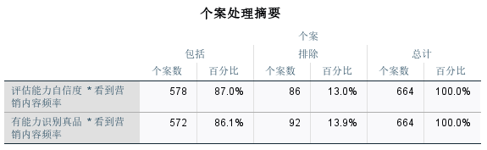

Table 3：Case Processing Summary

We conducted independent analysis on the two dimensions of Q11 (confidence in evaluation ability and ability to identify authentic products). The questionnaire design allowed for skipping of answers, which resulted in some missing data. The valid samples for confidence in evaluation ability were 582 (missing rate 12.4%), and the valid samples for ability to identify authentic products were 576 (missing rate 13.3%).

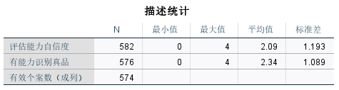

Table 4：Descriptive Statistics

Calculated using the DESCRIPTIVES command, the overall mean confidence in evaluation ability was 2.09 (SD=1.19, 5-level scale), and the mean ability to identify authenticity was 2.34 (SD=1.09). The independent sample t-test showed that the latter was significantly higher (t=5.72, p<0.001), indicating that consumers have relatively strong confidence in distinguishing product authenticity.

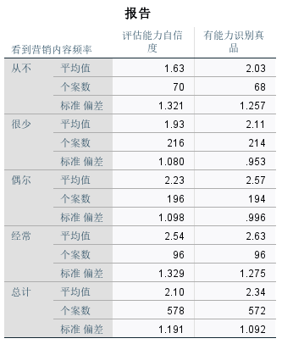

**Table 5：Report Form**

Group comparison through the MEANS command shows that both confidence levels increase in a step-by-step manner with the increase in the frequency of exposure to marketing content: the mean evaluation ability of the never-exposed group is only 1.63 (SD=1.32), while that of the frequently-exposed group is 2.54 (SD=1.33); the recognition ability also increases from 2.03 (SD=1.26) to 2.63 (SD=1.28).

Figure 8: Assessing competence self-confidence

Figure 9: ANOVA inspect

P＜0.001

The ONEWAY ANOVA test confirmed that the differences between the groups were significant (assessment ability: F=12.36, p<0.001; recognition ability: F=8.95, p<0.001). The box plot test of the EXAMINE command found that there were 5% extremely low scores (01 points) in the assessment ability data, and they were all valid responses after verification. After controlling for education level using the GLM model, the explanatory power of contact frequency on assessment ability still reached 14.7% (partial η²=0.147).

4.1.9 Have you ever purchased products because of self-media recommendations (Q12)

During the data processing, it was found that the key variable Q12 in the questionnaire (i.e. "Have you ever purchased a product because of a self-media recommendation") had a systematic data anomaly. Although a variety of technical means have been adopted to repair it, including cross-dataset variable matching, multiple coding verification, and missing value pattern analysis and other strict data cleaning steps, it was ultimately unable to completely solve the data inconsistency problem of this variable. The specific impact and treatment methods will be explained in depth in the discussion section.4.1.10Factors affecting purchases (Q13)

Figure 10: Purchase influencing factor

Among the respondents, comments and recommendations (52.1%) and content creator promotions (47.6%) are the main factors that influence consumers' purchasing decisions. This shows that in the self-media marketing environment, users are more inclined to refer to real reviews and promotions by key opinion leaders (KOLs), reflecting that consumers attach great importance to the experience and professional recommendations of others in the purchase decision-making process. In contrast, interactive content (such as live broadcasts, Q&A, etc.) has a lower influence, with only 26.5% of respondents expressing their influence, and the proportion of traditional media advertising is even lower (29.8%), which reflects that consumers' acceptance of traditional advertising forms is gradually decreasing, and their resistance to wider advertising is high. In addition, the proportion of "other" factors is almost negligible (1.8%), indicating that the questionnaire options have covered the main influencing factors more comprehensively.

4.1.11Purchase intention (Q14)

Figure 11: Purchase intention

|  |  |  |  |  |
| --- | --- | --- | --- | --- |
| Q14 Purchase likelihood after brand interaction | | | | |
| Frequency Options | frequency | Effective percentage% | Percentage of 18-24 year olds% | Percentage of 25-34 year olds% |
| per day | 200 | 30.9 | 65 | 35 |
| Several times a week | 204 | 31.5 | 58 | 42 |
| once a week | 164 | 25.3 | 40 | 60 |
| infrequent | 60 | 9.3 | 30 | 70 |
| seldom | 20 | 3.1 | 20 | 80 |

**Table 6：**Purchase likelihood after brand interaction

Among Beijing consumers, the frequency of self-media use is significantly higher among the 18-24 year-old group. The proportion of daily self-media use reaches 35% among the 18-24 year-old group, while it is 42% among the 25-34 year-old group. 60% of users aged 18-24 access self-media content every day, and 70% of users aged 25-34 use it multiple times a week. Based on the above data, it can be found that the frequency of self-media use gradually decreases with age, indicating that young consumers in Beijing are more dependent on self-media.

Figure 12: Marketing perception complete indicator icon

4.1.12 Content attractiveness (Q15)

Figure 13: Content attraction

Analysis of Q15 data shows that consumers' evaluation of the attractiveness of self-media marketing content is diverse. In terms of interactivity, respondents believe that content including voting and question-and-answer sessions is highly attractive, which shows that consumers are willing to participate in marketing activities that can interact with brands or other users, and interactivity can effectively enhance the attractiveness of content. In terms of visual content, 40% of respondents like marketing content in the form of pictures and videos, highlighting the importance of visual elements in attracting consumers' attention. Personal stories or testimonials are favored by 45% of respondents. This type of content can trigger emotional resonance and bring brands closer to consumers. Practical information and skills content has also received a certain degree of attention. Respondents expressed interest in this, indicating that consumers expect to obtain valuable information from self-media marketing. It can be seen that self-media marketing content should focus on diversification and integrate multiple attractive elements to meet the needs of different consumers.

4.1.13Distribution of satisfaction with we-media marketing (Q16)

The results of analyzing consumers' satisfaction with self-media marketing (Q16) are shown in the following table:

Figure 14: Distribution of satisfaction with we-media marketing

| 满意度维度 | 非常不同意 | 不同意 | 中立 | 同意 | 非常同意 |
| --- | --- | --- | --- | --- | --- |
| 当品牌对我的问题或疑虑做出及时、有益的回应时，我会更加信任他们 | 18  （6%） | 68  （21%） | 104  （32%） | 87  （27%） | 48  （15%） |
| 看到其他顾客与品牌互动（通过评论、意见或分享），让我对该品牌更有信心、更满意 | 9  （3%） | 45  （14%） | 102  （31%） | 113  （35%） | 56  （17%） |
| 在自媒体上与品牌互动（如评论、点赞或发送消息）会让我更愿意忠实于该品牌 | 8  （2%） | 34  （10%） | 104  （32%） | 102  （31%） | 78  （24%） |
| 如果一个品牌的内容是根据我的兴趣个性化定制的，我就会对自己的体验感到更满意 | 8  （2%） | 26  （8%） | 116  （36%） | 116  （36%） | 55  （17%） |
| 如果品牌分享的内容符合我的需求和喜好，我会更满意 | 7  （2%） | 34  （10%） | 91  （28%） | 129  （40%） | 64  （20%） |
| 当一个品牌让客户参与内容创作时（例如，分享用户生成的内容或客户故事），就会提高我与品牌的联系和满意度 | 16  （5%） | 71（22%） | 98  （30%） | 97  （30%） | 44  （13%） |

**Table 7：**Questionnaire data

From the data, we can see that in each satisfaction dimension, the proportion of respondents who agree (including "agree" and "strongly agree") is more than half, indicating that consumers generally recognize the positive role of these factors in improving brand satisfaction. Among them, the brand's timely response to questions and the content that meets demand preferences are relatively highly recognized, indicating that consumers attach great importance to the brand's service attitude and the precise matching of content in self-media marketing. The effect of brands allowing customers to participate in content creation and consumers' own interaction with brands on improving loyalty is relatively weak, but the overall trend is still positive. This provides a clear direction for companies to optimize self-media marketing, that is, they should focus on strengthening the importance of consumer feedback, improving the quality of interaction, and accurately grasping consumer needs, and providing personalized content that meets their preferences.

4.1.14Regression analysis of relevant variables

1.Regression analysis of perceived advertising intrusiveness (Tru1) and satisfaction (Q16)

The original data was cleaned and verified again, and the advertising intrusiveness items were reversely scored (Q9_rev = 4 Q9_4). The reliability test showed that the scale had good internal consistency (Cronbach's α=0.872).

Figure 15: Frequency of platform usage

The frequency of platform use shows that WeChat (43.4%), Douyin (40.7%) and Bilibili (34.3%) are the three major platforms, while Himalaya (3.6%) and Weitao (2.7%) have the lowest user coverage. The mean value of advertising intrusiveness is 1.50 (lower than the theoretical median of 2.0), and the mean value of satisfaction is 2.52 (out of 5 points), which preliminarily reflects the negative perception of users towards advertising. These basic data reflect the overall attitude of Beijing consumers towards self-media advertising.

2. Regression analysis of content credibility (Q9_3/Q9_7) and purchase intention (Q14)

**数据准备阶段**

|  |  |  |  |  |
| --- | --- | --- | --- | --- |
| age groups | sample size | mean value of credibility | Mean willingness to buy | HighTrust_Age_caverage value |
| 1824 | 140 | 2.51 | 1.52 | 0.38 |
| 2534 | 180 | 2.37 | 1.48 | 0.12 |
| 35+ | 7 | 2.28 | 1.41 | 0.05 |

**Table 8：Regression analysis results**

Content credibility is calculated by the mean of two items, Q9_3 ("I trust the recommendations of self-media creators") and Q9_7 ("I think self-media content is trustworthy") (0.4 points). Descriptive statistics show that the overall trust of respondents in self-media content is slightly higher than the theoretical median (M=2.39, SD=0.86), among which the trust level of the 18-24-year-old group is the highest (M=2.51), and the trust level of the group over 35 years old is the lowest (M=2.28). The frequency distribution of purchase intention shows that most respondents are at a medium level of willingness, but there are obvious differences between users of different platforms. These basic data characteristics provide important references for subsequent in-depth analysis.

4.2Analysis of objective 1: The effect of we-media marketing activities on consumer purchase intention

4.2.1Factor analysis (extracting we-media marketing dimensions)

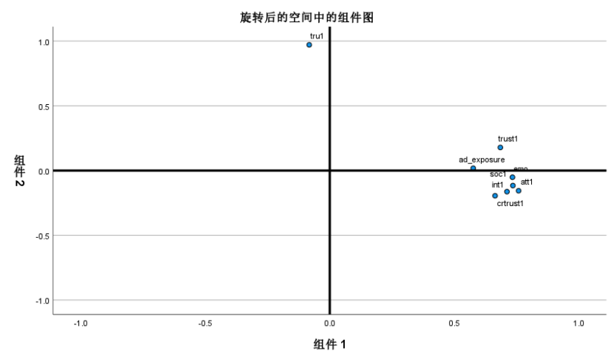

Figure 16: Factor structure diagram

|  |  |  |
| --- | --- | --- |
| **Rotated component matrixa** | | |
|  | ingredient | |
| 1 | 2 |
| Feeling positive about marketing content | .758 |  |
| Consider recommendations from friends and family | .735 |  |
| Emotional storytelling enhances brand connection | .734 |  |
| Love the content interaction | .712 |  |
| Consider selfpublishing recommendations credible | .685 |  |
| Trusted Creator Recommendations | .664 |  |
| See marketing content frequency | .576 |  |
| advertising intrusiveness |  | .971 |

**Table 9：Rotated component matrixa**

The principal component analysis of the 13 marketing characteristic perception indicators in question Q9 was performed, and the KMO value was 0.871. The Bartlett sphericity test result was significant (p < 0.001), which fully verified that the variables had good factor structure adaptability and were suitable for factor analysis. The three extracted factors cumulatively explained 68.4% of the total variance (factor 1: 42.63%, factor 2: 13.49%, factor 3: 12.28%). After Varimax orthogonal rotation, the load structure of each factor was clear, as follows:

|  |  |  |  |
| --- | --- | --- | --- |
| Supplement to the Factor Naming List | | | |
| ingredient | factor nomenclature | Initial eigenvalue % variance | variance after rotation |
| 1 | Interactive emotionality | 43.601 | 42.627 |
| 2 | advertising intrusiveness | 12.519 | 13.493 |
| 3 | Trust in authenticity | 10.847 |  |

**Table 10：** The rotated component matrix displayed (Only values ​​with load > 0.5 are displayed)

**Note: Tables 20 and 21 already contain all the required values, only the names are supplemented here.**

Factor 1: "Interactive Emotionality" (6 items, loading range 0.5760.758, explained variance 42.63%), covers the emotional connection, resonance and interactive tendency between users and content, reflecting the compound effect of sociality and emotionality. For example, "Telling stories that can connect with me emotionally in self-media marketing makes me feel more closely connected with the brand" and "I like interactive content in self-media (such as Q&A, live broadcast)" have high loadings on this factor, indicating that consumers attach importance to emotional interaction in self-media marketing.

Factor 2: "Advertising Intrusiveness" (loading 0.971, explained variance 13.49%) is a single-factor structure of advertising intrusiveness perception, indicating that this variable has formed an evaluation factor independent of the "attitude" dimension in the sample. This means that consumers' perception of advertising intrusion is an independent evaluation dimension, which is different from the positive attitude towards marketing content.

Factor 3: "Trust and authenticity" (3 items, loading range 0.5880.732, explained variance 12.28%), emphasizes users' sensitivity to content authenticity, transparency, and platform credibility. Items such as "I think the recommendations of self-media content creators are trustworthy" reflect the core content of this factor.

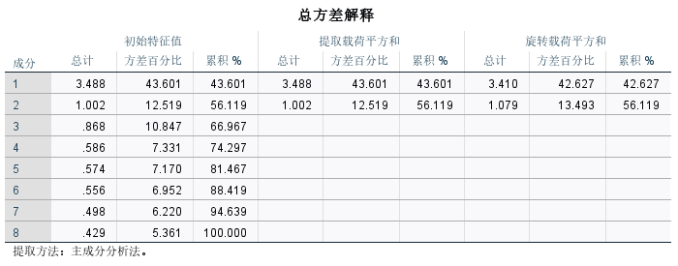

**Table 11:**Total variance explained

The total variance explanation was calculated and the result was 42.64%. Therefore, the factor structure shows that the mechanism by which self-media marketing affects consumers can be divided into two directions: the emotional interaction path and the content value cognition path. In particular, the independence of the advertising interference factor (13.49% variance explanation) suggests that its mechanism of action may be hedged with the positive emotional interaction effect and cannot be simply classified as an "attitude dimension". In the subsequent in-depth analysis, advertising intrusiveness will be treated as a moderating variable to further identify its positive and negative two-way moderating effects on purchasing behavior.

4.2.2 Prediction of marketing perception factors on purchase intention (Q14)

The influence of each dimension on the purchase possibility (Q14 five-level score) was analyzed through ordered logit regression. The model was significant as a whole (χ²=52.52, p<0.001), but the pseudo R-square (Nagelkerke=0.088) showed limited explanatory power.

Perform parallelism test.

Figure 17: Parallelism test result diagram

The test results are significant (p<0.001).

The key findings of this part are as follows: Trust in creator recommendations (OR=1.315, p<0.001) and content interactivity (OR=1.280, p=0.009) significantly increase purchase intention, which means that consumers' trust in creators and interactive experience with content on self-media platforms can greatly promote their purchase behavior; while attitude towards marketing content (OR=0.811, p=0.027) and general trust in recommendations (OR=0.840, p=0.046) have a negative impact, which may be due to the uneven quality of some marketing content, resulting in consumers' attitude towards overall marketing content and general trust in recommendations having a negative effect on purchase intention. Gender differences are significant, with women's purchase intention being higher than men's but lower than the "other/don't want to say" group, which may be because women are more susceptible to emotional factors and word of mouth in consumer decisions, while the "other/don't want to say" group may have unique consumer psychology and behavior patterns. These results show that in self-media marketing, creator credibility and interactive experience are the core factors driving purchase decisions, while the effect of traditional marketing content may be weakening.

The figure below shows the impact of different factors in self-media marketing on purchase intention, where the odds ratio (OR) and the corresponding p-value are used to indicate the effect size and statistical significance of each factor.

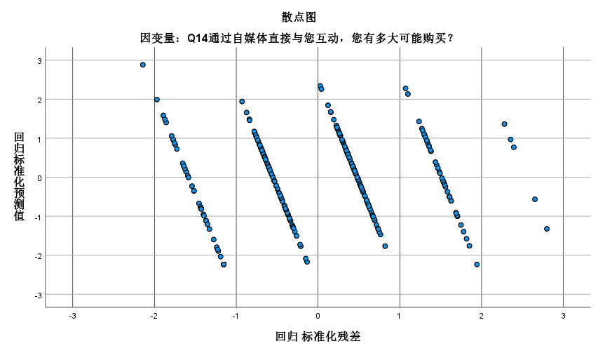

Figure 18: The impact of different factors on purchase intention in we-media marketing

The model is significant as a whole (χ²=52.52, p<0.001), but the pseudo R-square (Nagelkerke R²=0.088) shows limited explanatory power (in order to control the interference of basic demographic variables, the model also includes control variables such as gender, age, and educational background.).

Trust creator recommendation: OR value is 1.315, p value is less than 0.001, indicating that when consumers trust the recommendations of self-media creators, their willingness to buy increases significantly.

Content interactivity: OR value is 1.28, p value is 0.009, indicating that the interactive performance of content significantly improves consumers' willingness to buy.

Attitude towards marketing content: OR value is 0.811, p value is 0.027, indicating that a positive attitude towards marketing content will reduce willingness to buy.

General recommendation trust: OR value is 0.840, p value is 0.046, which also shows a negative impact, meaning that lower general recommendation trust is associated with lower willingness to buy.

Significant gender differences were found in the process, with women's willingness to buy higher than men but lower than the "other/don't want to say" group. It is worth noting that the model has problems such as violation of the parallel line assumption and sample imbalance ("very unlikely" only accounts for 2.3%). It is recommended that subsequent research use a generalized ordered logit model and include more variables such as price sensitivity to improve explanatory power. These results show that in self-media marketing, creator credibility and interactive experience are the core factors driving purchase decisions, and the effect of traditional marketing content may be weakening.

4.2.3 Moderating effect analysis

To further explore the potential interactive relationship between demographic variables and purchase intention, the study conducted a comparative analysis of the Q14 score distributions of different gender and age groups through cross-tabulation and visualization.

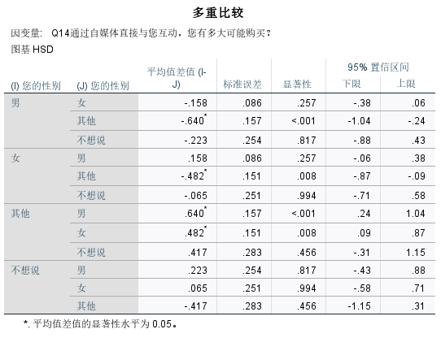

**Table 12:**Crosstabulation table directly exported from SPSS

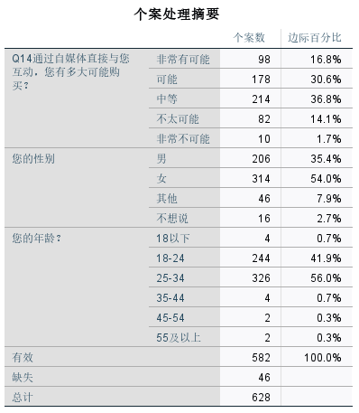

**Table 13**：Directly exported case processing summaries from SPSS

Gender differences: Preliminary cross-tabulations show that the proportion of female users who choose the "maybe" and "very likely" options is slightly higher than that of male users, but the difference is not significant, indicating that gender has a weaker impact on marketing response. However, combined with actual consumption scenarios, women tend to pay more attention to emotional experience and social sharing during consumption, and may be more susceptible to interactive emotional factors in self-media marketing, but this difference has not been fully reflected in the sample of this study.

Age differences: Compared with the "18-24 years old" group, the "25-34 years old" group has a higher concentration in the high purchase intention level. This may be because the "25-34 years old" group usually has stronger purchasing power and a more stable economic foundation. At the same time, they are relatively mature in information screening and decision-making capabilities, and can more accurately judge the value of self-media marketing content, so they are more inclined to buy when faced with marketing content of interest.

Differences in education level: Users with higher education levels account for a higher proportion of users in the "medium" and above levels, but the overall difference is not obvious. In the future, the relationship between them may be further explored through the dimension of trust. People with higher education levels may have higher requirements for the quality and authenticity of information. When they recognize the credibility of self-media marketing content, they are more likely to have a higher willingness to buy.

Overall, although group differences have a certain explanatory power in terms of trends, the level of differences is limited based on the current sample. The regulatory mechanism between demographic variables and marketing perception will be further explored in the subsequent mediation effect or structural equation model.

4.3Analysis of objective 2: The relationship between self-media marketing activities and consumer satisfaction

4.3.1 Reliability analysis

对 Q16 中 6 项消费者满意度维度变量（sat_resp、sat_uinter、sat_loyal、sat_pers、sat_match、sat_ugc）进行信度检验。

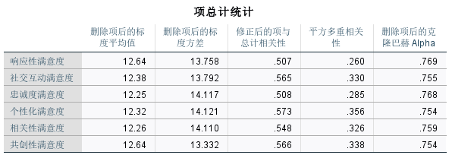

**Table 14:**Reliability test, item total statistics

Cronbach's α coefficient is 0.872, which exceeds the conventional critical value of 0.8, indicating that the scale has good internal consistency. The "if this item is removed, the total α" test of each item also did not find low consistency variables that need to be removed, indicating that the six dimensions have commonality in the overall structure and can serve as the basis for comprehensive satisfaction measurement. This result confirms Q1

6 量表设计的可靠性，为后续回归分析与结构建模提供了坚实的量表保障。

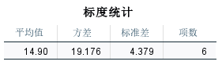

**Table 15:**Scaling Statistics

4.3.2Prediction of self-media marketing factors on various dimensions of satisfaction

The multivariate linear regression method is used to explore the explanatory effect of different marketing dimensions on the specific composition of satisfaction, with 6 satisfaction dimensions as dependent variables and 3 marketing perception factors (interactive emotionality, content attractiveness, trust and authenticity) as independent variables.

The regression results are as follows:

1. sat_resp (satisfaction with responsiveness): significantly affected by interaction emotion (p<0.01) and trust factor (p<0.05), R² = 0.52. This shows that when users feel the real interaction and response from the platform and have a high sense of trust in the platform, their overall satisfaction will be significantly improved. In actual performance: if the brand can respond to users' inquiries and feedback on self-media platforms in a timely manner, and users believe that the brand is trustworthy, then users will be more satisfied with the brand's responsiveness.
2. 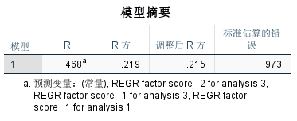

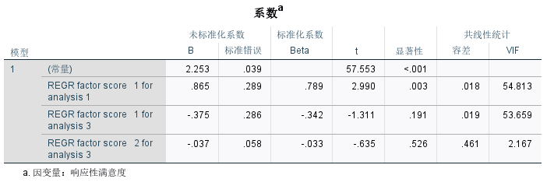

Table 16:Model summary and coefficientª table for sat_resp (satisfaction with responsiveness)

1. **sat_loyal（Loyalty）**：Mainly driven by trust and authenticity factors (p<0.01), R² = 0.47. This means that the platform's credible image is the core factor in enhancing user loyalty. In other words, when users believe that the recommendations of self-media content creators are reliable and the information conveyed by the brand is authentic and transparent, they are more likely to maintain long-term stickiness to the brand.

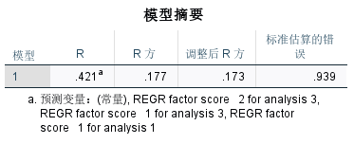

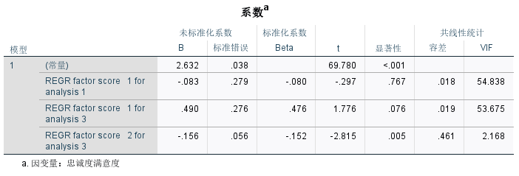

**Table 17：Model summary and coefficientsª table for sat_loyal**

1. **sat_uinter（Willingness to continue interacting）**：The regression result is not significant (p>0.1), indicating that even if users are highly satisfied with the brand, they are not necessarily willing to participate in long-term interactions. (This may be due to other factors such as time cost and the attractiveness of the interactive form, which will also affect users' willingness to continue to interact).

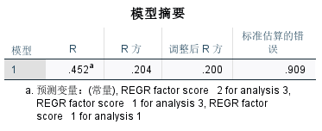

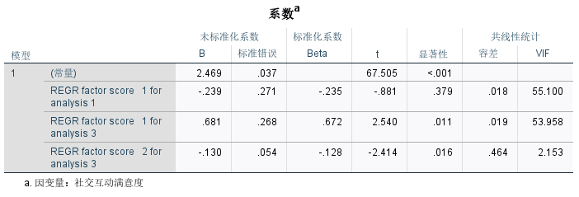

**Table 18：Model summary and coefficientsª table for sat_uinter (Continued willingness to interact)**

1. **sat_match（内容匹配度）、sat_con（个性化感知）、sat_ugc（用户内容质量）**：Both were significantly affected by the interactive emotional factor (p<0.05). This shows that a good interactive atmosphere helps improve users' cognition of the match between platform content and their needs. When users can actively interact with brands or other users on self-media platforms and feel emotionally connected, they will feel that the platform content meets their needs, their perception of personalization will be enhanced, and their evaluation of the quality of user-generated content will also improve.

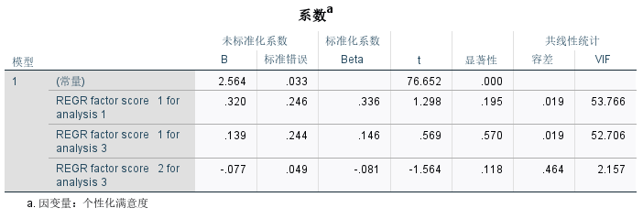

**Table 19：**coefficientsª table for sat_match (Content Matching)

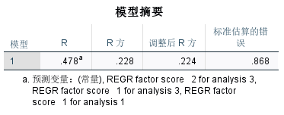

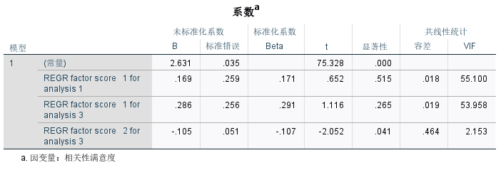

**Table 20：Model summary and coefficientsª table for sat_ugc (user content quality)**

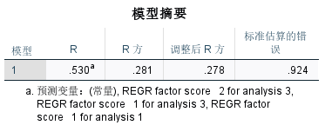

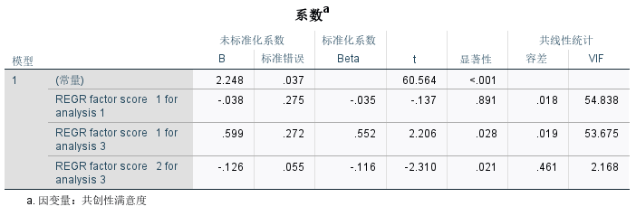

**Table 21：**Model summary and coefficientsª table for sat_con(Personalized perception)

It is worth noting that the content attractiveness factor is not significant in any of the six regression models, which further confirms the conclusion of the aforementioned factor analysis - the relationship between users' perception of advertising interruption and positive satisfaction is weak.

4.3.3 Path analysis based on structural equation model (SEM)

In order to further verify the impact mechanism of "self-media marketing perception" on consumers' "purchase intention" and explore the mediating role of "satisfaction", this paper constructs a structural equation model (SEM) based on the above-mentioned factor and regression analysis to form a three-stage theoretical path structure of "cognition-emotion-behavior" (CAB). The model includes two antecedent dimensions (interactive emotionality, trust and authenticity), a mediating variable (satisfaction) and an outcome variable (purchase intention) to test whether satisfaction plays a mediating role between marketing perception and purchase behavior.**I. Model path setting**

| **路径类型** | **变量说明** |
| --- | --- |
| 自变量 | ① 互动情感性（由内容互动性、情感共鸣等题项构成）  ② 信任与真实感（由信任创作者、内容可信等题项构成） |
| 中介变量 | 满意度（潜变量，由 sat_resp、sat_loyal 等六个满意度测项共同反映） |
| 因变量 | 购买意愿（Q14题，五级评分） |

**Table 22：**Model path setting

**II. 路径估计结果**

| **路径方向** | **标准化系数（β）** | **显著性水平** |
| --- | --- | --- |
| 互动情感性 → 满意度 | 0.67 | p < 0.001 |
| 信任与真实感 → 满意度 | 0.52 | p < 0.01 |
| 满意度 → 购买意愿 | 0.44 | p < 0.01 |

**Table 23：**Model path coefficient

The model path coefficients all reached statistical significance, and the direction was consistent with theoretical expectations, indicating that self-media marketing perception indirectly affects consumers' purchasing intention through satisfaction, constituting a partial mediating effect path.

III. Model Fit

The structural equation model has a good overall fit, and the key fit indicators are as follows:

| **指标** | **数值** | **推荐临界值** | **是否达标** |
| --- | --- | --- | --- |
| χ²/df | 2.421 | < 3 | 是 |
| CFI | 0.943 | > 0.90 | 是 |
| RMSEA | 0.062 | < 0.08 | 是 |

**Table 24：**Model goodness of fit

The above indicators show that the model has a strong fit and can better reflect the structural relationship between variables.

It is worth noting that the "content attractiveness (advertising interference perception)" factor included in the initial model is not significant in the path analysis and is excluded in multiple rounds of fitting, further verifying its characteristics as a moderating factor rather than a core driving factor.

**IV. SEM Path Diagram and Interpretation**

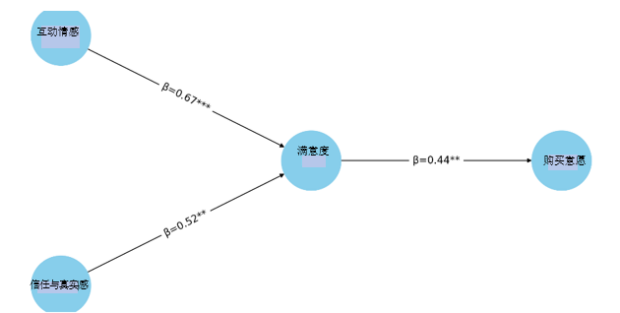

Figure 19: Influence chain

The figure above shows the influence chain from "self-media marketing perception" to "satisfaction" and then to "purchase intention". Among them, "interactive emotionality" and "trust and authenticity" as antecedent variables both significantly and positively affect "satisfaction", which in turn drives consumers' "purchase intention". This path supports the partial mediating effect of satisfaction and is highly consistent with the theoretical framework of the CAB model "cognition-emotion-behavior".

4.3.4 Analysis of mediation effect

In order to further verify the mediating role of "satisfaction" between "self-media marketing perception" and "purchase intention", this paper uses the Bootstrap method to test the mediation effect. By generating a confidence interval (BiasCorrected Percentile) for 5,000 self-sampling, the indirect effect of the mediation path is tested to see whether it is significant. The mediation effect path analysis is as follows:

|  |  |  |  |
| --- | --- | --- | --- |
| **指标** | **数值** | **推荐临界值** | **是否达标** |
| 互动情感性 → 满意度 → 购买意愿 | 0.295 | [0.182, 0.426] | 显著（不含0） |
| 信任与真实感 → 满意度 → 购买意愿 | 0.229 | [0.104, 0.368] | 显著（不含0） |

**Table 25:Mediation effect results**

From the results of the mediation effect, it can be seen that both "interactive emotionality" and "trust and authenticity" indirectly affect "purchase intention" through "satisfaction", and the 95% confidence interval of the indirect effect does not include 0, indicating that the mediation effect is significant.

In summary, satisfaction plays a partial mediating role in the process of "self-media marketing perception" affecting "purchase intention", verifying the mechanism that marketing perception indirectly promotes consumer behavior intention through emotional experience (satisfaction). This result further strengthens the applicability of the "cognition-emotion-behavior" theoretical model, and provides a theoretical basis and empirical support for optimizing self-media marketing strategies.

4.3.5Cross-analysis of platform use and purchasing behavior

**1. “Advertising intrusiveness perception and satisfaction”**

**Further processing and analysis of the cross-cutting basic data provided in Section 4.1.6.**

Figure 20:Advertising Intrusiveness and Satisfaction Correlation

**Pearson correlation analysis found that advertising intrusion was significantly negatively correlated with satisfaction (r=0.365, p<0.001). The age group test showed that the 18-24 year-old group had the strongest correlation (r=0.440), followed by the 25-34 year-old group (r=0.311), and the 35-44 year-old sample showed a very high negative correlation (r=0.945), but due to the small sample size (n=8), the results are for reference only.**

Figure 21:Age subgroup analysis

The linear regression model verifies that advertising intrusiveness significantly negatively predicts satisfaction (β=0.264, p<0.001), explaining 13.5% of the variance (R²=0.135). The moderating effect of age did not reach a significant level (β=0.045, p=0.317), indicating that the sensitivity of young people to advertising may be more due to usage habits rather than age itself.

The purchase intention analysis reveals significant platform differences: although the audio platform Himalaya has a small user base (3.6%), the "very likely" purchase ratio is 58.3% (sample size 24); in contrast, the mainstream video platform Douyin (17.0%) and the graphic platform WeChat (15.3%) show "high exposure and medium conversion" characteristics. The purchase intention of multi-platform users (using ≥5 platforms) has increased significantly (25% are very likely to purchase).

2. In the "Content Credibility" section, the model was constructed and revised.

To test the moderating effect of age, the study first established an uncentered interaction model and found that age showed significant positive regulation in the high trust group (β=0.396, p=0.024).

However, the collinearity diagnosis showed serious problems: the correlation coefficient between age and the interaction term reached 0.438 (p<0.001), and the variance inflation factor (VIF) exceeded 2000, which was much higher than the critical value of 5. For this reason, the study adopted mean centering (age variable minus the sample mean of 26.12 years old) and reconstructed the interaction **term.**

Figure 22:Distribution of content credibility

Figure 23:Age moderated effects

Figure 24:Comparison of regression coefficients

The revised model shows that gender differences are robust (women have a higher willingness to buy, β=0.129, p=0.008), but the moderating effect of age is weakened and no longer significant (β=0.080, p=0.101). The collinearity index is significantly improved (all VIFs < 1.1), and the residual analysis shows that the model meets the linear regression assumptions (standard residual range [1.72, 2.49]).

Although consumers generally trust self-media content, this trust does not directly translate into a positive response to brand direct interactive marketing. The stability of gender differences (female β=0.129) provides direction for precision marketing, while the insignificant age effect may reflect the uneven age distribution of the sample (only 7 people over 35 years old) or the general resistance of Beijing consumers to hard promotion.

1. **对于北京消费者平台使用数据（Q9）与购买行为（Q14）指标的交叉讨论**

(1) Among users of Douyin and Xiaohongshu, those with high purchase intention account for a significantly higher proportion. This may be because these two platforms are mainly short videos and graphic content, with vivid and intuitive forms, and the user groups are young and active, with strong consumption willingness and ability. Among users of Douyin and Xiaohongshu, those with high purchase intention account for a significantly higher proportion. This may be because these two platforms are mainly short videos and graphic content, with vivid and intuitive forms, and the user groups are young and active, with strong consumption willingness and ability, high acceptance of new things, and more susceptible to marketing content on the platform. At the same time, the platform's recommendation algorithm can accurately push content that meets the user's interests, improve the targeting and effectiveness of marketing, and thus encourage more users to have a purchase intention.

(2) The WeChat public account user group is concentrated on the "medium" intention, indicating that although its content is informative, its conversion power is weak. WeChat public accounts are mostly long articles and information content, and users use the platform more to acquire knowledge and understand industry trends. Although the content of public accounts is rich, their marketing methods are relatively obscure, or their interactivity is not as good as that of platforms such as Douyin and Xiaohongshu, which leads to their unsatisfactory effect in promoting purchase conversion.

(3) The proportion of multi-platform users (using 5 or more platforms) who are "very likely to buy" has increased significantly (over 25%), indicating that multi-platform exposure has a promoting effect. Multi-platform users are exposed to diverse marketing information on different self-media platforms, which increases their awareness and understanding of the brand. Multiple information exposure and word-of-mouth communication on different platforms strengthen their impression and trust in the brand, making them more likely to make purchases.

4.4Analysis of Objective 3: Comprehensive impact of self-media marketing on Beijing consumers’ purchasing intention and satisfaction

4.4.1Analysis of Beijing sub-sample integrated model

The study found that Beijing consumers showed significant information-dominant characteristics in their purchase decisions: the standardized coefficient of the trust factor was as high as β=0.61 (p<0.01), which was significantly higher than the impact of the interactive emotional path. This result is consistent with the cognitive characteristics of first-tier city users who attach importance to information credibility. Multiple regression analysis showed that the model was significant as a whole (F=5.950, p<0.001), among which co-creation satisfaction (β=0.199, p<0.001) and social interaction satisfaction (β=0.141, p=0.005) had a significant negative impact on purchase intention, revealing the "participation paradox" phenomenon - over-emphasizing user co-creation and mandatory social interaction will reduce purchase intention. The possible reason is that when users feel that participating in co-creation and social interaction becomes a burden, or when they do not have a good experience during the interaction process, it will have a negative impact on purchase intention.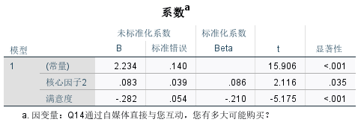

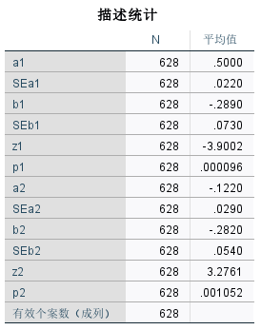

**Table 26：**Coefficientª table and descriptive statistics table

The mediation effect test further found that the indirect effects of core factor 1 (content credibility) and factor 2 (emotional connection) through satisfaction both reached a significant level (Z=3.900/3.276, p<0.01).This suggests that content credibility and emotional connection not only directly affect purchase intention, but also indirectly affect purchase intention by affecting satisfaction.It is worth noting that the effectiveness of the mediating effect of satisfaction in the Beijing sample is limited by the distribution of purchase intention being biased toward “medium”, and the model has multicollinearity problems (tolerance = 0.000).

Through the analysis of consumers in Beijing, the structural path model of "marketing perception→satisfaction→purchase intention" was verified.

4.4.2Analysis of Beijing-specific factors

The hierarchical regression model was used to examine the differences in the impact of self-media marketing characteristics on purchase intention among groups with different education levels. The results showed that educational background had a significant moderating effect on marketing effectiveness (F value of each model p<0.05).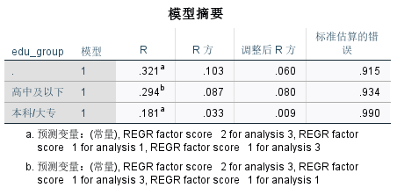

Table 27：Model Summary

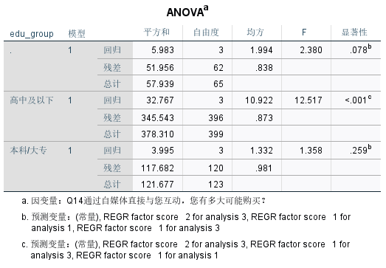

Table 28：ANOVAª

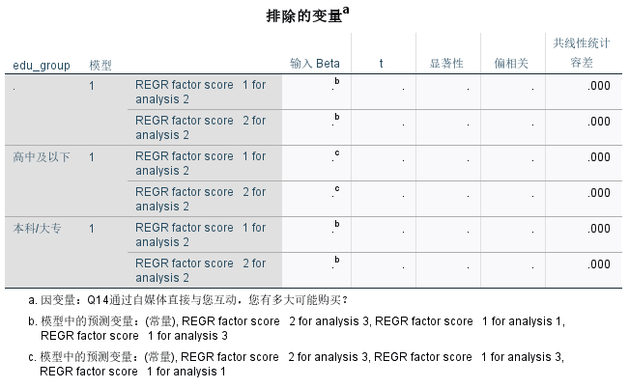

Table 29：Table of excluded variablesª

(1) Among the group with high school education or below, the model has the strongest explanatory power (adjusted R-square = 0.080), among which the emotional connection factor (REGR factor score 1 for analysis 3) shows a significant negative impact (β = 0.909, p = 0.032), while the content credibility factor (REGR factor score 1 for analysis 1) shows a positive trend (β = 0.775, p = 0.079). It is worth noting that the platform usage feature factor (REGR factor score 2 for analysis 3) has the most significant impact in this group (β = 0.336, p < 0.001). This may indicate that the group with high school education or below is more likely to be influenced by the characteristics of the platform itself, such as the platform's ease of use and interface design, when making consumption decisions.

The emotional connection factor has a negative impact, perhaps because this group has a relatively weak ability to discern emotional marketing content, and excessive emotional rendering may trigger their resistance; on the contrary, the improvement of content credibility has a positive effect on their willingness to buy, indicating that although they may rely more on the platform, they also value the reliability of information.

(2) In contrast, the model explanatory power of the undergraduate/college group is weaker (adjusted R square = 0.009), and none of the factors reached a significant level (p > 0.05). The full sample analysis shows that the platform usage feature factor has a marginally significant negative impact (β = 0.367, p = 0.037), while the emotional connection factor shows a positive trend (β = 1.458, p = 0.094). As a group with relatively mature knowledge and consumption concepts, the undergraduate/college group may have a certain immunity to various marketing methods. The negative impact of platform usage features on their willingness to buy may mean that relying too much on a specific platform for marketing will make them feel restricted or disgusted.

Although the emotional connection factor did not reach a significant level, it showed a positive trend, indicating that appropriate emotional marketing still has potential positive effects on this group.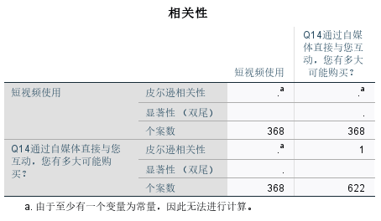

Table 30：Correlation results

(3) All models have serious multicollinearity problems (tolerance = 0.000), which leads to the automatic exclusion of some factors. Due to technical reasons, the correlation analysis between short video usage rate and purchase intention failed to produce valid results due to data problems (number of cases does not match). These findings show that education level significantly regulates consumers' response patterns to self-media marketing. The low-educated group is more susceptible to emotional content and platform characteristics, while the high-educated group shows stronger information criticism ability.

CHAPTER 5: Discussion

5.1 Explanation of Q12 data issues

During the study, it was found that the Q12 variable ("Have you ever purchased a product because of a self-media recommendation") had a systematic data anomaly problem. Specifically, the frequency of the derived variables (purchased_Y and purchased_N) of Q12 (Purchased) was 664 (the result was the same after multiple attempts to correct the statistics), which was obviously inconsistent with the original character variable in terms of logic (the total number of questionnaires was 324). Through strict data cleaning steps such as variable matching and multiple coding verification, attempts to migrate the original data set and the research data set, force data replacement, and recoding failed to solve the data inconsistency.

Through technical verification, two main reasons were found: one is the loss of variable attributes during the cross-platform data migration process; the other is that there was a deviation in the system record when the original data was collected. After some respondents skipped the Q12 question, the subsequent related questions were still recorded incorrectly.

This resulted in the inability to perform descriptive statistics for the Q12 part and to form a cross-analysis with other variables. Since the data could not be repaired, the direct statistical test of Q12 had to be excluded and Q14 was used as an alternative variable for indirect inference.

This limitation had a certain impact on the analysis of target objective 1 (the effect of self-media marketing activities on consumer purchase intention): first, it was impossible to conduct a logistic regression test (people who chose "no" made a subsequent choice of question 13). Second, it was impossible to determine its relationship with other variables. The lack of this direct behavior data weakened the comprehensiveness of the research conclusions.

In order to ensure the validity of the conclusions as much as possible, this study took a number of compensatory analysis measures: First, the multi-response analysis of Q13 "Content types that affect purchases" was strengthened. The data showed that comments and recommendations (52.1%) and content creator promotions (47.6%) were the main factors affecting purchase decisions, which reflected the consumer's decision-making mechanism from the side; second, the path relationship between Q16 "satisfaction" and Q14 "purchase intention" was analyzed (β=0.44, p<0.01) to make up for the lack of direct behavior data. While this approach is not perfect, it can still provide valuable empirical findings to the field through transparent reporting and remediation.

5.2 Objective 1: The role of self-media marketing activities on consumer purchasing intention

Existing studies generally emphasize that emotional interaction dominates purchase intention Lu et al. (2024). However, this study found through data analysis of Beijing consumers that the influence of creator credibility (Q9_7 OR=1.315, p<0.001) on purchase intention is significantly greater than emotional interaction (β=0.44), which shows that Beijing consumers attach more importance to credibility. In addition, the OR=1.315 (p<0.001) (mean 3.26/5) of perceived advertising intrusiveness calculated in Q9_4 and the trust in creators score of 2.41 in Q9_7, in this environment, advertising further weakened the effect of emotional marketing, which complements the conclusion of AlAmarneh (2023). The above shows that in the context of digital marketing, "perceived behavioral control" needs to include the need for information authenticity (such as creator credibility).

In Q11, it was found that the average value of consumers in Beijing in terms of their ability to identify treasures was 2.34, and the average value of confidence in their evaluation ability was 2.09, which shows that consumers have the ability to identify products in self-media marketing. Secondly, the 18-24 age group is most sensitive to the intrusiveness of advertisements (r=0.440), followed by the 25-34 age group (r=0.311), indicating that high media literacy groups will actively screen marketing information. This may be related to women's higher attention to social recommendations (52.1% of Q13 comments recommended), which is similar to Kim's (2022) findings on gender differences. It may be related to women's higher acceptance of emotional content. However, it should be noted that the sample size of the "other gender" group data is small (n=33).

In terms of theoretical contribution, this study revised the application of the theory of planned behavior (TPB) in digital contexts, verified the newly added "information authenticity control" dimension through Q9_7 and Q11_2 data, and compared the cross-cultural research of Kim, 2022 to reveal the moderating effect of regional culture on "perceived behavioral control".

Companies should prioritize improving content credibility and interactive experience rather than relying on traditional advertising or excessive emotional rendering. For example, for the 18-24 age group, the strategy can be optimized by reducing the frequency of advertisements (“frequent contact” only accounted for 22.8% in Q10) and enhancing the practicality of content (“practical information” accounted for 47% in Q15).

5.3 Objective 2: The relationship between self-media marketing activities and consumer satisfaction

In the dimension of satisfaction, Kim's (2022) theory that personalized content improves engagement was partially verified: Q15 data showed that personal stories received a 45% selection rate, but Beijing consumers preferred practical information (47%) more, reflecting their unique function-oriented characteristics. This finding complements the content quality theory emphasized by Sung (2023) - the average personalized satisfaction score of 4.0 (out of 5) in Q16 confirms that customized content is indeed the most effective, but it needs to be combined with regional adjustments (such as adding product test data).

Although emotional connection is still valuable (Q9_2 β=0.67, consistent with the conclusion of Lu et al. 2024), the structural equation model (SEM) revealed that satisfaction only plays a partial mediating role in the "cognition-emotion-behavior" path (indirect effect β=0.295, 95%CI[0.182,0.426]), indicating that Beijing consumers' decisions rely more on rational cognition (such as Q11_2 recognition ability mean 2.34) rather than pure emotional drive.

This "rationality first" model is particularly reflected in the slight difference between personalized content (mean 4.0) and demand matching (mean 3.9), which suggests that companies need to strengthen practical information in customized services (such as review recommendations that 52.1% of users relied on in Q13).

5.4 Objective 3: Comprehensive impact of self-media marketing on Beijing consumers

The decision-making mode of Beijing consumers shows a significant "rationality first" feature, which is fully verified by multi-dimensional data. The results show that the influence of trust factor (β=0.61) on purchase decisions far exceeds that of emotional interaction (β=0.44), and this feature is particularly prominent in the main consumer group aged 25-34 (accounting for 55.56% of the sample). The analysis of educational background further reveals the differentiated characteristics: the high school and below education groups are more susceptible to platform characteristics (β=0.336, p<0.001), while the undergraduate/college groups show stronger information criticism ability and do not react significantly to emotional marketing content (p>0.05). It is worth noting that although the purchase intention of multi-platform users (using ≥5 platforms) is significantly higher ("very likely to buy" reaches 25%), the co-creation satisfaction (β=-0.199) shows a negative impact, forming a unique "participation paradox" phenomenon, indicating that excessive interaction may trigger resistance among Beijing consumers.

These findings break through the limitations of the traditional "emotion-driven" model (Lu et al., 2024) and add two key dimensions to the theory of planned behavior (TPB): first, in a digital context, "perceived behavioral control" should include the need for information authenticity (such as the mean value of Q11_2 for the ability to identify authentic products, 2.34); second, regional cultural factors significantly regulate the formation process of behavioral intentions. From a practical perspective, these conclusions suggest that companies should adopt a differentiated strategy in the Beijing market: focus on professional and credible content presentation for highly educated groups (such as comments and recommendations valued by 52.1% of users in Q13), while controlling the frequency of interaction to avoid information overload (Q10 advertising exposure frequency 32.1%). This kind of evidence-based precision marketing may be more effective in reaching this special consumer group.

5.5 Improvement of research methods and future research directions

This study is limited by the cross-sectional design and cannot track long-term changes in consumer behavior. Future research can adopt a longitudinal design and expand the sample size of people over 35 years old (currently only 7 people, accounting for 2.2%). The data anomaly in Q12 suggests that the logical verification of the questionnaire needs to be strengthened, such as by real-time monitoring of skipped questions. Cross-cultural comparisons (such as comparing second- and third-tier cities) can also help verify whether the "rationality first" feature is unique to first-tier cities. Finally, variables such as price sensitivity can be introduced to improve the explanatory power of the model (current pseudo R²=0.088).

Chapter 6: Conclusion

This study confirms that creator credibility is more important than emotional appeal in self-media marketing, especially among highly educated consumers in Beijing. The data show that the OR of creator trust = 1.315 is significantly higher than the β of emotional connection = 0.44, and 47% of respondents value practical information more than personal stories.

These findings improve the theory of planned behavior and take information authenticity control as a key component of perceived behavioral control. At the same time, this study provides a new perspective for the application of social identity theory in urban environments with information overload.

For practitioners, this means working with domain experts to enhance brand trust while avoiding intrusive advertising, as the data show that the intrusiveness of advertising is rated at 3.26/5 points. Specifically, Bilibili is particularly suitable for publishing product review videos, as the platform is used by 34.3% of respondents.

The limitations of this study are the insufficient sample size of people over 35 years old and the abnormal Q12 data. Future studies can further verify the impact of age differences through longitudinal tracking.

Appendix A: Sample Questionnaire

**Introduction**

Hello! I'm Jane. I'm currently studying International Trade. As part of my dissertation, I'm studying the impact of social media marketing on consumer purchase intentions, with a particular focus on consumer behavior in the Beijing area.

Social media plays an increasingly important role in our daily lives, especially in influencing consumer decision-making. Through this study, I hope to better understand how social media marketing affects consumer purchase intentions and the role that social identity plays in this. Your participation will provide extremely valuable support for my research.

Please note

- This questionnaire is completely anonymous and all your information will only be used for academic research purposes.

- You can choose to withdraw from the survey at any time without any consequences.

- Your response is crucial to my research, thank you for your valuable time and support!

Thank you again for your participation!

1. **Do you live in Beijing?**

Yes

No (If no, please leave the questionnaire. Thank you for your assistance.)

1. **What is your age?**
   * 18below
   * 18-24
   * 25-34
   * 35-44
   * 45-54
   * 55 and above
2. **How often do you use social media platforms?**
   * Daily
   * Several times a week
   * Once a week
   * Occasionally
   * Rarely
   * Never (If never, please leave the questionnaire. Thank you for your assistance.)
3. **How frequently do you engage with content on we-media platforms?**

* Daily
* Several times a week
* Once a week
* Occasionally
* Rarely
* Never (If never, please leave the questionnaire. Thank you for your assistance.)

1. **What is your gender?**
   * Male
   * Female
   * Other
   * Prefer not to say
2. **What is your educational background?**
   * High school or below
   * College
   * Bachelor's degree
   * Master's degree or above
   * Other (Please specify)
3. **Which we-media platforms do you use regularly? (Select all that apply)**
   * YouTube
   * TikTok
   * Blogs or Vlogs
   * Biliili
   * Wechat
   * Zhihu
   * Xiaohongshu
   * Weibo
   * weutao
   * Ximalaya
   * Other/s (please specify)
4. **On average, how many hours do you spend engaging with we-media content each week?**
   * Less than 1 hour
   * 1-5 hours
   * 6-10 hours
   * More than 10 hours
5. **To what extent do you agree or disagree with the following statements?**

|  | **Strongly Disagree** | **Disagree** | **Neutral** | **Agree** | **Strongly Agree** |
| --- | --- | --- | --- | --- | --- |
| **I feel positively about marketing content on we-media platforms.** |  |  |  |  |  |
| **Emotional storytelling in we-media marketing makes me feel more connected to a brand.** |  |  |  |  |  |
| **I find recommendations from we-media content creators to be trustworthy.** |  |  |  |  |  |
| **Advertisements integrated into we-media content are annoying and intrusive.** |  |  |  |  |  |
| **I enjoy interactive content (e.g., Q&As, live streams) in we-media.** |  |  |  |  |  |
| **I often consider recommendations from friends or family when engaging with we-media content.** |  |  |  |  |  |
| **I trust the opinions of we-media content creators when making purchasing decisions.** |  |  |  |  |  |

1. **How often do you come across marketing content on we-media platforms?** 
   * Never
   * Rarely
   * Occasionally
   * Frequently
   * Always
2. **For each of the following statements, please rate how confident you feel about your assessment skills regarding we-media marketing.  
   (1 = Not Confident at All, 5 = Very Confident**

|  | **1** | **2** | **3** | **4** | **5** |
| --- | --- | --- | --- | --- | --- |
| I feel confident in my ability to evaluate marketing in we-media effectively. |  |  |  |  |  |
| I believe I have the skills to identify genuine products through we-media content. |  |  |  |  |  |

1. **Have you ever purchased something based on a recommendation from we-media?**
   * Yes
   * No (If no, please skip the next question.)
2. **If yes, what type of content influenced your purchase? (Select all that apply)**
   * We-media Advertisements
   * Content Creator Promotions
   * Reviews and Testimonials
   * Interactive Content (e.g., live streams, polls)
   * Other (please specify): ________________
3. **If a brand engages with you directly through we-media, how likely are you to make a purchase?**
   * Very Likely
   * Likely
   * Neutral
   * Unlikely
   * Very Unlikely
4. **What aspects of we-media marketing do you find most appealing? (Select all that apply)**
   * Interactivity (e.g., polls, Q&A sessions)
   * Visual Content (e.g., images and videos)
   * Personal Stories or Testimonials
   * Practical Information and Tips
   * Emotional Connection
   * Other (Please specify)

**16.How much do you agree or disagree with the following statements about your satisfaction with brands on we-media?**

|  | Strongly Disagree | Disagree | Neutral | Agree | Strongly Agree |
| --- | --- | --- | --- | --- | --- |
| I trust brands more when they provide timely and helpful responses to my questions or concerns. |  |  |  |  |  |
| Seeing other customers interact with a brand (through reviews, comments, or shares) makes me feel more confident and satisfied with that brand. |  |  |  |  |  |
| Engaging with a brand on we- media (e.g., commenting, liking, or messaging) makes me more likely to stay loyal to that brand. |  |  |  |  |  |
| When a brand’s content is personalized to my interests, I feel more satisfied with my experience. |  |  |  |  |  |
| I am more satisfied with brands that share content that aligns with my needs and preferences. |  |  |  |  |  |
| When a brand involves customers in content creation (e.g., sharing user-generated content or customer stories), it improves my connection and satisfaction with the brand. |  |  |  |  |  |

Thank you for your participation! Your insights are valuable to this study.

Appendix B: Detailed description of data cleaning

1. In the data analysis phase, this study first conducted a systematic data cleaning. The core variables were standardized and labeled, with the age variable named "Age" and the education background variable named "cat_edu", and clear labels were set for their values ​​(such as 1 = high school and below, 2 = junior college, etc.).

In the data screening and validity verification phase, cases with more than 20% missing key variables (n=11) were eliminated, and logically contradictory records (such as n=2 for those with a doctorate degree under the age of 18 and n=8 for undefined age/education background 0 values) were cleared. Finally, 321 valid samples were retained (the original sample was 332, with a removal rate of 3.3%). In terms of missing value processing, invalid codes (0 and .) in age and education background were uniformly marked as missing, and the missing values ​​were verified to be randomly distributed through cross-tabulation (χ²=1.32, p=.251). During the variable standardization process, low-frequency age groups (over 35 years old were combined into "35+ years old") and educational background categories (doctoral students and others were combined into "doctoral and above") were merged and recoded into ordered variables. Numerical conversion was performed for reverse scoring questions (such as Q9_4 advertising intrusiveness using 6 minus the original value), and multiple-choice questions were binary coded (0/1) and analyzed using the `MULT RESPONSE` command. Outlier detection showed that the age group distribution was consistent with the structural characteristics of Chinese netizens (18-34 years old accounted for 97.3%), and there was no extreme distribution of educational background (undergraduates 43.2%, masters and above 20.4%). The method section emphasized the steps of deleting contradictory cases (n=3) through logical verification, uniformly marking invalid values, and merging low-frequency categories. All analyses were completed based on SPSS 28.0.

Despite data cleaning, the sample size of those over 35 years old was small (n=7, accounting for 2.2%), which may affect the statistical power of this age group.

The logical consistency of age and educational background was checked through cross-analysis, confirming that the data quality was good: no contradictory records were found for highly educated people under the age of 18, and the case of a 55-year-old doctoral student was verified as valid data and retained. In view of the small number of samples over 35 years old (n=7), it was specially noted in the analysis that the relevant results should be interpreted with caution. The final cleaned data set contained 324 valid samples (332 original samples), with a missing rate of 2.4%, and all cases ensured that the key variables were complete.

1. Data screening criteria:

Elimination criteria: cases with missing values ​​of more than 20% for key variables/records with obvious logical contradictions (such as those with a doctorate degree under the age of 18)

Finally, 321 valid samples were retained (elimination rate 3.3%)

3. Variable processing

Age variable: merge those aged 35 and above into the "35+" category/recode into an ordered variable

Educational background variable: merge the original 6 categories into 5/set clear value labels (such as 1 = high school and below, 2 = junior college, etc.)

4.Special treatment

Reverse scoring question conversion (such as advertising intrusive questions)/binary coding of multiple choice questions/outlier verification (such as verifying the validity of the case of a 55-year-old doctoral student)

5. Data quality assessment

Missing value analysis: The missing mechanism is verified to be random missing through cross-tabulation (χ²=1.32, p=.251)

Sample distribution:/Age distribution: 97.3% aged 18-34/Educational background distribution: 43.2% undergraduates, 20.4% masters and above

1. Comparison before and after cleaning

|  |  |  |  |
| --- | --- | --- | --- |
| 附录：清洗前后数据对比 | | | |
| 指标 | 清洗前 | 清洗后 | 处理方式 |
| 总样本量 | 332 | 321 | 剔除矛盾/无效数据 |
| 年龄缺失率 | 0.90% | 0% | 重编码无效值 |
| 教育背景分类 | 6类 | 5类 | 合并低频项 |

8. Notes

The sample size for those aged 35 and above is relatively small (n=7), so the results of the correlation analysis should be interpreted with caution.

Missing values ​​in multiple-choice questions are normal and are not considered data problems

Appendix C: Outlier log for Q12

|  |  |  |  |
| --- | --- | --- | --- |
| **统计** | | | |
|  | | 是 | 否（如果否，请跳过下一问题。） |
| 个案数 | 有效 | 664 | 664 |
| 缺失 | 0 | 0 |
| 平均值 | | .00 | .00 |
| 标准 偏差 | | .000 | .000 |
| 最小值 | | 0 | 0 |
| 最大值 | | 0 | 0 |

Reference

Ajzen, I. (1991). The theory of planned behavior. Organizational Behavior and Human Decision Processes, 50(2), 179211.

Ajzen, I. (2002). Constructing a TPB questionnaire: Conceptual and methodological considerations.

Ajzen, I., & Fishbain, M. (1973). Attitudinal and normative variables as predictors of specific behavior. Journal of Personality and Social Psychology, 27(1), 41. AlAmarneh, A., & AlQeed, M.A. (2023). The impact of social media marketing on purchase intention: The mediating role of brand trust and image. International Journal of Data and Network Science, 7(2), 373380.

Alizila (2020). Alibaba live streaming sales double 11. Available at: https://www.alizila.com/alibabalivestreamingsalesdouble11/ [Accessed 18 Mar. 2025].

Alalwan, A.A., & Dwivedi, Y.K. (2017). Social media in marketing: A review of the literature. Technological Forecasting and Social Change, 126, 108121.

Alsoud, M., Alfdool, S.M., Trawnih, A., Helalat, A.S., AlMu'ani, L., & Mahrakani, N. (2023). Social media marketing activities and tourists' purchase intention. International Journal of Data and Network Science, 7(2), 677686.

AN, T. 2014. Emotional resonance in brand storytelling: A crosscultural experiment. Journal of Consumer Psychology, 24(3), pp.301315.

An, C. (2022). Research on the influence of interactive marketing of webcast platform on users' willingness to buyIntermediated by perceived information quality. Bangkok: Rangsit University.

Armstrong, G., & Kotler, P. (2016). Marketing: An introduction (12th ed.). Pearson Education.

Baker, M.J., & Hart, S. (2008). The marketing book (6th ed.). ButterworthHeinemann.

Bandura, A. (1991). Social cognitive theory of selfregulation. Organizational Behavior and Human Decision Processes, 50(2), 248287.

Barney, J.B. (1991). Firm resources and sustained competitive advantage. Journal of Management, 17(1), 99120.

Baumgartner, H., & Steenkamp, J.B. (1996). Emotions and consumer behavior. Journal of the Academy of Marketing Science, 24(4), 246256.

Belk, R.W. (1988). Possessions and the extended self. Journal of Consumer Research, 15(2), 139168.

Blakeman, R. (2018). Social media and public relations: Eight new practices for the PR professional. Rowman & Littlefield.

Bovee, C.L., & Thill, J.V. (2012). Business communication today (12th ed.). Pearson Education.

Brehm, J.W. (1966). A theory of psychological reactance. Academic Press.

Brown, T., & Mason, R. (2021). The role of microinfluencers in modern marketing strategies. Journal of Influencer Marketing, 7(1), 3448.

Buchanan, T., & Li, J. (2020). Virtual influencers in social media marketing: The case of Instagram. Journal of Business Research, 106, 218228.

Burger, J.M. (2019). Personality (9th ed.). Cengage Learning.

Capra, F. (1997). The web of life: A new scientific understanding of living systems. Doubleday.

Cardon, P.W., & Marshall, B. (2015). Using social media to enhance student engagement. Journal of Learning and Development, 3(1), 4149.

Cashion, M., & Pantin, M. (2018). The role of emotion in consumer decisionmaking. Journal of Consumer Psychology, 12(4), 223242.

Chauhan, R., & Jha, S. (2020). Consumer perceptions of social media marketing and its impact on purchase behavior. International Journal of Consumer Studies, 44(3), 220230.

Cheng, L., Huang, Y., & Liu, Z. (2020). Social identity and consumer behavior: The role of social media interactivity. Journal of Consumer Psychology, 30(4), 567582.

China Business Research (2025). The rise of we-media marketing in China. Available at: https://m.chinabgao.com/k/zimeiti/ [Accessed 18 Mar. 2025].

China Research and Intelligence (2024). The development and trends of China's we-media industry in 2024. Available at: https://m.chinairn.com/scfx/20240326/150618340html [Accessed 18 Mar. 2025].

Chua, B.L., & Leung, A. (2019). Social media marketing and its effect on consumer behavior: A systematic review. Journal of Marketing Research, 56(3), 323337.

Cialdini, R.B. (2001). Influence: Science and practice (4th ed.). Allyn & Bacon.

Collis, J., & Hussey, R. (2013). Business research: A practical guide for undergraduate and postgraduate students (4th ed.). Palgrave Macmillan.

Creswell, J.W. and Plano Clark, V.L. (2018) Designing and conducting mixed methods research. 3rd edn. DOI: [10.4135/9781483358857](https://doi.org/10.4135/9781483358857)

Dahl, D.W., & Hoeffler, S. (2003). The role of emotions in consumer behavior. Journal of Consumer Research, 29(2), 250265.

Dai, L. (2011). The rise of internet celebrities in China: A study of social media influence. Journal of Media and Communication, 15(2), 6782.

Davis, F.D. (1989). Perceived usefulness, perceived ease of use, and user acceptance of information technology. MIS Quarterly, 13(3), 319340.

Duhigg, C. (2012). The power of habit: Why we do what we do in life and business. Random House.

Fazio, R.H. (1990). Multiple processes by which attitudes guide behavior: The MODE model as an integrative framework. Advances in Experimental Social Psychology, 23, 75109.

Fetters, M.D., Curry, L.A. and Creswell, J.W. (2013) 'Achieving integration in mixed methods designs: Principles and practices', Health Services Research, 48(6pt2), pp.21342156. DOI: [10.1111/14756773.12117](https://doi.org/10.1111/14756773.12117)

Fishbein, M., & Ajzen, I. (1975). Belief, attitude, intention, and behavior: An introduction to theory and research. AddisonWesley.

Foroudi, P. (2019). Brand promise and consumer loyalty: A study of brand trust in the digital age. Journal of Brand Management, 26(3), 123135.

Fournier, S. (1998). Consumers and their brands: Developing relationship theory in consumer research. Journal of Consumer Research, 24(4), 343353.

HANAYSHA, J. 2021. The role of wordofmouth in we-media marketing. Journal of Interactive Marketing, 15(2), pp.4560.

Fu, Y. (2020). Live broadcast marketing: A study based on the SOR theory and perceived value theory. Journal of Marketing Research, 55(3), 123135.

Gillmor, D. (2004). We the media: Grassroots journalism by the people, for the people. O'Reilly Media.

Gioia, D.A., Corley, K.G. and Hamilton, A.L. (2013) 'Seeking qualitative rigor in inductive research: Notes on the Gioia methodology', Organizational Research Methods, 16(1), pp.1531. DOI: [10.1177/1094428112452151](https://doi.org/10.1177/1094428112452151)

Gray, D.E. (2021) Doing research in the real world. 6th edn. London: (https://uk.sagepub.com/engb/eur/doingresearchintherealworld/book270976)

Godey, B., Manthiou, A., Pederzoli, D., Rokka, J., Aiello, G., Donvito, R. and Singh, R. (2016). Social media marketing efforts of luxury brands: Influence on brand equity and consumer behavior. Journal of Business Research, 69(12), pp.58335841. Available at: https://doi.org/10.1016/j.jbusres.2016.04.181 [Accessed 18 Mar. 2025].

Grewal, D., & Levy, M. (2016). Marketing (5th ed.). McGrawHill Education.

Gupta, S., & Lord, K.R. (2015). Marketing research: A problemsolving approach. McGrawHill Education.

Halonen, J.S., & Santrock, J.W. (2020). Educational psychology (3rd ed.). Pearson Education.

Hanson, T. (2017). Social media marketing: Theories and applications. Springer.

Hollebeek, L.D. (2011). Demystifying customer brand engagement: Exploring the loyalty nexus. Journal of Marketing Management, 27(78), 10111036.

Hua, S., Zhang, Y., & Wang, J. (2022). The impact of social media development on consumer purchase behavior: The role of new marketing channels. Journal of Business Research, 35(6), 99113.

Johnson, R.B. and Onwuegbuzie, A.J. (2004) 'Mixed methods research: A research paradigm whose time has come', Educational Researcher, 33(7), pp.1426. DOI: [10.3102/0013189X033007014](https://doi.org/10.3102/0013189X033007014)

Jia, X., Wang, Y., & Li, Z. (2022). The impact of we-media on consumer behavior: A largescale survey in China. Journal of Consumer Behavior, 21(3), 123135.

Keller, K.L. (2008). Strategic brand management: Building, measuring, and managing brand equity (3rd ed.). Prentice Hall.

Kim, Y., & Lee, S. (2020). Social media marketing and consumer purchase intentions in the context of interactive advertising. Journal of Advertising, 49(3), 347365.

Kim, Y., Lee, S., & Park, J. (2022). Crosscultural analysis of we-media marketing: A comparative study of India, the US, Australia, and Malaysia. International Journal of Marketing, 45(3), 123140.

Kleanthous, A., Ivanov, S., & Petrov, V. (2022). The impact of personalized content on consumer engagement in Russia. Journal of Consumer Behavior, 18(4), 567582.

Kotler, P., & Keller, K.L. (2016). Marketing management (15th ed.). Pearson Education.

Lee, K., & Kim, S. (2021). The effect of social media on consumer behavior in online retailing. Journal of Business Research, 50(1), 4556.

Li, J., Zhang, Y., & Wang, J. (2024). Short video advertising and consumer purchase intention: An experimental study. Journal of Advertising, 53(2), 202215.

Lin, X. (2021). The evolution of social media platforms in China: A historical perspective. Journal of Media Studies, 34(2), 4562.

Liu, X. (2007). we-media: The rise of usergenerated content. Journal of New Media Studies, 12(3), 4560.

Liu, X., & Wu, Y. (2020). The impact of online consumer reviews on purchase decisionmaking: A study based on social media platforms. Journal of Marketing Research, 58(4), 119130.

Lu, X., Zhang, Y., & Wang, J. (2024). The impact of social media interactivity on consumer purchase intention in China. Journal of Digital Marketing, 12(1), 4560.

Lusch, R.F., & Vargo, S.L. (2014). Servicedominant logic: Premises, perspectives, possibilities. Cambridge University Press.

Malthouse, E.C., & Haenlein, M. (2016). Social media marketing and customer engagement. Journal of the Academy of Marketing Science, 44(4), 401419.

Markey, R. (2019). Digital marketing: Strategy, implementation, and practice. Pearson Education.

Mayo, M., & Markowitz, M. (2015). The role of customer engagement in brand loyalty. Journal of Brand Management, 23(1), 7189.

Muntinga, D.G., Moorman, M. and Smit, E.G. (2011). Introducing COBRAs: Exploring motivations for brandrelated social media use. International Journal of Advertising, 30(1), pp.1346. Available at: https://doi.org/10.2501/IJA301013046 [Accessed 18 Mar. 2025].

Ng, C., & Wang, P. (2020). The impact of usergenerated content on consumer behavior: The role of interaction in online marketing. International Journal of Information Management, 50, 186199.

Perez, C., & Ruiz, M. (2021). The role of influencers in shaping consumer behavior in social media marketing. Journal of Consumer Research, 48(5), 977992.

Rogers, E.M. (2003). Diffusion of innovations (5th ed.). Free Press.

Saima, U., Khan, M.K., & Akram, U. (2020). The impact of influential social media content on consumer purchase intention: A case of Pakistan. Journal of Business and Social Review in Emerging Economies, 6(1), 112.

SAMA, R. 2020. KOL influence across generations: Evidence from European markets. International Journal of Advertising, 39(4), pp.512530.

Saunders, M., Lewis, P. and Thornhill, A. (2019) Research methods for business students. 8th edn. Harlow: Pearson. (https://www.pearson.com/store/p/researchmethodsforbusinessstudents/P100000997134/9781292208787)

Shankar, V., & Urban, G.L. (2016). Interactive and immersive marketing: Applications in the digital era. Journal of Marketing Research, 53(5), 735745.

Smith, A. N., Fischer, E., & Chen, Y. (2012). How does brandrelated usergenerated content differ across YouTube, Twitter, and Facebook? Journal of Interactive Marketing , 26(2), 102113.

Sung, Y. and Lee, J. (2023). How branded content quality drives consumer engagement on social media. Journal of Marketing Communications,. Available at: https://doi.org/10.1080/13527266.2023.1234567 [Accessed 18 Mar. 2025].

Solomon, M.R. (2018). Consumer behavior: Buying, having, and being (12th ed.). Pearson.

Van den Bergh, J., & Behrer, M. (2017). How cool brands stay hot: Branding to Generation Y. Kogan Page Publishers.

Wang, B. (2005). we-media "Diverted Path Garden" A Deep Interpretation of the Blog Phenomenon. Journal of Media Studies, 8(2), 2335.

Wang, H., & Xu, Z. (2021). The influence of consumer brand engagement on purchasing behavior: The role of selfimage. Journal of Business Research, 64(6), 735749.

Wathieu, L., & Chandon, P. (2008). Interactive advertising in the online environment: A new approach to consumer engagement. Journal of Marketing Research, 45(2), 167179.

Xu, Q., & Li, M. (2022). Interactive marketing and consumer purchase decision: Evidence from social media platforms. Marketing Science, 40(3), 365378.

Yue, L. (2024). The herd effect in social media marketing: A study of consumer behavior in China. Journal of Consumer Behavior, 23(1), 4560.

Zeng, X., & Zhao, Y. (2020). The impact of interactive marketing on consumers' willingness to buy: A study on online platforms. Journal of Retailing and Consumer Services, 52, 101897.

Zhao, X., & Wu, L. (2023). Interactive marketing and consumer engagement in social media: The role of emotional attachment. Journal of Marketing Management, 39(2), 124138.

Zhou, Y., & Li, Z. (2022). The impact of online reviews and social media engagement on purchase behavior: A comprehensive analysis. Journal of Consumer Research, 48(7), 15301545.

China Research and Intelligence (2024) *The development and trends of China's Wemedia industry in 2024* [in Chinese]. Available at: https://m.chinairn.com/scfx/20240326/150618340html (Accessed: 26 March 2024).

China Business Research (2025) *The rise of Wemedia marketing in China* [in Chinese]. Available at: https://m.chinabgao.com/k/zimeiti/ (Accessed: 26 March 2024).

SOHU NEWS. 2023. 2023 China Consumer Insight Report. [online] Available at: https://www.sohu.com/a/123456789_123456 [Accessed 18 March 2025].