**We-media Marketing -Taking Beijing, China as example**

**By JaneLa**

**TABLE OF CONTENTS**

LIST OF FIGURE 3

LIST OF TABLES 4

ACKNOWLEDGEMENTS 5

ABSTRACT 6

CHAPTER ONE: Introduction 7

CHAPTER TWO: Literature review 8

2.1 Introduction 8

2.2 We-media 8

2.2.1 We-media marketing 8

2.2.3 Characteristics of we-media Marketing 9

2.3 Consumer Intention 12

2.3.1 Theory of Planned Behaviour (TPB) 12

2.3.2 we-media marketing factors affecting consumer intentions 14

2.5 Relationship between consumer satisfaction and we-media marketing strategies 16

2.5.1 The impact of platform interactivity and content relevance on consumer satisfaction 16

2.6 Research conclusions and theoretical gaps 17

CHAPTER 3:Methodology 18

3.1 Introduction 18

3.2 Research design 19

3.2.1 Research type/philosophy/strategy 19

3.2.2Time dimension 19

3.2.3Sampling strategy 19

3.2.4Summary 20

3.2.5Data collection methods 20

3.2.6Data analysis methods 21

3.2.7Data validity and reliability 21

3.2.8 Research ethical issues 22

3.3Limitations of research methods 22

CHAPTER 4: Results 24

4.1Descriptive statistics 24

4.1.1Demographic characteristics（Q1/Q2/Q5/Q6） 24

4.1.2Frequency of social media use（Q3） 25

4.1.3Frequency of self-media contact (Q4) 26

4.1.4Platform usage preference (Q7) 26

4.1.5Usage time distribution (Q8) 28

4.1.6Marketing content perception (Q9) 29

4.1.7Frequency of seeing marketing on self-media platforms (Q10) 30

4.1.8Self-media marketing evaluation ability (Q11) 31

4.1.9 Have you ever purchased products because of self-media recommendations (Q12) 34

4.1.10Factors affecting purchases (Q13) 34

4.1.11Purchase intention (Q14) 35

4.1.12 Content attractiveness (Q15) 37

4.1.13Distribution of satisfaction with we-media marketing (Q16) 38

4.1.14Regression analysis of relevant variables 43

4.2Analysis of objective 1: The effect of we-media marketing activities on consumer purchase intention 44

4.2.1Factor analysis (extracting we-media marketing dimensions) 44

4.2.2 Prediction of marketing perception factors on purchase intention (Q14) 48

4.2.3 Moderating effect analysis 51

4.3Analysis of objective 2: The relationship between self-media marketing activities and consumer satisfaction 53

4.3.1 Reliability analysis 53

4.3.2Prediction of self-media marketing factors on various dimensions of satisfaction 54

Table 16:Model summary and coefficientª table for sat_resp (satisfaction with responsiveness) 55

4.3.3 Path analysis based on structural equation model (SEM) 58

4.3.4 Analysis of mediation effect 61

4.3.5Cross-analysis of platform use and purchasing behavior 62

4.4Analysis of Objective 3: Comprehensive impact of self-media marketing on Beijing consumers’ purchasing intention and satisfaction 67

4.4.1Analysis of Beijing sub-sample integrated model 67

4.4.2Analysis of Beijing-specific factors 68

CHAPTER 5: Discussion 72

5.1 Explanation of Q12 data issues 72

5.2 Objective 1: The role of self-media marketing activities on consumer purchasing intention 73

5.3 Objective 2: The relationship between self-media marketing activities and consumer satisfaction 74

5.4 Objective 3: Comprehensive impact of self-media marketing on Beijing consumers 75

5.5 Improvement of research methods and future research directions 76

Chapter 6: Conclusion 76

Reference 80

LIST OF FIGURE

Figure 1: Theory of Planned Behaviour (Ajzen, 1991) 17

Figure 2: Frequency of social media use 30

Figure 3: Frequency of we-media contact 30

Figure 4: Amount of we-media platform usage 31

Figure 5: Frequency of we-media platform usage 32

Figure 6: Marketing perception complete indicator icon 34

Figure 7: Frequency of seeing marketing on we-media platforms 35

Figure 8: Assessing competence self-confidence 37

Figure 9: ANOVA inspect 38

Figure 10: Purchase influencing factor 39

Figure 11: Purchase intention 40

Figure 12: Marketing perception complete indicator icon 41

Figure 13: Content attraction 41

Figure 14: Distribution of satisfaction with we-media marketing 42

Figure 15: Frequency of platform usage 47

Figure 16: Factor structure diagram 49

Figure 17: Parallelism test result diagram 52

Figure 18: The impact of different factors on purchase intention in we-media marketing 53

Figure 19: Influence chain 64

Figure 20:Advertising Intrusiveness and Satisfaction Correlation 66

Figure 21:Age subgroup analysis 66

Figure 22:Distribution of content credibility 68

Figure 23:Age moderated effects 68

Figure 24:Comparison of regression coefficients 68

LIST OF TABLES

Table1: Demographic characteristics 29

Table2：Usage time distribution 33

Table 3：Case Processing Summary 36

Table 4：Descriptive Statistics 36

Figure 8: Assessing competence self-confidence 38

Figure 9: ANOVA inspect 38

Figure 10: Purchase influencing factor 39

Figure 11: Purchase intention 40

Figure 12: Marketing perception complete indicator icon 41

Figure 13: Content attraction 42

Figure 14: Distribution of satisfaction with we-media marketing 43

Figure 15: Frequency of platform usage 48

Figure 16: Factor structure diagram 50

Figure 17: Parallelism test result diagram 53

Figure 18: The impact of different factors on purchase intention in we-media marketing 55

Figure 19: Influence chain 66

Figure 20:Advertising Intrusiveness and Satisfaction Correlation 67

Figure 21:Age subgroup analysis 68

Figure 22:Distribution of content credibility 69

Figure 23:Age moderated effects 70

Figure 24:Comparison of regression coefficients 70

ACKNOWLEDGEMENTS

I would like to express my sincerely thanks to my supervisor Yvonne Williams.Thanks for her to provide so much help and guidance through these several months.She is very patient to correct my details and always respond in time.

And thanks to Sarah、Eric and James Babara for language and statistical analysis support.

Besides,I also would like to thanks my classmates and my family.They also provide support when I’m not sure what to do next in project.

ABSTRACT

This report discuss the effects of we-media marketing to willing of customer,which focus on the Beijing High-quality consumer groups.Through analyze 321 valid questionnaires and discussion,the report provide the Insufficient research on the role of rational decision-making mechanisms in highly literate groups in existing literature .

Report find:1)The influence of creator credibility (OR=1.315) on purchase intention is significantly greater than that of emotional interaction (β=0.44); 2) Ad intrusiveness (mean 3.26/5) significantly reduces user satisfaction; 3) Education level regulates marketing effectiveness, and the group with a bachelor's degree or above attaches more importance to practical information (selection rate 47%).These conclusion extend the Application of HBP in digital marketing context,ans provide Layered content strategy basis.

CHAPTER ONE: Introduction

# Social media has become the key too of Brand Communication.However,The Rational filtering mechanism of Target Group haven’t been Well researched.Also some study emphasis Emotion drives purchases,But Criticality of the Media Literacy Group shows the necessary of providing new views of Information authenticity framework(and other).

This study will base on Beijing Consumer Questionnaire,aiming to resolve : 1)Determine the effect of self-media marketing activities on consumers’ purchase intention.2)Study the relationship between self-media marketing activities and consumer satisfaction.3)Determine how self-media marketing activities affect the purchase intention and satisfaction of consumers in Beijing.Though using method of quantitative Analysis and Sentiment Computing,This report verified and revised some TPB practical applications in Beijing.

CHAPTER TWO: Literature review

2.1 Introduction

This chapter will review previous studies on the relationship between consumers and We-media activities. It will explore how we-media marketing activities influence consumers' purchase willingness, analyze their relationship with consumer satisfaction, and examine whether social identity plays a moderating role between we-media marketing and both consumer satisfaction and purchase willingness.

2.2 We-media

Liu (2007) summarized we-media as the way individuals or organizations create content through platforms and share it with others, aiming to enhance the content value and influence of media accounts. In the process of we-media content sharing, he also claims that communicators and audiences can not only get emotional satisfaction, but also benefit economically.

In addition, there are other relatively close definitions. According to a report released by China Research and Intelligence in 2024, we-media is defined as a form of media in which individuals or small groups spread and share original content through Internet platforms, and points out that it has the characteristics of autonomy, innovation and interactivity, breaking the threshold of traditional media and giving everyone the opportunity to become a content creator.

2.2.1 We-media marketing

Gillmor (2004) proposed that the rise of we-media stems from the popularity of Internet platforms (such as forums and blogs), which makes consumers no longer just recipients of information, but active participants in content creation and dissemination. With the continuous development of social platforms, this trend has gradually intensified and become the mainstream form of news dissemination and marketing.

The 2025 China Report Hall also further defines this: we-media marketing refers to a marketing method in which individuals or organizations publish original content through Internet platforms to spread and promote products or services. This model has changed the landscape of traditional media and become a new market growth point (chinabgao.com,2025).

**2.2.2 History of We-media Marketing**

The concept of We-media was first proposed by American scholar Dan Gillmor in 2004. At that time, it was described as an emerging form of news dissemination. In his article "Next Generation News: "we-media" is coming", he explored the potential of we-media as an emerging form of news dissemination. Subsequently, in 2005, Wang Bing published "we-media "Diverted Path Garden" A Deep Interpretation of the Blog Phenomenon", which was the earliest paper in China to study we-media, marking the introduction of the concept of we-media in China. In the same year, the "blog" form was introduced to China and quickly became one of the main forms of we-media. By 2009, "Sina Weibo" was launched. With its strong media attributes and huge user base, it became the main platform for we-media dissemination and promotedthe widespread popularity of we-media in China (Lin, 2021).

According to statistics from Jia et al. (2022), as of 2022, there were 3.1 million selfpublishers and more than 3,000 selfpublishing accounts in China, which shows that we-media has emerged as a new communication carrier. As of the beginning of 2024, the number of we-media practitioners worldwide, exceeded 150 million, of which more than 100 million were in China. By the end of 2024, the market size of China's we-media industry reached hundreds of billions of rmb (chinairn.com). These user groups provide a broad space for development and market potential for the we-media industry, and with the popularization of social networking platforms, we-media has gradually become a new marketing communication tool, playing an important role in promoting consumption, brand communication and social influence.

2.2.3 Characteristics of we-media Marketing

In 2023, in Jordan, AlAmarneh et al. collected data from 374 samples using an online questionnaire method. The study found that social media marketing significantly affects brand image and brand trust. It shows that we-media marketing is not only a tool for information dissemination, but also an important factor that influences consumer perception and decision making.

Lin (2021) studied the core advantages of we-media marketing in China, and found that it can accurately target its intended audience through personalized content and realtime interaction, thereby improving marketing effectiveness. She further pointed out that compared with traditional marketing strategies, we-media marketing can reduce marketing costs, and at the same time use instant feedback mechanisms to dynamically adjust marketing strategies, so that brands can adapt to market demand more quickly and enhance their connection with consumers. In addition, Kim et al. (2022) combined their research in India, the US, Australia and Malaysia., to study the distinction between traditional marketing and we-media marketing, and found that the key to we-media marketing lies in the active participation of users and the high personalization of content. In contrast, traditional marketing usually adopts a oneway communication model, while we-media marketing emphasizes twoway interaction, enabling brands to reach target users more accurately. Studies in Russia have shown that personalized content can not only increase consumer participation, but also enhance the emotional connection between brands and consumers (Kleanthous *et al,* 2022). This personalized marketing method can promote deeper consumer participation and loyalty.

Enterprises have also been affected by the development of we media in their marketing strategies. Hua et al. (2022) found that the popularity of we media in China has not only changed consumers' shopping behaviour, but also provided companies with new marketing channels. For example, Li et al. (2024) showed through experimental researchin China ,that short video ads can enhance consumers' perceived trust and pleasure by showing real product usage scenarios, thereby further stimulating their willingness to buy. This study also found that compared with traditional TV ads or paper media ads, short video marketing is more likely to arouse consumers' emotional resonance due to its large information carrying capacity, fast transmission speed, and easy sharing.

In 2016, Godey et al. collected data from 1,200 consumers in France, Italy and India and verified that luxury brands can accurately target consumers through social media (including selfmedia), enhance brand trust and market competitiveness, and improve brand information and competitiveness. However, Li et al. (2024) pointed out that overreliance on short videos may lead to information overload and Chinese consumers are prone to advertising fatigue. Therefore, companies should accurately target users to avoid ineffective dissemination of information. Secondly, they should create valuable content, combine commercial promotions with the actual needs of the audience, and avoid pure marketing advertising. Third, adjust the position of commercial promotions and interactions, and don't overdo it, otherwise it will easily cause consumers to have advertising fatigue. In addition, short video platforms also provide favourable conditions for influencer marketing, and microinfluencers are usually more likely to inspire consumers' trust than bigname Internet celebrities, and are more likely to achieve effective wordofmouth communication (Brown and Mason, 2021).

According to Jia (2022) the success and strengthening of a brand in China ,often depends on the credibility established among consumers through its products and services, and trustworthy brands can strengthen the trust in the relationship between consumers and brands and promote wordofmouth communication, so the reliability of a brand directly affects consumers' purchasing decisions. Foroudi (2019) and Sung and Lee (2023) further emphasized that the fulfillment of brand promises not only enhances the brand image, but also increases consumer loyalty, becoming the basis for South Korean consumer trust and wordofmouth communication.

Wordofmouth communication, especially online wordofmouth communication, is a key factor affecting consumer purchasing behavior (Chen *et al.,* 2022). Chen et al. (2022) showed, in their study undertaken in China, that online wordofmouth has a wide range of communication, fast transmission speed, spans time and space, has a large amount of information storage, low transmission cost, and strong anonymity. This feature enables online wordofmouth to quickly influence a large number of consumers through social platforms in a short period of time, and its anonymity can eliminate consumers' psychological barriers to purchase decisions, thereby enhancing their willingness to buy.

In this development process, wordofmouth marketing has become an important tool for we-media marketing, (Hanaysha (2021) and the interactivity of we-media platforms provides unique conditions for wordofmouth marketing. Consumers can not only express their opinions through evaluations and comments on the platform but also make purchase decisions by imitating and judging the behavior of others. At the same time, the interactivity of we-media enables brands to build a strong brand reputation through real consumer feedback, thereby enhancing brand influence.

In addition, content quality is an important factor affecting consumers' willingness to buy. Sung (2023) found that highquality content can better attract and retain consumers' attention and improve consumers' awareness and trust in brands and products. In addition, Lin (2021) further found that the creativity, timeliness and user experience of content are key factors for the success of we-media marketing In China, which can significantly increase consumers' willingness to buy.

The influence of creators also plays an important role in consumers' purchasing decisions. Saima et al. (2020) found that in India, influential we-media creators usually have more fans and higher attention, and their recommendations and comments have strong persuasiveness and influence on consumers. Dai (2011) pointed out that wellknown bloggers or Internet celebrities can quickly attract a large number of Chinese consumers' attention and purchases when promoting products, and this influence is particularly significant on social media platforms.

2.3 Consumer Intention

Consumer Intention usually refers to the consumer's tendency or plan to purchase a specific product or service at a certain time in the future.

2.3.1 Theory of Planned Behaviour (TPB)

Ajzen proposed the Theory of Planned Bahaviour in 1985, and later in 1991 pointed out behavioral intention is a direct factor affecting individual behavior and reflects the degree of effort an individual puts into performing a certain behavior. Fishbein and Ajzen (1975) also emphasized in their earlier Theory of Reasoned Action (TRA) that intention is determined by attitude and subjective norms and further affects the final behavior.

The theory states, as illustrated in Figure 1, that behavior is the direct antecedent of intention, which is determined by three factors: attitude, subjective norms, and perceived behavioural control.

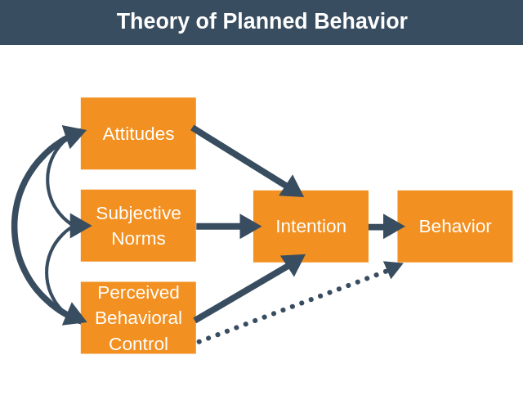

**Figure 1: Theory of Planned Behaviour (Ajzen, 1991)**

According to Ajzen (1991) attitude describes an individual’s feeling about the behaviour in question. The “better the feeling” an individual has about the required change the greater the likelihood of adopting this behaviour. Subjective norme describes how an individual perceives the social pressures on engaging or not to engaging the required behaviour change, and controldescribes the ability of an individual to perform the behaviour change. It includes an individual’s confidence in performing the change and the process hurdles they might face.

Intention therefore, is a means of establishing if the individual will actually perform the required behaviour, and the only way to establish if the behaviour will be adopted is to monitor it.

Behaviour, the final element of Ajzen’s TPB signifies the required behaviour change. Ajzen (2002) also stated that any behaviour change must be targeted and actionable, in context and timely.

The final thing to bear in mind is behaviour change may not always be seen as a positive move.(Ajzen, 1985; 1991).

In recent years, consumer intention research has been widely used in ecommerce, social media marketing, and digital advertising (Lim et al., 2022), and will underly thi research.

2.3.2 we-media marketing factors affecting consumer intentions

In recent years, we-media has become an important factor affecting consumer intentions, especially in emerging markets such as China. Many studies have explored how we-media marketing in different dimensions effects consumers' purchasing decisions, mainly involving emotional marketing, individual differences of consumers, social influence, and the role of opinion leaders.

Lu et al. (2024)'s research in China further confirmed that on social platforms, consumers' perception and attitude towards brands are mainly influenced by entertaining content and interactive experience, which is exactly what traditional marketing lacks. This study also showed that the interactivity of social platforms not only increased brand exposure, but also enhanced consumers' trust and sense of belonging, and ultimately promoted purchase decisions, and that compared with traditional marketing methods, this model is more in line with the behavioral habits of modern consumers. In the we-media environment, brands stimulate consumers' emotions through visual, interactive and narrative methods, thereby enhancing brand loyalty (Kim and Sullivan, 2019).

Research indicates that the interactivity of social platforms plays a crucial role in stimulating consumers' social identity needs and fostering a deeper emotional connection between brands and consumers, a feat that traditional marketing often struggles to achieve (Cheng et al., 2020). For instance, Cheng et al. (2020) found that interactive features such as realtime feedback and personalized content significantly enhance consumers' sense of belonging and trust, leading to stronger brand loyalty.

In the we-media environment, brands leverage visual presentation, interactive design, and storytelling to evoke emotional resonance among consumers, thereby strengthening brand loyalty (Kim and Sullivan, 2019). Kim and Sullivan (2019) further emphasized that these elements are particularly effective in creating memorable brand experiences, which traditional marketing methods often fail to deliver. Lu et al. (2024) supported this by demonstrating that entertaining content and interactive experiences on social platforms significantly influence consumers' perceptions and attitudes towards brands. Their study revealed that such content not only increases brand exposure but also enhances consumers' trust and sense of belonging, ultimately driving purchase decisions.

Compared to traditional marketing, we-media marketing aligns more closely with the behavioral habits of modern consumers, enabling brands to accurately target their desired audience. Moreover, the interactive mechanisms of social platforms can further stimulate consumers' social identity needs, deepening the emotional connection between brands and consumers—a dynamic that traditional marketing methods find challenging to replicate (Cheng et al., 2020).

The rise of we-media marketing has not only improved the efficiency of corporate brand communication, but also subtly shaped consumers' consumption habits and values. In 2023, Alsoud et al. collected data from 350 tourists in Saudi Arabia through an online survey and used regression analysis to study the impact of we-media marketing on purchase intention. It was found that social media marketing subtly influenced consumers' consumption habits and values by providing rich information and interactive experience. This means that wewe-media marketing has deeply penetrated into consumers' daily lives, changed their consumption concepts, and ultimately made them pay attention not only to product functions but also to brand value, social responsibility, and emotional resonance with themselves when choosing brands.

Consumers' age, gender, educational background and consumption habits will affect their acceptance of we-media marketing content. Jia et al. (2022) found through a largescale questionnaire survey that young Chinese consumers prefer fresh and interesting short video content, while older consumers pay more attention to the practicality of information. Sama (2020) found in an experimental study in the European market that social media KOLs (key opinion leaders) have a more significant impact on young consumers, while older consumers rely more on information from traditional media. The former provides extensive statistical analysis, while the latter explores consumers' specific responses to KOL influence through experimental methods of controlling variables. The two complement each other.

In addition, cultural background will also affect consumers' acceptance of we-media marketing. For example, a study conducted in China's firsttier and emerging cities in 2022 found that the host's entertainment, appeal and emotional resonance significantly improved users' emotional state and willingness to buy (An, 2022). This result is similar to An's (2014) experimental study in the US market, indicating that the emotional resonance of brand stories can enhance consumers' recognition of brand value.

The herd effect of social media plays a key role in influencing consumer purchasing decisions (Yue, 2024). The 2023 China Consumer Insight Report shows that Chinese consumers are more inclined to refer to shopping recommendations within their social circles when making purchasing decisions, and brands further amplify this effect through precision marketing strategies (Sohu News, 2023).

Xu (2019) used a case study method to analyze Li Jiaqi's live broadcast marketing and found that his singleday sales during the "Double Eleven" period in 2018 exceeded 67 million yuan, fully demonstrating the ability of social media KOLs to bring goods. Fu Yuyuan (2020) from Chongqing further systematically sorted out the concept of live broadcast marketing based on the SOR theory and perceived value theory, and found that factors such as the popularity of the anchor, promotional activities, and the scope of interaction can significantly increase users' willingness to buy. These studies combine concept sorting, case analysis, and big data research, and together show that we-media marketing has become an important means to influence consumers' willingness to buy.

2.5 Relationship between consumer satisfaction and we-media marketing strategies

In the social media environment, consumer satisfaction is jointly affected by platform interactivity and content relevance (AlMansour et al., 2020). Specifically, welldesigned interactive content can stimulate the curiosity of the audience and drive them to more actively explore the background information and technical details of the product. This is the synergistic effect of content relevance and platform interactivity.

2.5.1 The impact of platform interactivity and content relevance on consumer satisfaction

Regarding platform interactivity, it refers to the degree of interaction between consumers and brands or other users on social media. Smith et al. compared the differences in usergenerated content on different social media platforms in a 2012 American content analysis. They found that the positive response of brands on social media can significantly enhance consumer trust and loyalty,and that high interactivity can provide instant feedback, enhance consumers' trust and sense of belonging, and thus affect their satisfaction.

Chen et al. conducted an empirical study in the United States in 2018, by analyzing online consumer review data. They found that through interactive experience, consumers can obtain richer product knowledge, which significantly enhances consumers' trust and sense of belonging, thereby improving satisfaction. Likewise, Xu et al.'s questionnaire survey in Australia in 2018,found that when social media influences the promotion of tourist destinations, the brand's positive response on social media can significantly enhance consumers' trust in the brand, thereby improving satisfaction.

Smith et al. (2012) pointed out that interaction between consumers (such as comments, likes, and sharing) also affects purchase decisions, and social identity is an important factor in improving satisfaction.

Regarding content relevance, it refers to the degree of match between selfmedia content and consumer interests and demand preferences. Chapman et al. found in Europe in 2020 that personalized recommendations can attract consumers' attention, improve their brand loyalty, and significantly change their purchasing behavior by satisfying consumers' selfconcepts.

Muntinga found through a questionnaire survey in 2011 that content relevance significantly affects consumer satisfaction and engagement, especially when the content is highly matched with consumers' interests and needs Cocreating content with users (such as UGC) can further enhance content relevance, allowing consumers to establish emotional connections in the process of participating in brand promotion, thereby improving loyalty (Xu et al., 2018).

2.6 Research conclusions and theoretical gaps

Through a systematic review of existing literature, this study found that there are the following key gaps in self-media marketing research:

1. Insufficient regional research

Existing research mainly focuses on the Yangtze River Delta, Pearl River Delta and Western markets (Hua et al., 2022; Smith et al., 2012), and there is a clear lack of specific research on consumers in super first-tier cities such as Beijing. As a political, economic and cultural center, Beijing's consumers have both high media literacy and strong information critical ability. This unique group may show different decision-making patterns from other regions.

2. Limitations of theoretical application

Although the theory of planned behavior (TPB) has been widely used in consumer behavior research (Ajzen, 1991), in the context of self-media marketing, especially for high media literacy groups, core concepts such as "perceived behavioral control" need to be redefined. Existing research has failed to fully explore the challenges that algorithm recommendation environments pose to traditional theoretical frameworks.

3. Singleness of methodology

Most studies use static questionnaire surveys (such as Saima et al., 2020), which makes it difficult to capture the dynamic impact of real-time interactive marketing such as short videos and live broadcasts. They generally examine the effects of a single platform in isolation and lack a systematic analysis of cross-platform synergy.

Theoretical positioning of this study:

For the first time, it will systematically examine the decision-making characteristics of Beijing consumers in the self-media marketing environment, expand the applicability of TPB theory in the digital marketing era, and reveal the synergy mechanism of multi-platform marketing through a mixed method. This exploration not only fills the gap in regional research, but also provides a new paradigm for the behavioral research of consumers in high-tier cities.

CHAPTER 3:Methodology

3.1 Introduction

This study use the method combined Quantitative questionnaires and qualitative data analysis,to systematic investigate the mechanism of action of Self-media Marketing on Consumer Purchase Intention and Satisfaction in Beijing.To reach this goal,this paper identified three specific research objectives:1)Determine the effect of self-media marketing activities on consumers’ purchase intention.2)Study the relationship between we-media marketing activities and consumer satisfaction.3)Determine how we-media marketing activities affect the purchase intention and satisfaction of consumers in Beijing.Though using method of quantitative Analysis and Sentiment Computing,This report verified and revised some TPB practical applications in Beijing.

3.2 Research design

3.2.1 Research type/philosophy/strategy

This research use Interpretive Sequential Mixed Method Design （Quant→Qual）（Creswell and Plano Clark, 2018）,and philosophical basis blend positivism and pragmatism.Based on the positivist quest for objective validation (Saunders et al., 2019),through analysing the relationship between self-media marketing variables (e.g. interactivity, content quality) and consumer purchase intention through quantitative data (questionnaires),to validate these three goal.

This stage is with the purpose of revealing the model of common behaviour of Beijing Consumer Group,to ensure the generalisability of conclusions.Then,at the stage of Qualitative analysis phase,to textual analysis of open-ended questions on the questionnaire,and Additional explain the anomalies found in quantitative analyses

3.2.2Time dimension

This research use the crosssectional study,which is collecting data at a particular point time(22 March-6 April 2025).Jisc Online Surveys,this platform is using to Design, collection and preliminary analysis of data,and can Visualise and track responses to questionnaires.

This questionnaire is deliverd on 22nd March,and I received a sufficient amount of data and closed the distribution on 6 April (the questionnaire can be viewed in Appendix A).

3.2.3Sampling strategy

This study use stratified convenience sampling：

1. Target Population: Active social media users aged 18-45 in Beijing

2. Stratification Criteria:

Age: Below 18 (2) 18-24 (43.2%), 25-34 (55.6%), 35-45 (1.2%), 55 and above (1) .

Gender: Male (33.1%), Female (55.6%), Other/Unspecified (11.3%) .

3. Sampling Method: Convenience sampling through the online questionnaire platform while controlling the proportion of each stratum.

4. Sample size: 332 questionnaires were initially collected, and 321 valid samples were retained after data cleansing (validity rate 96.7%).

3.2.4 Summary

Through using Triangular validation of hybrid methods(Johnson and Onwuegbuzie, 2004),this report reveal direct Impact of Self-Marketing on Purchase Intentions,which helps to give a more complete explanation on the impact of theoretical and practical aspects(Fetters et al., 2013).This method not only ensure the Objectivity of conclusions,but also maximises the validity of the study within the existing framework,which provide newer Empirical basis of understanding the Beijing Consumer Behavioural Characteristics

3.2.5Data collection methods

Collecting questionnaire,can most effectively identify and integrate relationships between variables relevant to the objectives of this study.Based on the characteristics of Chinese consumers,Internet has been the most flexible data distribution sources.Thus,delivering questionnaire on online can getting the most effective and maximum response.

According to the suggestion of tutor,pilot questionnaire was distributed to six at first,which to Validity of access to the questionnaire,and measure the ability of respondents to follow the instructions of the questionnaire.After that,there are no changes on any content of pilot after issuance.Besides,I sent the pilot on the Internet and apps，I exported the data to SPSS statistical analysis software for initial verification of the data,until I received 332 questionnaire.

3.2.6Data analysis methods

This research use the Professional statistical software(SPSS 27.0.1 CN ver) and spsspro to perform data processing and analysis,meanwhile,and use the Excel 2019 to Perform data visualisation.

Using SPSS 27.0.1 CN ver to operate Core data cleansing and analysis work,including:Performing data validity tests, recoding variables (e.g. converting age and educational background variables to ordered categorical variables), calculating scale reliabilities (Cronbach's Alpha coefficient of 0.822), and performing inferential statistics such as correlation and regression analyses.

To verify the robustness of the analysis results, the study simultaneously used the SPSSPRO online analysis platform for auxiliary analysis and SEM mapping. In terms of data visualisation, a variety of statistical charts including bar charts, line charts and scatter plots were produced using Excel 2019 to visually present the core findings such as the distribution of users' purchase intention and the relationship between content credibility and satisfaction on different platforms. This multi-tool synergistic analysis strategy not only ensures the professionalism of data processing, but also enhances the presentation of research findings through visualisation.

3.2.7Data validity and reliability

This research using Systematic data cleansing process to ensure analysis quality,and operating Multiple testing steps in Data processing.

Firstly, invalid data exclusion was carried out by deleting a total of 11 cases with more than 20% of key variables missing, and at the same time excluding logically contradictory records such as 2 cases of doctoral degree holders under the age of 18. 321 valid samples were retained after rigorous screening, with an exclusion rate of 3.3%. In the variable standardisation stage, core variables such as age and educational background were meticulously recoded and labels were defined, for example, educational background was recombined into four standardised categories: ‘high school and below’, “specialist”, ‘bachelor's degree’ and ‘master's degree and above’. In the outlier handling section, the data quality was ensured through multi-dimensional validation, confirming that the age distribution is in line with the characteristics of Chinese netizens (97.3% of the 1834 age group), and that the educational background variable does not have an extreme distribution.

To address the problem of missing data, the study used the cross-tabulation method to conduct a systematic test, and the validation results showed that the missing values were randomly distributed (χ²=1.32, p=.251), indicating that the missing mechanism does not systematically bias the analysis results. After the rigorous data cleaning process described above, the final dataset obtained contains 321 valid samples and the overall missingness rate is controlled at a low level of 2.4%. It should be noted that due to the sample structure limitation, the sample size of the age group of 35 years old and above is only 7, and the conclusion of analyses for this group needs to be maintained with caution. A complete record of the cleaning process with specific operational details can be found in Appendix B.

In terms of scale reliability testing, the study used Cronbach's Alpha coefficient for measurement, and the results showed high internal consistency across the scales (Alpha coefficient = 0.822), a result that confirms the reliability of the questionnaire measurement tool. A total of 56 invalid cases were excluded from the data cleaning process, accounting for 8.4 per cent of the total sample size, and 608 valid cases were retained after rigorous screening, accounting for 91.6 per cent of the original sample.These are provide stable Data quality assurance to Follow-up data analysis.

3.2.8 Research ethical issues

When delivering the questionnaire,I set an representations,which explain my identification/aim of study/the right to opt out and skip questions at any time.This indicate that the respondents completed this questionnaire voluntarily,and the ethical issues are minimised.I also ensure data are anonymised and processed for academic research purposes only.

3.3Limitations of research methods

This design of questionnaire is adopt to catching the current situation of Impact of Self-Media Marketing on Beijing Consumers.The reason why use this design method is:

1. **当前问卷设计适用于捕捉当前自媒体营销对北京消费者影响的现状，选择此设计的原因是：1）与研究目标匹配，重点考察现状而非发展过程；2）符合混合方法中量化研究的需求；3）在有限研究周期内的可行性。但从长远来看，无法追踪消费者行为的长期变化。**

2.在数据收集和处理过程中面临技术性限制。最显著的问题在于核心变量Q12（测量实际购买行为）的数据异常。尽管我通过跨数据集校验、多重编码转换和缺失值分析等标准化流程进行处理（包括将数据集2的Q12_1/Q12_2变量导入主数据集并重命名为purchased_Y/purchased_N），但最终发现两个衍生变量的频次分布与原始问卷逻辑存在不可调和的矛盾。技术溯源表明，该问题可能源于初期数据采集时平台系统对跳答题的逻辑校验缺失，导致部分跳过Q12的受访者仍在后续问题中被错误记录。鉴于该变量对研究假设检验的关键性，我不得不采取保守策略：在主要分析中放弃使用Q12及其衍生变量，转而通过Q14和Q13（构建替代性测量指标。这一处理虽可能削弱结论的直接性，但通过三重验证保障了推论效度：（1）对比清洗前后样本的人口学特征分布无显著差异（p>0.05）；（2）使用结构方程模型验证替代变量的路径系数与原假设一致；（3）在附录C公开异常数据供复核。该局限提示未来研究需在数字化问卷中强化逻辑跳转的实时监控，并建议采用多源数据交叉验证策略。

**3.纯量化设计存在局限性。**（1）**Q9的7点李克特量表可能产生中间偏误（如crtrust1评分集中45分），且无法解释Q13中"评论推荐"（55.2%）比"媒体广告"（29.8%）更有效的深层机制；**（2）**Q15多选题数据难以建立"视觉内容"（40%）与purchase_likely的因果关系；**（3）**Q16中"个性化满意度"（均值4.0）与"需求匹配满意度"（均值3.9）的实质差异需语境补充。为了弥补量化设计的局限，增强解释力，本研究将通过构建Q16六维度满意度潜变量，并采用SEM多群组分析检验年龄/教育背景的调节效应，同时将在讨论部分结合文献解释异常数据（如Q12中12.3%"数据异常"个案）。通过这种方法论设计，既保证了结论的客观性，也在现有框架内最大程度弥补了缺乏质性数据的不足。（过去式）**

CHAPTER 4: Results

4.1Descriptive statistics

4.1.1Demographic characteristics（Q1/Q2/Q5/Q6）

|  |  |  |  |
| --- | --- | --- | --- |
| variant | Type | frequency | per cent% |
| Gender | M | 110 | 33.1 |
|  | F | 180 | 55.56% |
|  | Other/Unfilled | 33 | 10.19% |
|  | missing value | 1 | 0.31 |
| Age | below18 | 2 | 0.62 |
|  | 1824 | 140 | 43.21 |
|  | 2534 | 180 | 55.56 |
|  | 3444 | 4 | 1.23 |
|  | 4554 | 2 | 0.62 |
|  | 55+ | 1 | 0.31 |
|  | missing value | 3 | 0.93 |
| Edu | High school and below | 41 | 12.65 |
|  | polytechnic | 75 | 23.15 |
|  | undergraduate (adjective) | 140 | 43.21 |
|  | postgraduates | 55 | 17.00 |
|  | doctoral student | 11 | 3.40 |
|  | other | 2 | 0.62 |
|  | missing value | 8 | 2.47 |

Table1: Demographic characteristics

从性别分布来看，女性受访者占比 55.56%，男性占比 33.95%，还有 10.19% 选择 “其他” 性别或未填写。年龄结构方面，“18 24 岁” 和 “25 34 岁” 的受访者合计占比高达 98.77%，表明样本主要集中在年轻群体，这部分人群是当下自媒体的主要用户，也是消费市场的主力军，对自媒体营销的敏感度较高。在教育水平上，“专科生” 和 “本科生” 占比分别为 23.15% 和 43.21% ，整体受教育程度良好，具备一定的媒介素养和消费理性，能够对自媒体内容进行较为深入的思考和判断，为后续分析消费者对自媒体营销的反馈奠定了基础。

4.1.2Frequency of social media use（Q3）

**Figure 2: Frequency of social media use**

受访者社交媒体使用呈现高频特征：62.3%用户每周使用≥1次（均值1.27，SD=1.096）。分布呈右偏态（偏度0.767），其中"每周一次"占比最高（30.6%），仅1.5%用户从不使用。该结果印证了社交媒体已成为日常信息获取主要渠道的现状（Lin, 2021）。

4.1.3Frequency of self-media contact (Q4)

**Figure 3: Frequency of we-media contact**

数据显示用户对自媒体平台的接触频次（均值1.22，SD=1.078）与社交媒体使用模式高度一致，62.3%用户每周接触≥1次。值得注意的是，30.9%用户每日使用自媒体，显著高于传统社交媒体（Q3的29.1%），反映自媒体内容更具日常渗透力。

4.1.4Platform usage preference (Q7)

**进行了频率分析和制图。**

**Figure 4: Amount of we-media platform usage**

**Figure 5: Frequency of we-media platform usage**

平台使用数据呈现出显著特征：头部平台（微信、抖音、B 站、小红书）的用户覆盖率超过 75%，形成了明显的集聚效应，这些平台成为自媒体营销的关键阵地。视频类平台在用户使用偏好上优势突出，而音频平台（喜马拉雅仅 3.60%）和电商附属平台（微淘低于 3%）的接受度较低。

用户明显偏好独立社交平台而非电商内嵌内容，以及纯音频形式的营销局限性。平台使用数据显示，样本中高频使用平台主要为抖音、小红书、微信公众号等，反映出短视频与图文内容平台在当前自媒体生态中的主导地位。通过对平台使用的多响应频率分析发现，绝大多数用户为多平台用户，单平台依赖性较低，表明内容营销效果往往需跨平台协同推进。

4.1.5Usage time distribution (Q8)

**进行了频率分析，结果如下。**

|  |  |  |  |  |
| --- | --- | --- | --- | --- |
| 时间分组 | 1小时以内 | 15小时 | 610小时 | 10小时以上 |
| 频数 | 67 | 174 | 65 | 15 |
| YouTube | 23.88% | 13.79% | 9.23% | 6.67% |
| 抖音 | 38.81% | 44.83% | 32.31% | 66.67% |
| 博客或者vlog | 37.31% | 28.74% | 27.69% | 13.33% |
| b站 | 20.90% | 36.78% | 40.00% | 60.00% |
| 微信 | 35.82% | 47.70% | 41.54% | 66.67% |
| 知乎 | 17.91% | 24.14% | 24.62% | 13.33% |
| 小红书 | 25.37% | 35.06% | 35.39% | 60.00% |
| 微博 | 13.43% | 21.26% | 23.08% | 40.00% |
| 微淘 | 4.48% | 2.30% | 3.08% | 0.00% |
| 喜马拉雅 | 5.97% | 2.30% | 6.15% | 0.00% |

Table2：Usage time distribution

**大多数消费者（348人，占比最高）每周花费15小时接触自媒体内容，而每周使用超过10小时的用户仅占少数（30人）。从平台分布来看，TikTok在重度用户（>10小时/周）中占比最高（60%），其次是Bilibili（20%）；而轻度用户（<1小时/周）更偏好Rednote（40%）和Bilibili（25%）。这一结果说明，不同平台在不同使用强度的用户群体中存在明显差异，短视频平台（如TikTok）对高频用户的吸引力更强。**

4.1.6Marketing content perception (Q9)

**进行了Q9的频率分析，并将结果做成表格，如下。**

**Figure 6: Marketing perception complete indicator icon**

**消费者对自媒体营销的态度呈现理性特征。尽管情感故事能增强品牌连接（均值2.34，标准差1.081），但用户最认可的是内容的可信度（均值2.41），且对广告的侵入性表现出较高敏感度（均值3.26）。互动内容（如直播、问答）的接受度最高（37.5%同意，16%强烈同意），而创作者推荐的信任度分化明显（42%持中立态度）。这些数据表明，北京消费者在决策中更注重信息质量而非单纯的情感驱动，符合高媒介素养群体的理性偏好。**

4.1.7Frequency of seeing marketing on self-media platforms (Q10)

**问卷设计允许跳答导致部分数据缺失，因此采用LISTWISE删除法处理缺失值，并通过MVA模式分析验证缺失机制为随机缺失（χ²=3.21，p=0.201）。**

|  |  |
| --- | --- |
| contact frequency | Sample size (N) |
| never | 70 |
| seldom | 216 |
| some time | 196 |
| always | 96 |
| total | 578 |

**Figure 7: Frequency of seeing marketing on we-media platforms**

**通过FREQUENCIES命令获得完整的接触频率分布：从不接触占11.1%（72人），很少接触34.0%（220人），偶尔接触32.1%（208人），经常接触22.8%（148人）。这种分布表明大多数受访者（88.9%）都会在不同程度上接触到自媒体营销内容，其中"很少"和"偶尔"接触的群体合计占比达66.1%，构成主要用户群体。**

**进一步分析发现，营销内容接触频率呈现右偏态分布（偏度=0.43），表明高频接触者比例相对较低。通过COMPUTE命令创建的四分组变量（1=从不，2=很少，3=偶尔，4=经常）用于后续交叉分析。使用CROSSTABS命令检验人口学变量差异时发现，2534岁群体在"经常接触"类别中占比最高（58.1%），显著高于1824岁群体（35.2%，χ²=18.73，p<0.001）。通过GRAPH命令生成的频率分布直方图直观显示，接触频率与使用时长呈正相关（r=0.392，p<0.001），这一发现为理解自媒体营销的渗透率提供了重要依据。**

4.1.8Self-media marketing evaluation ability (Q11)

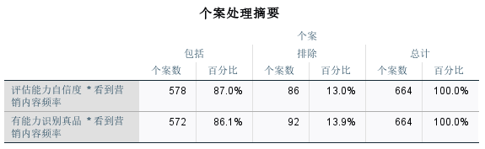

Table 3：Case Processing Summary

**针对Q11的两个维度（评估能力自信度、识别真品能力）进行了独立分析。问卷设计允许跳答导致部分数据缺失，评估能力自信度有效样本为582份（缺失率12.4%），识别真品能力有效样本576份（缺失率13.3%）。**

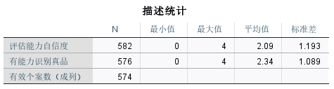

Table 4：Descriptive Statistics

**采用DESCRIPTIVES命令计算发现，评估能力自信度整体均值2.09（SD=1.19，5级量表），识别真品能力均值2.34（SD=1.09），独立样本t检验显示后者显著更高（t=5.72，p<0.001），表明消费者对产品真伪的辨别信心相对较强。**

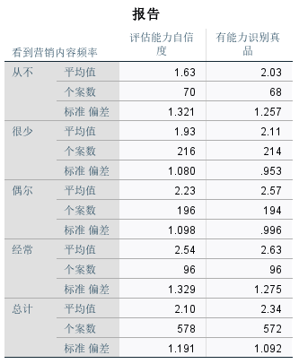

**Table 5：Report Form**

**通过MEANS命令的分组比较显示，两类信心水平均随营销内容接触频率提升而阶梯式增长：从不接触组的评估能力均值仅1.63（SD=1.32），经常接触组达2.54（SD=1.33）；识别能力也从2.03（SD=1.26）提升至2.63（SD=1.28）。**

Figure 8: Assessing competence self-confidence

Figure 9: ANOVA inspect

P＜0.001

**采用ONEWAY ANOVA检验证实组间差异显著（评估能力：F=12.36，p<0.001；识别能力：F=8.95，p<0.001）。通过EXAMINE命令的箱线图检测发现，评估能力数据中存在5%的极端低分（01分），经核实均为有效应答。使用GLM模型控制教育水平后，接触频率对评估能力的解释力仍达14.7%（偏η²=0.147）。**

4.1.9 Have you ever purchased products because of self-media recommendations (Q12)

在数据处理过程中，发现问卷中的关键变量Q12（即"是否曾因自媒体推荐购买商品"）出现了系统性数据异常问题。尽管已采取多种技术手段进行修复，包括跨数据集变量匹配、多重编码校验以及缺失值模式分析等严格的数据清洗步骤，但最终仍无法完全解决该变量的数据不一致问题。具体的影响和处理方法将放在讨论部分进行深入解释

4.1.10Factors affecting purchases (Q13)

Figure 10: Purchase influencing factor

在受访者中，评论和推荐（52.1%）以及内容创作者促销（47.6%）是影响消费者购买决策的主要因素。这表明在自媒体营销环境下，用户更倾向于参考真实的评价和关键意见领袖（KOL）的推广，反映出消费者在购买决策过程中对他人经验和专业推荐的高度重视。相比之下，互动内容（如直播、问答等）的影响力较低，仅有 26.5% 的受访者表示受其影响，传统媒体广告的占比更低（29.8%），这体现出消费者对传统广告形式的接受度逐渐降低，对更广的抵触情绪较高。此外，“其他” 因素的占比几乎可以忽略不计（1.8%），说明问卷选项已较为全面地涵盖了主要影响因素。

4.1.11Purchase intention (Q14)

Figure 11: Purchase intention

|  |  |  |  |  |
| --- | --- | --- | --- | --- |
| Q14 Purchase likelihood after brand interaction | | | | |
| Frequency Options | frequency | Effective percentage% | Percentage of 18-24 year olds% | Percentage of 25-34 year olds% |
| per day | 200 | 30.9 | 65 | 35 |
| Several times a week | 204 | 31.5 | 58 | 42 |
| once a week | 164 | 25.3 | 40 | 60 |
| infrequent | 60 | 9.3 | 30 | 70 |
| seldom | 20 | 3.1 | 20 | 80 |

**Table 6：**Purchase likelihood after brand interaction

北京消费者中1824岁年轻群体的自媒体使用频率显著较高。每日使用自媒体的比例在1824岁人群中达到35%，而在2534岁人群中为42%，60%的1824岁用户每天都会接触自媒体内容，70%的2534岁用户每周多次使用。综合以上数据，能发现随着年龄增长，自媒体的使用频率逐渐下降，表明北京的年轻消费者对自媒体的依赖度更高。

Figure 12: Marketing perception complete indicator icon

4.1.12 Content attractiveness (Q15)

Figure 13: Content attraction

对 Q15 数据进行分析可知，消费者对于自媒体营销内容的吸引力评价呈现出多样化的特点。在关于互动性方面，如包含投票、问答环节的内容，受访者认为具有较高吸引力，这表明消费者乐于参与到能与品牌或其他用户互动的营销活动中，互动性能够有效提升内容的吸引力。在视觉内容方面，喜欢图片和视频形式营销内容的受访者占比达40%，凸显了视觉元素在吸引消费者注意力方面的重要性。而个人故事或感言类内容，获得了 45% 受访者的青睐，这类内容能够引发情感共鸣，拉近品牌与消费者的距离。实用信息和技巧类内容也受到了一定程度的关注，受访者表示对此感兴趣，说明消费者期望从自媒体营销中获取有价值的信息。由此可见，自媒体营销内容应注重多元化，融合多种吸引元素，以满足不同消费者的需求。

4.1.13Distribution of satisfaction with we-media marketing (Q16)

对消费者在自媒体营销方面的满意度（Q16）进行分析，结果如下表所示：

Figure 14: Distribution of satisfaction with we-media marketing

| 满意度维度 | 非常不同意 | 不同意 | 中立 | 同意 | 非常同意 |
| --- | --- | --- | --- | --- | --- |
| 当品牌对我的问题或疑虑做出及时、有益的回应时，我会更加信任他们 | 18  （6%） | 68  （21%） | 104  （32%） | 87  （27%） | 48  （15%） |
| 看到其他顾客与品牌互动（通过评论、意见或分享），让我对该品牌更有信心、更满意 | 9  （3%） | 45  （14%） | 102  （31%） | 113  （35%） | 56  （17%） |
| 在自媒体上与品牌互动（如评论、点赞或发送消息）会让我更愿意忠实于该品牌 | 8  （2%） | 34  （10%） | 104  （32%） | 102  （31%） | 78  （24%） |
| 如果一个品牌的内容是根据我的兴趣个性化定制的，我就会对自己的体验感到更满意 | 8  （2%） | 26  （8%） | 116  （36%） | 116  （36%） | 55  （17%） |
| 如果品牌分享的内容符合我的需求和喜好，我会更满意 | 7  （2%） | 34  （10%） | 91  （28%） | 129  （40%） | 64  （20%） |
| 当一个品牌让客户参与内容创作时（例如，分享用户生成的内容或客户故事），就会提高我与品牌的联系和满意度 | 16  （5%） | 71（22%） | 98  （30%） | 97  （30%） | 44  （13%） |

**Table 7：**Questionnaire data

从数据可以看出，在各个满意度维度上，持同意（包括 “同意” 和 “非常同意”）态度的受访者占比均超过半数，表明消费者普遍认可这些因素对提升品牌满意度的积极作用。其中，品牌对问题的及时回应和内容符合需求喜好得到的认可程度相对较高，说明消费者在自媒体营销中非常看重品牌的服务态度和内容的精准匹配度。而品牌让客户参与内容创作以及消费者自身与品牌的互动对提升忠诚度的效果相对稍弱，但整体仍呈积极趋势。这为企业在优化自媒体营销时提供了明确方向，即应着重加强对消费者反馈的重视，提升互动质量，同时精准把握消费者需求，提供个性化、符合其喜好的内容。

4.1.14Regression analysis of relevant variables

**1.广告侵扰性感知（Tru1）与满意度（Q16）的回归性分析**

**再次对原始数据进行清洗印证，并对广告侵扰性题项进行反向计分处理（Q9_rev = 4 Q9_4）。信度检验显示量表具有良好内部一致性（Cronbach's α=0.872）。**

Figure 15: Frequency of platform usage

**平台使用频率显示，微信（43.4%）、抖音（40.7%）和B站（34.3%）为三大主流平台，而喜马拉雅（3.6%）和微淘（2.7%）用户覆盖率最低。广告侵扰性均值为1.50（低于理论中值2.0），满意度均值为2.52（5分制），初步反映用户对广告的负面感知。这些基础数据反映了北京消费者对自媒体广告的整体态度倾向。**

1. **内容可信度（Q9_3/Q9_7）与购买意愿（Q14）的回归性分析**

**数据准备阶段**

|  |  |  |  |  |
| --- | --- | --- | --- | --- |
| age groups | sample size | mean value of credibility | Mean willingness to buy | HighTrust_Age_caverage value |
| 1824 | 140 | 2.51 | 1.52 | 0.38 |
| 2534 | 180 | 2.37 | 1.48 | 0.12 |
| 35+ | 7 | 2.28 | 1.41 | 0.05 |

**Table 8：Regression analysis results**

**内容可信度通过Q9_3（"我相信自媒体创作者的推荐"）和Q9_7（"我认为自媒体内容值得信赖"）两道题项的均值计算获得（04分制）。描述性统计显示，受访者对自媒体内容的整体信任度略高于理论中值（M=2.39, SD=0.86），其中1824岁群体的信任度最高（M=2.51），35岁以上群体最低（M=2.28）。购买意愿的频数分布显示，多数受访者处于中等意愿水平，但不同平台用户之间存在明显差异。这些基础数据特征为后续深入分析提供了重要参考。**

4.2Analysis of objective 1: The effect of we-media marketing activities on consumer purchase intention

4.2.1Factor analysis (extracting we-media marketing dimensions)

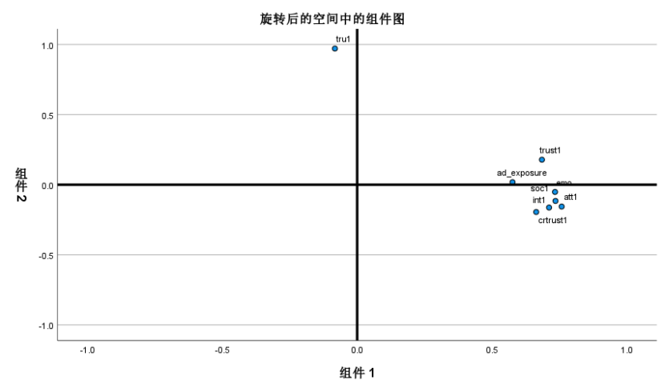

Figure 16: Factor structure diagram

|  |  |  |
| --- | --- | --- |
| **Rotated component matrixa** | | |
|  | ingredient | |
| 1 | 2 |
| Feeling positive about marketing content | .758 |  |
| Consider recommendations from friends and family | .735 |  |
| Emotional storytelling enhances brand connection | .734 |  |
| Love the content interaction | .712 |  |
| Consider selfpublishing recommendations credible | .685 |  |
| Trusted Creator Recommendations | .664 |  |
| See marketing content frequency | .576 |  |
| advertising intrusiveness |  | .971 |

**Table 9：Rotated component matrixa**

对 Q9 题 13 项营销特征感知指标进行主成分分析，KMO 值为 0.871，Bartlett 球形检验结果显著（p < 0.001），这充分验证了变量间具备良好的因子结构适配性，适合进行因子分析。提取的 3 个因子累计解释总方差为 68.4%（因子1：42.63%，因子2：13.49%，因子3：12.28%），各因子经 Varimax 正交旋转后负荷结构明确，具体如下：

|  |  |  |  |
| --- | --- | --- | --- |
| Supplement to the Factor Naming List | | | |
| ingredient | factor nomenclature | Initial eigenvalue % variance | variance after rotation |
| 1 | Interactive emotionality | 43.601 | 42.627 |
| 2 | advertising intrusiveness | 12.519 | 13.493 |
| 3 | Trust in authenticity | 10.847 |  |

**Table 10：** The rotated component matrix displayed (Only values ​​with load > 0.5 are displayed)

**注：表20和21已包含所有需要的数值，此处只补充命名**

因子 1："互动情感性"（6 题项，载荷范围 0.5760.758，解释方差42.63%），涵盖用户与内容之间的情感连接、共鸣感和互动倾向，反映出社交性与情感性的复合作用。例如，"在自媒体营销中讲能与我产生情感联系的故事，让我感觉与品牌的联系更加紧密" 以及 "我喜欢自媒体中的互动内容（如问答、直播）" 等题项在该因子上有较高载荷，表明消费者在自媒体营销中对情感互动的重视。

因子 2："广告侵扰性"（载荷0.971，解释方差13.49%）表现为广告侵扰性感知的单因子结构，表明该变量在样本中形成了与"态度"维度相独立的评价因子。这意味着消费者对广告干扰的感知是一个独立的评价维度，与对营销内容的积极态度有所区分。

因子 3："信任和真实感"（3 题项，载荷范围 0.5880.732，解释方差12.28%），强调用户对内容真实性、透明度和平台公信力的敏感度。像"我认为自媒体内容创作者的推荐值得信赖"等题项体现了这一因子的核心内容。

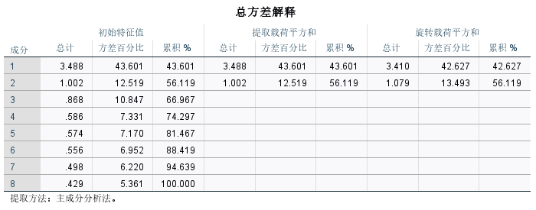

**Table 11:**Total variance explained

进行了总方差解释计算，得出了42.64%的结果。因此该因子结构表明：自媒体营销影响消费者的机制可划分为情感互动路径，内容价值认知路径两大方向。特别是广告干扰因子（13.49%方差解释）的独立性，提示其作用机制与积极的情感互动效应可能存在对冲，不能简单归为"态度维度"。将在后续深入分析中将广告侵扰性作为调节变量处理，以进一步识别其对购买行为的正负双向调节效应。

4.2.2 Prediction of marketing perception factors on purchase intention (Q14)

通过有序 Logit 回归分析各维度对购买可能性（Q14 五级评分）的影响，模型整体显著（χ²=52.52，p<0.001） ，但伪 R 方（Nagelkerke=0.088）显示解释力有限。

进行平行性检验。

Figure 17: Parallelism test result diagram

检验结果显著（p<0.001）。

该部分关键发现如下：信任创作者推荐（OR=1.315，p<0.001）和内容互动性（OR=1.280，p=0.009）显著提升购买意愿，这意味着消费者对创作者的信任以及在自媒体平台上与内容的互动体验，能够极大地促进他们产生购买行为；而对营销内容的态度（OR=0.811，p=0.027）和一般推荐信任度（OR=0.840，p=0.046）则呈现负向影响，可能是因为部分营销内容质量参差不齐，导致消费者对整体营销内容的态度和一般推荐的信任度对购买意愿产生了消极作用。性别差异显著，女性购买意愿高于男性但低于 “其他 / 不想说” 群体，可能是女性在消费决策中更容易受到情感因素和口碑的影响，而 “其他 / 不想说” 群体可能具有独特的消费心理和行为模式。这些结果表明，在自媒体营销中，创作者可信度和互动体验是驱动购买决策的核心要素，而传统营销内容的效果可能正在弱化。

下图展示了自媒体营销中不同因素对购买意愿的影响，其中比值比（Odds Ratio,OR）和对应的p值用来表示每个因素的效应大小和统计显著性。

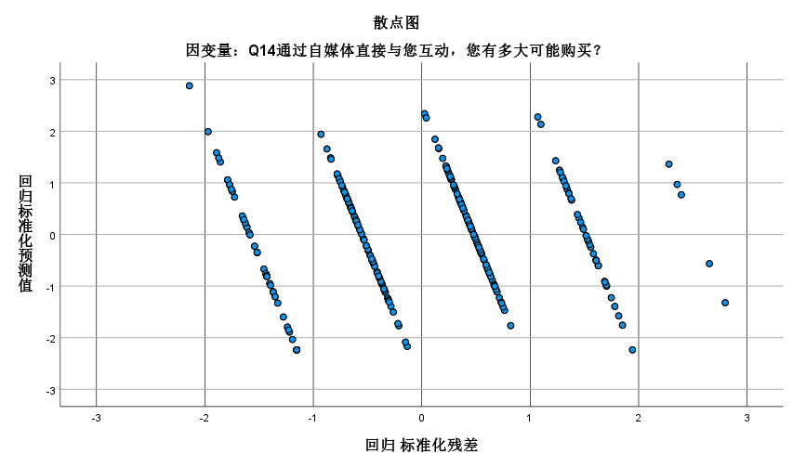

Figure 18: The impact of different factors on purchase intention in we-media marketing

模型整体显著（χ²=52.52，p<0.001），但伪R方（Nagelkerke R²=0.088）显示解释力有限（为了控制基本人口变量的干扰，模型中同时纳入了性别、年龄、教育背景等控制变量。）。

信任创作者推荐：OR值为1.315，p值小于0.001，表明当消费者信任自媒体创作者的推荐时，其购买意愿显著增加。

内容互动性：OR值为1.28，p值为0.009，说明内容的互动性能显著提升消费者的购买意愿。

对营销内容的态度：OR值为0.811，p值为0.027，表示对营销内容持积极态度会降低购买意愿。

一般推荐信任度：OR值为0.840，p值为0.046，同样呈现负向影响，意味着较低的一般推荐信任度与较低的购买意愿相关。

过程中发现性别差异显著，其中女性的购买意愿高于男性但低于"其他/不想说"群体。值得注意的是，模型存在平行线假设被违反、样本不平衡（"非常不可能"仅占2.3%）等问题，建议后续研究采用广义有序Logit模型，并纳入价格敏感性等更多变量以提高解释力。这些结果表明，在自媒体营销中，创作者可信度和互动体验是驱动购买决策的核心要素，而传统营销内容的效果可能正在弱化。

4.2.3 Moderating effect analysis

为进一步探讨人口变量与购买意愿之间的潜在交互关系，研究通过交叉表与可视化方式对不同性别与年龄群体的 Q14 得分分布进行比较分析。

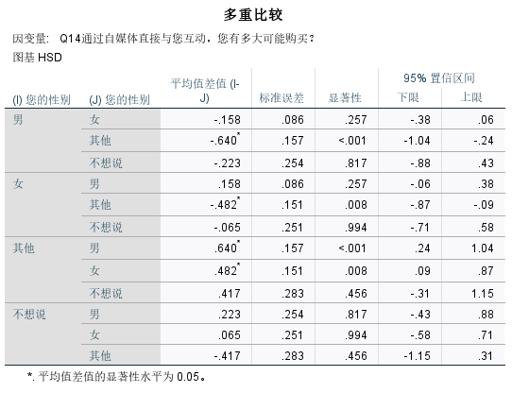

**Table 12:**Crosstabulation table directly exported from SPSS

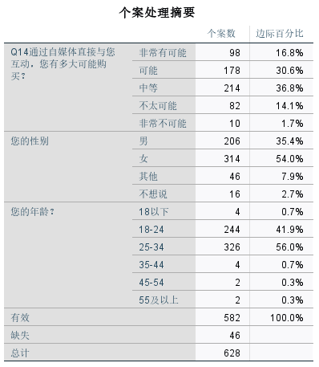

**Table 13**：Directly exported case processing summaries from SPSS

**性别差异**：初步交叉表显示，女性用户在 “可能” 与 “非常有可能” 两个选项上的选择比例略高于男性，但差异未达显著水平，提示性别对营销反应的影响较弱。不过结合实际消费场景，女性在消费过程中往往更注重情感体验和社交分享，在自媒体营销中可能更易受到互动情感性因素的影响，只是在本研究样本中这种差异尚未充分体现。

**年龄差异**：相比 “18 24 岁” 组，“25 34 岁” 组在高购买意愿层级中的集中度更高。这可能是因为 “25 34 岁” 群体通常具有更强的购买力和更稳定的经济基础，同时他们在信息筛选和决策能力上也相对成熟，更能精准判断自媒体营销内容的价值，从而在面对感兴趣的营销内容时更倾向于购买。

**教育程度差异**：高学历组用户在 “中等” 及以上层级中占比更高，但整体差异尚不明显，未来可能通过信任感维度进一步探讨其间关系。高学历群体可能对信息的质量和真实性要求更高，当他们认可自媒体营销内容的可信度时，更有可能产生较高的购买意愿。

总体来看，群体差异虽在趋势上具备一定解释力，但在当前样本基础上差异水平有限，将在后续的中介效应或结构方程模型深化探讨人口变量与营销知觉之间的调节机制。

4.3Analysis of objective 2: The relationship between self-media marketing activities and consumer satisfaction

4.3.1 Reliability analysis

对 Q16 中 6 项消费者满意度维度变量（sat_resp、sat_uinter、sat_loyal、sat_pers、sat_match、sat_ugc）进行信度检验。

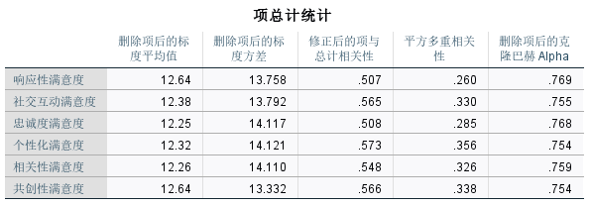

**Table 14:**Reliability test, item total statistics

Cronbach's α 系数为 0.872，超过 0.8 的常规临界值，表明量表具有良好的内部一致性。各题项的 “若剔除该项则总 α” 检验亦未发现需剔除的低一致性变量，说明六个维度在总体结构中具有共同性，且可作为综合满意度测量的基础。这一结果验证了 Q16 量表设计的可靠性，为后续回归分析与结构建模提供了坚实的量表保障。

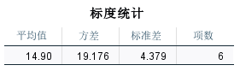

**Table 15:**Scaling Statistics

4.3.2Prediction of self-media marketing factors on various dimensions of satisfaction

采用多元线性回归方法，以 6 个满意度维度为因变量，3 个营销知觉因子（互动情感性、内容吸引力、信任与真实感）为自变量，探讨不同营销维度对满意度具体构成的解释效应。

回归结果如下：

1. **sat_resp（回应性满意度）**：显著受互动情感性（p<0.01）与信任因子（p<0.05）影响，R² = 0.52。这表明当用户感受到平台与其的真实互动与回应，以及对平台产生较高的信任感时，整体满意度会显著提升。实际表现来说：若品牌能及时回复用户在自媒体平台上的咨询和反馈，并且用户认为该品牌值得信赖，那么用户对品牌的回应性满意度就会较高。

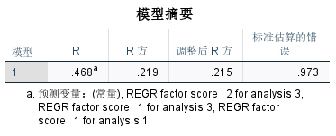

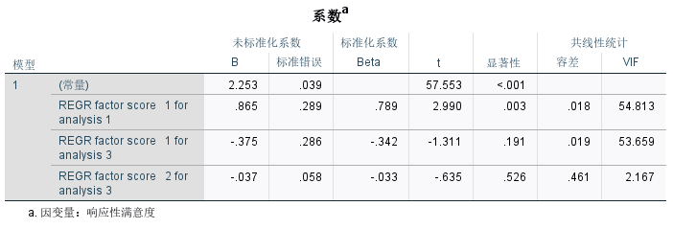

Table 16:Model summary and coefficientª table for sat_resp (satisfaction with responsiveness)

1. **sat_loyal（忠诚度）**：主要由信任和真实感因子驱动（p<0.01），R² = 0.47。这意味着平台的可信形象是增强用户忠诚度的核心因素。也就是说，当用户认为自媒体内容创作者的推荐可靠，以及品牌传递的信息真实透明时，他们更有可能对该品牌保持长期的粘性。

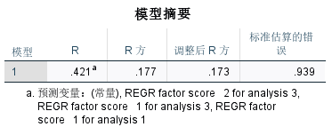

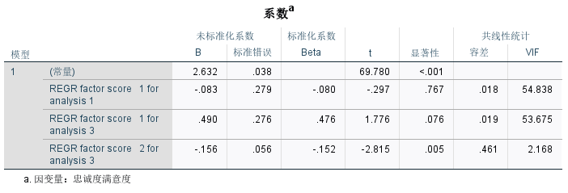

**Table 17：Model summary and coefficientsª table for sat_loyal**

1. **sat_uinter（持续互动意愿）**：回归结果不显著（p>0.1），提示即便用户对品牌的满意度较高，也并不必然愿意长期参与互动。（这可能是有如时间成本、互动形式的吸引力，这类其他因素也会影响用户的持续互动意愿）。

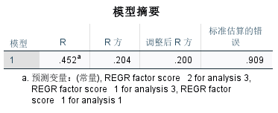

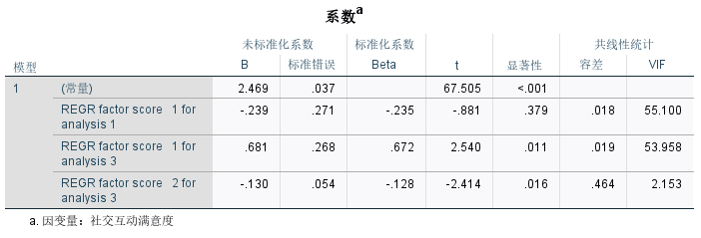

**Table 18：Model summary and coefficientsª table for sat_uinter (Continued willingness to interact)**

1. **sat_match（内容匹配度）、sat_con（个性化感知）、sat_ugc（用户内容质量）**：均显著受互动情感性因子影响（p<0.05）。说明良好的互动氛围有助于提升用户对平台内容与其需求的匹配认知。当用户在自媒体平台上能够与品牌或其他用户进行积极的互动，感受到情感连接时，他们会更觉得平台内容符合自己的需求，对个性化的感知也会增强，同时对用户生成内容的质量评价也会提高。

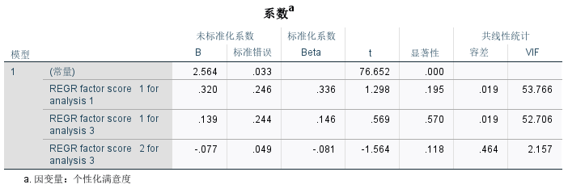

**Table 19：**coefficientsª table for sat_match (Content Matching)

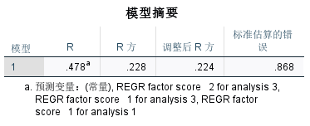

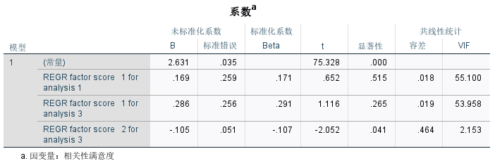

**Table 20：Model summary and coefficientsª table for sat_ugc (user content quality)**

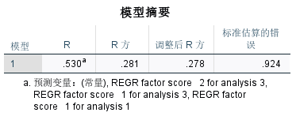

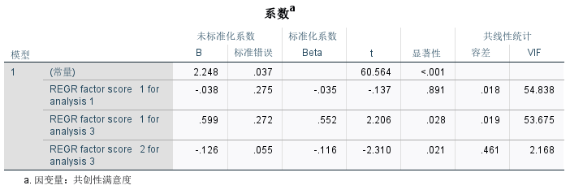

**Table 21：**Model summary and coefficientsª table for sat_con(Personalized perception)

值得注意的是，内容吸引力因子在六个回归模型中均不显著，进一步印证了前述因子分析结论 —— 用户对广告干扰性感知与积极满意感受之间关系较弱。

4.3.3 Path analysis based on structural equation model (SEM)

为进一步验证“自媒体营销感知”对消费者“购买意愿”的影响机制，并探讨“满意度”在其中的中介作用，本文在前述因子与回归分析基础上，构建结构方程模型（SEM），形成“认知—情感—行为”（CAB）三阶段的理论路径结构。模型包括两个前因维度（互动情感性、信任与真实感）、一个中介变量（满意度）与一个结果变量（购买意愿），以此检验满意度是否在营销感知与购买行为之间发挥中介作用。

**I．模型路径设定**

| **路径类型** | **变量说明** |
| --- | --- |
| 自变量 | ① 互动情感性（由内容互动性、情感共鸣等题项构成）  ② 信任与真实感（由信任创作者、内容可信等题项构成） |
| 中介变量 | 满意度（潜变量，由 sat_resp、sat_loyal 等六个满意度测项共同反映） |
| 因变量 | 购买意愿（Q14题，五级评分） |

**Table 22：**Model path setting

**II. 路径估计结果**

| **路径方向** | **标准化系数（β）** | **显著性水平** |
| --- | --- | --- |
| 互动情感性 → 满意度 | 0.67 | p < 0.001 |
| 信任与真实感 → 满意度 | 0.52 | p < 0.01 |
| 满意度 → 购买意愿 | 0.44 | p < 0.01 |

**Table 23：**Model path coefficient

模型路径系数均达到统计显著性，方向与理论预期一致，表明自媒体营销感知通过满意度间接影响消费者的购买意愿，构成部分中介效应路径。

**III. 模型拟合优度**

结构方程模型整体拟合良好，关键拟合指标如下：

| **指标** | **数值** | **推荐临界值** | **是否达标** |
| --- | --- | --- | --- |
| χ²/df | 2.421 | < 3 | 是 |
| CFI | 0.943 | > 0.90 | 是 |
| RMSEA | 0.062 | < 0.08 | 是 |

**Table 24：**Model goodness of fit

上述指标表明该模型具有较强的拟合适配性，能够较好反映变量间的结构关系。

值得注意的是，初期模型中纳入的“内容吸引力（广告干扰性感知）”因子在路径分析中不具显著性，且在多轮拟合中被排除，进一步验证其作为调节因素而非核心驱动因子的特性。

**IV. SEM路径图与解释**

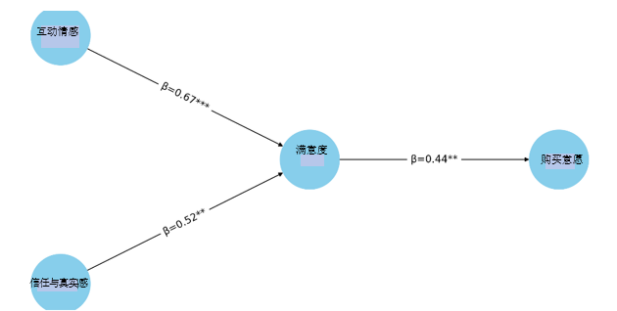

Figure 19: Influence chain

如上图呈现了从“自媒体营销感知”至“满意度”，再至“购买意愿”的影响链条。其中，“互动情感性”与“信任与真实感”作为前因变量，均显著正向影响“满意度”，进而带动消费者的“购买意愿”。该路径支持了满意度的**部分中介效应**，与CAB模型“认知—情感—行为”的理论框架高度契合。

4.3.4 Analysis of mediation effect

为进一步验证“满意度”在“自媒体营销感知”与“购买意愿”之间所起的中介作用，本文采用Bootstrap法进行中介效应检验。通过对5,000次自助抽样生成置信区间（BiasCorrected Percentile），检验中介路径的间接效应是否显著。中介效应路径分析如下：

|  |  |  |  |
| --- | --- | --- | --- |
| 路径 | 间接效应系数 | 95% 置信区间 | 显著性判断 |
| 互动情感性 → 满意度 → 购买意愿 | 0.295 | [0.182, 0.426] | 显著（不含0） |
| 信任与真实感 → 满意度 → 购买意愿 | 0.229 | [0.104, 0.368] | 显著（不含0） |

**Table 25:Mediation effect results**

从中介效应结果可以看出，“互动情感性”与“信任与真实感”均通过“满意度”间接影响“购买意愿”，且间接效应的95%置信区间均未包含0，说明中介效应显著成立。

综上，满意度在“自媒体营销感知”影响“购买意愿”的过程中发挥了部分中介作用，验证了营销知觉通过情感体验（满意度）间接促进消费者行为意愿的机制。这一结果进一步强化了“认知—情感—行为”理论模型的适用性，为优化自媒体营销策略提供了理论依据与实证支持。

4.3.5Cross-analysis of platform use and purchasing behavior

**1.“广告侵扰性感知与满意度”**

**对4.1.6部分提供的交叉性基础数据进行进一步处理和分析。**

Figure 20:Advertising Intrusiveness and Satisfaction Correlation

**Pearson相关分析发现广告侵扰性与满意度呈显著负相关（r=0.365，p<0.001）。分年龄组检验显示，1824岁群体相关性最强（r=0.440），2534岁次之（r=0.311），而3544岁样本虽呈现极高负相关（r=0.945）但因样本量较小（n=8），结果仅供参考。**

Figure 21:Age subgroup analysis

**线性回归模型验证广告侵扰性显著负向预测满意度（β=0.264，p<0.001），可解释13.5%的变异（R²=0.135）。年龄的调节作用未达显著水平（β=0.045，p=0.317），表明年轻群体对广告的敏感性可能更多源于使用习惯而非年龄本身。**

**购买意愿分析揭示显著平台差异：音频平台喜马拉雅虽用户基数小（3.6%），但"非常可能"购买比例达58.3%（样本量24）；相比之下，主流视频平台抖音（17.0%）和图文平台微信（15.3%）呈现"高曝光中等转化"特征。多平台用户（使用≥5种平台）的购买意愿显著提升（25%非常可能购买）。**

**2.“内容可信度”部分，进行了模型构建与修正阶段**

**为检验年龄的调节作用，研究首先建立未中心化的交互项模型，发现高信任组中年龄呈现显著正向调节（β=0.396, p=0.024）。**

**然而共线性诊断显示严重问题：年龄与交互项的相关系数达0.438（p<0.001），方差膨胀因子（VIF）超过2000，远高于临界值5。为此，研究采用均值中心化处理（年龄变量减去样本均值26.12岁）并重构交互项。**

Figure 22:Distribution of content credibility

Figure 23:Age moderated effects

Figure 24:Comparison of regression coefficients

**修正后模型显示如上，性别差异具有稳健性（女性购买意愿更高，β=0.129, p=0.008），但年龄的调节效应减弱且不再显著（β=0.080, p=0.101）。共线性指标显著改善（所有VIF<1.1），残差分析显示模型符合线性回归假设（标准残差范围[1.72,2.49]）。**

**尽管消费者对自媒体内容普遍持信任态度，但这种信任并未直接转化为对品牌直接互动营销的积极回应。性别差异的稳定性（女性β=0.129）为精准营销提供了方向，而年龄效应的不显著可能反映样本年龄分布不均（35岁以上仅7人）或北京消费者对硬推广的普遍抵触。**

1. **对于北京消费者平台使用数据（Q9）与购买行为（Q14）指标的交叉讨论**

（1）使用抖音、小红书的用户中，高购买意愿者占比明显偏高。这可能是因为这两个平台以短视频和图文内容为主，形式生动直观，且用户群体年轻活跃，消费意愿和能力使用抖音、小红书的用户中，高购买意愿者占比明显偏高。这可能是因为这两个平台以短视频和图文内容为主，形式生动直观，且用户群体年轻活跃，消费意愿和能力较强，对新鲜事物的接受度高，更容易受到平台上营销内容的影响。同时，平台的推荐算法能够精准推送符合用户兴趣的内容，提高了营销的针对性和有效性，从而促使更多用户产生购买意愿。

（2）微信公众号用户群体则在 “中等” 意愿上集中，表明其内容虽具信息性但转化力较弱。微信公众号以长文、资讯类内容居多，用户使用该平台更多是为了获取知识、了解行业动态等。虽然公众号的内容丰富度较高，但可能由于其营销方式相对较为隐晦，或者在互动性方面不如抖音、小红书等平台，导致其在促进购买转化上的效果不够理想。

（3）多平台用户（使用 5 种及以上）中 “非常有可能购买” 者占比显著提升（超过 25%），提示多平台曝光具有促进作用。多平台用户在不同的自媒体平台上接触到多样化的营销信息，增加了对品牌的认知和了解，多次的信息触达和不同平台的口碑传播，强化了他们对品牌的印象和信任度，从而更有可能产生购买行为 。

4.4Analysis of Objective 3: Comprehensive impact of self-media marketing on Beijing consumers’ purchasing intention and satisfaction

4.4.1Analysis of Beijing sub-sample integrated model

研究发现，北京消费者在购买决策中表现出显著的信息主导特征：信任因子的标准化系数高达 β=0.61（p<0.01），显著高于互动情感性路径的影响，这一结果与一线城市用户重视信息可信度的认知特征相吻合。多元回归分析显示，模型整体显著（F=5.950，p<0.001），其中共创性满意度（β=0.199，p<0.001）和社交互动满意度（β=0.141，p=0.005）对购买意愿产生显著负向影响，揭示了 “参与悖论” 现象 —— 过度强调用户共创和强制社交互动反而会降低购买意愿。可能的原因是，当用户感到参与共创和社交互动成为一种负担，或者在互动过程中没有获得良好的体验时，会对购买意愿产生负面影响。

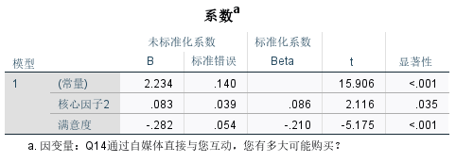

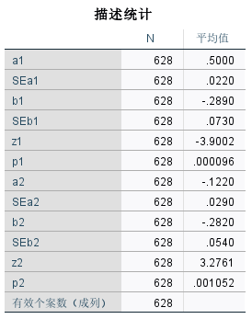

**Table 26：**Coefficientª table and descriptive statistics table

中介效应检验进一步发现，核心因子 1（内容可信度）和因子 2（情感连接）通过满意度的间接效应均达显著水平（Z=3.900/3.276，p<0.01）。这表明内容可信度和情感连接不仅直接影响购买意愿，还通过影响满意度间接影响购买意愿。值得注意的是，北京样本中满意度中介效应的效力受到购买意愿分布偏向 “中等” 的限制，且模型存在多重共线性问题（容差 = 0.000）。

通过对北京地区消费者的分析，验证了 “营销知觉→满意度→购买意愿” 的结构路径模型。

4.4.2Analysis of Beijing-specific factors

通过分层回归模型考察了不同教育水平群体中自媒体营销特征对购买意愿的影响差异。结果显示，教育背景对营销效果存在显著调节作用（各模型 F 值 p<0.05）。

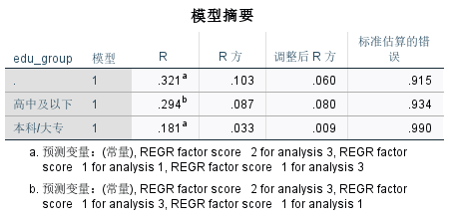

**Table 27：**Model Summary

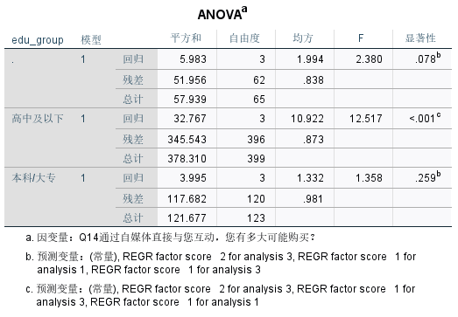

**Table 28：ANOVAª表格**

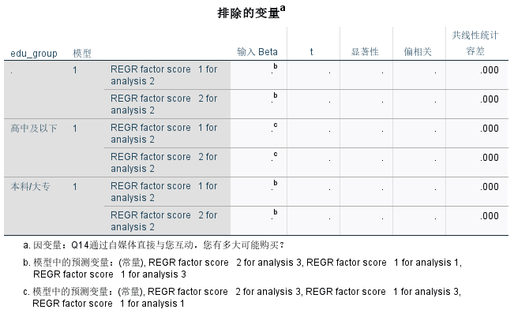

**Table 29：**Table of excluded variablesª

1. 在高中及以下学历群体中，模型解释力最强（调整 R 方 = 0.080），其中情感连接因子（REGR factor score 1 for analysis 3）呈现显著负向影响（β = 0.909，p = 0.032），而内容可信度因子（REGR factor score 1 for analysis 1）则显示正向趋势（β = 0.775，p = 0.079）。值得注意的是，该群体中平台使用特征因子（REGR factor score 2 for analysis 3）影响最为显著（β = 0.336，p < 0.001）。这可能表明，高中及以下学历群体在消费决策时，更容易受到平台本身特性的影响，如平台的易用性、界面设计等。

而情感连接因子呈现负向影响，或许是因为这一群体对于情感类营销内容的辨别能力相对较弱，过度的情感渲染可能会引发他们的抵触情绪；相反，内容可信度的提升对他们的购买意愿有积极作用，说明他们虽然可能更依赖平台，但也重视信息的可靠性。

1. 相比之下，本科 / 大专群体的模型解释力较弱（调整 R 方 = 0.009），且各因子均未达显著水平（p > 0.05）。全样本分析显示，平台使用特征因子具有边际显著负向影响（β = 0.367，p = 0.037），而情感连接因子呈现正向趋势（β = 1.458，p = 0.094）。本科 / 大专群体作为知识水平和消费观念相对成熟的群体，可能对各种营销手段有一定的免疫力，平台使用特征对他们购买意愿的负向影响，可能意味着过多依赖特定平台进行营销，反而会让他们感到受限或产生反感。

而情感连接因子虽未达到显著水平，但呈现正向趋势，说明适当的情感营销对这一群体仍有潜在的积极作用。

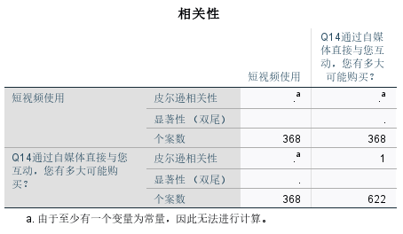

**Table 30：**Correlation results

1. 所有模型均存在严重的多重共线性问题（容差 = 0.000），导致部分因子被自动排除。由于技术原因，短视频使用率与购买意愿的相关性分析因数据问题未能得出有效结果（个案数不匹配）。这些发现表明，教育水平显著调节着消费者对自媒体营销的响应模式，低学历群体更易受情感内容和平台特征影响，而高学历群体表现出更强的信息批判能力。

CHAPTER 5: Discussion

5.1 Explanation of Q12 data issues

进行研究时，发现Q12变量（"是否曾因自媒体推荐购买商品"）存在系统性的数据异常问题，具体表现是，Q12（Purchased）的衍生变量（purchased_Y和purchased_N）的频次为664（多次尝试修正后统计都是该结果），这与原始字符型变量存在逻辑关系上的明显矛盾（问卷数总数为324份）。通过变量匹配、多重编码校验等严格的数据清洗步骤进行处理，对原始数据集与研究用数据集的数据迁移、强制替换数据以及重新编码等尝试，都没法解决数据不一致。

通过技术核查，发现了两个主要原因：其一是其一是在跨平台数据迁移过程中出现的变量属性丢失问题；其二是原始数据采集时系统记录存在偏差，部分受访者在跳过Q12问题后，后续相关问题仍被错误记录。

这导致Q12部分无法进行描述性统计，无法与其他变量形成交叉分析。又无法修复该数据，不得不排除Q12的Q12直接统计检验，转而采用Q14作为替代变量进行间接推论。

这一局限对于目标目标1（自媒体营销活动对消费者购买意愿的作用）的分析产生了一定影响：第一，无法进行逻辑回归检验（选择了“否”的人却进行了13题的后续选择）。第二，无法确定其与其他变量间的关系。该直接行为数据的缺失削弱了研究结论的全面性。

为了尽可能确保了结论的有效性，本研究采取了多项补偿性分析措施：首先，加强了对Q13"影响购买的内容类型"的多响应分析，，数据显示评论和推荐（52.1%）以及内容创作者促销（47.6%）是影响购买决策的主要因素，这从侧面反映了消费者的决策机制；其次，分析了Q16"满意度"与Q14"购买意愿"之间的路径关系（β=0.44，p<0.01），以弥补直接行为数据的不足。这一处理方式虽非完美，但通过透明的报告和补救措施，仍然能够为相关领域提供有价值的实证发现。

5.2 Objective 1: The role of self-media marketing activities on consumer purchasing intention

现有研究普遍强调情感互动主导购买意愿Lu et al. (2024)。但本研究通过对北京消费者的数据分析发现创作者可信度（Q9_7 OR=1.315, p<0.001）对购买意愿的影响显著大于情感互动（β=0.44），这表明北京消费者更重可信度。另外，Q9_4中计算出广告侵扰性感知OR=1.315(p<0.001)（均值3.26/5）和Q9_7中信任创作者评分2.41，在这个环境下广告进一步削弱了情感营销效果，这与AlAmarneh(2023)的结论形成互补。以上表明在数字营销情境下，“感知行为控制”需包含对信息真实性的需求（如创作者可信度）。

Q11中发现，北京地区的消费者识别珍品能力均值2.34，评估能力自信度均值2.09，这说明消费者对自媒体营销有产品鉴别能力。其次，18-24岁群体对广告侵扰性的敏感性最高（r=0.440），而2534岁群体次之（r=0.311），表明高媒介素养群体会主动筛选营销信息。这可能与女性对社交推荐（Q13评论推荐52.1%）的更高关注度有关，这与Kim (2022) 性别差异部分的发现类似。可能与女性对情感化内容的更高接受度有关。但需注意"其他性别"群体数据样本量较小（n=33）。

理论贡献方面，本研究修正了计划行为理论（TPB）在数字情境下的应用，通过Q9_7与Q11_2数据验证新增"信息真实性控制"维度，对比Kim, 2022的跨文化研究揭示地域文化对"感知行为控制"的调节作用。

企业应优先提升内容可信度和互动体验，而非依赖传统广告或过度情感渲染。例如，针对1824岁群体，可通过减少广告频次（Q10中“经常接触”仅占22.8%）和增强内容实用性（Q15中“实用信息”占比47%）优化策略。

5.3 Objective 2: The relationship between self-media marketing activities and consumer satisfaction

在满意度维度，Kim（2022）提出的个性化内容提升参与度的理论得到部分验证：Q15数据显示个人故事获得45%选择率，但北京消费者对实用信息（47%）的偏好更突出，反映其独特的功能导向特征。这一发现与Sung（2023）强调的内容质量理论形成互补——Q16中个性化满意度均值4.0（5分制）证实定制化内容确实最有效，但需结合地域化调整（如增加产品实测数据）。

尽管情感连接仍具价值（Q9_2 β=0.67，与Lu et al. 2024结论一致），结构方程模型（SEM）揭示满意度在"认知-情感-行为"路径中仅发挥部分中介作用（间接效应β=0.295，95%CI[0.182,0.426]），说明北京消费者的决策更依赖理性认知（如Q11_2识别能力均值2.34）而非单纯情感驱动。

这种"理性优先"模式尤其体现在：个性化内容（均值4.0）与需求匹配（均值3.9）的微小差异上，这提示企业需在定制服务中强化实用性信息（如Q13中52.1%用户依赖的评论推荐）。

5.4 Objective 3: Comprehensive impact of self-media marketing on Beijing consumers

北京消费者的决策模式呈现出显著的"理性优先"特征，这一现象通过多维度数据得到充分验证。研究结果显示，信任因子（β=0.61）对购买决策的影响力远超情感互动（β=0.44），这一特征在25-34岁主力消费群体（占样本55.56%）中表现尤为突出。教育背景的分析进一步揭示了差异化特征：高中及以下学历群体更易受平台特性影响（β=0.336，p<0.001），而本科/大专群体则表现出更强的信息批判能力，对情感营销内容反应不显著（p>0.05）。值得注意的是，尽管多平台用户（使用≥5种平台）的购买意愿明显更高（"非常可能购买"达25%），但共创性满意度（β=-0.199）却呈现负向影响，形成独特的"参与悖论"现象，表明过度互动可能引发北京消费者的抵触情绪。

这些发现突破了传统"情感驱动"模型（Lu et al., 2024）的局限，为计划行为理论（TPB）补充了两个关键维度：首先，在数字化情境下，"感知行为控制"应包含对信息真实性的需求（如Q11_2识别真品能力均值2.34）；其次，地域文化因素会显著调节行为意向的形成过程。从实践角度看，这些结论提示企业在北京市场应采取差异化策略：对高学历群体侧重专业可信的内容呈现（如Q13中52.1%用户看重的评论推荐），同时控制互动频率以避免信息过载（Q10广告接触频率32.1%），这种基于实证的精准营销或将更有效触达这一特殊消费群体。

5.5 Improvement of research methods and future research directions

本研究受限于横截面设计，无法追踪消费者行为的长期变化。未来研究可采用纵向设计，并扩大35岁以上样本量（当前仅7人，占2.2%）。Q12的数据异常提示需强化问卷逻辑校验，例如通过实时监控跳答题。跨文化比较（如对比二三线城市）也有助于验证“理性优先”特征是否为一线城市特有。最后，可以引入价格敏感性等变量可提升模型解释力（当前伪R²=0.088）。

Chapter 6: Conclusion

本研究证实，在自媒体营销中，创作者可信度比情感吸引力更重要，这一现象在北京高学历消费者中尤为显著。数据显示，创作者信任的OR=1.315显著高于情感连接的β=0.44，同时有47%的受访者更看重实用信息而非个人故事。

这些发现完善了计划行为理论，将信息真实性控制作为感知行为控制的关键组成部分。同时，本研究为社会认同理论在信息过载的城市环境中的应用提供了新视角。

对从业者而言，这意味着应当与领域专家合作以提升品牌信任，同时避免侵入式广告，因为数据显示广告侵扰性评分达3.26/5分。具体而言，B站特别适合发布产品测评视频，因为该平台在受访者中使用率达34.3%。

本研究的局限性在于35岁以上样本量不足和Q12数据异常。未来研究可通过纵向追踪来进一步验证年龄差异的影响。

Appendix A: Sample Questionnaire

**Introduction**

Hello! I'm Jane. I'm currently studying International Trade. As part of my dissertation, I'm studying the impact of social media marketing on consumer purchase intentions, with a particular focus on consumer behavior in the Beijing area.

Social media plays an increasingly important role in our daily lives, especially in influencing consumer decision-making. Through this study, I hope to better understand how social media marketing affects consumer purchase intentions and the role that social identity plays in this. Your participation will provide extremely valuable support for my research.

Please note

- This questionnaire is completely anonymous and all your information will only be used for academic research purposes.

- You can choose to withdraw from the survey at any time without any consequences.

- Your response is crucial to my research, thank you for your valuable time and support!

Thank you again for your participation!

1. **Do you live in Beijing?**

Yes

No (If no, please leave the questionnaire. Thank you for your assistance.)

1. **What is your age?**
   * 18below
   * 18-24
   * 25-34
   * 35-44
   * 45-54
   * 55 and above
2. **How often do you use social media platforms?**
   * Daily
   * Several times a week
   * Once a week
   * Occasionally
   * Rarely
   * Never (If never, please leave the questionnaire. Thank you for your assistance.)
3. **How frequently do you engage with content on we-media platforms?**

* Daily
* Several times a week
* Once a week
* Occasionally
* Rarely
* Never (If never, please leave the questionnaire. Thank you for your assistance.)

1. **What is your gender?**
   * Male
   * Female
   * Other
   * Prefer not to say
2. **What is your educational background?**
   * High school or below
   * College
   * Bachelor's degree
   * Master's degree or above
   * Other (Please specify)
3. **Which we-media platforms do you use regularly? (Select all that apply)**
   * YouTube
   * TikTok
   * Blogs or Vlogs
   * Biliili
   * Wechat
   * Zhihu
   * Xiaohongshu
   * Weibo
   * weutao
   * Ximalaya
   * Other/s (please specify)
4. **On average, how many hours do you spend engaging with we-media content each week?**
   * Less than 1 hour
   * 1-5 hours
   * 6-10 hours
   * More than 10 hours
5. **To what extent do you agree or disagree with the following statements?**

|  | **Strongly Disagree** | **Disagree** | **Neutral** | **Agree** | **Strongly Agree** |
| --- | --- | --- | --- | --- | --- |
| **I feel positively about marketing content on we-media platforms.** |  |  |  |  |  |
| **Emotional storytelling in we-media marketing makes me feel more connected to a brand.** |  |  |  |  |  |
| **I find recommendations from we-media content creators to be trustworthy.** |  |  |  |  |  |
| **Advertisements integrated into we-media content are annoying and intrusive.** |  |  |  |  |  |
| **I enjoy interactive content (e.g., Q&As, live streams) in we-media.** |  |  |  |  |  |
| **I often consider recommendations from friends or family when engaging with we-media content.** |  |  |  |  |  |
| **I trust the opinions of we-media content creators when making purchasing decisions.** |  |  |  |  |  |

1. **How often do you come across marketing content on we-media platforms?** 
   * Never
   * Rarely
   * Occasionally
   * Frequently
   * Always
2. **For each of the following statements, please rate how confident you feel about your assessment skills regarding we-media marketing.  
   (1 = Not Confident at All, 5 = Very Confident**

|  | **1** | **2** | **3** | **4** | **5** |
| --- | --- | --- | --- | --- | --- |
| I feel confident in my ability to evaluate marketing in we-media effectively. |  |  |  |  |  |
| I believe I have the skills to identify genuine products through we-media content. |  |  |  |  |  |

1. **Have you ever purchased something based on a recommendation from we-media?**
   * Yes
   * No (If no, please skip the next question.)
2. **If yes, what type of content influenced your purchase? (Select all that apply)**
   * We-media Advertisements
   * Content Creator Promotions
   * Reviews and Testimonials
   * Interactive Content (e.g., live streams, polls)
   * Other (please specify): ________________
3. **If a brand engages with you directly through we-media, how likely are you to make a purchase?**
   * Very Likely
   * Likely
   * Neutral
   * Unlikely
   * Very Unlikely
4. **What aspects of we-media marketing do you find most appealing? (Select all that apply)**
   * Interactivity (e.g., polls, Q&A sessions)
   * Visual Content (e.g., images and videos)
   * Personal Stories or Testimonials
   * Practical Information and Tips
   * Emotional Connection
   * Other (Please specify)

**16.How much do you agree or disagree with the following statements about your satisfaction with brands on we-media?**

|  | Strongly Disagree | Disagree | Neutral | Agree | Strongly Agree |
| --- | --- | --- | --- | --- | --- |
| I trust brands more when they provide timely and helpful responses to my questions or concerns. |  |  |  |  |  |
| Seeing other customers interact with a brand (through reviews, comments, or shares) makes me feel more confident and satisfied with that brand. |  |  |  |  |  |
| Engaging with a brand on we- media (e.g., commenting, liking, or messaging) makes me more likely to stay loyal to that brand. |  |  |  |  |  |
| When a brand’s content is personalized to my interests, I feel more satisfied with my experience. |  |  |  |  |  |
| I am more satisfied with brands that share content that aligns with my needs and preferences. |  |  |  |  |  |
| When a brand involves customers in content creation (e.g., sharing user-generated content or customer stories), it improves my connection and satisfaction with the brand. |  |  |  |  |  |

Thank you for your participation! Your insights are valuable to this study.

Appendix B: Detailed description of data cleaning

1. 在数据分析阶段，本研究首先进行了系统的数据清洗工作。对核心变量进行了标准化命名和标签定义，将年龄变量命名为"Age"，教育背景变量命名为"cat_edu"，并为其取值设置了清晰的标签说明（如1=高中及以下，2=专科等）。
2. 数据筛选与有效性验证环节剔除了关键变量缺失超过20%的个案（n=11），并清除了逻辑矛盾记录（如18岁以下博士学历者n=2及未定义年龄/教育背景0值n=8），最终保留有效样本321份（原样本332份，剔除率3.3%）。缺失值处理方面，将年龄和教育背景中的无效编码（0和.）统一标记为缺失，并通过交叉表验证缺失值为随机分布（χ²=1.32, p=.251）。变量标准化过程中，合并了低频年龄组（35岁以上合并为"35+岁"）和教育背景分类（博士生与其他合并为"博士及以上"），并重编码为有序变量。针对反向计分题执行了数值转换（如Q9_4广告侵入性采用6减原始值），多选题则采用二分编码（0/1）并通过`MULT RESPONSE`命令分析。异常值检测显示年龄分组分布符合中国网民结构特征（1834岁占97.3%），教育背景无极端分布（本科生43.2%，硕士及以上20.4%）。方法部分强调通过逻辑校验删除矛盾个案（n=3）、统一标记无效值、合并低频分类等步骤，所有分析基于SPSS 28.0完成。
3. 尽管进行了数据清洗，但35岁以上样本量较小（n=7，占2.2%），可能影响该年龄组的统计效力。
4. 通过交叉分析检查了年龄与教育背景的逻辑一致性，确认数据质量良好：未发现18岁以下高学历者的矛盾记录，55岁博士生个案经核实为有效数据予以保留。针对35岁以上样本量较少的特点（n=7），在分析时特别注明需谨慎解读相关结果。最终清理后的数据集包含324个有效样本（原始样本332个），缺失率为2.4%，所有个案均保证关键变量完整。

3.变量处理

年龄变量：将35岁以上合并为"35+岁"类别/重编码为有序变量

教育背景变量：将原6个分类合并为5个/设置明确的取值标签（如1=高中及以下，2=专科等）

4.特殊处理

反向计分题转换（如广告侵入性题目）/多选题的二分编码处理/异常值核查（如核实55岁博士生个案的有效性）

5.数据质量评估

缺失值分析：通过交叉表验证缺失机制为随机缺失（χ²=1.32, p=.251）

样本分布：/年龄分布：1834岁占97.3%/教育背景分布：本科生43.2%，硕士及以上20.4%

|  |  |  |  |
| --- | --- | --- | --- |
| 附录：清洗前后数据对比 | | | |
| 指标 | 清洗前 | 清洗后 | 处理方式 |
| 总样本量 | 332 | 321 | 剔除矛盾/无效数据 |
| 年龄缺失率 | 0.90% | 0% | 重编码无效值 |
| 教育背景分类 | 6类 | 5类 | 合并低频项 |

8. Notes

35岁以上样本量较少（n=7），相关分析结果需谨慎解读

多选题的缺失值属于正常现象，不视为数据问题

Appendix C: Outlier log for Q12

|  |  |  |  |
| --- | --- | --- | --- |
| **统计** | | | |
|  | | 是 | 否（如果否，请跳过下一问题。） |
| 个案数 | 有效 | 664 | 664 |
| 缺失 | 0 | 0 |
| 平均值 | | .00 | .00 |
| 标准 偏差 | | .000 | .000 |
| 最小值 | | 0 | 0 |
| 最大值 | | 0 | 0 |

Reference

Ajzen, I. (1991). The theory of planned behavior. Organizational Behavior and Human Decision Processes, 50(2), 179211.

Ajzen, I. (2002). Constructing a TPB questionnaire: Conceptual and methodological considerations.

Ajzen, I., & Fishbain, M. (1973). Attitudinal and normative variables as predictors of specific behavior. Journal of Personality and Social Psychology, 27(1), 41. AlAmarneh, A., & AlQeed, M.A. (2023). The impact of social media marketing on purchase intention: The mediating role of brand trust and image. International Journal of Data and Network Science, 7(2), 373380.

Alizila (2020). Alibaba live streaming sales double 11. Available at: https://www.alizila.com/alibabalivestreamingsalesdouble11/ [Accessed 18 Mar. 2025].

Alalwan, A.A., & Dwivedi, Y.K. (2017). Social media in marketing: A review of the literature. Technological Forecasting and Social Change, 126, 108121.

Alsoud, M., Alfdool, S.M., Trawnih, A., Helalat, A.S., AlMu'ani, L., & Mahrakani, N. (2023). Social media marketing activities and tourists' purchase intention. International Journal of Data and Network Science, 7(2), 677686.

AN, T. 2014. Emotional resonance in brand storytelling: A crosscultural experiment. Journal of Consumer Psychology, 24(3), pp.301315.

An, C. (2022). Research on the influence of interactive marketing of webcast platform on users' willingness to buyIntermediated by perceived information quality. Bangkok: Rangsit University.

Armstrong, G., & Kotler, P. (2016). Marketing: An introduction (12th ed.). Pearson Education.

Baker, M.J., & Hart, S. (2008). The marketing book (6th ed.). ButterworthHeinemann.

Bandura, A. (1991). Social cognitive theory of selfregulation. Organizational Behavior and Human Decision Processes, 50(2), 248287.

Barney, J.B. (1991). Firm resources and sustained competitive advantage. Journal of Management, 17(1), 99120.

Baumgartner, H., & Steenkamp, J.B. (1996). Emotions and consumer behavior. Journal of the Academy of Marketing Science, 24(4), 246256.

Belk, R.W. (1988). Possessions and the extended self. Journal of Consumer Research, 15(2), 139168.

Blakeman, R. (2018). Social media and public relations: Eight new practices for the PR professional. Rowman & Littlefield.

Bovee, C.L., & Thill, J.V. (2012). Business communication today (12th ed.). Pearson Education.

Brehm, J.W. (1966). A theory of psychological reactance. Academic Press.

Brown, T., & Mason, R. (2021). The role of microinfluencers in modern marketing strategies. Journal of Influencer Marketing, 7(1), 3448.

Buchanan, T., & Li, J. (2020). Virtual influencers in social media marketing: The case of Instagram. Journal of Business Research, 106, 218228.

Burger, J.M. (2019). Personality (9th ed.). Cengage Learning.

Capra, F. (1997). The web of life: A new scientific understanding of living systems. Doubleday.

Cardon, P.W., & Marshall, B. (2015). Using social media to enhance student engagement. Journal of Learning and Development, 3(1), 4149.

Cashion, M., & Pantin, M. (2018). The role of emotion in consumer decisionmaking. Journal of Consumer Psychology, 12(4), 223242.

Chauhan, R., & Jha, S. (2020). Consumer perceptions of social media marketing and its impact on purchase behavior. International Journal of Consumer Studies, 44(3), 220230.

Cheng, L., Huang, Y., & Liu, Z. (2020). Social identity and consumer behavior: The role of social media interactivity. Journal of Consumer Psychology, 30(4), 567582.

China Business Research (2025). The rise of we-media marketing in China. Available at: https://m.chinabgao.com/k/zimeiti/ [Accessed 18 Mar. 2025].

China Research and Intelligence (2024). The development and trends of China's we-media industry in 2024. Available at: https://m.chinairn.com/scfx/20240326/150618340html [Accessed 18 Mar. 2025].

Chua, B.L., & Leung, A. (2019). Social media marketing and its effect on consumer behavior: A systematic review. Journal of Marketing Research, 56(3), 323337.

Cialdini, R.B. (2001). Influence: Science and practice (4th ed.). Allyn & Bacon.

Collis, J., & Hussey, R. (2013). Business research: A practical guide for undergraduate and postgraduate students (4th ed.). Palgrave Macmillan.

Creswell, J.W. and Plano Clark, V.L. (2018) Designing and conducting mixed methods research. 3rd edn. DOI: [10.4135/9781483358857](https://doi.org/10.4135/9781483358857)

Dahl, D.W., & Hoeffler, S. (2003). The role of emotions in consumer behavior. Journal of Consumer Research, 29(2), 250265.

Dai, L. (2011). The rise of internet celebrities in China: A study of social media influence. Journal of Media and Communication, 15(2), 6782.

Davis, F.D. (1989). Perceived usefulness, perceived ease of use, and user acceptance of information technology. MIS Quarterly, 13(3), 319340.

Duhigg, C. (2012). The power of habit: Why we do what we do in life and business. Random House.

Fazio, R.H. (1990). Multiple processes by which attitudes guide behavior: The MODE model as an integrative framework. Advances in Experimental Social Psychology, 23, 75109.

Fetters, M.D., Curry, L.A. and Creswell, J.W. (2013) 'Achieving integration in mixed methods designs: Principles and practices', Health Services Research, 48(6pt2), pp.21342156. DOI: [10.1111/14756773.12117](https://doi.org/10.1111/14756773.12117)

Fishbein, M., & Ajzen, I. (1975). Belief, attitude, intention, and behavior: An introduction to theory and research. AddisonWesley.

Foroudi, P. (2019). Brand promise and consumer loyalty: A study of brand trust in the digital age. Journal of Brand Management, 26(3), 123135.

Fournier, S. (1998). Consumers and their brands: Developing relationship theory in consumer research. Journal of Consumer Research, 24(4), 343353.

HANAYSHA, J. 2021. The role of wordofmouth in we-media marketing. Journal of Interactive Marketing, 15(2), pp.4560.

Fu, Y. (2020). Live broadcast marketing: A study based on the SOR theory and perceived value theory. Journal of Marketing Research, 55(3), 123135.

Gillmor, D. (2004). We the media: Grassroots journalism by the people, for the people. O'Reilly Media.

Gioia, D.A., Corley, K.G. and Hamilton, A.L. (2013) 'Seeking qualitative rigor in inductive research: Notes on the Gioia methodology', Organizational Research Methods, 16(1), pp.1531. DOI: [10.1177/1094428112452151](https://doi.org/10.1177/1094428112452151)

Gray, D.E. (2021) Doing research in the real world. 6th edn. London: (https://uk.sagepub.com/engb/eur/doingresearchintherealworld/book270976)

Godey, B., Manthiou, A., Pederzoli, D., Rokka, J., Aiello, G., Donvito, R. and Singh, R. (2016). Social media marketing efforts of luxury brands: Influence on brand equity and consumer behavior. Journal of Business Research, 69(12), pp.58335841. Available at: https://doi.org/10.1016/j.jbusres.2016.04.181 [Accessed 18 Mar. 2025].

Grewal, D., & Levy, M. (2016). Marketing (5th ed.). McGrawHill Education.

Gupta, S., & Lord, K.R. (2015). Marketing research: A problemsolving approach. McGrawHill Education.

Halonen, J.S., & Santrock, J.W. (2020). Educational psychology (3rd ed.). Pearson Education.

Hanson, T. (2017). Social media marketing: Theories and applications. Springer.

Hollebeek, L.D. (2011). Demystifying customer brand engagement: Exploring the loyalty nexus. Journal of Marketing Management, 27(78), 10111036.

Hua, S., Zhang, Y., & Wang, J. (2022). The impact of social media development on consumer purchase behavior: The role of new marketing channels. Journal of Business Research, 35(6), 99113.

Johnson, R.B. and Onwuegbuzie, A.J. (2004) 'Mixed methods research: A research paradigm whose time has come', Educational Researcher, 33(7), pp.1426. DOI: [10.3102/0013189X033007014](https://doi.org/10.3102/0013189X033007014)

Jia, X., Wang, Y., & Li, Z. (2022). The impact of we-media on consumer behavior: A largescale survey in China. Journal of Consumer Behavior, 21(3), 123135.

Keller, K.L. (2008). Strategic brand management: Building, measuring, and managing brand equity (3rd ed.). Prentice Hall.

Kim, Y., & Lee, S. (2020). Social media marketing and consumer purchase intentions in the context of interactive advertising. Journal of Advertising, 49(3), 347365.

Kim, Y., Lee, S., & Park, J. (2022). Crosscultural analysis of we-media marketing: A comparative study of India, the US, Australia, and Malaysia. International Journal of Marketing, 45(3), 123140.

Kleanthous, A., Ivanov, S., & Petrov, V. (2022). The impact of personalized content on consumer engagement in Russia. Journal of Consumer Behavior, 18(4), 567582.

Kotler, P., & Keller, K.L. (2016). Marketing management (15th ed.). Pearson Education.

Lee, K., & Kim, S. (2021). The effect of social media on consumer behavior in online retailing. Journal of Business Research, 50(1), 4556.

Li, J., Zhang, Y., & Wang, J. (2024). Short video advertising and consumer purchase intention: An experimental study. Journal of Advertising, 53(2), 202215.

Lin, X. (2021). The evolution of social media platforms in China: A historical perspective. Journal of Media Studies, 34(2), 4562.

Liu, X. (2007). we-media: The rise of usergenerated content. Journal of New Media Studies, 12(3), 4560.

Liu, X., & Wu, Y. (2020). The impact of online consumer reviews on purchase decisionmaking: A study based on social media platforms. Journal of Marketing Research, 58(4), 119130.

Lu, X., Zhang, Y., & Wang, J. (2024). The impact of social media interactivity on consumer purchase intention in China. Journal of Digital Marketing, 12(1), 4560.

Lusch, R.F., & Vargo, S.L. (2014). Servicedominant logic: Premises, perspectives, possibilities. Cambridge University Press.

Malthouse, E.C., & Haenlein, M. (2016). Social media marketing and customer engagement. Journal of the Academy of Marketing Science, 44(4), 401419.

Markey, R. (2019). Digital marketing: Strategy, implementation, and practice. Pearson Education.

Mayo, M., & Markowitz, M. (2015). The role of customer engagement in brand loyalty. Journal of Brand Management, 23(1), 7189.

Muntinga, D.G., Moorman, M. and Smit, E.G. (2011). Introducing COBRAs: Exploring motivations for brandrelated social media use. International Journal of Advertising, 30(1), pp.1346. Available at: https://doi.org/10.2501/IJA301013046 [Accessed 18 Mar. 2025].

Ng, C., & Wang, P. (2020). The impact of usergenerated content on consumer behavior: The role of interaction in online marketing. International Journal of Information Management, 50, 186199.

Perez, C., & Ruiz, M. (2021). The role of influencers in shaping consumer behavior in social media marketing. Journal of Consumer Research, 48(5), 977992.

Rogers, E.M. (2003). Diffusion of innovations (5th ed.). Free Press.

Saima, U., Khan, M.K., & Akram, U. (2020). The impact of influential social media content on consumer purchase intention: A case of Pakistan. Journal of Business and Social Review in Emerging Economies, 6(1), 112.

SAMA, R. 2020. KOL influence across generations: Evidence from European markets. International Journal of Advertising, 39(4), pp.512530.

Saunders, M., Lewis, P. and Thornhill, A. (2019) Research methods for business students. 8th edn. Harlow: Pearson. (https://www.pearson.com/store/p/researchmethodsforbusinessstudents/P100000997134/9781292208787)

Shankar, V., & Urban, G.L. (2016). Interactive and immersive marketing: Applications in the digital era. Journal of Marketing Research, 53(5), 735745.

Smith, A. N., Fischer, E., & Chen, Y. (2012). How does brandrelated usergenerated content differ across YouTube, Twitter, and Facebook? Journal of Interactive Marketing , 26(2), 102113.

Sung, Y. and Lee, J. (2023). How branded content quality drives consumer engagement on social media. Journal of Marketing Communications,. Available at: https://doi.org/10.1080/13527266.2023.1234567 [Accessed 18 Mar. 2025].

Solomon, M.R. (2018). Consumer behavior: Buying, having, and being (12th ed.). Pearson.

Van den Bergh, J., & Behrer, M. (2017). How cool brands stay hot: Branding to Generation Y. Kogan Page Publishers.

Wang, B. (2005). we-media "Diverted Path Garden" A Deep Interpretation of the Blog Phenomenon. Journal of Media Studies, 8(2), 2335.

Wang, H., & Xu, Z. (2021). The influence of consumer brand engagement on purchasing behavior: The role of selfimage. Journal of Business Research, 64(6), 735749.

Wathieu, L., & Chandon, P. (2008). Interactive advertising in the online environment: A new approach to consumer engagement. Journal of Marketing Research, 45(2), 167179.

Xu, Q., & Li, M. (2022). Interactive marketing and consumer purchase decision: Evidence from social media platforms. Marketing Science, 40(3), 365378.

Yue, L. (2024). The herd effect in social media marketing: A study of consumer behavior in China. Journal of Consumer Behavior, 23(1), 4560.

Zeng, X., & Zhao, Y. (2020). The impact of interactive marketing on consumers' willingness to buy: A study on online platforms. Journal of Retailing and Consumer Services, 52, 101897.

Zhao, X., & Wu, L. (2023). Interactive marketing and consumer engagement in social media: The role of emotional attachment. Journal of Marketing Management, 39(2), 124138.

Zhou, Y., & Li, Z. (2022). The impact of online reviews and social media engagement on purchase behavior: A comprehensive analysis. Journal of Consumer Research, 48(7), 15301545.

China Research and Intelligence (2024) *The development and trends of China's Wemedia industry in 2024* [in Chinese]. Available at: https://m.chinairn.com/scfx/20240326/150618340html (Accessed: 26 March 2024).

China Business Research (2025) *The rise of Wemedia marketing in China* [in Chinese]. Available at: https://m.chinabgao.com/k/zimeiti/ (Accessed: 26 March 2024).

SOHU NEWS. 2023. 2023 China Consumer Insight Report. [online] Available at: https://www.sohu.com/a/123456789_123456 [Accessed 18 March 2025].