**CURRICULUM VITAE**

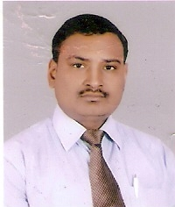

**RAJEEV BHARDWAJ**

Email : - [rajeevbhardwaj022@gmail.com](mailto:rajeevbhardwaj022@gmail.com)

Mobile : - 09454354962,8858802610

S 26/245, R – EP Gautam Bihar Colony

Meerapur Basahin, Varanasi – 221010.

**OBJECTIVE**

To attend the highest post in a reputed organization through sustained efforts and hard work.

**EXPERIENCE**

**Currently I am working with HDFC BANK as BSO from October 2013 to till date.**

**ACADEMIC QUALIFICATION**

* B.Sc Ag. from Udai Pratap College Varanasi in 2001.
* Intermediate from U.P. Board in 1996.
* High School from U.P. Board in 1994.

**Hobbies and interests**

Listening Music, Extensive traveling, Making friendship and do work in the time.

**Personal details:**

Father’s name : Mr. Vijay Shankar

Mother’s name : Mrs. Vimala Devi

Date of birth : 05 – May - 1979

Marital status : Married

Language : English & Hindi

Sex : Male.

**DECLARATION**

The above information is true to the best of my knowledge. I can assure you that if given an opportunity, I will prove my self in the organization as an individual & as a part of team.

____________________

Place: - Varanasi .

Date: - 21/11/2014. (Rajeev Bhardwaj)