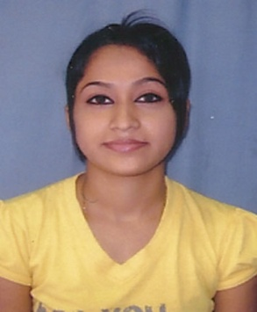**CURRICULUM VITAE**

**CAREER OBJECTIVE**

To seek a position demanding innovative and challenging employment that will utilize my education and skills and offering opportunities for learning and development.

**PERSONAL INFORMATION**

Name : Tushi das

E-mail Id : [tushi.das1@gmail.com](mailto:tushi.das1@gmail.com)

Phone No. : 8721053710

Specialisation : Accountancy

Father’s Name : Sunil das

Sex : Female

Date of Birth : 24-06-1989

Community/Caste : Scheduled Caste

Nationality : Indian

Region : Guwahati (Assam)

Present Address : Sarada Girls Hostel

C/o R C Das Complex hno-107

A K Azad Road, Rehabari-781008

Guwahati Assam

Permanent Address : Dmc hno-161

Lhomithi Colony

Near Lhomithi High School

Dimapur Nagaland 797112

**EDUCATIONAL QUALIFICATIONS**

|  |  |  |  |  |
| --- | --- | --- | --- | --- |
| Sl.no | Year | Course | %(marks) | University(Institution) |
| 1 | 2011-13 | M.Com | 7.1 (CGPA) | Gauhati University |
| 2 | 2008-11 | B.Com | 53.27 | Gauhati University |
| 3 | 2007-08 | HSSLC | 65.67 | NBSE |
| 4 | 2005-06 | HSLC | 78.04 | CBSE |

**ACHIEVEMENTS**

* Course on DIC from ALTAIR Computer Information Centre under Computer Society of India, Mumbai.
* Course on E-office from Manipal Institute of Computer Education, Manipal.
* Course on Accounting with TALLY.ERP.9 from NIIT.
* Won the Best Athlete (girls) in the annual college week in 2012.
* Cleared written examination of IBPS CLERICAL CADRE - 1 in 2011, CLERICAL CADRE - 3 in 2013 & IBPS RRB - 2 in 2013.

**STRENGTHS**

Achievement oriented and ability to manage changes, well disciplined, quick learner, extremely patience and can carry responsibility.

**ACADEMIC PROJECT**

Project: “Awareness of Health Insurance among general public”

Workshop: UGC Sponsored National Workshop on “Research Paper Writing and Presentation”

**LANGUAGES KNOWN**

English, Hindi, Bengali, Assamese

**HOBBIES**

Listening to music and playing games.

**PROFILE**

* A firm believer of God.
* I believe in the maxim “Work is Worship”.

**DECLARATION**

I hereby declare that the information furnished above is true and correct to the best of my knowledge & belief.

Date: Tushi Das

Place: Signature