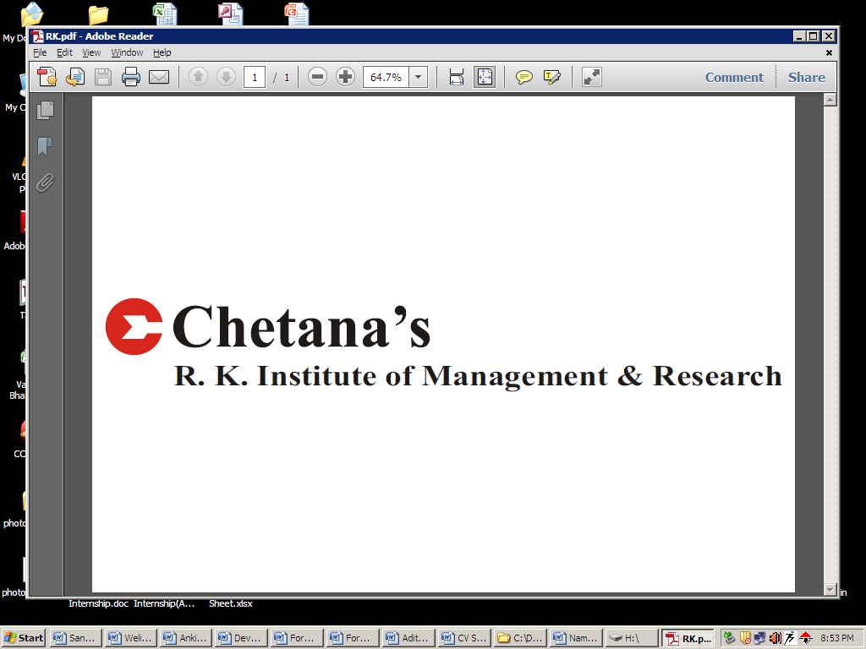

**DENIS NADAR**

**Date of Birth**: 17th December, 1992(22 years)

**Email id:** denispaulraj@yahoo.com

**Mobile No.:** 07208320347

**Present Address:**

301, B Wing, Kaveri Apartment, MG Road,

Goregaon(West), Mumbai- 400104.

**Post Graduate Diploma in Management** Specialization: **FINANCE**

**Academics:**

|  |  |  |  |  |
| --- | --- | --- | --- | --- |
| **Degree** | **Institute** | **Board/University** | **Percentage** | **Year** |
| P.G.D.M(1st year) | Chetana’s Institute of Management & Research | A.I.C.T.E | 69.04 (1stYr) | 2014 |
| B.Com(Accounting & Finance) | Vivek College of Commerce | Mumbai | 71.00 | 2013 |
| H.S.C. | Vivek Vidyalaya Junior College | Maharashtra | 67.17 | 2010 |
| S.S.C. | Vivek Vidyalaya | Maharashtra | 76.15 | 2008 |

**SummerInternship :**

**Company Name: Birla Sunlife Insurance** **May - June 2014**

**Project Title: Sectorial analysis of cement industry**

**Brief Description**:

* Macro analysis of industry
* Performed Ratio analysis
* Technical analysis of cement sector

**Academic Projects:**

**Finance:**

**Equity Research Project –Speciality Restaurants Ltd**

* Macro analysis of industry
* Performed Ratio analysis
* Prepared recommendation report for Speciality Restaurants Ltd

**Acquisition of JLR by Tata Motors Ltd**

* Valuation of the company
* Funding of the Acquisition

**Additional Qualification:**

* Successfully completed M.Com part 1(2014)

**Extra Curricular activities:**

* Khandelwal case study competition committee in Chetana’s Institute of Management & Research
* ELIXIR committee in Chetana’s Institute of Management & Research
* Arthanad committee in Chetana’s Institute of Management & Research
* Participated in a Yes Bank ‘Im the change’ social movie making competition

I confirm that, the above information is true and correct to the best of my knowledge.

**Date: / / Signature**