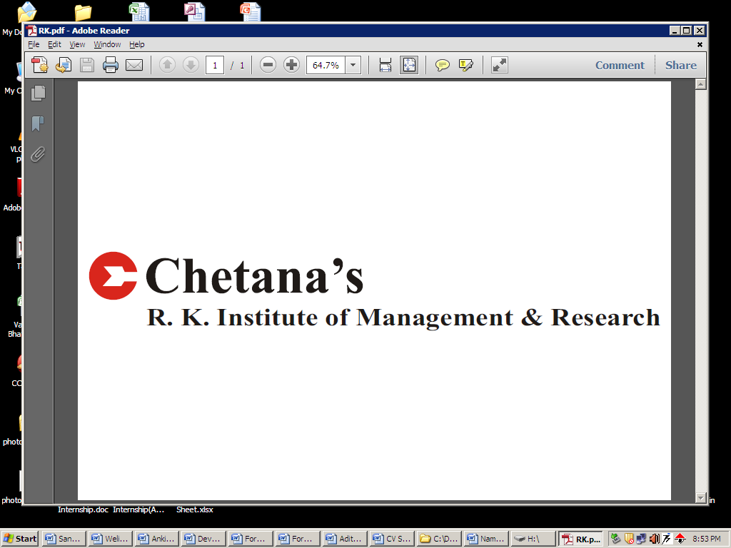
AAFTAB KHAN
+919029295757
aaftab26@gmail.com
POST GRADUATE DIPLOMA IN MANAGEMENT Specialization: FINANCE

EDUCATION QUALIFICATIONS:

Degree | Institute | Board/University | Percentage | Year
P.G.D.M. | Chetana’s Institute of Management & Research | A.I.C.T.E | 72.53 | 2014
B.E(ETRX) | Rizvi College of Engineering | Mumbai | 70.00 | 2010
H.S.C | Rizvi College Of Arts Science & Commerce | Maharashtra | 85.50 | 2006
S.S.C | CH+2 High School | Jharkhand | 73.60 | 2004

CERTIFICATES:

- Completed NCFM Financial Markets (beginners) module
- Completed NCFM Commercial Banking (beginners) module

KEY ATTRIBUTES & SKILLS:

- Multi-tasking
- Hard working
- Team player
- Basic knowledge of MS Word, MS Excel & MS Power point

SUMMER INTRNSHIP:

A project on Credit appraisal process at DENA Bank

KEY TASKS HANDLED

- Assisted in the entire Credit appraisal process starting from verifying the form to disbursing the loan
- Worked on credit transaction & Credit appraisal process which included Risk management & credit Ratings

KEY LEARNINGS

- Learnt the procedure of Retail loans
- Process of DENA Bank

CSR AT CHETANA’S:

FDA (Food and Drug Authority): This was an initiative undertaken to create awareness regarding benefits of registration under FDA amongst vendors and shop keepers. The task assigned to me was to create this awareness amongst vendors and shopkeepers in Borivali area
PROFESSIONAL EXPERIENCE:

Company: IBM India Pvt. Ltd.
Designation: System Support Representative
Duration: June 2011 – May 2012

KEY TASKS

- My responsibility was to give maintenance & Technical Support for IBM P series & Storage servers
- Worked with clients. e.g. Tech mahindra, Indusind bank, Kotak bank, Arca parmacy, Camlin, Canara bank, HDFC ergo, Tata capital, Birla sunlife etc
KEY LEARNING
- Successfully achieved effective & timely execution of projects
- Effective customer grievance management

EXRA CURRICULAR ACTIVITIES:

- Coordinated College events at Rizvi College of Engineering
- Won 1st prize for Dramatics & Fashion show in Engineering College cultural events
- Participated in activities like singing, Painting & outdoor sports in Engineering College events

ACHIEVEMENTS:

- 1st rank holder in SSC in my School
- 1st rank holder in HSC in my College

PERSONAL DETAILS:
Date of Birth: 17th March, 1988 (25 years)
Place of Birth: Gaya
Address: B-301, Poonam Paradise, Haidry Chowk, Mira Road, East, 401107, Thane, Maharashtra
Languages known: English, Hindi, Urdu
Hobbies & interest: Exercising, listening to Indian music, watching movies

Date: Signature

