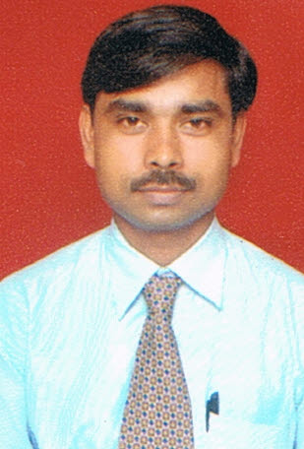

CURRICULUM VITAE
KRISHNA SHUKLA R. NO.5, RUPA DEVI SOC. Contact No.9220909692
SAVARKAR NAGAR Email Id krishna.shukla51@gmail.com
THANE (W) 400604

OBJECTIVES

Seeking a challenge position to utilize my skills and abilities. Which offers a professional growth while being resourceful, innovative and flexible.
OVERVIEW

An effective communicator with excellent relationship building and interpersonal skills, strong analytical, problem solving & organizational abilities. Possess a flexible and deal oriented attitude.
EDUCATIONAL QUALIFICATION

Education | Board/ University | Passing Year | percentage
S.S.C | U.P.Board Allahabad | 1994 | 48%
H.S.C | U.P.Board Allahabad | 1996 | 52%
B.Com | Purvanchal University | 1999 | 58%
M.Com | Purvanchal University | 2001 | 51%

TECHNICAL QUALIFICATION

COMPUTER KNOWLEDGE:

- MS Word, MS Excel.
- Graphic Designing DTP
- Photoshop, Page Maker, Corel Draw.
- Web Designing
- Gif Animation, Flash, Dreamwever, Firework, html.

WORK EXPERIENCE

1) Currently working as a "Corporate Relationship officer” in "HDFC BANK LTD".
(Duration since March 2008 to till date)
Work Profile

- Coordinate with the Head of the Salary Account Process. In Making Presentations, with the MIS Reports of KCM's, updating the daily basis Asset product updates and cross sells.
- Reconciliation of data for the budgeting purpose.
- Creating the Reports deals with Individual level and Zone level.
- Setting up the tentative targets for the Relationship Managers.
- Mail Management, deals with the corporate level issues of the Relationship Managers and checking out the status of the Issues with the given TAT period.
- Conducting the joint meet with the team regarding the productivity and quality of performance.
- Checking with the corporate about the account activated status of the employee.
- Keeping the daily track records of KCM’s and their Sales and Non – Sales Persons.

- Keeping in touch with the Product Dept, HR Dept and with Operation Dept for updates.
- Involved in joining formalities and training the team and new recruits.

2) Worked as an “Account Authorizer” in “ATLAS DOCUMENTARY FACILITATORS CO. PVT.LTD."
(Duration June.2007 to March.2008)

3) Worked as a “Store in charge ” in
“PRATHMESH BUILDERS & DEVELOPERS”
(Duration Feb. 2004 to May.2007)

4) Worked as an “Accountant” in “GAJRAJ ROADLINS.”
(Duration Sep.2001 to Feb.2004)

PERSONAL DETAILS

1) Date of Birth : 7th. Sep. 1978
2) Religion : Hindu
3) Martial Status : Married
4) Nationality : Indian
5) Language Known : Hindi, English

GENERAL EXPERIENCE
1) Discharging duty in positive manner.
2) Doing job task in time bound manner.
3) High standard of discipline in all fields.

STRENGTHS
Hard working, self motivated,
Ready to any kind of work that suit my qualification and experience.
Willingness to learn
Time management skills.
Energetic.

HOBBIES

Watching Cricket, News, Listening song.

DECLARATION

I hereby declare that the above mentioned details are true and best of my knowledge.
Yours faithfully,
(KRISHNA SHUKLA)
Date:
Place:

