

Balaji Institute of Modern Management (BIMM)
(Course Approved by AICTE, Ministry of HRD, Govt. of India)

S. No: 55/2-7, Tathawade, Wakad, Off Mumbai - Bangalore Bypass, Pune - 411 033.
Office: 020-66741049 Placements Committee: 020-66741045
Telefax: 020-66741046 : 020-66741047/48
E-mail: placements@bimmpune.com Website: www.bimmpune.com

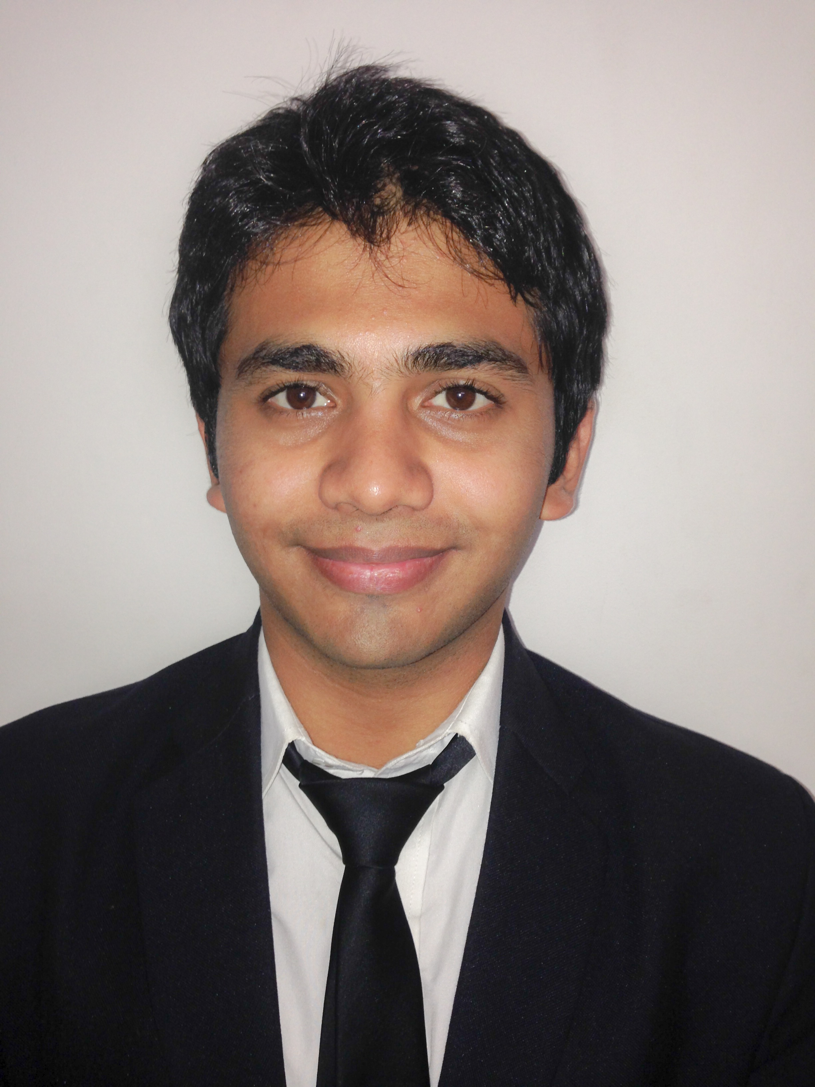

CURRICULUM -VITAE

DISCIPLINE

Marketing

PERSONAL DATA
NAME | Indivar Tewari
FATHER’S NAME | I.S.Tewari
DATE OF BIRTH | 11th Sep 1988
PERMANENT ADDRESS | Laxmi Niketan
PERMANENT ADDRESS | Railway Station Road
PERMANENT ADDRESS | Raebareli-229001
PERMANENT ADDRESS | Uttar Pradesh.
CONTACT NUMBER | +91-9545965076
PRESENT ADDRESS FOR  CORRESPONDENCE | B-202 ,
PRESENT ADDRESS FOR  CORRESPONDENCE | Atul Paradise
PRESENT ADDRESS FOR  CORRESPONDENCE | Dutta Mandir Road,
PRESENT ADDRESS FOR  CORRESPONDENCE | Wakad ,Pune – 411033
PRESENT ADDRESS FOR  CORRESPONDENCE | Maharashtra
EMAIL – ID | Indiv.001@gmail.com
MOBILE NO. | +91-9545965076

2. LANGUAGES KNOWN
LANGUAGES | SPEAK | READ | WRITE
ENGLISH | Yes | Yes | Yes
HINDI | Yes | Yes | Yes

3. ACADEMICS
EXAMINATION / DEGREE | INSTITUTE / UNIVERSITY | YEAR of PASSING | SUBJECTS/ DISCIPLINE | % of MARKS | CLASS
10TH | S.J.S Public School, Raebareli (U.P.); C.B.S.E. Board | 2004 | Science | 75.60 | 1st
12TH | S.J.S Public School, Raebareli (U.P.); C.B.S.E. Board | 2006 | PCM | 73.00 | 1st
B. Tech | S.V.C.S.T,  Bhopal(M.P.);  RGPV University | 2011 | Electronic  & Communication | 69.00 | 1st
PGDM | Balaji Institute Of Modern Management, Pune (Maharashtra) | 2014 | I.T. & Marketing | 67.05(1st year) | 1st

I certify that the marks mentioned in serial no. 3 above have been verified as correct.

Date:

4. WORK EXPERIENCE
SR. nO. | ORGANISATION | POSITION HELD & NATURE OF WORK | DURATION IN MONTHS
NA | NA | NA | NA

DIRECTOR
 | 5. VOCATIONAL TRAINING
SR. NO. | PROJECT tITLE | Organisation | Duration in Months
1. | STEG(Special Test Equipment Group) | H.A.L | 1
2. | Robot Hurdle Designing | SVCST BHOPAL | 1

6. MY CORPORATE INTERFACE DETAILS:
SR. NO. | NAME OF THE COMPANY | LOCATION | DATE
1. | Orchid Hotel | Bangalore | 11/09/12
2. | Mangalore Refineries & Petrochemicals | Bangalore | 12/09/12
3. | Atlas Logistics | Bangalore | 12/09/12
4. | Ernst & Young | Kolkata | 01/08/13
5. | Electrosteel Castings Ltd. | Kolkata | 01/08/13
6. | Ellenbarrie Industrial Gases Ltd. | Kolkata | 02/08/13
7. | Emami Ltd. | Kolkata | 02/08/13
8. | Emami Pharma Ltd. | Kolkata | 03/08/13

7. PROJECT UNDERTAKEN
PROJECT TITLE | ORGANIZATION | PROJECT PROFILE IN BRIEF | DURATION
Market Analysis For LT Jointing Kits For 1.1kv In Eastern Region(Kolkata, Bhubaneswar And Jamshedpur) | 3M India Ltd. | Identify all retailers in respective territory, Survey all competitor product offerings, Study the pricing of competitors, analyze the problems faced by customers like Dealers, Retailers & End users and search for potential retailers. | 1st June 2013 - 31st July 2013

9. HOBBIES & INTERESTS
Solving puzzles, Playing Sudoku,Travelling, Surfing, Interacting with people.

8. ACHIEVEMENTS
Achieved certificate in Maths Olympiad.
Achieved prizes in drawing and sports.
Achieved prizes in volunteering in school and college times.

10. CO–CURRICULAR ACTIVITIES
Parcipated in comedy skit at Mini Dristhi competition at SBS .
Participated in dance at the Inter Duals competition at SBS.
Participated in creativity at Dristhi, Mini Drishti and Inter Duals.

Date: 25/04/ 2014

Place: Pune Signature of the Student

COUNTER SIGNED

Date: 25/04/ 2014 Stamp & Signature of the Director

