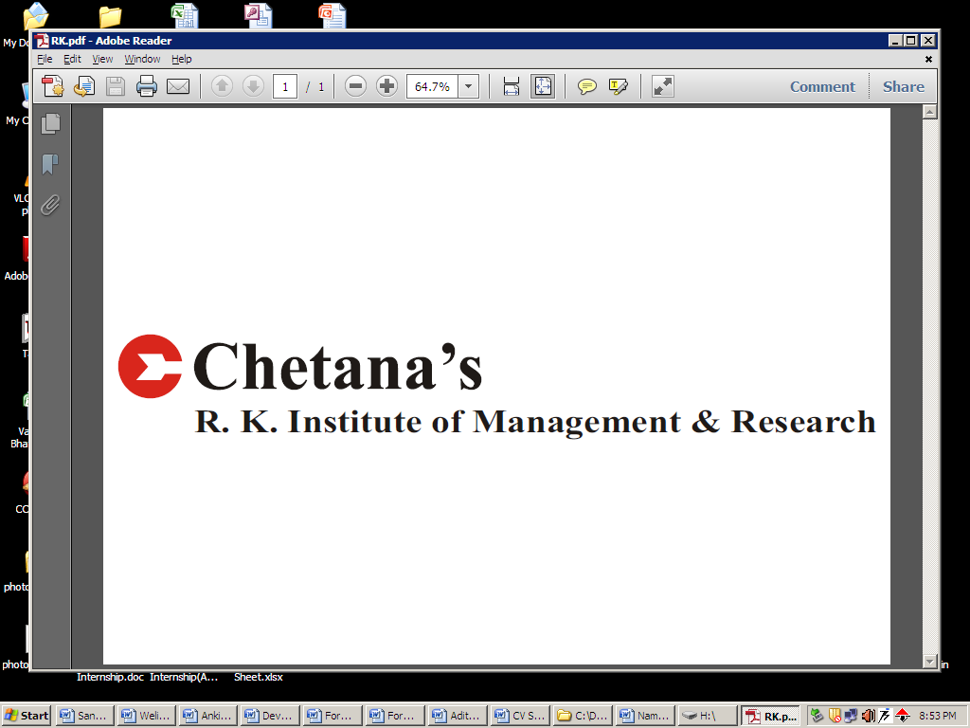
PRATIKSHA PRADEEP BHOSALE
9423915638
bhosale.pratiksha@rocketmail.com

MASTERS IN MANAGEMENT STUDIES SPECIALIZATION: FINANCE

EDUCATION QUALIFICATIONS:

Degree | Institute | Board/University | Percentage | Year
MMS  (SEM-III) | Chetana’s R. K. Institute of Management & Research | Mumbai | 66.83 | 2013-14
MMS(1st Year) | Chetana’s R. K. Institute of Management & Research | Mumbai | 68.8 | 2012-13
B.E. (COMPUTER) | Shah and Anchor Kutchhi Engineering College | Mumbai | 63.67 | 2011
HSC | M. J. College, Jalgaon | Maharashtra | 65.83 | 2007
SSC | P. N. LunkadKanyaShala | Maharashtra | 72.13 | 2005

KEY ATTRIBUTES& SKILLS:

- Easy adaptation to working conditions
- Managing Multiple Priorities
- Patient communicator

SUMMER INTERNSHIP:

A Project on checking the viability of Thal-III expansion plan using capital budgeting toolsat Rashtriya Chemicals & Fertilizers Ltd.

- KEY TASKS HANDLED:

- Analysed the financial viability of the project using methods like IRR and payback period.

- KEY LEARNINGS/ACHIEVEMENTS:

- Experianced the working environment of company and learned practical application of IRR and payback period.
- Understanding the team dynamics and learned to work more efectively as a team.

OTHER PROJECTS:

- Analysis of Mutual Funds in India.
- Graduation project: Use of Technology in Fleet Management System.

CSR AT CHETANA’S:

- FDA (Food and Drug Authority): This was an initiative undertaken to create awareness regarding benefits of registration under FDA amongst vendors and shopkeepers.The task assigned to me was to create this awareness amongst vendors and shopkeepers in Malad(E), Mumbai.

- Jagruti:This was an initiative undertaken to create awareness regarding Gandhian Philosophy and Principles. The task assigned was to create this awareness by selling the autobiography of Mahatma Gandhi to the corporate employees as well as government employees. Also the autobiography was sold to the comman people of the targeted area.

EXTRA- CURRICULAR ACTIVITIES:

- Participated in K.C. College Business Plan competition.

- National Conference of Energy Management - Synergy. (Feb 2013)
Key Activities:
- Conducted Research among women on saving energy
- Prepared questionnaire and conducted survey
PERSONAL DETAILS:

Date of Birth: 27th June, 1990(23 Years)
Place of Birth: Chalisgaon
Address:A-3/2, VittasanchayHsg. Soc., Vashigaon, Chembur, Mumbai-400074.

Languages known:English, Hindi, Marathi

Hobbies and interests: Reading

