KRISHANPAL
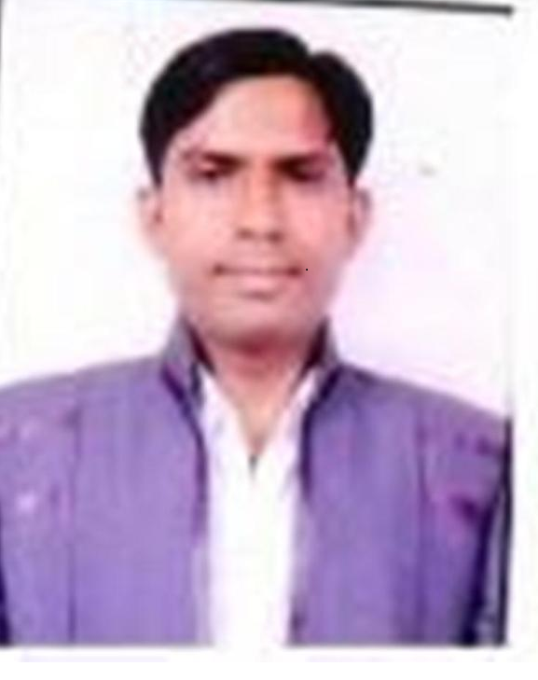 H.NO-509,
Bhowapur near kaushambi
Distt Ghaziabad
U.P- 201012.
Contact No-9910912123
PASSPORT NO: - M16209138
E-MAIL: krishanpal_2000@yahoo.co.in, krishanpalp@gmail.com

- MAJOR INTERESTS  - Cash  Management  - Back Office  - Process  - Soft Skill  - Team Management  - Time Management  - Strength  - Good Relation Maintaining Capability  - Enthusiastic, Punctuality, Laborious, Determined.  - Eagerness to learn positive Thinking towards goals  - High Patience | OBJECTIVE  To join a position of responsibility and be an asset in a professionally managed progressive organization, where I can exploit my knowledge and experience.  PROFILE  Highly organized & motivated, able to work effectively as part of a Team or Individual.  TATA CROMA (INFINITI RETAIL.LTD)  Tenure : Dec 2008 To Till Date  Designation : Account Executive  Achievement:  - Handling 3 stores at IGI Airport for 5 years  - Appreciated for taking initiative in starting Sales person Id  - Handled operations as well as with finance and played key role resolving ftp issue which was a major problem in inventory management  - Trained staff as well as Head-cashiers for different work environment for Airport.  - Won award for being “Most Resourceful Employee” at Airport Store by S.M  Job Responsibility :  - Handling & Collecting Sale cash on daily basis.  - 100% accuracy in cash counting.  - Handling a team of cashiers at the front-end and Point-of-sale (POS) machines.  - Tally credit card transactions with the Bank statements.  - Better command in SAP, in terms cash & card entries book in the SAP  - As per auditor reports action taken on points for high or medium risk  Vishal Mega Mart  Tenure: DEC.2007 TO OCT.2008  Designation :- Head Cashier  Job Responsibility:-  - Handling & Collecting Sale cash on daily basis.  - 100% accuracy in cash counting.  - Handling a team of cashiers at the front-end and Point-of-sale (POS) machines.  - Making payments in case of refunds.  - Tally Credit Card transaction with Batch close statements (Batch settlement reports).  EDUCATIONAL QUALIFICATION  - M.A Geography from C.C.S.University  - B. A. Geography (H) from Delhi University  - 12th from C.B.S.E, Delhi.  - 10th from C.B.S.E, Delhi.  PERSONAL DETAILS  Father’s Name : Shri Gopal  Date of Birth : 12th July, 1985  Marital Status : Married  Hobbies : Listening To Music  Language Known : English, Hindi  Personality Traits : Punctual & Smart Working  Nationality : Indian  Date : __________ Place : ________

