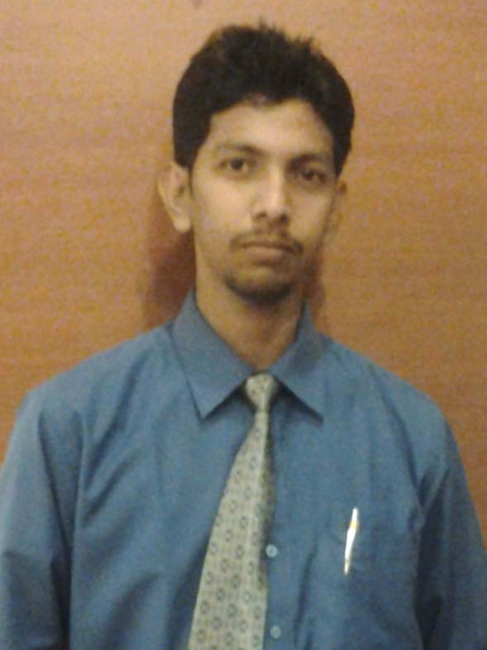
RESUME

SUMON MAHANTA
E.Mail-mahantasumon111@gmail.com
Phone : +91 9706347312/9577520615

CAREER OBJECTIVE:
To find a challenging position to meet my competencies, capabilities, skills, education and experience
Experience Highlights-
As a officers sales in Axis Bank, Guwahati (9th feb’2013 –Till date)
Job Responsibilities:
- Plan and carry out sales activities to achieve numbers and value targets of savings/current accounts for the allocated branches through self sourcing, in accordance with agreed business plans and target.
- To identify and resolve service issues faced by the Corporate
- Achieve cross-sell targets for MF/Demat/ FD/ LI/Assets/G.I.
- Ensure sourcing of quality accounts by maintaining the depletion rate within agreed limits.

ACADEMIC QUALIFICATION:

Examinations | Board / University | Institutions | Year
B.Sc.(Phy chem, Math) | Gauhati University | Abhayapuri College | 2010
Higher Secondary | Assam Higher Secondary Educational Council, Assam | Abhayeswari HS&MP School | 2005
Matriculation | Secondary Educational Board of Assam, Assam | Abhayeswari HS&MP School | 2003

Strengths:
- Self starter and self motivated
- To quickly grasp product knowledge and apply it in operations
- Adapting to changes instantly
- Open to challenges and new learning opportunities.
- Strong Decision making ability
- Ability to balance various priorities & accomplish multiple tasks
- Strong sense of personal accountability, leading from the front and approaching every situation with positive energy and enthusiasm
- Highly analytical, numerate and proficient in complex modeling and their implementation.
- Outstanding presentation, communication and interpersonal skills
- Drive for making things happen
- I am open to work in any location in NorthEast
Accreditations:
- MS Office (MS Office, Excel, Power Point, Access)
- Tally 7.2
- Fluency in INTERNET surfing
Achievements:
- “New BDE highest CASA opening Guwahati Circle ”, March’2013
- HEAT OF THE BEAT AC OPENING WINNER , JULLY2013
- CASA THUNDER WINNER GUWAHATI CIRCLE DEC'13
- MASTER STROK (CASA CAMPAINGE) WINNER , MARCH'14
- G.I. GURU WINNER,MARCH'14
- HEALTHY HABBIT (G.I) WINNER,APR'14
- OTR MAHASANGRAM (VIR) WINNER, JUN'14
- ABC Q1 WINNER,JULLY,14
- MASTER STROK (CASA) Winner JUN'14

Languages known: - Assamese, English and Hindi, Bengali (READ WRITE AND SPEAK)

Personal Details:-
Date of Birth – 28th September 1987
Father’s Name – Bhola Nath Mahanta

Marital Status- Single

CONTACT INFORMATION:

Permanent Address Present Address
LACHIT NAGAR W\N0-3 House No-04 , DURGASOROBAR
P. O. ABHAYAPURI KAMAKHYA GATE.
DIST- BONGAIGAON GUWAHATI 781009, ASSAM
783384, ASSAM PHONE NO-9706347312
PHONE(M)- 097063-47312

Declaration:
I hereby declare that the information furnished by me is correct to the best of my knowledge.

PLACE: Guwahati.

Sumon Mahanta
DATE:

