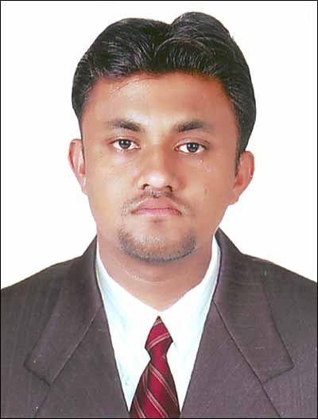
SATINDER PAL
Saraba nagar
Gali no3 Malout Dist. Muktsar Mb. 94179-14354
email:satinderpalgoyal@gmail.com

CURRICULUM VITAE

PERSONAL DETAILS .

Full Name : Satinder Pal Goyal
Date of Birth : 28 Feb., 1984.
Father’s Name : Mr. Prem Nath
Mother’s Name : Mrs. Bindra Rani

Permanent Add. : Sarabha Nagar
Gali No 3 Malout
Dist Muktsar (pb)-152107
Religion : Hindu
Nationality : Indian
Gender/ Marital Status : Male/ Married
Language Known : English, Punjabi & Hindi

OBJECTIVE .

On emotional intelligence front, I possess a high degree of positive attitude and hardworking ability to work well with others. Having strong educational qualification in the field of management, Company which will offer challenging opportunities to prove my skills and also offer maximum professional growth and development.

EDUCATIONAL QUALIFICATION .

- MBA from Punjab Technical University, Jalandher in MIMIT Institute, Malout.
in session 2007-2009 with 72% marks .

- B.A. from Punjab University Chandigarh in session April /2007 .

- Stenography from ITI Bathinda under P.S.T.E.B. in session sep/2004 .

- Stenography in high speed in language dept Bathinda in session sep/2005 .

- Six month computer course in Maharaja Aggarsain college in Bathinda .

PROFESSIONAL QUALIFICATION

MBA from Punjab Technical University, Jalandher in MIMIT Institute, Malout.
Specialization in Marketing as major & Finance as minor.

WORK EXPERIENCE .

- job in the HDFC bank malout branch from Dec 9, 2009 to Dec 1, 2010 on the post sales Executive .
- job in Axis bank Malout branch on the post Business Development Executive from Dec 2, 2010 to march 2012 .
- Job in Axis bank malout branch on post of Officer Sales from April 2012 to May 2013 .
- Job in Axis bank malout branch on post of AM-Sales From June 2013 to till date .
- Job in Axis bank circle office chandigarh as sales coordinator for entire Punjab from Dec,2014 to till date
COMPUTER/IT & OTHER SKILLS .

- Basic Knowledge of Computer with six month computer course .
- Knowledge of Internet

TRAINING .

- Training of 6weeks at Ultratech Cement in Bathinda under the project of “Awareness of Brand Ultratech among masons as compare to ACC and Ambuja ”

ACHIEVEMENTS & EXTRA CURRICULAR ACTIVITIES .

- Snap on the wall on the circle wall for qualify in double of the threshold target in second quarter .
- Medal from circle head for best performance in life insurance compain in first quarter of 2012 .
- certficate from circle head for high value current accounts compain in oct 2012 .
- Prize from circle head axis bank for qualify in circle wall of frame champions for six top BDEs of the circle in first quarter end of 2011 .
- Certificate from circle head axis bank for achievement of goals in 2nd quarter End of 2011 .
- Certificate from circle head axis bank for best performance in General insurance campaign 2011.
- Win 1st prize in game Sudoku in Eklego 07 function in MIMIT Malout .
- 2nd prize in Business Quiz in Eklego 09 function in MIMIT, Malout.
- Organize the Paper Presentation in Eklego 09 function in MIMIT, Malout.

HOBBIES .

Observing about others ,Listening music and remain busy in work

DECLARATION: .

I here by declare that above information provided by me is very much true to my knowledge and brief.

( SATINDER PAL GOYAL )

