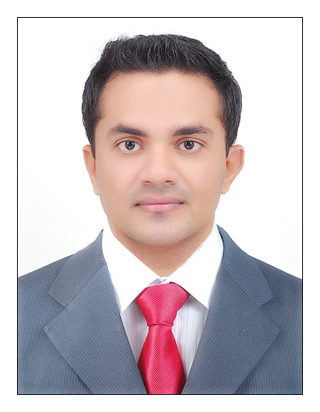 muhammad faizal

Nadapuram-Calicut.

faizalvp@yahoo.com

9061 33 66 95

Seeking to work professionally in a reputable firm, with an aim to contribute positively towards the objectives of the organization, using commitment to work, perfection and youth as my key tools.

- Customer Care | - Interpersonal Skills
- Teamwork | - Managing under Pressure
- Business Communications | - Quantitative Ability

Education

Master of Business Administration (Marketing)

Computer Skills

Microsoft Office • All Versions
Microsoft Windows • All Versions

Skills & Strengths

- Problem Solving and Decision Making Skills.
- Energetic, creative, Committed, Self Dependant, Team Player, customer mania driven
- Financial and Analytical Skills
- Leadership Skills
- Good Planning and Organizing Skills
- Good command of MS Office applications
- Ability to work under stress
- Ability to work in multi task environment

Language Skills

- English – Writing, reading & speaking
- Arabic – Read & write
- Malayalam - Native speaker, can read & write
- Hindi – Reading, writing & speaking
- Tamil-Speaking
- Kannada-Speaking

work experince
OCT 2012-DEC 2014

Worked as a Area Manager for COASTAL KITCHEN CORPORATE CATERING SERVICE, Bangalore-India

Role & Key Responsibilities

- Setting sales targets
- Maximising sales and profitability
- Providing team with a stimulating and supportive environment
- Maintaining and increasing standards of customer service
- Driving team performance
- Controlling the training and development of staff

NOV 2009 – AUG 2012

Worked as a Marketing Executive for AST SOLUTIONS LLC,Dubai.

Role & Key Responsibilities

- Focused on good customer service and orientation
- Meeting customers requirements efficiently
- Dealing with high profile customers
- Taken initiative to improve the process related projects.
- Placing myself in the shoes of the customers & understanding their problems
- Achieving team’s Target
- Sending daily sales report to the management.

MAY 2004 – SEP 2009
Worked as a Real Estate Agent for Parco Real Estate,Bangalore-India.

Role & Key Responsibilities

Present purchase offers to sellers for consideration
- Act as an intermediary in negotiations between buyers and sellers, generally representing one or the other
- Compare a property with similar properties that have recently sold to determine its competitive market price.
- Advise clients on market conditions, prices, mortgages, legal requirements and related matters
- Promote sales of properties through advertisements, open houses, and participation in multiple listing services
- Accompany buyers during visits to and inspections of property, advising them on the suitability and value of the homes they are visiting.
- Prepare documents such as representation contracts, purchase agreements, closing statements, deeds and leases
- Interview clients to determine what kinds of properties they are seeking
- Coordinate property closings, overseeing signing of documents and disbursement of funds
- Generate lists of properties that are compatible with buyers' needs and financial resources
- Contact property owners and advertise services to solicit property sales listings

Personal Details

Date of Birth : 7th March 1984

Sex : Male

Marital Status : Single

Nationality : Indian

Driving license : Valid Indian Driving license

Declaration:
I hereby declare that the particulars given above are true to the best of my knowledge and belief.

muhammad faizal

