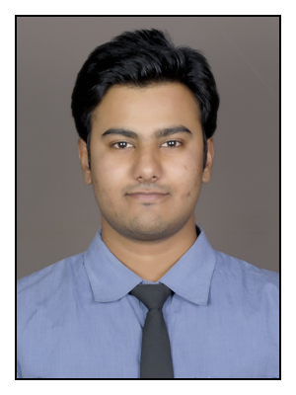

Amit Jain
Permanent Address:  24/5 Balkeshwar colony, Agra(U.P.)-282005  Contact: +91-9540234446  E-Mail:  amit.jain1721@gmail.com  Personal Data:  Date of Birth: 17th Oct.1989  Sex: Male  Nationality: Indian  Marital Status: Single  Hobbies & Interests:  - Surfing on Internet  - Playing cricket  - Dancing(free style)  Key Skills:  - Decision making  - High Potential  - Team Worker  - Conversant with English & Hindi  Computer Proficiency:  - Language: C, asp.net.  - Database: Access.  - Operating system : Windows | Educational Qualifications  - PGDBRM Diploma in Banking from Manipal University, Bangalore.  - Bachelor of Technology Rajasthan Technical University in Computer Science stream.  Carrier Objectives  Seeking a challenging position in a progressive growing organization to  work hard, achieve success and acquire the richness and variety of  experience as I move forward in the field of Banking.  Personal Value  I mainly believe in hardworking and strong determination and always give the best to achieve success in all fields.  Experience  Deputy Manager (Relationship Officer)  Kotak Mahindra Bank ltd  August 2014 - Present  - Maintained profile for all new and existing customers as per individual financial requirement.  - Provided assistance to all walk-ins and developed relationships to maximize sales.  - Admirable experience in performing various banking operations as relationship officer for clients  - Maintained sales tools and increase optimal practices to facilitate sales.  - Developed customer profile and initiated sales activities through cross selling.  - Evaluated all customer relationship and assisted to resolve all customer issues.  - Developed strategies to retain customers and expand the customer base for bank.  - Facilitated strategies to increase customer service base and minimized risks.  Software Engineer  Girnar Technologies  April 2012- May 2013  - Experienced the working on c# platform and making small projects.  - Working in a team as well as individually.  - Designing dataflow, forms, logic with C#.  - Using session and Java script.  - Java language implementation  - Using Access database.  Academic Details  2013-14 PGDBRM (8.01 CGPA) Manipal University  2007-11 B.Tech.(67%) RTU, Kota  2006-07 AISSCE (XII) CBSE Board  2004-05 AISSE (X) CBSE Board  Awards & Achievements  - Having 7th n 8th I.T. NITAT aptitude test certificates.  - Won prize in Microsoft competition at Jaipur.  - Won Ist prize in cricket competition.  Social Responsibility Program  - Attended various seminars conduted by AKSHAYAPATRA.  - Helping under privileged by providing them food and clothes.

I declare that the above information is true to the best of my knowledge.

Place: Noida Sincerely
Amit Jain

