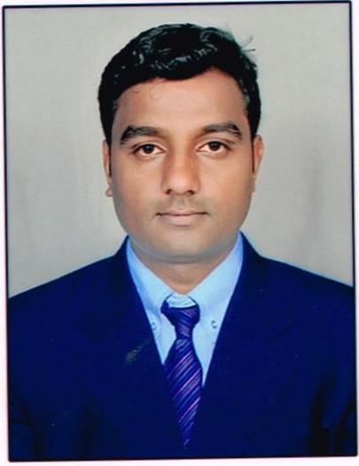
SHORT SUMMURY:

Sadanand Hiremath
At: Mansur 580007
Taluk-Dist: Dharwad
State: Karanataka
Location: Dharwad
Phone: 9164042110
Email:hiremath2110@gmail.com

Date of Birth: 5 June 1989
Gender: Male
Nationality: Indian

Name |  | : Sadanand Hiremath
Nationality |  | : Indian
Father’s Name |  | : Thirakayya Hiremath
Mother’s Name |  | : Suvarna Hiremath
Place |  | : Dharwad
Year of Passing Degree |  | : 2011
College |  | : SMC College of Commerce, Dharwad
M.com in |  | : Commerce(2013)
University |  | : Karnatak University, Dharwad
Preferred Job Location |  | : Anywhere
Languages Known : Kannada, Hindi, English

Marital Status : Single

Domain Knowledge
Accounts/Event Management

RESUME
Sadanand Hiremath
At: Manasur
Taluk: Dharwad 580007
Dist: Dharwad
Karnatak, India
Phone No: 9164042110
E-mail ID: hiremath2110@gmail.com

Educational Qualification:

Sl No | Qualification | Institute | University | %
1 | SSLC | Basel mission | KSEEB | 59.84%
2 | PUC | Madeena college | Karnatak University | 53.16%
3 | B.Com | SMC college | Karnatak University | 60.33%
4 | M.com (External) in | KU, Dharwad | Karnatak University | 45.07%

As Business development Manager
JOB Experience In Muthoot Finance Ltd 23/11/2011 to till Date

♦ Key Skills
- Experts in operating system like windows XP, Windows 2000.
- Proficiency in MS office
- Skilled in computer typing and settings
- Good verbal and written communication

♦ Strengths and Accomplishments: Enthusiastic and creative; demonstrated abilities to meet deadlines and objectives. Excellent organizational and communication talents; solid skills in improving productivity and efficiency while reducing costs.

I hereby declare the above mentioned details are true to the best of my knowledge.

Place: Dharwad

Sadanand Hiremath Date :

