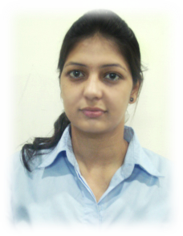
Curriculum Vitae

Sandeep Kaur
H.No-693/19 Ralia Ram Colony
Jail road
Dist: Gurdaspur
Punjab (INDIA)
Pin Code-143521
Email: sandeep.randhawa24@gmail.com
Phone No: +91-9988833882

CARRER OBJECTIVE

Ready to dedicate myself in an organization which provides an opportunity for my creativity and be a contributing member to the success of the organization by effectively utilizing the skills I have acquired..

EDUCATIONAL QUALIFICATION

QUALIFICATION | SCHOOL/COLLEGE | BOARD /UNIVERSITY | YEAR | %AGE
B.Tech  (Computer Science Engineering) | Lovely Professional university, Punjab | LPU | 2009-2013 | 7.5cgpa
12th | Pt. Mohan lal S.D  College, Gurdaspur | Punjab Board | 2009 | 68.3%
10th | Little Flower Convent  School, Gurdaspur | ICSE | 2007 | 74.4%

TECHNICAL SKILLS

Software : SQL Server
Languages : HTML,C, C++, ASP.net

EXPERIENCE

- Sales Executive in Top Careers &You(Ludhiana)
(from: 6th July 2013 to 8th feb 2014)
- Sales Executive in IDBI bank
(from: 8th feb 2014 to till date)

EXTRA CURRICULARR ACTIVITIES

- Painting
- Sketching

LANGUAGES KNOWN

- English
- Hindi
- Punjabi

STRENGTH

- Positive Attitude
- Hard working
- Leadership skills
- Team Worker
- Quick learner
- Ability to handle work in an efficiently and timely manner.

HOBBIES AND INTEREST

- Listening Songs
- Watching Movies
- Sketching
- Travelling
- Playing Games

PERSONAL DETAILS

Father’s Name : Mr. Satnam Singh
Mother’s Name: Mrs. Daljit Kaur
Date of Birth : 24 – 11 – 1990
Gender : Female

Sandeep kaur

