CURRICULUM VITAE
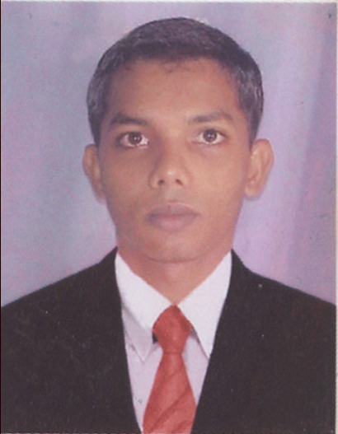

Alick Darius D’Souza
H.No. 1/74, Opp. Grand St. Anthony’s Chapel,
Gaura Waddo, Calangute, Bardez, Goa - 403516
Mobile: +91 9823494046
E-mail: alickdsouza@gmail.com

Career Objective

To obtain a position in a progressive organization that provides growth through challenging assignments where my skills can be put to optimum use and contribute towards the common goals of the organization.

Current Work Experience

Presently working for Thomas Cook India Ltd. as “Customer Relations Executive” in Foreign Exchange Dept. from 02/07/2012 till date. As the Brand name suggests, Thomas Cook is recognized world wide for its Foreign Exchange & Travel related services. Presently Thomas Cook is holding AD-II license to carry on foreign exchange business of retail & wholesale trxns i.e. purchase / sales of Foreign Currencies/TC’s/DD’s/Prepaid Multi-Currency Forex Card as well as sending money abroad through TT remittance.

Job Profile

- Quoting/Booking currency rates, handling & processing retail transactions i.e. purchase/ sales of foreign currencies/ TC’s/Prepaid forex cards of our clients (walk-ins as well as corporate clients) over the counter or delivery at our client’s residence or their offices.
- Quoting/Booking currency rates & handling bulk purchases/sales of our wholesale customers over the counter or doing collections at their respective offices.
- Issuing Foreign Drafts and processing outward remittance i.e. TT’s of our clients.
- Processing inward transfers of our clients through Money Gram & Express Money Transactions.
- Identifying new customers like Travel Agents/ Banks/ Consulates/Corporate for our Forex related services.
- Assisting in sorting, packing & delivery of our currency for exports at airport.
- Handling office Cash Counters in absence of Staff

Previous Job Experiences

Worked for Wall Street Finance Ltd. (Spice Money) as “Marketing Executive” from 27/12/2010 to 30/06/2012. Which is a primary agent for Western Union Money Transfer also holding ADII license for Foreign Exchange & Outward Remittance of Money.

Job Profile

- Marketing & Outsourcing of New Agents to do Western Union Money Transfer Business
- Having tie ups with Banks, Co-operative Societies & other financial institutes
- Looking after branding & advertising of the co. as well as sub agents
- Solving any issues of sub agents regarding Western Union Money transfer
- Handling office Cash Counters in absence of our regular staff

Worked for Paul Merchants Ltd. as “Business Development Officer” from 15th November 2007 till 21st December 2010. Which is a Primary Agent for Western Union Money Transfer, Forex with AD II License, Travel Agents of railways, Airway and Accommodations bookings.

Job profile:

- Attending to queries & issues of existing WU Sub Agents
- Marketing & sourcing of New Western Union Sub Agents as well as Forex Tie ups with Hotels, FFMC’s & Banks
- Maintaining & building cordial business relations with Western Union Sub Agents as well as Customers
- Western Union software Installation & attending to any software related queries of Sub Agents
- Punching accounting entries, encashment receipts, etc.
- Handling Bulk Pickups, offloading currencies as well as sale of foreign currencies
- Arrangements of funds & issuing cheques of sub agents in the absence of Accountant

Worked as a “Time Keeper” in HR dept. in Hotel Marinha Dourada, Arpora, Goa from 17th May 2007 to 14th November 2007.

Job Profile:

  - Daily attendance of Staff
  - Submission of PF & ESIC of new Joinees
  - Holding appointment dates of interviews for new candidates
  - Disbursement of staff salary
  - Solving any staff related issues & queries

Worked as Trainee in Taj Holiday Village, Sinquirim in Front Office (Reception), House Keeping, F&B Service & Kitchen Depts, from 1st May 2006 to 31st November 2006.

Educational Qualifications

- Graduation B.Com First Class, securing 63.00%
GOA UNIVERSITY - 2005
Goa-India

- H.S.S.C First Class, securing 63.00%
GOA BOARD - 2002
Goa- India

- S.S.C Second Class with 56.00%
GOA BOARD - 2000
Goa- India

Other Qualifications

- PG Diploma in Hotel Management & Tourism, Passed in the year 2006
- Web Designing HTML
- Summer Course in Accounting Package Tally 7.2
- Short term Course in First Aid from Indian Red Cross Society

Personal Information

Gender Male

Date of Birth 19th December, 1984

Nationality Indian

Marital status Single

Religion Roman Catholic

Passport No. G2249749

Expires On 28/02/2017

Personal Skills

- Interpersonal Skill To built and maintain good relations with colleagues & clients

- Hard Worker Punctual and can take on challenges and responsibilities.

- Dedicated Hardworking and sincere dedication to work.

- Languages known English, Hindi and Konkani.
(Read, write & speak)

Hobbies & Interests

Playing outdoor games like Football & Cricket, Surfing the net, listening to music & making new friends.

