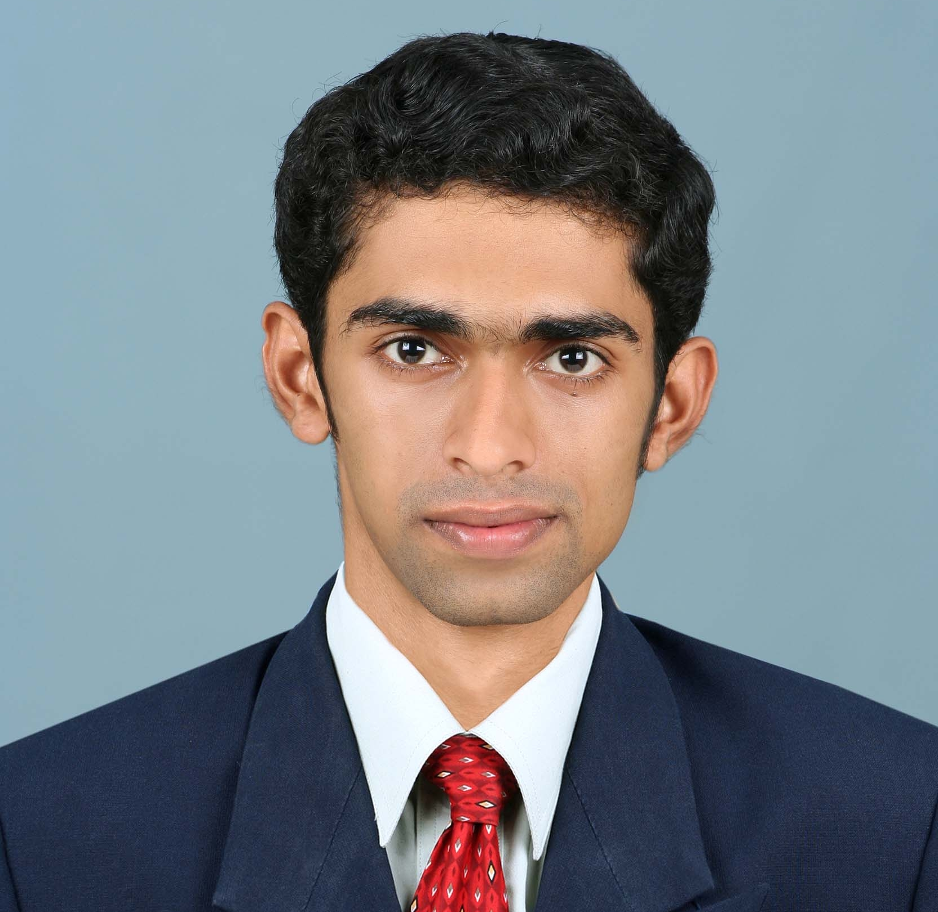
K. M. ABRAHAM

Mobile: +91 9962894394
Phone: +91 44 26210028
+91 481 2564370
E-mail: kma.sandeep@gmail.com
CAREER OBJECTIVE
To pursue a career in an organization, which will facilitate continuous learning and best utilization of my skill sets and which will be rewarding for the organization and me.
CAREER PROFILE

1. Organization : HSBC Bank (Chennai, India)
Designation : Sr. Premier Client Manager
Duration : September 2013 to May 2014

- Job Description :
  - Acquiring & developing trusting relationships with affluent clients and key stakeholders.
  - Develop sales plan for each relationship to provide an array of services.
  - Coordinating and Assisting RMs in handling client relationship.
  - Identifying and guiding clients for their Basic banking needs.
  - Creating Investment Platforms for New Banking Relationships and ensuring activation of the Retail Investment System.
  - Retaining and Value building existing clientele.
  - Collaborate with internal teams regarding development and implementation of cross-selling initiatives.
  - Facilitate regular communication with external resources to develop new businesses.

Designation : Premier Wealth Manager
Duration : November 2010 to August 2013

- Job Description :
  - Acquiring and Servicing High Net worth Clients and their related businesses.
  - Conceptualize Strategic Financial Plans for clients based on results of Comprehensive Need Assessment.
  - Providing Wealth Management Solutions: Mutual Funds and Insurance to meet the financial objectives of clients.
  - Staying current with Internal and External Knowledge to help clients meet short and long term financial goals.
  - Periodic discussion with clients to evaluate their portfolio and suggest necessary rebalancing.

Accomplishments:
- Successfully completed a nine month integration Assignment with HSBC InvestDirect Securities (I) Ltd (from July 2012 to March 2013).
- Secured numerous new Ultra HNI relationships to achieve significant scale in revenue.
- Recognized for valuable contribution in several CSR initiatives of the Bank.
- Won special recognition for high client satisfaction levels and in treating customers fairly in year 2013.
- Awarded for outstanding performance in Money Campaign 2012.
- Among the first members in the acquisition team to initiate mortgage business.

2. Organization : Aditya Birla Money Mart Ltd (Chennai, India)
Designation : Sales Manager
Duration : March 2010 to June 2010

- Job Description :
  - Acquired and advised clients for Equity Investment.
  - Acquired clients in Bullion trading and investment.
  - Recommended and initiated clients to alternate asset classes: Managed Futures, Structured Products, Private Equity and Real Estate Funds.
Accomplishment
  - Successfully build a book of clientele from Zero base, which became the highest revenue generator to the retail team.

3. Organization : ICICI Securities Limited (Chennai, India)
Designation : Relationship Manager
Duration : November 2006 to March 2010

- Job Description :
  - Developed and oversaw new clients for Online Investments (ICICI Direct.com)
  - Advised clients on investments in Equities & Derivatives.
  - Identified Clients Risk Profile, Needs and Financial Objectives through Personal Financial Planning.
  - Recommended Tax planning solutions with focus on Mutual Funds and Insurance.
  - Trained new staff and clients on financial products and Online Trading platform.
Accomplishments:
- Consistently exceeded monthly Sales goals while providing highest level of customer service.
- Was among the Top 10 Relationship Managers in Equity Revenue generation.
- Selected based on product expertise to support the training team.

4. Organization : Religare Securities Limited (Thrissur, India)

Designation : Business Ambassador
Duration : January 2006 to July 2006

- Job Description
- Identified and developed clients for trading in Equities and Derivatives and advised them in managing their portfolio.
- Acquired and guided clients in Commodity Trading (MCX and NCDEX).
- Created Mutual Fund clientele, and monitored and managed the fund portfolios.
Accomplishment:
- Initiated and implemented Client referral program and Asset Allocation model for Business Development.

5. Organization : Kotak Securities Limited (Thrissur, India)
Designation : Sales Executive
Duration : December 2004 to December 2005

- Job Description : Acquired, advised and guided clients on various Investment products: Equities, Derivatives and Mutual Funds.
Accomplishment
- Among the best in the region in Mutual Fund New Fund Offer collection in 2005.

EDUCATION
Degree  /Diploma | Specialization | College /University | Year
MBA | Marketing and Human Resource Management | Nehru College of Management / Bharathiar University | 2001-2003
B Com | Costing and Taxation | Baselius College / MG University | 1998-2001
+2 | Costing and Taxation | Baselius College / MG University | 1996-1998
10th |  | Marian Junior College / C.B.S.E. | 1995-1996

STRENGTHS

- Analytical and Conceptual Skills

- Organizational and Planning Skills

CERTIFICATIONS

- Certified by AMFI for Mutual Funds.

- Certified by IRDA for Life Insurance.

PERSONAL DETAILS

Date of Birth | : | August 15th, 1980
Gender | : | Male
Marital Status | : | Single
Nationality | : | Indian
Passport Number | : | L4177486
Linguistic Proficiency | : | English, Tamil, Malayalam, Hindi and French
Interests | : | Reading, Listening to music, Outdoor games and Traveling.

CONTACT ADDRESS

AC57/3, BLUESTAR,
5TH AVENUE, ANNA NAGAR,
CHENNAI - 600 040
TAMIL NADU, INDIA

