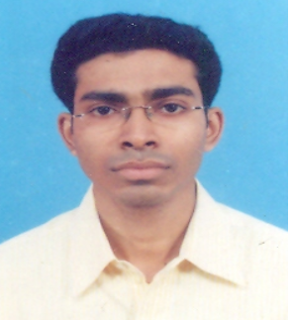

CURRICULUM VITAE

NAME: KOUSHIK KUNDU
ADDRESS: 28/1/1 KHAGENDRA NATH GANGULY LANE,
SALKIA, HOWRAH, WEST BENGAL.PIN – 711106

MOBILE No: 9831135478

E-mail: koushiktheking@gmail.com
OBJECTIVE
To be part of a leading organization with challenges and opportunities to grow and having good environment with committed, dedicated people, so that I can explore myself fully and realize my potential.
PRESENT EMPLOYMENT STATUS:
Presently working as an executive in Capital Market Division with ICICI Bank Ltd sister concerns the 3i InfoTech BPO Pvt. Ltd.
Responsibility:
- Arrange the fund for Pay-In of NSE, BSE, MCX, & also NCDEX.
- Process the RTGS/NEFTs within TAT.
- Process the Transfer and also clearing cheques.
- Prepare & confirm the BG/FDs Documentation.
- Visit to Client for better service, and also resolve the client’s requirements.

PROFESSIONAL EXPERIENCE:
- Worked with Dynamic Equities Pvt. Ltd. as an executive officer in share account department for 5 years 10 months (2008-2013).
- Worked as a processing officer with ADFC Pvt. Ltd. a sister concern of the HDFC Bank Ltd for 4.1 years (from 2004 to 2006 in CMS/Clearing department & 2006 to 2008 with Stock Exchange department).
- Worked with the TTTI (Technical Teacher Training Institute) as an executive officer in a/c department for 1 year contract (Oct. 2002 – Sept. 2003)

Responsibility (In Dynamic Equities Pvt. Ltd.):
- Managing and leading a team towards achieve the organizational goal.
- Reconcile the Bank, Exchange and also Clients ledgers.
- Analyzing the Clients, Banks and Exchanges requirement and resolving the same timely.
- Regular discussion with the higher management regarding the ongoing processes and quality improvement strategies.
- Implementation of these plans into actions through regular interaction with the team members.

Responsibility (In CMS/Clearing Department of HDFC Bank Ltd.):
- Processes all type of clearing and transfer cheques and check the reports.
- Processes the return cheques from RBI clearing house.
- Control the outstanding dues of outstation clearing cheques.
- Process the CBDT form time to time.
- Maintain the EOD Report perfectly.

Responsibility (In Stock Exchange Department of HDFC Bank Ltd.):
1. Generate report and funded the PayIn of NSE, BSE, MCX, & also NCDEX.
2. Managing remittances – Issuing Managers Cheques and Demand Draft on demand of account holders. And timely delivery of the same to the customers.
3. Processes the RTGS and also booking the FD’s.
4. Processing the Transfer Cheques and giving timely credits to the account holders
5. Generate the branch journal report and also checked that.

ACADEMIC QUALIFICATION:

- B.Sc from Calcutta University (2002)
- H.S. from WBCHSE (1999)
- Madhyamic from WBBSE (1997)
- BSE F&O Exam

COMPUTER KNOWHOW:

Complete GNIIT from NIIT.
Conversant with Cashin, Finware, Flexcube Finacale and also Expart, Ecomm of Synergy Software.

STRENGTH
- Always do things with full confidence and do not get perturbed by initial difficulties.
- Very quick but careful in making decision as to get the best result.
HOBBIES
- Love to Listening the music.
- Making new friends.
- Visiting new places.
PERSONAL DETAILS
- Date of Birth :- 21.01.1981
- Father’s Name :- Late Manick Ch. Kundu
- Sex :- Male
- Marital status:-Unmarried
- Nationality:-Indian
- Language Known: - English, Bengali, Hindi.
- Mobile No. :- 9831135478
- Expected CTC : Negotiable

DECLARATION:
The above information furnished by me is true to the best of my knowledge and belief.
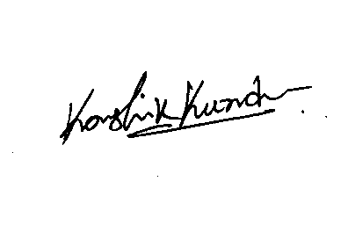 KOUSHIK KUNDU

