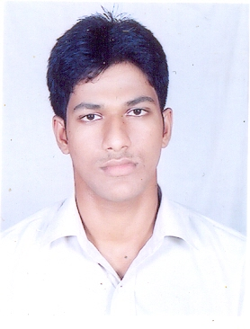
SANDEEP JENA
S/O MR. SANJAYA JENA
QR. NO. D/20 OTM COLONY,
AT/PO CHOUDWAR
CUTTACK,
ODISHA-754025
PHONE NO.- +91-9124464823
Email ID: sandeepjrocks@gmail.com

Career Objective
Intend to build a career with leading corporate firm or institute with committed & dedicated people, which will help me to explore myself fully and realize my potential. To make sincere and continuous efforts towards building a promising career and to take challenges in life so that I can contribute to the growth and success of the organization I
am working with.

Educational Qualification
EDUCATION | BOARD | INSTITUTE | YEAR OF PASSING | PERCENTAGE
10th | BSE | KALINGA VIDYAPITHA | 2005 | 78
+2 SCIENCE | CHSE | J.K.B.K JUNIOR COLLEGE | 2007 | 67
B.TECH IN ELECTRONICS & TELECOM. ENGG. | BPUT | SYNERGY INSTITUTE OF ENGG. & TECHNOLOGY | 2011 | 6.49(CGPA)
M.TECH IN ELECTRONICS & COM. ENGG. | BPUT | GANDHI INSTITUTE FOR TECHNOLOGY | CONTINUING
Software Familiarity
Languages : C/ C++.
Operating System : Windows XP/Vista/7
Software Packages : MS Office

JOB PROFILE
Worked as a Marketing Executive At Indic Institute Of Design And Research from 21.08.12to12.09.13.

Co curricular Activities
Presented a seminar on ‘Role of electronics in cricket broadcasting’ in 7th semester & ‘Electronics bomb’ in 8th semester in SIET,Dhenkanal.
Submitted a mini project on ‘Variable DC power control’ & a major project on’Toll plaza using radio frequency identification’ in SIET,Dhenkanal.

Extra-curricular Activities
1. Represent my school in many science exibition
2. Represented my school and got best student award in 2002
3. Represented my school in quiz compition in 2002
4. Participated in many cultural event & won best actror award
5. Represented my school in Interschool Debate competition and won prize
6. Organizer of many academic & cultural events

Special Interests
Planning & organizing events & functions,Cooking ,Listening to music & Gardening

Personal Skills
Honest and Energetic, Quick Learner, Easily Adaptable to Various Situations, Ready to Accept Challenges, Believe in Team Work, Good Coordinating Capability

Personal Profile
NAME : SANDEEP JENA
FATHER’S NAME : MR. SANJAYA JENA
MOTHER’S NAME : MRS. ANITA JENA
DATE OF BIRTH : 28/02/1990
AGE : 24
SEX : Male
MARITAL STATUS : Single
NATIONALITY : Indian
LANGUAGES KNOWN : English, Hindi & Oriya
MOBILE NUMBER : +91-9124464823

Declaration

I do hereby declare that the above mentioned information is correct to the best of my knowledge and belief and I bear the responsibility for the correctness of these particulars.

DATE: 20/08/14
PLACE:CHOUDWAR SANDEEP JENA

