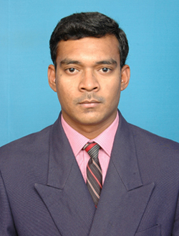  No:90/33 , Perumal koil Street ,  Velapadi, Vellore.  Pincode-632001  Cell : 7502886127  Mail id : sgjjpf@gmail.com  Father’s name : G.Sekar  Mother’s name : S.Girija  Date of birth : October 22,1989  Sex : Male.  Nationality : Indian.  Hobbies : Listening Music | S.JOTHESHWARAN  OBJECTIVE  To work in an organization with an opportunity for continuous improvement that leads to the growth of the organization as well as the individual. Willing to work as a key player in challenging and creative environment.  PROFESSIONAL RECORD  2007-2011 B.TECH, with 70%.  Department of Information and Technology  Ranipettai Engineering College, Walajah, .  Vellore District.  2005-2007 HSC , with 65%  Desia Matric Hr Sec School , Vellore  2004-2005 S.S.L.C with 75%  Desia Matric Hr Sec School , Vellore  .  SKILL SET  - Programming languages : C, C++  - Operating System : MS-Dos , Windows 2007/Xp  - Application Tools : Rational rose  - Web Technology :HTML , Asp.net  - Database :MS-Access, SQL Server2008  - Package :MS-Office  AREA OF INTEREST  - Technical Support  - Customer Service  - Programming in C and C++  - Customer handling
Place :VELLORE  Date : 22/06/2015 | EXPERIENCE  WORKED AS FACULTY FOR COMPUTER SCIENCE IN SRI VIJAY MATRIC SCHOOL,VELLORE( 2 YEARS)  WORKED AS SYSTEM ADMINSTRATOR IN HIMALAYA OFFSET , VELLORE( 2 YEARS )  STRENGTH  - Adaptable and Hardworking  - Commitment to team work  - Flexible and self motivated  - Creative Thinking  EXTRA CURRICULAR ACTIVITIES  - Actively participated in college sports.  - District Table Tennis Player  PROJECT DETAILS  Project Title : A Trace-Driven Approach to Evaluate the Scalability of P2P-Base Video-on-Demand Service  Language : Dot Net Technologies  Team size : 4  ADDITIONAL QUALIFICATION  - Computer Hardware And Troubleshooting(TPGET,Vellore)  - Diploma in Dot Net Technologies(NIIT)  DECLARATION  I hereby declare that the above information furnished is true to the best of my knowledge.  S.Jotheshwaran

