CURRICULUM VITAE

POST APPLLEID: BANK OFFICER(FRONT OFFICE/BACK OFFICE)
+RETAIL BANKING+BRANCH BANKING)
Sharathchandra s poojary 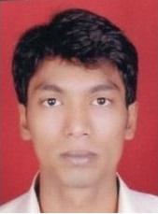
S/o Sundar poojary
R-No E/1, Santhoshimatha Nagar,
Tagore Nagar 5,
Vikroli(E),Mumbai 83.
Ph:+919867184479
Email ID: sharath.s.poojary@gmail.com

career objective:
To take up a challenging career in an any field where I can use my organizational skills, education background and ability to achieve the goals of the organization.

ACADEMIC QUALIFICATION:

Course | Institution | University Board | Year of Passing | Aggregate Marks
PGDBO  (Post graduation diploma in banking operations) | IFBI  (Insurance Finance and Banking Institute) | NIIT | 2013 | 73%
BCA | Pompei College.Aikala | Mangalore | 2012 | 55.58%
II PUC | Vidhya Vardhaka  P.U College, Mundkur | Karnataka Broad | 2009 | 67.16%
SSLC | Vidhya Vardhaka  P.U College, Mundkur | Karnataka Broad | 2007 | 63.04%

TECHNICAL QUALIFICATION:

NISM Series-V : Depositoy Operations Module Certification Examination. | NISM  (National Institute Of Securities Market) | NISM | June 2014 | 68%
NSDL-Depository Operations Module of the NCFM | NCFM  (National Certification in Financial Market) | NSDL | Jan 2014 | 65%

Technical skills:
- Core Banking Software : FINACLE
- Programming Languages : C, C++, HTML, Java,VB
- Operating Systems : Windows, Unix
- Database : DBMS,SqlServer05,Vb.Net
- Database Packages : Oracle
- Web Designing Tools : HTML, XML

WORK EXPIRIENCE:
- Worked as a Trainee software tester in Sourcepage Technologies Pvt.Ltd Mangalore from dec 2011 to may 2012.
Sourcepage Technologies Pvt. Ltd is a consulting company providing training, software and consulting services on the IT industry on a global basis. Realizing the importance of quality process the company is equipped in providing quality services to our clients worldwide on the main two areas i.e. learning and providing training for students and IT based Development services

WORK EXPIRIENCE:

Company : ICICI Bank Ltd. – Dadar Branch, Mumbai.
Duration : 31st October 2013 to 07th November 2015
Designation : Senior Officer – Branch Banking (Demat Desk
Officer)

KEY RESPONSIBILITIES

- Currently handling Demat Desk.
- Handled Customer Query desk.
- Handled Cash Counter.
- Handled SOX Audit of Branch.
- Handling FCRM software for processing customer requests.
- Handling Branch Audit.
- Strategize and Implement business plans to attain the branch business targets for the products and services of the bank.

- Manage customer relationships and Promote opportunities for cross-marketing/ business development.
- Assured quick resolution of customer queries & problems and maintained consistently high quality standards in client interaction to increase business through positive customer feedback.
- Advising the customer the appropriate Deposit and Investment schemes, etc.
- Seek out ways to increase client satisfaction.

INTERNSHIP

Company : ICICI BANK LIMITED.
Duration : 31st oct 2013 – 31st jan’2014
Objective : To Study & Handle Various Operations in the Retail Branch
Banking

ACHIEVEMENTS

Have qualified for “Monsoon Madness” contest of ICICI Bank for the month of July 2014 from Mumbai region.

Have qualified for “August Kranti” contest of ICICI Bank for the month of August 2014 from Mumbai region.

Have qualified for “Sizling September” contest of ICICI Bank for the month of september 2014 from Mumbai region.

OTHER ACTIVITIES, ABILITIES & KNOWLEDGES:
- Having full knowledge of Branch Banking Operations
- Having knowledge of Bank Specific product & Processes
- Having Thorough Knowledge of Application Software for Banking Operation(ASBO)
- Having Knowledge of Effective Business communication
- Having Knowledge & familiar with Retail Banking(RB )
- Familiar with Financial Product & Services(Insurance, Mutual Funds)
- Having Knowledge of Retail Banking Products
- Having knowledge & familiar with Software testing & Developing

PASSPORT DETAILS:

Passport No : N5698376
Passport Expiry Date: 28/12/2025
Place Of Issue : Mumbai

Personal Profile:
Father Name : Sundar S Poojary
Mother Name : Lalitha S Poojarthy
Date of Birth : 31/07/1989
Sex : Male
Nationality : Indian
Language Know : English, Kannada, Hindi, Tulu & Marati.
Contact Nos. : +919867184479

Declaration:
I Sharathchandra S Poojary hereby declare that the above mentioned details is true for the best of o my knowledge.

Place: VIKHROLI 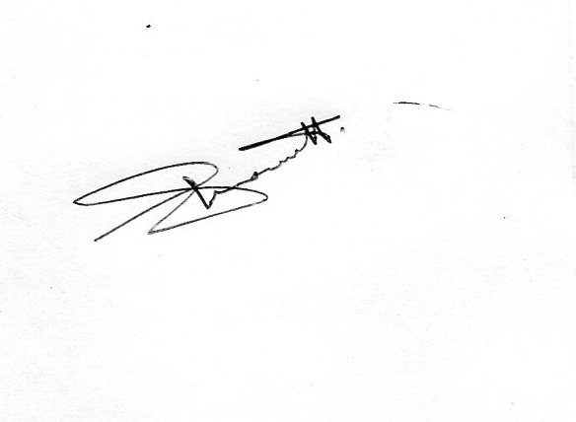
Date: [ Sharathchandra S Poojary ]

