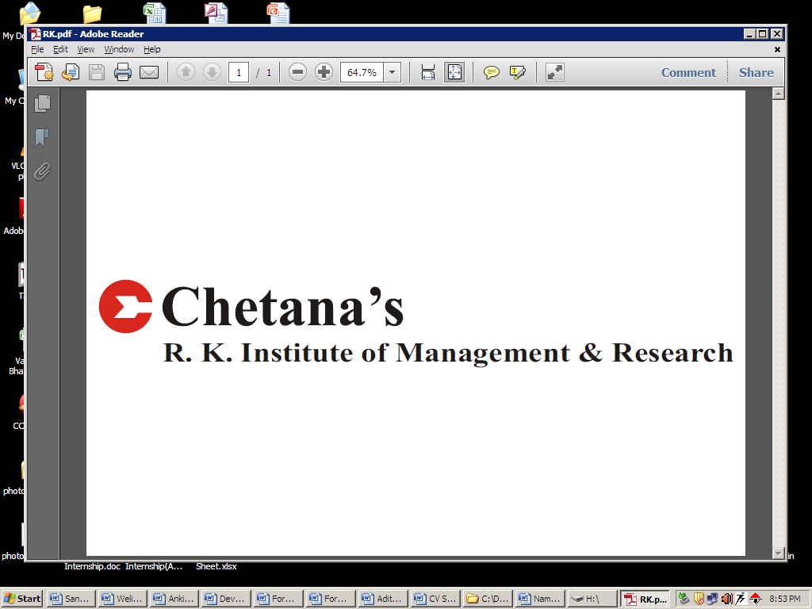

**Name: Mansi Mehta**

**Phone no: 9920162010**

**Email Id:** [**mansimehta576@gmail.com**](mailto:mansimehta576@gmail.com)

**Post Graduation Diploma in Management Studies SPECIALIZATION:Marketing**

**EDUCATION QUALIFICATIONS:**

|  |  |  |  |  |
| --- | --- | --- | --- | --- |
| **Degree** | **Institute** | **Board/University** | **Percentage** | **Year** |
| PGDM | Chetana’s Institute of Management & Research | A.I.C.T.E | 71.80 | 2014 |
| M.com | Mumbai University | Mumbai | 58.75 | 2011 |
| B Com | Mithibai College | Maharashtra | 72 | 2009 |
| H.S.C | Mithibai College | Maharashtra | 68.33 | 2006 |
| S.S.C | St. John’s High School | Maharashtra | 68.80 | 2004 |

**KEY ATTRIBUTES& SKILLS:**

Adaptable ,flexible, initiative, team-work, , excellent communication skills

**SUMMER INTERNSHIP:**

A Project on Marketing Research and Marketing of Cloud Products With Channel Partners and Customers in **Ingram Micro**

* **KEY TASKS HANDLED:**

1. Finding the Customers for Cloud Business
2. Data analysis and providing report to Management
3. Marketing Activities for creating awareness
4. Managing and tracking Interns all across India
5. Creations of EDM/Emailer Campaign to promote Ingram Micro Cloud Business

* **KEY LEARNINGS/ACHIEVEMENTS:**

1. Able to generate orders through online marketing
2. Able to create awareness about the various integrated products of cloud
3. Confidence of creating a relevant reports which are useful to management
4. Leadership with good team work

**CSR AT CHETANA’S:**

1. **FDA (Food and Drug Authority):** This was an initiative undertaken to create awareness regarding benefits of registration under FDA amongst vendors and shopkeepers. The task assigned to me was to create this awareness amongst vendors and shopkeepers in Malad East
2. **Jagruti:** This was an initiative undertaken to create awareness regarding Gandhian Philosophy and Principles. The task assigned was to create this awareness by selling the autobiography of Mahatma Gandhi to corporate, students, government officials, etc

**EXTRA- CURRICULAR ACTIVITIES:**

* Member of organizing committee in the Elixir Committee by Chetana’s Institute of Management & Research.
* Worked as Class Representative

**PERSONAL DETAILS:**

Date of Birth: 14th August, 1988

Place of Birth: Mumbai

Address: E-104, Anmol Tower, Opp. Patel Petrol Pump, Goregoan (W). Mumbai-

000062

**Languages known**: English, Hindi, Marathi, Gujarati

**Hobbies and interest:** Dancing, Listening to Music, Travelling

**Date: Signature**