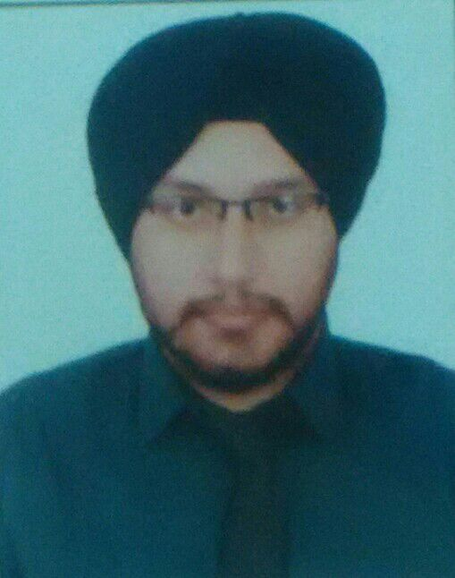

**SIMRANJEET SINGH Mobile number: 09873072050**

**Email: aman.simran11@gmail.com**

**162 GAGAN VIHAR EXTN.**

### Career Objective

To work in an organisation that provides a challenging environment to develop my skills and also offers ample opportunities for career growth. I would also like to contribute to Technical advancement adding values to Technology, to Society and myself.

### Educational Qualification

|  |  |  |  |  |  |  |  |  |  |  |  |  |
| --- | --- | --- | --- | --- | --- | --- | --- | --- | --- | --- | --- | --- |
| |  |  |  |  |  |  | | --- | --- | --- | --- | --- | --- | | ***Course*** | | ***Institute/University*** | | ***Year of passing*** | ***Percentage*** | | ***High School***  ***Intermediate***  ***B.B.A(MKT& FIN)***  ***M.B.A(HR & MKTG)*** | C.B.S.E  C.B.S.E  G.G.S.I.P.U  G.G.S.I.P.U | | 2006  2008  2012  2015 | | 70%  68%  68.5%  70% | |

**Professional Experience**

* Experience of working in D.T.D.C for 8 months( October 2012 to may 2013)
* In my training period I was able to be the part of major project of D.T.D.C as an executive
* I also awarded with the title of employee of the month

### Software Exposure

* Ms-word
* Ms-excel
* Ms-power point

### Achievements

* Done anchoring in college fest
* Got first prize in add- mad show
* Participated as a coordinator in management fest

### Strengths

I am a fast learner, hardworking, responsible, honest, sincere and fully dedicated towards my work.

I have good communication skill, will power to succeed and firm belief in God.

I am self-disciplined; target oriented with high level of integrity and co-ordination skills and can undertake self-responsibility whilst being a team player.

### Hobbies

* Net Surfing
* Acting
* Playing cricket
* Solving puzzles

### Personal Details

Date of Birth : 29-07-1990

Father’s Name : MR.BALJEET SINGH

Languages Known : English, Hindi and Punjabi

Nationality : Indian.

Marital Status : Single.

Gender : Male

### Declaration

I, Simranjeet Singh hereby declare that all the details furnished above are true to the best of my knowledge and belief.

Place: Delhi Simranjeet Singh.