**CURRICULAM VITAE**

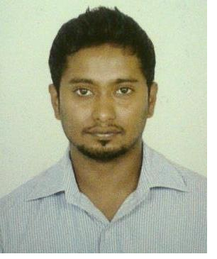

**TINTU C V**

#105, HMT Main Road, Gokulam, Mathikere, Opp. KEB OFFICE, Bangalore-560054.

**Email**: [tintu.cv7@gmail](mailto:tintu.cv7@gmail.com).com

**Mob: +918197532417.**

**Career Objective**

To be result oriented, innovative and pursue a challenging career opportunity which would utilize my professional knowledge, skill and experience, thus resulting in quantum growth and success of self and organization.

**EXPERIENCE**

|  |  |  |  |
| --- | --- | --- | --- |
| **Firm** | **Designation** | **Duration** | **Year** |
| **HDFC Bank** | Senior Sales Officer | 2.3years | June2006-2008 Sep |
| **ICICI Prudential** | Unit Manager | 10months | May 2009-2010 Feb |
| **KotakMahindraBank** | Assistant Manager | 2.6 years | June 2010-2012 Dec |

**Professional Experience:**

**Job profile in HDFC Bank** (Bangalore) (June2006-2008 Sep).

● To manage a team of Executives

● To have appointments with HR or Finance manager of the corporate

● To provide presentations

● To open salary accounts for corporate

● To sell Mutual funds, Demat accounts and credit cards

● To satisfy customer’s expectations

● To clarify client’s queries

● To check KYC norms.

**Job Profile in ICICI Prudential** (Bangalore) (May 2009-2010 Feb).

● To recruit Financial Advisors

● Give them training and support

● Make them to write the IRDA Exam

● To handle a team of Advisors

● Go for calls with them

● Motivate them to get the business

● Solve their problems

● Make them active

● Take care of the logins and issuance of the policies

● Take care of advisors commission and rewards.

**Job profile in Kotak Mahindra bank** (Bangalore) (June 2010-2012 Dec).

**Working for Kotak Mahindra Bank as Asst. Manager.**

● Acquisition of large/medium size corporate for current account and salary

account.

• Be a one point of contact to the corporate for all the business banking requirements and managing the relationship

● Smooth roll out of account opening process. Ensure the corporate does salary

transfers in the account opened with in the time frame.

● Cross selling other third party products for higher revenue generation.

● Conducting activities and getting Help desk in corporate at regular interval.

● Meet Revenue targets for the month and preparing blue print for market

expansion.

**Educational Qualifications**

|  |  |
| --- | --- |
| SSLC | Swamy Vivekananda English School, Shimoga.  DVS Independent College, Shimoga. |
| PUC |
| BBM | Sahyadri commerce College, Shimoga |
| MBA | Shankargatta School Of Management, shimoga. |

**Computer Skills**

OPERATING SYSTEM WIN7, WIN XP

**Extracurricular Activities**

• Actively participated in various cultural programs, in school and college levels.

• Participated in management programs

**Key Result Areas**

● Recruitment of people

● Motivating people

● Corporate sales

● Presentation

● Team management

● Customer Handling

**Personal Data**

Date of Birth : 20th Jan 1985

Age : 28

Gender : Male

Nationality : Indian

**Languages Known**

English, Malayalam, Tamil, Hindi, Kannada and Telugu

**Hobbies**

● Listening Music

● Watching TV

● Playing cricket, football

**Declaration**

I hereby declare that all the information furnished above is true to best of my knowledge. Place: Bangalore

Date: [Tintu c v]