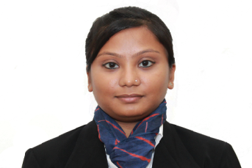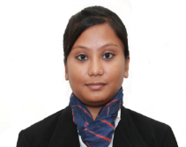

|  |  |  |  |  |  |  |  |
| --- | --- | --- | --- | --- | --- | --- | --- |
| **Education** | | | | | | | |
| **Course** | **Stream** | **Board/University** | | **Institution** | | **Year of Passing** | **% / CGPA** |
| **PGDM** | Marketing & Finance | All India Council of Technical Education | | Fortune Institute of International Business(FIIB), New Delhi | | Expected 2015 | 6.09/10 |
| **BBA** | Management | Indraprastha University | | Institute of Information Technology and Management, New Delhi | | 2013 | 70% |
| **XII** | Commerce | CBSE | | R.B Sr. Sec. School, New Delhi | | 2010 | 67% |
| **X** | General | CBSE | | R.B .Sr. Sec. School, New Delhi | | 2008 | 64% |
| **Corporate Internship Program – PGDM** | | | | | | | |
| **Mott MacDonald** *Trainee & Intern* April 2014 - June2014  ***Assessment of Financial Literacy and Inclusion in India with focus on Delhi NCR region***   * To evaluate the needs and gaps of Financial Literacy amongst different socio economic classes in Delhi & NCR region * Conducted primary research through questionnaire and analyzed through excel and SPSS * Recommended Mott MacDonald to suggest government to create financial awareness among people especially women and youth by sending banking correspondents to each areas and through workshops, camps and advertisements | | | | | | | |
| **Integrated Term Project - PGDM** | | | | | | | |
| ***ICICI Bank*** October 2014  ***Analysis of ICICI bank***   * To understand teller department’s process and to analyze financial data of ICICI bank * Conducted secondary research for analysis of banking industry and ICICI bank * Recommended ICICI bank to reduce their service charges and maintain better relationship with its customers by responding to their complaints in stipulated time | | | | | | | |
| **Coursework Projects - PGDM** | | | | | | | |
| **Course** | | | **Title** | | **Objective and Learning** | | |
| ***Marketing*** | | | Customer Value Creation  -Why Motorola failed in the Indian market? | | * Collected Primary data by interacting and interviewing customers through self-made questionnaire * Understand customer’s mobile requirement and analyzed their needs and reason for why Motorola did not survive in the Indian market. Presented as a video case study | | |
| ***Marketing Research(Graduation)*** | | | Comparative study of Customer Preferences on  Lenovo and Dell Laptops | | * Collected Primary data by interacting and interviewing college going students * Determined the preference level of consumer towards laptop | | |
| **Other Elective Courses**: *Product & Brand Management, Consumer Behavior, Business Intelligence &Analytics, Advanced Marketing Research, Services Marketing, Business to Business, Business Research and Consulting, Financial Statement Analysis, Social media Marketing* | | | | | | | |
| **Other Information** | | | | | | | |
| **Position of Responsibility Held**   * Trained interns at Mott MacDonald   **Extracurricular Achievements**   * Completed Live project for Prognosys E-Service Pvt Ltd on *“Segmentation of Networking Channel Partners”* * Volunteered in *SAMAVESH 2014 in FIIB &* for activities of Finance club and Cultural Committee of FIIB in 2013 * Participated in *ADMAX* – advertisement competition 2013 at FIIB, New Delhi * Participated in National Seminar on *Issues & Challenges in the Growth of Indian Economy in 2012* at IITM, New Delhi * Played VolleyballCompetition at Zonal Level, 2008-2010 , New Delhi   **Other Skills and Interest**   * Understand and can speak Hindi, English & Bengali fluently * Possess basic knowledge of MS – Word, MS – Excel & IBM SPSS * Enjoy solving logical puzzles | | | | | | | |