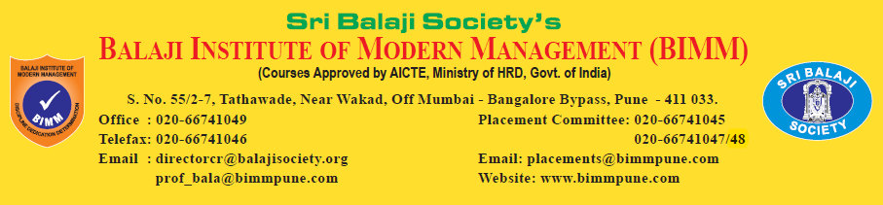

**CURRICULUM VITAE**

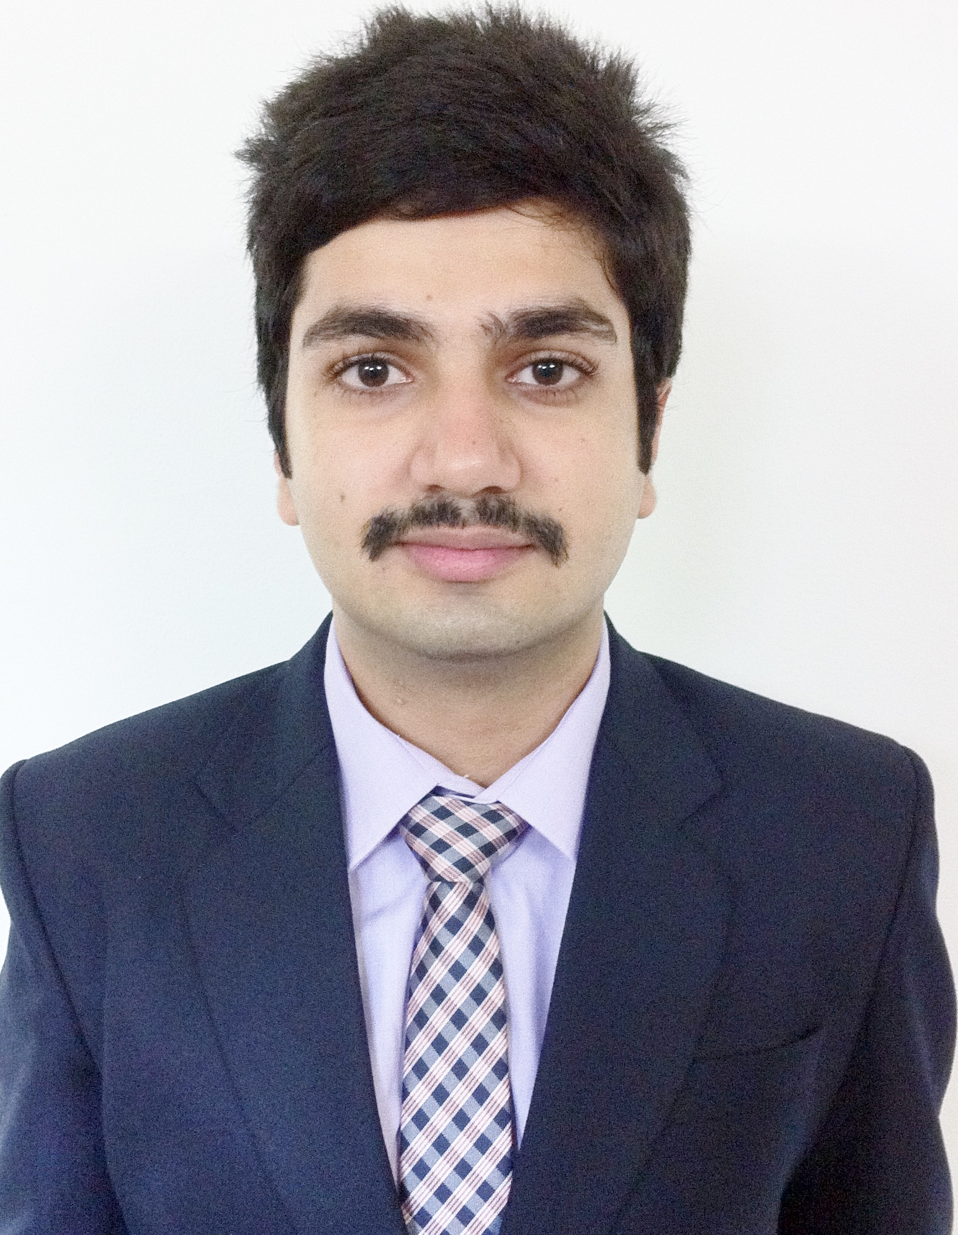

|  |
| --- |
| **DISCIPLINE** |
| **MARKETING** |

|  |  |  |  |
| --- | --- | --- | --- |
| **1. PERSONAL DATA** | | | |
| **NAME** | | **ISHAAN MALHOTRA** | |
| **FATHER'S NAME** | | **SUNIL MALHOTRA** | |
| **DATE OF BIRTH** | | 0  9  9  1  2  12  5  **0**  **(dd/mm/yyyy)** | |
| **PERMANENT ADDRESS** | | **C-7 BASANT VIHAR,LASHKAR** | |
| **GWALIOR,M.P** | |
| **474009** | |
| **CONTACT NUMBER** | | **0751-4011661** | |
| **PRESENT ADDRESS FOR**  **CORRESPONDENCE** | | **203,MEERA BUILDING ALANKAPURI OPP BANK OF MAHARASHTRA PASHAN SUS ROAD,PUNE** | |
| **411021** | |
|  | |
| **E-MAIL ID** | | [**malhotraishaan@yahoo.co.in**](mailto:malhotraishaan@yahoo.co.in) | |
| **MOBILE NUMBER** | | **8390910222** | |
|  | | | |
| **2. LANGUAGES KNOWN (TICK APPROPRIATELY)** | | | |
| **LANGUAGES** | **SPEAK** | **READ** | **WRITE** |
| **ENGLISH** |  |  |  |
| **HINDI** |  |  |  |

|  |  |  |  |  |
| --- | --- | --- | --- | --- |
| **3. ACADEMICS: Xth AND XIIth STANDARD** | | | | |
| **NAME OF THE**  **EXAMINATION** | **BOARD** | **YEAR OF PASSING** | **PERCENTAGE OF MARKS** | **CLASS** |
| **Xth STANDARD** | **CBSE** | **2007** | **67.8%** | **SSC** |
| **XIIth STANDARD**  **STREAM(Commerce)** | **CBSE** | **2009** | **74.2%** | **HSC** |

|  |  |  |  |  |
| --- | --- | --- | --- | --- |
| **4. ACADEMICS: GRADUATION/ POST GRADUATION** | | | | |
| **DEGREE WITH**  **STREAM** | **INSTITUTE AND UNIVERSITY** | **YEAR OF PASSING** | **PERCENTAGE**  **OF MARKS** | **CLASS** |
| **BBA (MARKETING)** | **ANSAL INSTITUTE OF TECHNOLOGY**  **TILAK MAHARASHTRA VIDHYAPEETH(Gurgaon)** | **2012** | **57.4%** | **2nd** |
| **PGDM(MARKETING)** | **BALAJI INSTITUTE OF MODERN MANAGEMENT(Pune)** | **2014** | **62%**  **Till 1st sem** |  |

**I certify that the marks mentioned in serial no. 3 & 4 above have been verified as correct**

**Date: DIRECTOR**

|  |  |  |  |
| --- | --- | --- | --- |
| **5. PROJECTS UNDERTAKEN** | | | |
| **Sr.**  **No.** | **PROJECT TITLE** | **ORGANISATION** | **DURATION**  **FROM TO** |
| **1** | **Analysing the commercial fleet potential in Gwalior for bias and Radial Tyres & to promote sales promotion of JK Tyres & Industries Ltd.** | **JK TYRE COMPANY** | **1st June-31st July 2011** |
| **2** | **Consumer Preference Towards Organised Retail** | **Reliance Digital** | **3rd June-31st July 2013** |

|  |  |  |  |
| --- | --- | --- | --- |
| **6. MY CORPORATE INTERFACE DETAILS-1: DURING JULY 2012** | | | |
| **Sr. No.** | **NAME OF THE COMPANY** | **LOCATION** | **DATE** |
| **1** | **MINDA MANAGEMENT SERVICES LTD.** | **MANESAR** | **10-09-2012s** |
| **2** | **MINDARIKA PVT LTD.** | **MANESAR** | **10-09-2012** |
| **3** | **ARVATO SERVICES INDIA PVT LTD.** | **GURGAON** | **10-09-2012** |
| **4** | **SUZUKI MOTORCYCLES INDIA PVT LTD.** | **MANESAR** | **10-09-2012** |
| **5** | **APPULSE RETAIL SOFTWARE SOLUTION** | **GURGAON** | **10-09-2012** |
| **6** | **RAMCO SYSTEMS LTD.** | **DELHI** | **10-09-2012** |
| **7** | **MLS AND COMPANY** | **GURGAON** | **10-09-2012** |
| **8** | **ENERGY AVENUES PVT LTD.** | **DELHI** | **10-09-2012** |
| **9** | **BTW INDIA PVT LTD.** | **DELHI** | **11-09-2012** |
| **10** | **SMC MANAGEMENT SERVICES LTD.** | **DELHI** | **11-09-2012** |
| **11** | **ABC ENTERPRISES** | **DELHI** | **11-09-2012** |
| **12** | **NOAM MANAGEMENT CONSULTING PVT LTD.** | **GURGAON** | **10-09-2012** |
| **13** | **VIMAL ORGANICS LTD.** | **GHAZIABAD** | **11-09-2012** |
| **14** | **SHEETAL REFINERIES PVT LTD.** | **HYDERABAD** | **14-09-2012** |
| **15** | **KS OILS LTD.** | **MORENA** | **14-09-2012** |

**If more space is required, attach appendix 'A'**

|  |  |  |  |
| --- | --- | --- | --- |
| **7. MY CORPORATE INTERFACE DETAILS-2: COMPANY PROJECT STUDIES** | | | |
| **Sr.No** | **NAME OF THE COMPANY** | **LOCATION** | **DATE** |
| **1** | **MMTC Ltd.** | **NEW DELHI** | **15-07-13** |
| **2** | **MOBISOLV INNOVATIVE MOBILE SOLUTIONS** | **NEW DELHI** | **15-07-13** |

**If more space is required, attach appendix 'B'**

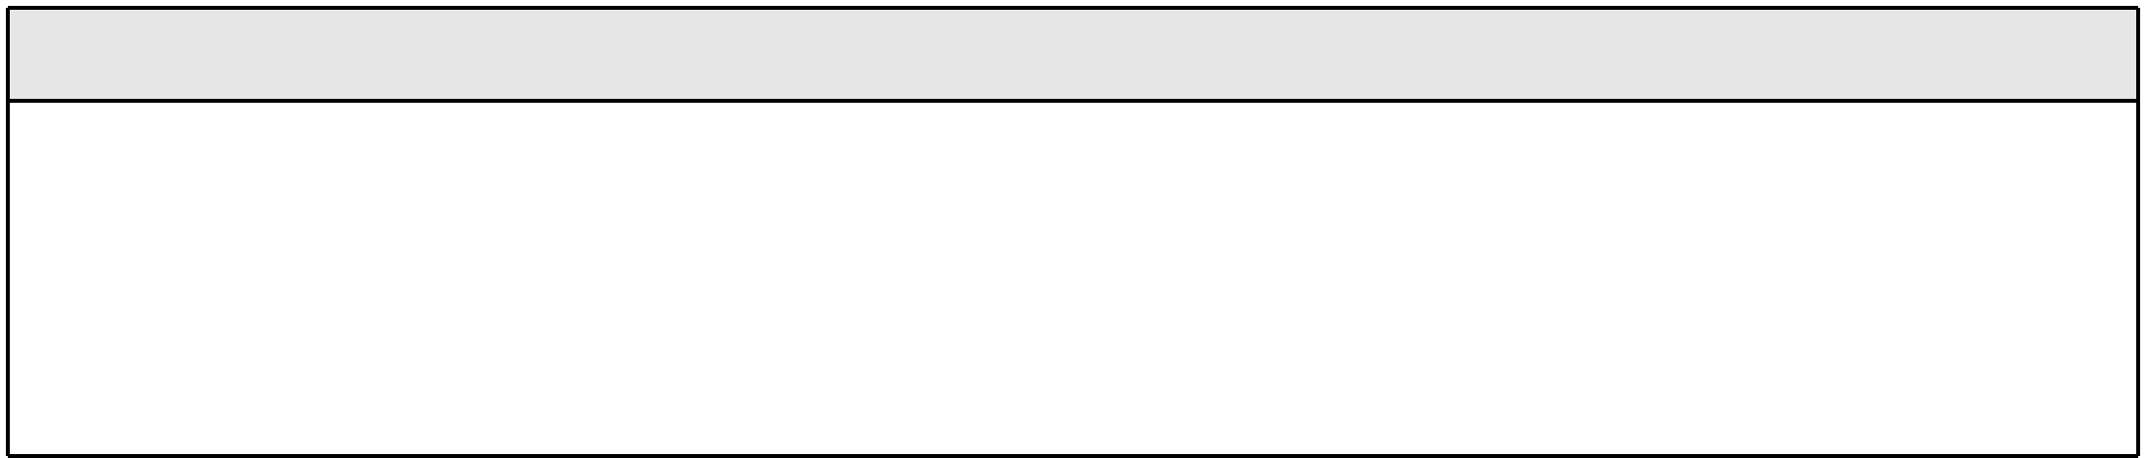

**8.CO-CURRICULAR ACTIVITIES**

* Participated in Inter-School Cricket Tournament.
* Stood 1st in Collage Competition.
* Participated in dance in cultural event of the college.



**9.HOBBIES & INTERESTS**

* Listening to Music
* Watching movies
* Swimming
* Playing games
* Surfing on Net

Date: Signature of Student

COUNTER SIGNED

Date : Stamp & Signature of Director