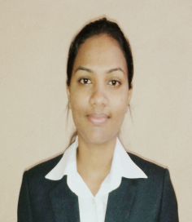**RESUME**

**GAUTAMI G. DESSAI SOLIENCAR**

Contact No: +91-8806727915  
E-mail: [gautamidessai0412@gmail.com](mailto:gautamidessai0412@gmail.com)

**OBJECTIVE**

* Seeking a position that offers a high degree of challenge, responsibility and upward mobility.
* Excellent analytical, interpersonal and communication skills.
* Proficient in grasping new concepts quickly and utilizing them in an effective manner.

**Professional Qualification**

* PGDBA (Post Graduate diploma in business administration) from Adarsha Institute of Management 2014

**Academic Qualification**

* BCA from Shree Damodar College of Commerce and Economics – 2010
* HSSC in Commerce from Smt. CTN higher Secondary School – 2007
* SSC from Guardian Angel High School – 2005

**Achievements**

* Won School level Badminton Championship.
* Won All India quiz Competition School level.

**Hobbies**

* Playing Badminton.
* Gardening.

**Extracurricular Activities**

* Actively participated in JRC & NSS.
* Organized various events in college.

**Academic Project**

* Had developed a Software based on LIC (POLICIES) in the year’2010
* Had done an Internship project on Inventory Management’2014

**Academic Internship**

* **Company:** Zephyr Biomedical Systems (TULIP GROUP)   
   **Role:** Management Trainee  
   **Duration:** 11 Weeks (28th April – 12th July)  
   **Responsibility:** Worked in Finance Department   
   Learned about Various Operations in finance department

**Work Experience**

* **Company:** IndusInd Bank

**Designation:** Relationship Officer

**Duration:** 6 Months

* **Company:** SMG Group (Muktar Automobiles Pvt. Ltd.)

**Designation:** Accounts Assistant

**Duration:** 9 Months

**Personal Information**

* **DOB: 04th December 1989**
* **Address: Kush Mansion D-6, Bansai , Curchorem Goa.**

**403706**

* **Languages Known : English, Konkani, Hindi, Marathi**

**GAUTAMI GURUDAS DESSAI SOLIENCAR**