**NIGAM NIRUPAM**

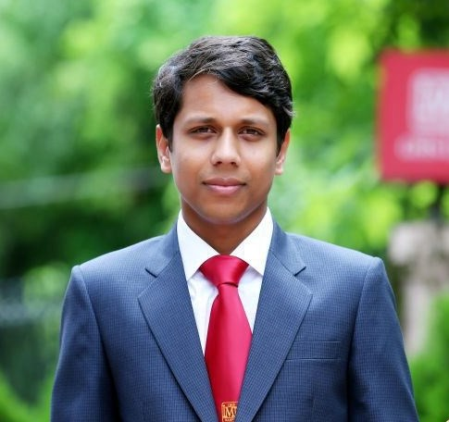

**Major/Minor: MARKETING/I.T**

**Address: K-103/2 K-K PURI COLONY JHANSI (U.P**

**Cell No.: 9792680894**

**nigamnirupam@rediffmail.com**

|  |  |  |  |
| --- | --- | --- | --- |
| **PROFESSIONAL PROFILE** | | | |
| ***Results-driven energetic individual possessing sound knowledge & skills in Marketing with professional strengths as follows:***   * Excellent team leadership, interpersonal skills. * Diligent worker possessing quality of goal oriented and willingness to learn new things. | | | |
| **Summer Internship (May-June 2014)**   * Completed my Summer Training from **Hindustan Unilever (Indore)**;   Worked upon a project titled “**Analysis of sales & Distribution Of Vending machine at Indore Territory”**  **Accomplishments/Skills acquired during internship:**   * Performed a sales & Distribution of Vending Machine & Give Presentation of Machine in Different Offices. * Utilized the above analysis to convince 6 Client for first meeting out of 10 Prospective client. * Learned about sales & Distribution of Machine & its Premixes. * Visiting Various Industries for Installation of Vending Machine.   **Academic Credentials** | | | |
| **Name of Course** | **Institution/Board/University** | **Percentage** | **Year of Passing** |
| Post Graduate Diploma in Management (PGDM)  *Major – Marketing Minor – I.T* | Dr. Gaur Hari Singhania Institute of Management & Research (GHS-IMR)  (approved by AICTE and accredited equivalent to MBA by the Association of Indian Universities) | 61.00 | 2015 |
| B.M.S | Mumbai University, Mumbai | 65.66% | 2011 |
| Class XII | St. Mark’s College, Jhansi  (C.I.C.S.E.) | 52.63% | 2007 |
| Class X | St. Mark’s College, Jhansi  (C.I.C.S.E.) | 52.51% | 2005 |
| **Research & Academic Projects**  **Final Research Project**  IMPACT OF PACKAGING ON CONSUMER BUYING BEHAVIOUR.  **Other Academic Projects**   * Done Marketing Mix Mapping of haier Electronic. * Visit Parle-G (Mumbai, Ajmer), Goldiee Masale factory (Kanpur), Tilonia Village (Pushker),Raymonds(Pushker). * Done Summer Training At Airtel communication (Mumbai,Nerul) * Conduct Test between Ready To cook & ready To Eat at Kanpur. | | | |
| **OTHER DETAILS** | | | |

**Date of Birth**

* 02.09.1989

**Hobbies**

* Interact with People
* Web Browsing

**Language Proficiency**

* English
* Hindi

**Co-curricular Activities**

* Participated in G.K Quiz Contest organized by Aptech.
* Participated in N.S.I.C program as a Coordinator.
* Participated in Brand Craft as a Registration Desk Coordinator.
* Participated In Economic seminar at Pillai College.
* Participated in H.R SUMMIT as a Registration Desk Coordinator.

**Extra Activities**

* Student Alumni Committee Coordinator at GHS-IMR
* Newsletter committee Coordinator at GHS-IMR.
* Conduct Alumni Meet 2014 as overall coordinator
* Participated as volunteer Zeast Feast Navi Mumbai festival (Belapur).
* Conduct various in-house games at graduation level.

**Date:**

**Place:**