**ANKIT GOUR**  
4-A, R.K. Puram  
Kota (Rajasthan)  
09971299974  
ankit8685@gmail.com

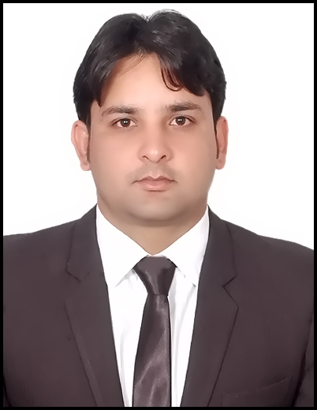

**PGDM Specialization:** Finance and Marketing

**CAREER OBJECTIVE**

Build a career with a company where my knowledge and skill set can be utilized in a challenging and creative environment.

**PROFESSIONAL QUALIFICATION**

|  |  |  |  |  |
| --- | --- | --- | --- | --- |
| **YEAR** | **DEGREE** | **PERCENTAGE** | **INSTITUTE** | **UNIVERSITY** |
| 2013 – 15 | PGDM | 6.75 | IMS, Ghaziabad | AICTE |
| 2009-12 | B.B.A. | 55.33% | P.I.M.D. , Indore | Vikram University |
| 2009 | 12TH | 54.6% | L.B.S. School, kota | N.I.O.S. |
| 2006 | 10TH | 46.2% | D.A.V. School, kota | C.B.S.E |

**EXPERIENCE**

**Kotak Mahindra Old Mutual Life Insurance Duration:** 12.01.2015 – 15.01.2016

**Designation: Deputy Manager**

* Responsible for Development of Supervisors and Executives.
* For recruitment of agency partners.
* Business development in my zone and to handle all the operational works.
* To manage the team working under my environment.

**INTERNSHIP SYNOPSIS**

**Organization Name:**DCM SHRIRAM

**Duration of Internship:**1 May 2014 to 15 June 2014

**Title:**Fund Management Process of DCM SHRIRAM Ltd. Kota (Raj.)

**Inference:** To minimize the clearing cost of outstation cheques, Payment procedure of Custom Duty, Payment process through SAP.

**LIVE PROJECTS & INDUSTRIAL VISITS**

**Organization: Future Group BIG BAZAR**

**Duration: 1 Week**

Exposure of Sales (Combo Pack) and Marketing in 6 Din MahaBachat -2013

**VISITS:**

* Mother Dairy, New Delhi.
* Instrumental Limited, Kota (Rajasthan)
* NTPC, Anta Dist. Bahran (Rajasthan)
* Kota Super Thermal Power Station, Kota (Rajasthan)
* Chambal Fertilisers and Chemical Limited, Gadepan, Kota (Rajasthan)
* DCM SHRIRAM Kota (Rajasthan)
* Coca Cola India Limited, Ghaziabad (U.P.)
* Pepsi Co. in Dubai (UAE)

**CERTIFICATE PROGRAMME / WORKSHOPS / CONFERENCES**

* Received Certificate of completion for successfully completing 2 days workshop on “Sales and Negotiation Skills”.
* Yellow Belt Six Sigma certified.
* Participated in Inter-Departmental Academic Fest of PGDM programme “KYUUDAN – HR Fest”.
* Attended 25 National Convention on “Growth in times of Uncertainty” held at Country Inn, Sahibabad.
* Attended International Conference on “Reinventing Management Strategy” held at IMS Ghaziabad.
* Attended a full day student development programme conducted by Global Human Resource Development Centre (GHRDC).

**ACHIEVEMENTS**

* Successfully organized **The Growth Net Conference-“Reviving Growth – Reversing the Tide”at Hotel Taj Palace, New Delhi.**
* Got Certificate of Appreciation in organizing the annual cultural fest (**Mélange**) of IMS Ghaziabad.
* Got Certificate of Appreciation on achieving annual target before time by **Kotak Life.**

**KEY ATTRIBUTES**

**#** Punctuality, Multitasking skills. **#** Zeal to learn new things.

**#** Leadership Quality. **#** Adaptable.

**INTERESTS & PASSION**

**#**Photography **#**Computer Savvy

**#** Travelling. **#**Off-roading.

**PERSONAL DETAILS**

**Date of Birth :** 23 May 1991

**Gender :** Male

**Father Name :** V.S. Gour **Passport No. :** L3644024 **Languages Known :** English and Hindi

**Computer Efficacies:** SAP R/3 (Finance Module), MS- Excel, PowerPoint, MS - Word

**Permanent Add :** 4-A, R.K. Puram, Kota (Raj.)

**DECLARATION**

I hereby declare that the information provided above is true and the best of my knowledge.

Date:

Place: Signature