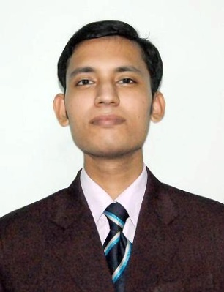 **GOBINDA DEY**

🕿+918867814911,91-9437709528

🖂 gobindadey86@gmail.com

**Objective**

To synergize my work with company’s motto and be in an organization where I can effectively contribute my technical and managerial skills as well as nurture talent in a highly competitive work environment.

**Strengths**

* Natural people skills with the square to find positive and applicable solutions.
* Good analytical and problem solving skills.

**Academic Qualification**

|  |  |  |  |  |  |
| --- | --- | --- | --- | --- | --- |
| Examination | Discipline/  Specialization | School/college | Board/  University | Year of Passing | % |
| **PGDM** | **Agribusiness management** | **Udaybhansinhji Regional Institute of Cooperative Management** | **AICTE** | **2011** | 63% |
| **B.Tech** | **Biotechnology** | **IASE University** | **IASE University** | **2008** | 73% |
| **Intermediate** | **Science Math’s Stream** | **Nilgiri College** | **C.H.S.E** | **2004** | 49% |
| **S. S. C** | **S.S.C** | **Balasore Zilla School** | **B.S.E** | **2001** | 66% |

**Computer Proficiency**

Software : SPSS, Excel, SAS

Operating Systems: Windows 9X/2000/XP, DOS 6.0.

**Work Experience**

1. **National Horticulture Board ,Gurgaon**

***1st April, 2011 to 5th September 2012***

**Jr. Horticulturist Officer (Market Intelligence System) :**

* + - Develop Market Intelligence.
    - Identifying the sources of Data Collection.
    - Conducting Market Research.
    - Preparation of Module on Data Collection.
    - Data Analysis & Interpretation through various software & statistical techniques such as excel and spss
    - Report Generation.

1. **Spices Board, Kochi**

***28th Feb, 2013 to 17th OCT 2014***

**Market Research Trainee:**

* + - Market research and data analysis of quality parameters of spices
    - Capacity development analysis of spice industry
    - Analysis of various pesticide residues of spices
    - Report generation on various trade policies and tariffs of different countries pertaining to spices

**Workshop AND TRAININGS ATTENDED**

* Attended the training on Bioinformatics & Statistics in aquaculture research from 22-01-2007 to 22-02-2007 in the office of the **Assistant Director of Fisheries, Balasore.**
* Attended marketing seminar and workshop by **Neilson Company**, organized in **IIM,Ahemedabad** during 2nd and 3rd October 2010**.**
* Participated in the MDMS(Management Development Module for Students) program held in IIM,Ahemedabad (Annual International Management Summit) between 26th to 28th November 2010.

**Computer Skills**

Software : SPSS, Excel

Operating Systems: Windows 9X/2000/XP, DOS 6.0

**linguistic Proficiency**

* English, Hindi,Oriya,Bengali

**REFERANCE DETAILS**

Dr. Pss Thampi, Deputy Director,

Spices Board

Mobile no:8129590590

Dr.G. K Vidyashankar, Deputy Director Marketing

Spices Board

Mobile no:9745610026

**Personal Details**

* Date of Birth : 10th Jun 1986.
* Language Known : English, Hindi,Oriya,Bengali.
* Fathers Name : Kamalakanta Dey
* Permanent Address : At –Padhuanpada New Colony

Po- Azimabad

Dist- Balasore,State-Orissa

Pin- 756001

**declaration**

I hereby declare that the above mentioned details are true to the best of my knowledge.

Date:

Place: **Gobinda Dey**