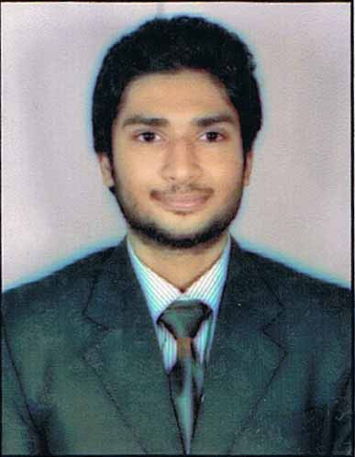

|  |  |  |
| --- | --- | --- |
| **Sanyam Khanorkar**  **Specialization : Finance** | Date of Birth  Correspondence Address  E-mail  Contact No.  Marital Status | : 6th June 1991  : Flat 21, “Roshan Manzil”, near Jain mandir , Bazaar Road, Bandra West , Mumbai – 400050, India.  : sanyam.khanorkar6691@gmail.com  : 08983393439, 0712-2740072  : Single |

### ACADEMIC CREDENTIALS

|  |  |  |  |  |
| --- | --- | --- | --- | --- |
| YEAR | DEGREE | INSTITUTE | BOARD/UNIVERSITY | RESULT (%) |
| 2013-14 | MMS (1st year) | MET Institute of Management | University of Mumbai | 65.35 |
| 2013 | B.E. (Mechanical) | G. H. Raisoni College of Engineering | Nagpur University/G.H.R.C.E. | 64.00 |
| 2009 | HSC | M. Mohota College Of Science | Maharashtra | 73.00 |
| 2007 | SSC | Bhavan’s B. P. Vidhya Mandir | C.B.S.E. | 89.00 |

### SUMMER INTERNSHIP

Organization: **iFAST Financial Pte. Ltd.**  Duration: **May’2014 – July’2014 (**02 months)

Project : Understanding the changing trends in the mutual fund distribution – with respect to IFA segment

(Individual financial advisor)

Description : Comparison of changes done by advisors in their business model to adapt to changing regulations

with other channels of distributors ( like banks , broking companies)

To study the awareness and acceptability of mutual fund platforms by financial advisors

### KEY ACADEMIC PROJECTS

* **Consumer Protection Act (1986)**

Importance of the act

Amendment in 2002

* **Eurozone Crisis**

Eurozone Crisis and its impact on India

* **Hedge funds**

Introduction to how hedge funds are managed

### TECHNICAL PROFICIENCY

* Microsoft Office

### ACHIEVEMENTS/ ACTIVITIES

* **Awarded 2nd price for paper presentation at Technoivision 6.0, RKNEC, Nagpur.**(2011)
* Awarded 3rd position in the event TRIALATHON, SIMERATIONS 2013.

**LANGUAGE PROFICIENCY**

* English (Fluent)
* Hindi (Fluent)
* Marathi (Fluent)
* Chinese (Elementary)

### INTERESTS

* Travelling
* Online research
* Listening to music (to indie-rock, pop and classical music)
* Working Out

I hereby affirm that the information in this document is accurate and true to the best of my knowledge.

Place: **Mumbai**

Sanyam Khanorkar