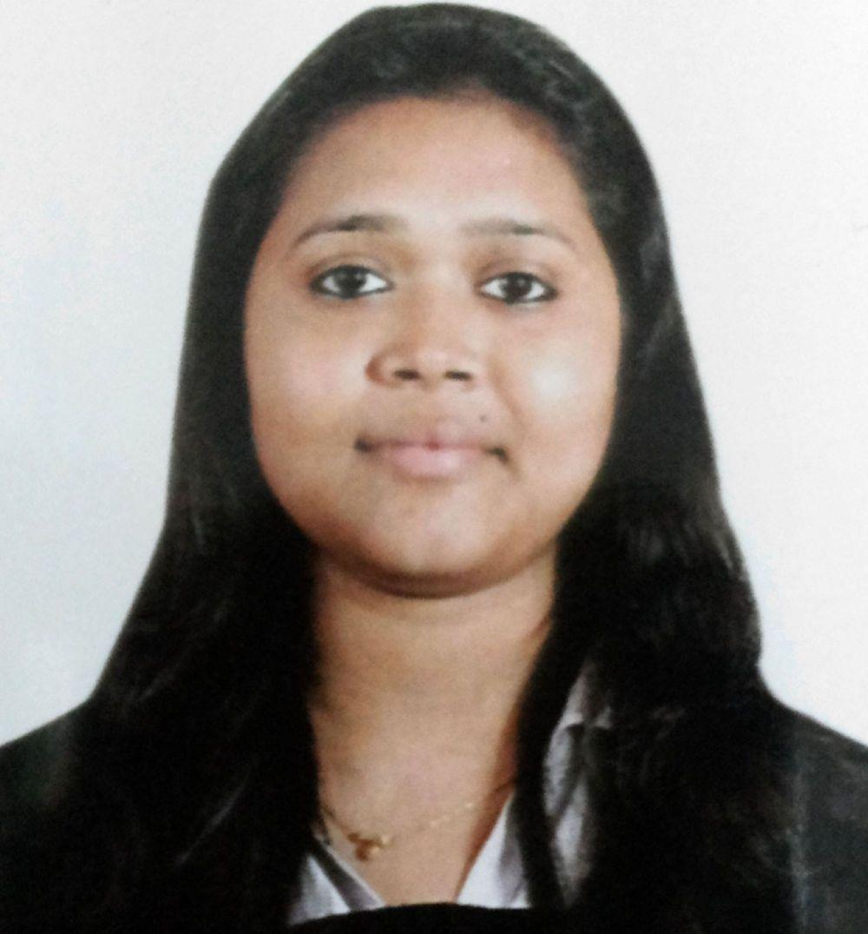**SHIVANI SAHAI AGARWAL**

Mob: +91- 7408433320

Email ID –shivani12342@gmail.com

Female / 23 years

**Objective**: Seeking to work in a healthy and challenging environment where I can utilize my past experience and current knowledge that is mutually beneficial to both my employer and myself and allow for future growth and advancement.

**ACADEMIC BACKGROUND**

|  |  |  |  |  |
| --- | --- | --- | --- | --- |
| **Year** | **Qualification** | **Institution** | **Subjects** | **%** |
| 2013 | PGDM | SRMS International Business School  Lucknow | Major – Finance  Minor - Marketing | 76 |
| 2011 | B.Com | Allahabad University | Tax, Corporate a/c, Insurance, Cost Accounting, Finance, Marketing, Business Organization, Audit. | 53 |
| 2008 | Intermediate | St. Anthony Convent Girls Inter-college. Allahabad | Commerce | 65 |
| 2006 | High School | St. Anthony Convent Girls Inter-college. Allahabad | Science, English, Social Science, Mathematics, and Hindi | 65 |

**PROFESSIONAL EXPERIENCE**

**ICICI Securities Ltd January 2014 - March 2015**

Senior Relationship Manager

* Provided financial solutions by understanding the current and future needs, through various available financial products.
* Meeting and developing relations with clients for providing financial services and support
* Received mutual fund award on national level

**Aegon Religare Life Insurance April 2013 -December 2013**

Relationship Manager

* Provided financial solutions through insurance products
* Received Employee of the month award for May and October for collecting highest revenue and score in the branch.
* Did campaigning for the company’s products and ideas in various parts of the city.
* Did KILB promotion and awareness among the masses.

**CERTIFICATION COURSES**

* IRDA (2014)
* AMFI (2014)

**SUMMER INTERNSHIP**

**Tata Steel,** a top ten global steel maker, world’s second most geographically diversified steel producer with annual production of nearly30 million tonnes.

**Project Title:** Working Capital and Receivables Management of Tata Steel

* Analysed the working capital of Tata Steel.
* Analysed the financial position of the various customers of Tata Steel.

**EXTRA CURRICULAR ACTIVITIES**

* Organized Intra College competition and Radio Jingle competition.
* Participated and won in Intra College dancing and singing competition.
* Participated and won in Inter College management fest and Ad Fest.
* Industrial exposure in organizations such as Bombay Stock Exchange, Jawaharlal Nehru Port Trust, Zuventus Pharmaceuticals, Parag Dairy, Scooters India Limited.
* A two-day live project in PARLE-G, Allahabad studying the manufacturing process of Parle-G and Cookies 20-20.