**Curriculum Vitae**

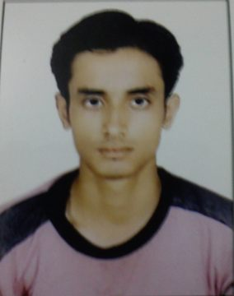

# Name : ASHISH KUMAR

**Address :** K.worah Building Fatehpur Lane Jharia, Dhnabad

Jharkhand

**Mobile No : 8092589831,9093677205**

**E-mail :** [singh.ashish120@gmail.com](mailto:singh.ashish120@gmail.com)

**Career Objective:-**

Serve for the organization by making optimum utilization of my skills and knowledge and grow with the organization growth.

**Academic Qualifications:**

|  |  |  |  |  |
| --- | --- | --- | --- | --- |
| **Degree/ Certificate** | Specialization | Board/University | **Year** | **% / CGPA** |
| MBA | Finance | NIT Durgapur | 2013-2015 | 5.97/10* |
| B.Com  Account (Hons.) | Accounts | VBU,Hazaribagh | 2011 | 64.50% |
| 12th | Commerce | CBSE | 2008 | 61.0% |
| 10th |  | CBSE | 2006 | 60.8% |

**\*CGPA is calculated on 10 point scale.**

**Summer Internship Program:**

During my MBA, I have completed summer internship program. The details as follows:-

|  |  |  |
| --- | --- | --- |
| **Name of Organization** | **Project Title** | **Duration** |
| BCCL | “Working Capital Management” | 2 Months |

**Research Project:**

During my MBA I also completed research projects. The details are as follows:-

|  |  |  |
| --- | --- | --- |
| **Project Title** | **Name of the organization** | **Duration** |
| “Impact of Grading System on the performance of Indian IPO ” | NIT Durgapur | 4 Months |

**Skills and Capabilities :**

* Discipline.
* Ability to do work in team.
* Positive Attitude.

**Extra-curricular:**

* Work for NGO “UDDESH”

**Achievements:-**

* Successfully qualified **NISM V-A** certification.

**Personal Details:**

**Date of Birth :**  18th September, 1991

**Fateher’s name :** Mr. Ranjeet Singh

**Gender** **:** Male

**Languages Known :** English, Hindi.

I hereby declare that the information given above is true and correct.

Date: Signature: